HARRIERS RUN FOR THEIR COUNTRY!

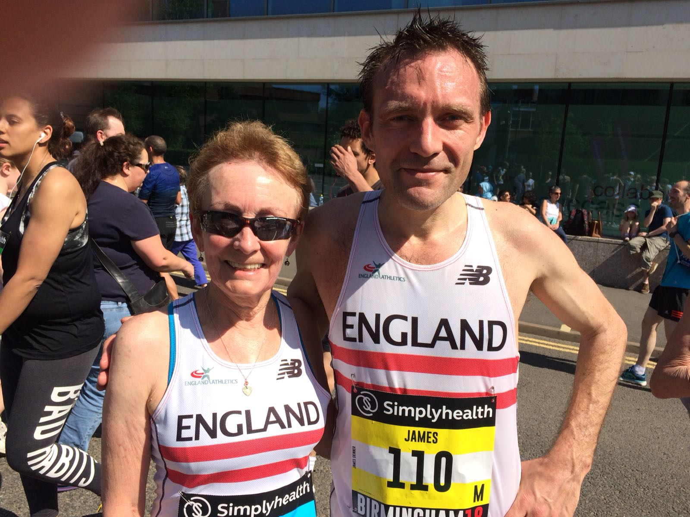

**Marion Hemsworth and James Skinner.**

2 Haywards Heath Harriers athletes who were selected to run at the British Masters Athletics Federation Simply Health 10 km race at Birmingham last Sunday were James Skinner and Marion Hemsworth. Both came first in their age categories against opposition from the home nations. James was first vet 45 finished and finished in a credible 16th place overall in the race in a time of 33 minutes and 12 seconds. Marion finished as first V65 in the race in a time of 52 minutes and 35 seconds.

Last weekend the Mid Sussex Marathontook place over 3 days. With the hot weather affecting the runners for all 3 races the personal times were not as quick as their best times. If runners completed all 3 races they would get an extra medal to show for all their hard work.

Harriers, Chris Smith, enjoyed the tough conditions of the new Haywards Heath 10 mile course that took in twisting sections in Beechurst Gardens and fast downhill sections. He finished first in a time of 56 minutes and 20 seconds. Second was Simon Heath in 56 minutes 58 seconds and third was Aled Anderson (Arena Ac) in 1 hour 3 minutes and 56 seconds. In the ladies race, another Harrier, Katie Morgan, was first home in 1 hour 11 minutes and 48 seconds, 2nd lady was Mia Klimaytys in 1 hour 14 minutes and 32 seconds and third was Linda Schofield in 1 hour 15 minutes and 3 seconds.

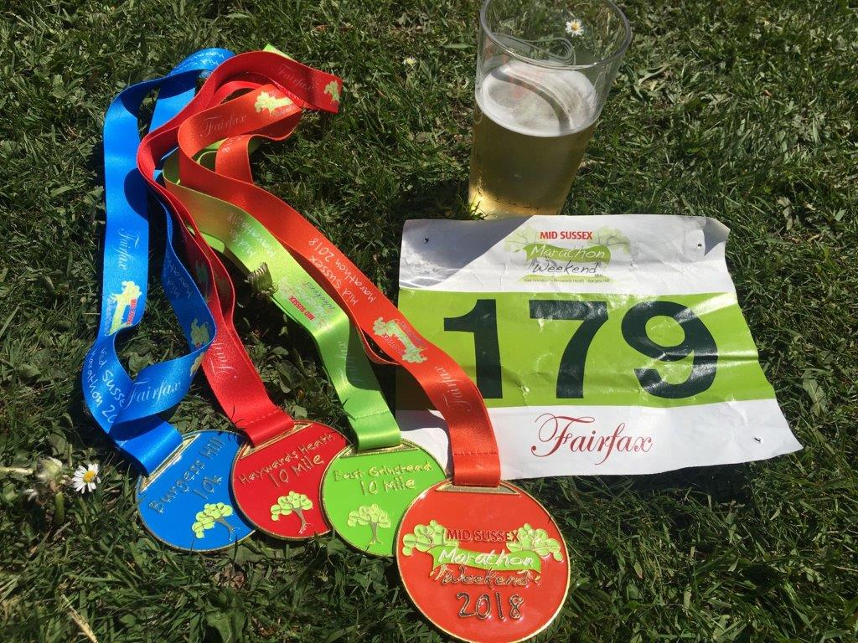

**The Mid Sussex Marathon.**

The East Grinstead 10 miler results were as follows:

2nd James Collins 1 hr 04:53; 10th Tom Mullen 1 hr 13:35; 12th Alex McGregor 1 hr 13:40; 15th Katie Morgan 1 hr 14:13; 32nd Dave Warren 1 hr 19:03; 65th Richard Haynes 1 hr 27:38; 66th Matt Quinton 1 hr 28:21; 72nd Chris Avison 1 hr 29:35; 79th Maresa Pitt 1 hr 31:35; 93rd Bruce Girvan 1 hr 32:47; 110th Noami Cikalo 1 hr 35:12; 135th Sarah Banks 1 hr 38:45; 144th Kath Buckeridge 1 hr 41:13; 175th Andrew Wilson 1 hr 46:44; 187th Teresa Mockridge 1 hr 48:36; 213th Damita Ewen 1 hr 53:03; 214th Abigail Redd 1 hr 53:04; 231st Justine Tanner 1 hr 56:42; 310th Alison Mitchell (CRC) 2 hrs 17:28; 312th Amy Mitchell 2 hrs 17:28

The Haywards Heath 10 miler results were as follows:

1st Chris Smith 56:20; 13th Alex McGregor 1 hr 09:43; 19th Katie Morgan 1 hr 11:48; 20th Jack Chivers 1 hr 11:57; 24th Tom Mullen 1 hr 12:56; 46th Dave Warren 1 hr 16:35; 61st Matt Quinton 1 hr 19:56; 108th Chris Avison 1 hr 27:00; 109th Carl Bicknell 1 hr 27:07; 110th Sam Ridley 1 hr 26:56; 134th Bruce Girvan 1 hr 29:33; 138th Kath Buckeridge 1hr 29:44; 153rd Eric Hepburn 1 hr 31:44; 208th Gemma Morgan 1 hr 37:03; 211th Andrew Wilson 1 hr 38:08; 235th Shelagh Robinson 1 hr 39:43; 250th Howard Booth 1 hr 41:44; 276th Jacqueline Barnes 1 hr 43:35; 298th Damita Ewen 1 hr 47:00; 299th Abigail Redd 1 hr 47:00; 315th Justine Tanner 1 hr 48:23; 362nd Sarah Hamilton 1 hr 54:31; 402nd Amy Mitchell 2 hrs 01:46; 403rd Alison Mitchell (CRC) 2 hrs 01:46.

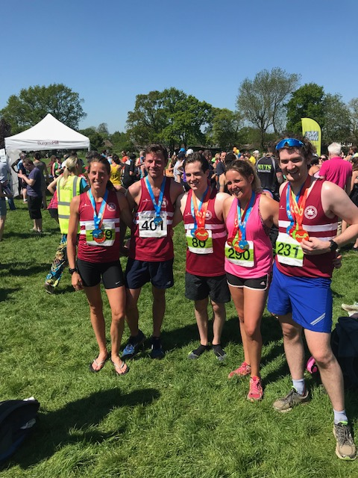

**Harriers at the Burgess Hill 10 km.**

Also, at the weekend, Matt Cook and Oli Farr both took part in the Milton Keynes Marathon. Matt was first home in 3 hours 22 minutes and 39 seconds and Oli finished in 4 hours 3 minutes and 16 seconds.

At the Three Forts Marathon, Josh Pewter finished in a marvellous 2nd place in a time of 3 hours 33 minutes 57 seconds! Paul Sargent of Burgess Hill Runners took first place in 3 hours 25 minutes and 56 seconds.

Tim Hicks took part on 28 April in the Yorkshire Three Peaks fell race which was a 23 mile hill race climbing up and down the peaks Pen-y-ghent, Whernside and Ingleborough. Tim broke the club record with a new time of 5 hours 9 minutes and 30 seconds. He climbed 5,053 feet of hill climb over the whole race. His time was a new club record by 29 seconds Well done Tim!!

At the Haywards Heath Track & Field meeting held on 26 April, there were many good performances. But the best Harriers performances on the night were the new club records by Emma Navesey in the senior women’s Harriers record on 5 minutes 21.3 seconds who was closely followed by young and upcoming star, Darja Knotkova-Hanley in a new Harriers under 20 record of 5 minutes 22.1 seconds.

The Harrier Track and Field results were as follows:

Track events:

Girls 9/10 60m: Erin Gaston 10.1 secs; Poppy Carmichael 10.3 secs; Megan Eyre 10.5 secs.

Boys 9/10 60m: Alex Stubbs 9.4 secs; Arun Khurshead 9.8 secs; Jack Twibell 9.8 secs; Liam Capel 10.7 secs.

Girls U/13 75m: Mae Robinson 12.3 secs; Eva Carmichael 12.4 secs.

Boys U/13 75m: Charlie Parvin 11.0 secs; Ben Taylor 12.2 secs; Noah Perrett 13.4 secs.

Girls U/20 100m: April Hanslow 13.5 secs.

Girls U/15 100m: Hannah Taylor 15.7 secs.

Men U/20 100m: Christian Lambert 12.7 secs.

Boys U/15 100m: Ethan Lambert 13.7 secs; Lio Robinson 15.5 secs.

Girls U/13 150m: Ella Chatfield 26.7 secs.

Girls U/13 150m: Amy Rutherford 25.8 secs.

Boys 9/10 150m: Arun Khurshead 24.4 secs; Jack Twibell 24.9 secs; Liam Capel 27.1 secs; Johnny Rutherford 29.2 secs.

Boys U/13 150m: Charlie Bonwick-Adams 22.4 secs; Alex Todd 23.2 secs; Alex Booth 23.7 secs; George Bonwick-Adams 24.5 secs; Noah Perrett 27.4 secs.

Boys U/15 200m: Ethan Lambert 28.6 secs.

Girls 9/10 600m: Megan Eyre 2 mins 10.5 secs.

Boys 9/10 600m: Arun Khurshead 2 mins 5.9 secs.

Girls U/13 600m: Phoebe Whiting 2 mins 3.8 secs; Amy Rutherford 2 mins 15.9 secs; Ella Chatfield 2 mins 17.9 secs.

Boys U/13 600m: Charlie Bonwick-Adams 1 min 51.5 secs; Alex Todd 1 min 55.6 secs; George Bonwick-Adams 2 mins 4.0 secs; Noah Perrett 2 mins 16.4 secs.

MILE RACE: James Skinner 4 mins 45.2 secs; Ben Gibson 5 mins 00.8 secs; Russ Mullen 5 Mins 7.0 secs; Emma Navesey 5 mins 21.3 secs; Darja Knotkova-Hanley 5 mins 22.1 secs; Paul Cousins 5 mins 25.6 secs; Jasmine Mamoany 6 mins 12.8 secs;

Girls U/15 800m: Harriet Dray 2 mins 51.7 secs.

Boys U/17 800m: Adam Dray 2 mins 10.4 secs.

Field events:

Girls 9/10 Long Jump: Erin Gaston 2m 67; Megan Eyre 2m 54; Poppy Carmichael 2m 45.

Girls U/13 long Jump: Amy Rutherford 3m 09; Mae Robinson 2m 72; Eva Carmichael 2m 58.

Boys 9/10 Long Jump: Alex Stubbs 3m 05; Johnny Rutherford 3m 00.

Boys U/13 Long Jump: Alex Booth 4m 00; Alex Todd 3m 95; George Bonwick-Adams 3m 49; Charlie Bonwick-Adams 3m 36; Ben Taylor 2m 66; Liam Capel 2m 55.

Men U/20 Long Jump: Christian Lambert 5m 17.

Boys U/15 Long Jump: Ethan Lambert 4m 17; Lio Robinson 3m 90.

Boys U/15 Javelin: Lio Robinson 25m 56.

Boys U/13 Shot George Bonwick-Adams 5m 22; Charlie Bonwick-Adams 4m 94.

.

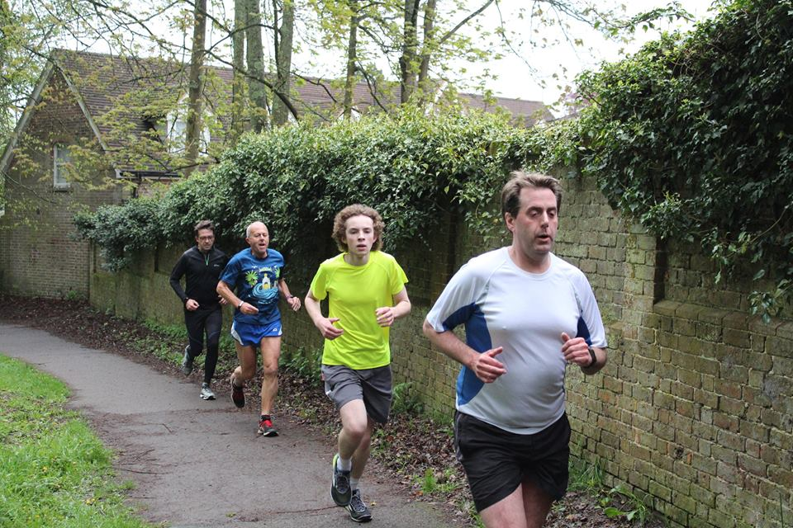

**George Adams (in yellow).**

At the Worthing parkrun, Emma Navesey knocked off 20 seconds from her Senior Women’s club 5k record in a time of 18 Mins 21 seconds.

Meanwhile at Clair parkrun, at Haywards Heath, young George Adam had a superb run on Saturday improving on his previous week’s pb by 14 seconds in a time of 18 minutes 44 seconds

Parkrun is the new running phenomenon. This free run over 5km every Saturday at 9 o’clock in the morning is organised by parkrun uk, with local volunteers in many parks across the country are helping people from everywhere to improve their health and well-being. In Sussex there are 10 parkruns. The numbers taking part last Saturday morning was a staggering 4,617 parkrunners.

Totals for each parkrun were as follows; Hove 475, Tilgate 579, Eastbourne 355, Chichester 253, Hove Prom 390, Bevendean 34, Peacehaven 149, Clair 156, Preston park 507, Bognor 289, Horsham 463, Hastings 381, Worthing 514 and East Grinstead 72.

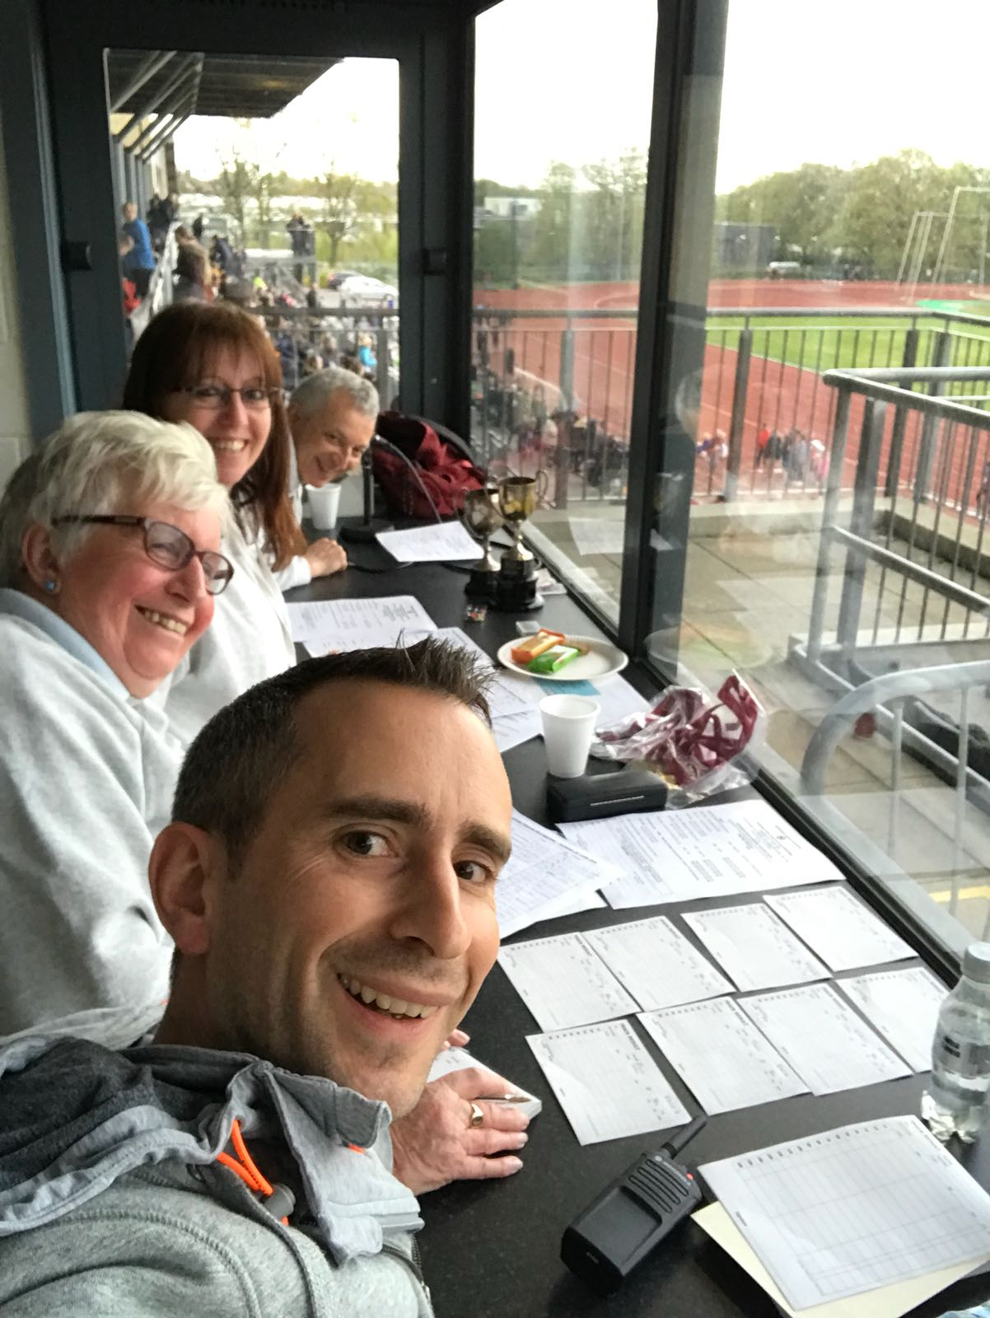

**Helping out?**

If any Harriers would like to help in the future at any of our events, there are many jobs that need filling. You could be helping with these smiley faces in the results section. Or you could have a go with the stop watch or help making teas and coffees. We are always in need of support and helping your club out means we can put on events like the Haywards Heath Harriers Track and Field meeting a couple of weeks ago in April. If you re interested in helping coach the juniors on a Tuesday night, then please get in touch with Linda Tullett.