**Harriers with their bronze medal haul from the Sussex Track and field Championship at K2, Crawley.** 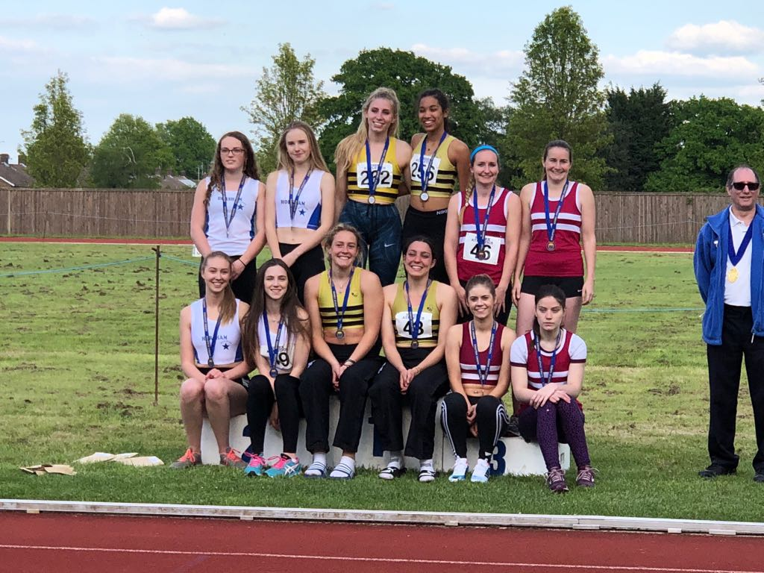

**Senior Women’s 4 x 100 metres: Top row L-R: Lucie Venables, Helen Diack; Bottom row L-R: Brittany Croydon-Kempster, Katie Grant.**

Full results from the Sussex Track and Field Championships on the 12th and 13th of May were as follows:

U/13 Boys Minithon:

34th Alexander Booth (LJ 3.58, 150m 22.39 secs, Shot Putt DNS).

= 37th George Bonwck-Adams (LJ 3m 33, 150m 23.60secs, Shot Putt 5m 07).

= 37th Thomas Pearce (LJ 3m 58, 150m 23.2 secs, Shot Putt 3m 58).

47th Charlie Bonwick-Adams (LJ 3m 18, 150m DNS, Shot Putt DNS).

U/17 Boys: 1500m: 4th Adam Dray: 4:17.89 (pb), 9th Nathan Buckeridge (Crawley/Haywards Heath Harriers) 4:31.65.

Men’s 5000m: 11th James Skinner: 15:40.16 secs (new Harrier Record**)**; 15th Russ Mullen 16:37.00.

U/17 Women: 100m (Heat 2): 4th Eliza Martin 14.74 secs.

U/17 Womens 3000m: 4th Jasmine Mamoany 12:22.19.

U/20 Women’s 3000m: 1st Darja Knotkova-Hanley: 10:29.68 (new Harrier Record).

Senior Women’s 4 x 100m: 3rd Haywards Heath Harriers: 57.79 secs.

James Collins completed in his first ever fell race on Sunday at the inter counties event in the Peak District. After finishing in 65th place, James said that he thoroughly recommended the event. He finished in a time of 55 minutes and 40 seconds.

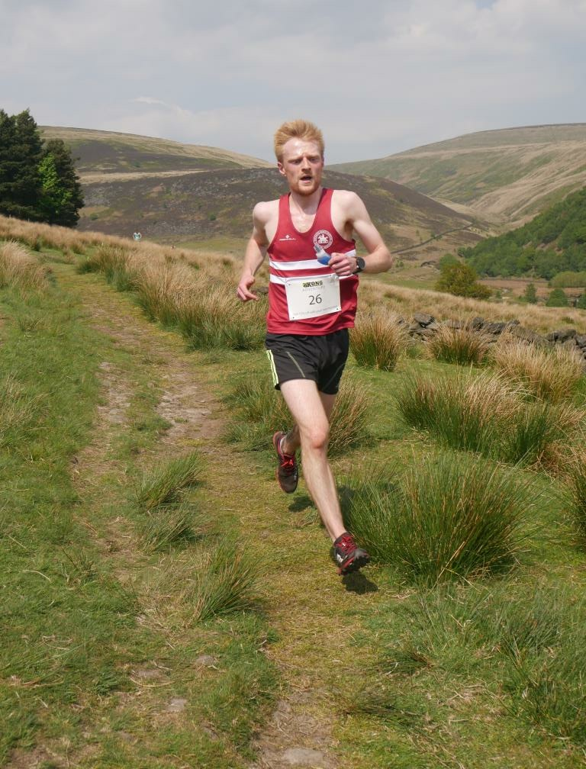

**James Collins at the Inter Counties Fell running event in Derby**.

Harriers Results Roundup:

Last Wednesday evening at Littlehampton was the 3rd West Sussex Fun Run League meeting of the year. A bunch of Harriers took part in this run along the beach over sand and shingle and getting their feet wet from the many pools of water on the way. The five brave Harriers who took part in this event were Phil Payne who came 14th in 29:50, followed by Kim Lo in 36th place in 32:09 (Kim was first women). Other Harriers were 154th Graham Kenward 37:39, 240th Amy Mitchell 42:30 and 328th Richard Bates 47:06.

At the Horsham 10k on Sunday 20th May, Katie Morgan won the women’s race. The results were as follows:

Katie Morgan 39:00; Matt Quinton 42:21; Matt Howells 44:03; Phil Scott 45:06; Sam Ridley 45:30; Carl Bicknell 48:58; Chris Glanfield 49:29; Karen Thompson 49:42; Gail Lelliott 59:09; Peter Cobbett 62:13.

Emma Navesey took part in the Pursuit Mile at Parliament Hill on Saturday 19th May. She was chased by Hannah England (who ran in 2012 Olympics!) who had a 45 second handicap. Emma beat Hannah with a time of 5 minutes and 25 seconds.   
  
Josh Pewter ran in the Sutton 10km race and finished in a new personal best time of 35 mins 47 seconds. This put him in about 13th place overall in the race.

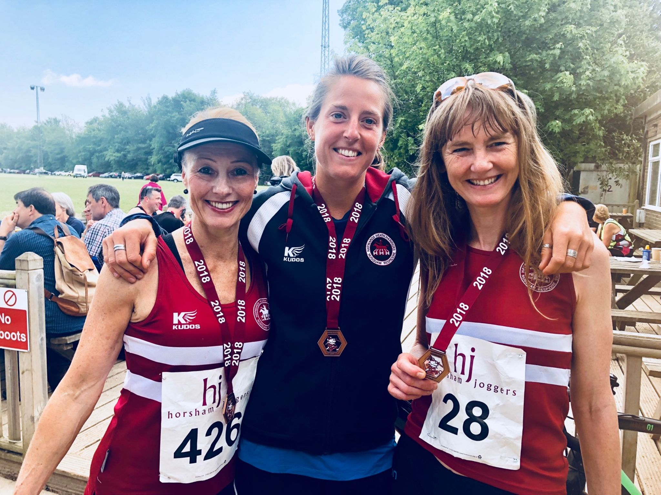

**L-R: Sam Ridley, Katie Morgan and Karen Thompson at the Horsham 10km.**

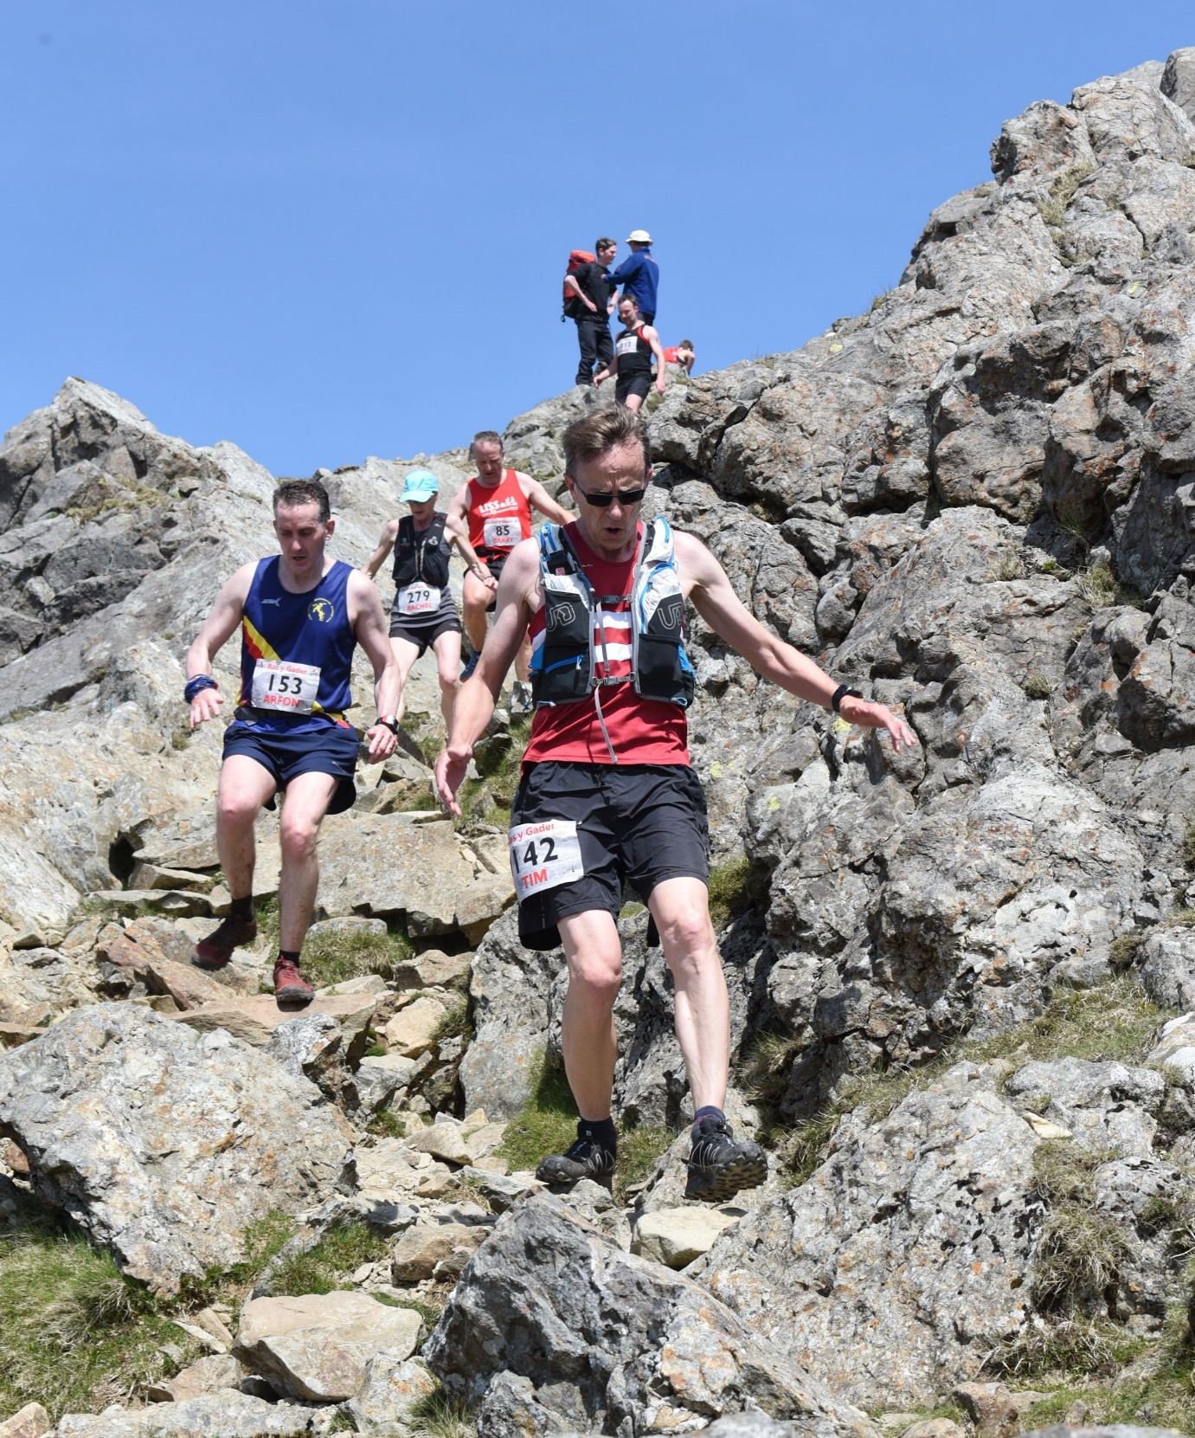

**Tim Hicks and fell running at Cader Idris.**

Tim said that this was his favourite fell race, Cader Idris in Wales, 11 miles up and down a 3000ft mountain. This was the 12th time Tim has run this event. He said, “Too hot for a fast time but you don’t often get to see the views from the top of a Welsh mountain.  It’s great to have the support of my family watching the race, so the weather was a bonus for them too.” Tim finished in 143rd place (out of 281) in a time of 2 hours 10 mins 43 seconds.

Last Sunday at Erith, at the Southern Athletic Leagues match, a team of harriers in co-hort with Lewes Athletic Club took on a host of other clubs in a double match setting, competing against clubs from Kent AC, Swale, Bexley Thanet, Medway, Sutton and Cambridge Harriers. Haywards Heath and Lewes came 3rd place in their match.

The Harriers results were as follows:

Men:

Martin Dawson: 400m 55.9 secs; High Jump 1m 63; Triple Jump 11m 29.

Mark McLoughlin: 800m 2 min 31.0 secs; 1500m 5 mins 26.9 secs; 3000m 12 min 30.9 secs.

Tim Popkin: 3000m s/c 15 min 25.2 secs; 800m 2 min 31.6 secs; 3000m 11 min 54.4 secs; 1500m 5 min 26.7 secs.

Paul Cousins: Javelin 17m 50; 3000m 10 min 24.8 secs; 1500m 4 min 52.5 secs.

4 x 100m Lewes / Haywards Heath Harriers: 50.3 secs.

4 x 400m Lewes / Haywards Heath Harriers: 3 min 58.4 secs.

Women:

Brittany Croydon-Kempster: 100m 14.6 secs; 200m 30.9 secs; 400m 70.1 secs; Long Jump 4m 41.

Jenny Denyer: 1500m s/c 10 min 27.5 secs; Triple Jump 5m 76; Shot Putt 5m 48; Discus 16m 25; Hammer 17m 83; Javelin 11m 31.

4 x 100m Lewes / Haywards Heath Harriers: 63.1 secs.