Middy Report 8 July 2018.

SILVER MEDAL FOR HARRIER’S RELAY

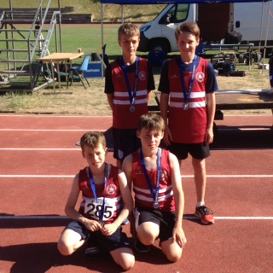
Alex Todd, Archie Hale, George and Charlie Bonwick-Adams.

The Sussex Under 13 Track and Field Championships and Quadkids Championships for the under 11’s were held at the Withdean Stadium in Brighton on 30 June.
In the Under 13’s, Charlie Parvin ran 13.81 seconds in his heat of the 100 metres finishing in second place and then finished 8th in the final in a time of 14.63 seconds after injuring his foot. Archie Hale finished 3rd in his heat of the Under 13’s 100m metres in a time of 14.25 seconds and then ran 14.08 seconds in the final to finish in a superb 6th place. Archie also finished 8th in the long jump with a jump of 4.02 metres and he also ran in the 200 metres and finished in a time of 29.08 seconds in his heat and then placed 8th in the final in 29.89 seconds.

Arun Khursheed and Oliver Cooper also both brilliantly completed the Quadkids minithon. Arun ran 11.41 seconds in the 75 metres sprint, he then ran the fastest race out of all the under 11’s in the 600 metres race and stormed it in a time of 1 minute 49.74 seconds.
Oliver ran 12.44 seconds in the 75 metres sprint, he then ran the 600 metres race in 2 minutes 17.77 seconds.

At the Youth Development League at Walton on 01 July, Joseph Martin came first in the 3000 metres race in a personal best time of 9 minutes and 23.2 seconds.

At the Round Hill Romp at Steyning on 4 July
Three Harriers took part in this West Sussex Fun Run League event covering 5 miles over road and footpaths through Steyning and up an over Round Hill. First home was Mark McLoughlin in 121st place a time of 49 minutes and 27 seconds. He was followed by Mark Armitage in 161st place in a time of 52 minutes 19 seconds and next Harrier was Richard Bates in 327th place in a time of 64 minutes and 38 seconds.

Bewl 15 mile race on July 1st.
Lots of Harriers took part in this tough, undulating course around Bewl Water. Results were as follows:
21st Rob Watts 1:47.28; 22nd Michael Burke 1:48.21; 25th Ben Duncan 1:49.20; 38th Katie Morgan 1:54.33; 55th Mark Green 1:57.41; 160th Matt Quinton 2:13.07; 236th Naomi Cikalo 2:21.04; 274th James Sadler 2:26.24; 280th Carl Bicknell 2:26.41; 303rd Oli Farr 2:28.31; 448th Marion Hemsworth 2:43.35; 555th Gary Johnston 2:57.59; 682nd Chris Glanfield 3:23.29.

Telscombe Cliff Run
Sam Ridley ran the 8.1 miles race in 1 hour 12 minutes and 10 seconds.

Downland Dash on 23 June.
Two Haywards Heath Harriers ran in the Downland Dash 5 mile race which is held in the village of Keymer in Mid Sussex. Young Ryan Armstrong was first home in 87th place in a time of 38 minutes and 53 seconds. Second home was Richard bates in 225th position in a time of 55 minutes and 05 seconds.

Heathfield 10 km on 24 June
Haywards Harrier Katie Morgan was 23rd overall and was the first lady finisher in a time of 41 minutes and 39 seconds. Other Harrier results were; 29th Jack Chivers 42:48; 56th Matt Quinton 44:55; 82nd Matt Howells 47:49; 91st Naomi Cikalo 48:51; 99th Oliver Farr 49:37; 123rd Karen Thompson 52:25; 146th Chris Glanfield 54:09; 260th Gail Lelliott 67:08; 262nd Peter Cobbett 67:54.

Haywards Heath Harrier, Will Herbert who also is a triathlete, competed in the SCA Sussex Champs 50mile Bike Time Trial on 01 July and finished in 17th position in a time of 2 hours and 2 minutes.

At the South of England Master’s at Battersea on 24th June, thrower Mike Bale won both silver and a bronze medals when he came 2nd in the Weight with 12.65m and 3rd in the Discus with a throw of 29.24m. He also came 4th in the Hammer with 31.24 metres.

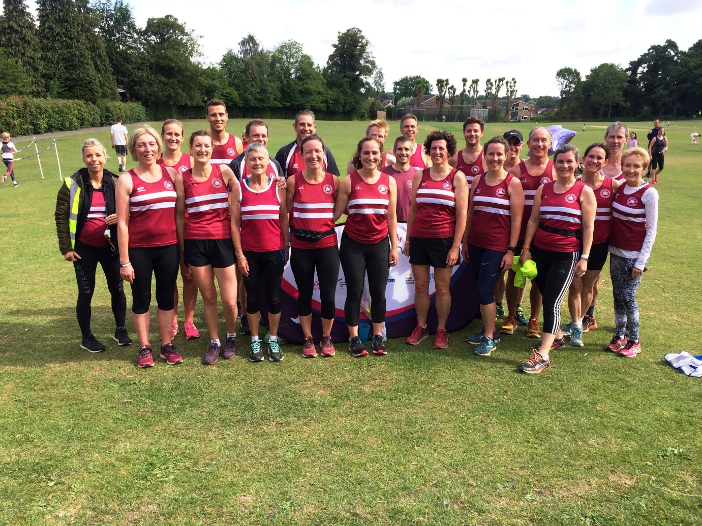
Beetroots at Clair parkrun.

On 16th June, the Heath Harriers (also known as the Beetroot Army) took part in what hopefully will be an annual parkrun for the club. Running in their beetroot vests, twenty-four the Harriers came to Clair park to show their colours by wearing their beetroot coloured running vests.

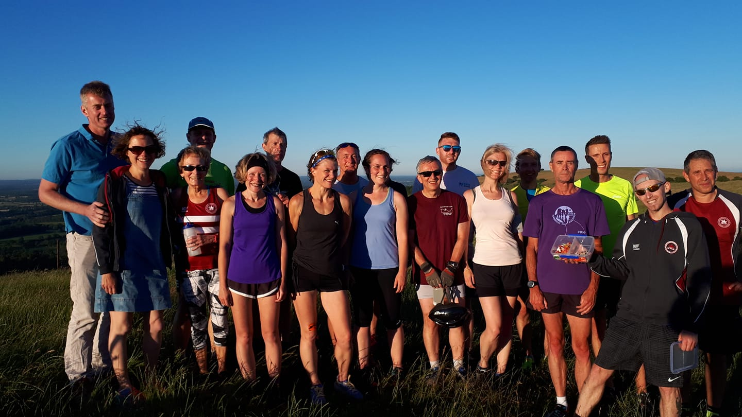
Harriers at the Blackcap Handicap.

On Wednesday 27 June, on a Sunny evening on the South Downs Way in the east side of Ditchling Beacon, the Blackcap Handicap out and back 5 mile race was taking place. The weather was the best conditions for years. The Handicap is a race with a difference and starts with the slowest runners starting off first, one by one until the last runner (the fastest runner) starts. Thus, giving each runner an even chance of winning the race as they all should (in theory) finish at the same time. The results were as follows:
1st Verity Coombes 45.00 (overall time), 43:30 (run time); 2nd Kim Lo 46:34 (35:01); 3rd Graham Kenward 46:53 (41:23); 4th Marion Hemsworth 47:06 (47:06); 5th Ben Gibson 47:19; (29:19); 6th Oliver Farr 47:55 (41:25); 7th Mark Sykes (on a bike) 47:56 (25:56); 8th Paul Cousins 48:12 (32:42); 9th Ian Dumbrell 48:14 (38:44); 10th Richard Haynes 48:20; 38:50; 11th Lydia Levy 49:21 (42:51); 12th Marcus Kimmins 49:39 (32:39); 13th Maresa Pitt 50:01 (43:31); 14th Mike Essex 50:57 (43:27); 15th Claire Kenward 51:45 (43:45).

