Middy Report, 6th April

Harriers Shine in Sussex Relays and Beyond
By Jack Chivers
This weekend saw one of the highlights of the road racing year for Sussex running clubs with the annual County Road Relay Championships at Christs Hospital School, Horsham. Haywards Heath Harriers were there with a record number of teams; a total of 62 runners from juniors to veterans, and the club enjoyed several fantastic individual and team results.
The U13 Girls and Boys and U15 Boys performed well as a team and Adam Dray got off to a flyer in the 1stleg of the U15 Boys 3 x 1 mile 93 yard team, coming in a brilliant 4th place with a time of 5:43. There were also some great team performances from the ladies, but this year it was the men who excelled. The senior Men’s A Team finished in 7th place, but they were outshone by the V50 Men’s team of Barry Tullett, Phil Scott and Paul Cousins who won the Silver Medal. However, the stars of the day were the V40 Men’s team of James Skinner, Paul Tomlinson, Rob Watts and Marcus Kimmins who led from the start and romped home with the gold medal, with James Skinner also picking up the fastest V40 male medal with a time of 10:28.
The Harriers success this weekend wasn’t limited to the relays however. Kim Lo continued her strong start to the year by finishing as first female in the Bungay Black Dog Marathon in Norfolk. Her impressive finishing time of 3 hours 18 minutes not only won her the race, but was achieved despite recently recovering from a cold. She attributed the performance to a good pacing strategy, commenting that “steady pace is key to good marathons I feel”. Even more impressively, this was Kim’s second win in two weeks after also coming first female in the Woking 5 Mile race last Sunday, while her partner Phil Payne also excelled with a 6th place overall result.
Another Haywards Heath runner to win a race this weekend was Jack Chivers, who competed in the Run Richmond 5k multi-terrain race held in the London Royal Park this Saturday. His finishing time of 19 minutes, 26 seconds was marred by a calf injury suffered during the race, but was still good enough to earn him first place overall.
Other notable performances this week included Shelagh Robinson who completed the 34 mile Vale Coast Ultra race in South Wales in an outstanding time of 7 hours and 46 minutes despite a very challenging route, and Michael Burke who completed the Croydon Half Marathon in 1 hour and 24 minutes. That time was good enough for 24th place overall and proved to be even more satisfying for Michael as it took place only a week after he completed the Chester 50 Mile ultra race in 9 hours 36 minutes.
Finally, last weekend also saw two victorious performances at the Crawley AC Open Meeting at the K2 track. Adam Dray took first place in the U15 1500m Boys race in 04:42.32, and Russ Mullen achieved both a win and a new personal best in the Senior Men’s 3000m with a finishing time of 9:33.15.
Full club results for the Sussex Road Relays are as follows:
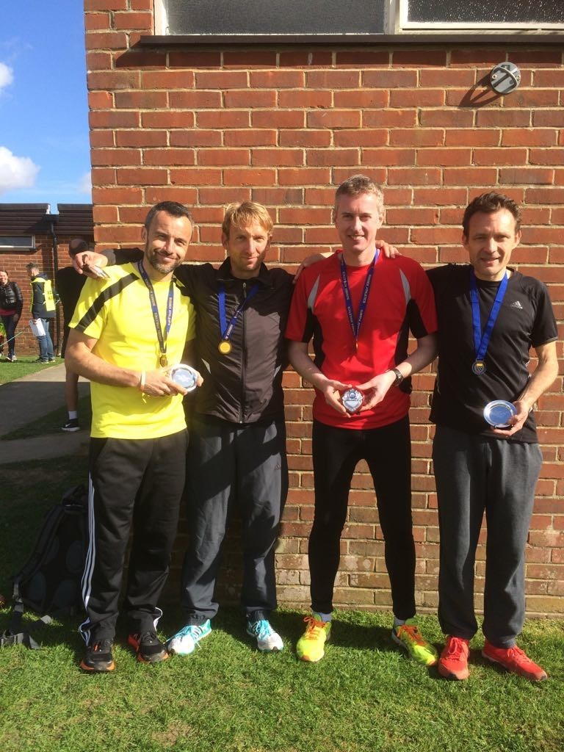
The victorious MV40: Paul Tomlinson, Marcus Kimmins, Walter Grabble, James Skinner
U13 GIRLS – 3 x 1 mile 93 yards
A Team – 16th: Phoebe Whiting (7.19), Fionnuala Lingard (7.40), Harriet Dray (7.42)
B Team – 18th: Millie Francis (8.21), Millie Sommerville (7.38), Phoebe Whiting (7.33) N/S
U13 BOYS – – 3 x 1 mile 93 yards
A Team – 15th: Harvey Bashford-Dickens (6.32), Patrick Stedman (6.47), Ryan Armstrong (6.56)
B Team – 21st: Alfie Geere (7.01), Tom Spensley (7.08), Alex Todd (7.01)
C Team – 26th: Will Spensley (6.59), Louis Henry (8.07), Ethan Lambert (7.55)
U15 BOYS – 3 x 1 mile 93 yards
A Team – 11th: Adam Dray (5.43), Ben Fenner-Meadows (6.45), William Fry (7.00)
U15 GIRLS – Non Scoring
Lily Bliss-Tomlinson (U13) (7.16)
SEN WOMEN – 3 x 2 miles 241 yards
A Team – 10th: Emma Navesey (13.16), Darja Knotkova-Hanley (U17) (14.08), Hannah Chapman (13.35)
B Team - 12th: Amy Mitchell (U17) (14.16), Abigail Redd (14.12), Mags Lazell (13.51)
C Team – 20th: Verity Coombes (14.24), Niamh Lingard (16.41), Emma Navesey (13.48) N/S
D Team – 26th: Michelle Holdstock (17.13), Justine Tanner (17.15), Michelle Pearce (16.35)
V40 Ladies – 3 x 2 miles 241 yards
A Team – 13th: Claire Annesley (16.29), 2. Sarah Hamilton (16.48), Jacqueline Barnes (16.04)
V50 Ladies – 3 x 2 miles 241 yards
A Team – 13th: Clare Kenward (15.09), Linda Tullett (18.08), Jenny Denyer (24.18)
Senior Men – 6 x 2 miles 241 yards
A Team – 7th: Phil Radford (10.18), Russ Mullen (10.39), Ben Gibson (10.59), Tom Mullen (11.29),
Matt Cook (11.21), James Collins (10.56)
B Team – 15th: Dan Blain (U17) (11.41), Phil Payne (11.39), James Bennett (12.26),
Cooper Sommerville (U17) (12.04), Richard Cole (12.51), Russ Mullen (11.02) N/S
V40 Men – 4 x 2 miles 241 yards
A Team – 1st: James Skinner (10.28), Paul Tomlinson (11.01), Rob Watts (12.05),
Marcus Kimmins (11.05) – Gold Medal
B Team – 9th: Julian Boyer (12.12), Andy Dray (13.08), Gary Johnson (15.15), Julian Boyer (12.57) N/S
James Skinner – fastest V40 Leg – 10.28
V50 Men – 3 x 2 miles 241 yards
A Team – 2nd: Barry Tullett (12.16), Phil Scott (12.51), Paul Cousins (11.46) – Silver Medal
B Team – 13th: Carl Bicknell (14.03), Graham Kenward (14.56), Mark Sykes (15.18)
V60 Men – 3 x 2 miles 241 yards
A Team – 9th: Cliff Comber (13.13), John Morgan (16.41), Richard Bates (18.18)
N/S = Non-scoring team

