West Sussex Fun Run League
By Mike Parish

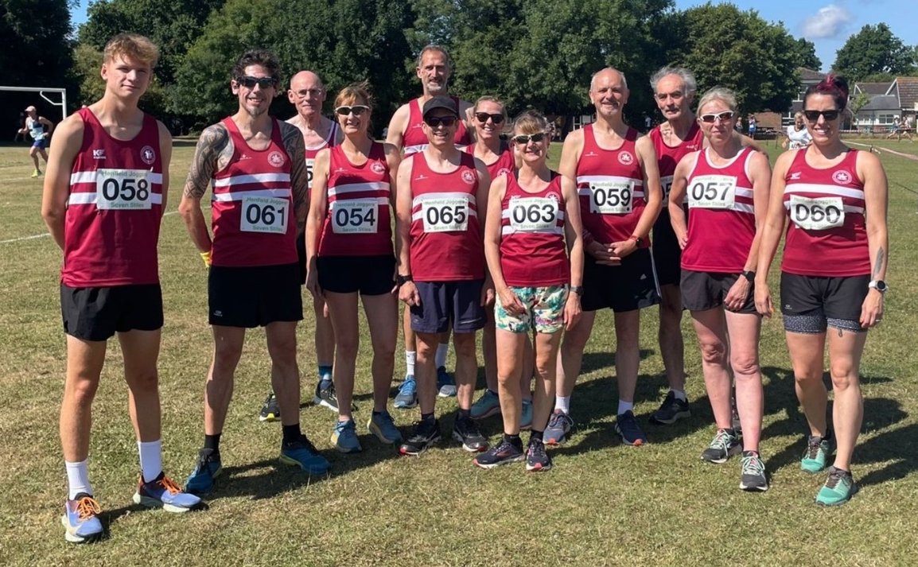
Haywards Heath Harriers at the Seven Stiles race.
SUNDAY JULY 24th saw the next run in the West Sussex Fun Run League calendar, hosted by Henfield Joggers. On a hot, sunny day the banners from all 16 athletics clubs went up on Kings Field as athletes warmed up ready for the run.
This is a beautiful four-mile trail race from Kings Field in Henfield, onto the open roads for a short distance before starting the trails. The run went down the side of the river Arun with runners having to avoid ending up going down the embankment onto the flood plains and taking care on the cracked scorched pathways. This led into a short run along the Downs Link, a disused railway line that connects the South Downs and North Downs before heading back to the finish line.
Henfield Parish Church have done a lot of work bringing Ukrainian refugees into the community and one joined the event producing an amazing run.
Haywards Heath Harriers pulled together a team of eleven athletes who took part, with some great running from front runners Harvey Alcock and Andy Hind and Abigail Redd running a great race. There was some great teamwork from Sarah Hamilton and Michael Parish pacing in the middle of the pack with Sarah Hamilton, making it to the finish line first.
Race results were: 1st Liam Briscoe, Fittleworth Flyers, 22:26; 2nd Harvey Alcock, Haywards Heath Harriers, 24:02; 3rd Ollie Owen, Worthing Harriers, 24:09.
Harrier’s results were: 2nd Harvey Alcock, 24:02; 6th Andy Hind, 25:13; 19th Julian Boyer, 26:51; 114th Ian Tomkins, 32:41; 132nd Abigail Redd, 33:50; 137th Kath Buckeridge, 34:09; 181st Sarah Hamilton, 37:32; 192nd Michael Parish, 38:28; 237th Caroline Gumm, 42:50; 242nd Carys Hind 43:08; 279th Richard Bates, 49:03, 282nd Rupert Purchase, 50:16.
Athletics:
Under 13 Track and Field League
By Linda Tullett

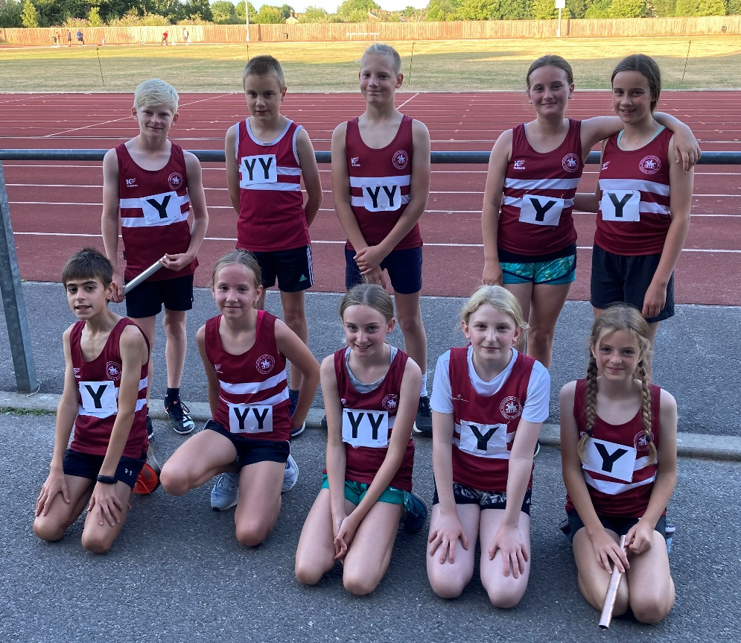
The Under 13’s athletic team at Crawley on 15 July.

The Haywards Heath Harriers under 13 team took part in the final round of the Sussex Under thirteen Track and Field League which was held at K2 (Crawley) on Friday 15 July. Haywards Heath Harriers finished in fourth place out of six teams. Individually there were some great performances, but despite not having a full team, it was the overall team spirit that was the winner on the night. Athletes were willing to fill events to gain those vital extra few points and support each and every team member in cheering and encouraging them with many gaining personal best performances. We are now looking forward to the League final in September where we hope we can get a full team out and continue with the great performances that the Under 13’s have been producing all this season.

The results were:

Boys:
Charlie Stay: 1st 75m ‘A’ string 10.9 secs; 2nd Long Jump ‘A’ string 4.27 metres.
William Kean: 2nd 75m ‘B’ string 12.3 secs; 5th Long Jump ‘B’ string 2.43 metres.
Ben Farmer: 5th 150m ‘A’ string 24.3 secs; 2nd High Jump ‘B’ string 0.95 metres.
Jack Diack: 3rd High Jump ‘A’ string 1.00 metres; 3rd Shot Putt ‘A’ string 3.52 metres.
4 x 100m Relay: 4th Haywards Heath Harriers 63.6 secs.

Girls:
Jessica Diack: 4th 75m ‘A’ string 11.8 secs; 3rd Long Jump ‘A’ string 3.14 metres.
Lorni Cole: 4th 150m ‘A’ string 27.4 secs; 2nd High Jump ‘B’ string 0.95 metres.
Annabelle Parkin: 3rd 600m ‘A’ string 1 min 59.3 secs; 1st Discus ‘A’ string 12.76 metres.
Isabelle Jarman: 3rd 600m ‘B’ string 2 min 00.1 secs; 1st Discus ‘B’ string 9.78 metres.
Lucy Roderick: 2nd 1000m ‘A’ string 4 min 10.3 secs; 4th Long Jump ‘B’ string 2.95 metres.
Naia Myles: 2nd 1000m ‘B’ string 4 mins 19.5 secs; 3rd High Jump ‘A’ string 1.20 metres.
4 x 100m Relay: 3rd Haywards Heath Harriers 66.8 secs.

Under 15 Track and Field League

The final round of the Sussex Under 15 League took place on Friday 22 July and what an exciting evening it was. There were some fantastic individual performances with many personal bests, but it was the team spirit amongst all the competing athletes that was the real success. Everyone got behind all the athletes as they ran, jumped or threw their hearts out to gain as many vital points in their event to add to the overall team score. Our largest turnout of the season was well rewarded with a fourth place out of the nine competing clubs and that was largely down to the willingness to fill the events from everyone. We now look forward to the league final on Friday 2nd September and hope for a full team of athletes competing.

Results were as follows:

Boys:
Ollie Stay: 7th 100m ‘A’ string 13.2 secs (pb); 7th 200m ‘A’ string 27.6 secs (pb); 2nd Discus ‘B’ string 12.25 metres.
Marley Tighe: 6th 100m ‘B’ string 13.9 secs (pb); 4th Long Jump ‘B’ string 3.47 metres.
Sam Harper: 6th 200m ‘B’ string 31.0 secs; 8th 800m ‘A’ string 2 mins 34.0 secs (pb); 4th High Jump ‘A’ string 1.40 metres (pb).
Arun Khursheed: 6th 300m ‘A’ string 41.8 secs (pb); 2nd 1500m ‘A’ string 4 min 27.6 secs (pb); 6th Long Jump ‘A’ string 4.10 metres (pb).
Oliver Skinner: 5th 300m ‘B’ string 45.4 secs (pb); 4th 800m ‘B’ string 2 mins 30.5 secs (pb).
Finlay Blythe: 1st 1500m ‘B’ string 4 mins 33.2 secs (pb).
Oliver Cooper: 2nd High Jump ‘B’ string 1.30 metres; 3rd Javelin ‘B’ string 13.86 metres.
Adam Beckett: 5th Shot Putt ‘A’ string 6.29 metres; 5th Discus ‘A’ string 15.62 metres; 6th Javelin ‘A’ string 16.50 metres.
4 x 100m Relay: 6th Haywards heath Harriers 57.0 secs.

Girls:
Lucy Barker: 3rd 100m ‘A’ string 13.4 secs (pb); 4th 200m ‘A’ string 28.5 secs; 2nd High jump ‘B’ string 1.30 metres (pb).
Siobhan McMahon: 2nd 100m ‘B’ string 13.8 secs; 1st 200m ‘B’ string 28.9 secs (pb); 1st Long Jump ‘A’ string 4.83 metres.
Matilda Perez: 3rd 300m ‘A’ string 46.9 secs (pb); 6th Long Jump ‘B’ string 3.66 metres (pb).
Alexandra Young: 4th 300m ‘B’ string 55.4 secs (pb); 5th Shot Putt ‘A’ string 4.63 metres (pb).
Alice Grimley: 7th 800m ‘A’ string 3 mins 2.07 secs.
Anya Cole: 3rd High Jump ‘A’ string 1.35 metres (pb); 7th Javelin ‘A’ string 9.23 metres.
Lois Perrett: 3rd Shot Putt ‘B’ string 4.33 metres (pb); 3rd Discus ‘B’ string 10.53 metres (pb); 6th Javelin ‘B’ string 5.87 metres.
4 x 100m Relay: 2nd Haywards Heath Harriers 55.8 secs.

Ultra and Trail Running!
Siobhan Amer and Kim Lo took part in the Writtle Round 50 Kilometres Trail race in Essex on Sunday 24 July. It was Siobhan’s first ever trail ultra. Partnered by Kim, the pair made it through to the finish in hot conditions.

Road Running:
Oliver Farr has now completed his 81st Marathon, on his quest for a hundred marathons. His latest marathon was at Holland-on-Sea is Essex in the Hair and Tortoise, Life’s a beach Marathon that took place on Sunday 24 July. He finished in four hours and twenty-eight minutes.

Siobhan Amer and Kim Lo

Parkrun round-up:

Great parkrun results this week with the harriers taking the first five places at Clair parkrun and the first three smashing their personal bests on this testing course with sub eighteen minutes recorded by them.

It was also Sarah Hamilton’s two hundred and fiftieth parkrun and Arun Khursheed’s fiftieth this weekend. Both celebrated with cakes after their parkruns: sufficient to keep them both with high energy levels for the whole of next week!

Abi Redd also finishing as first lady at Ifield Mill Pond parkrun.

Clair parkrun: 1st Will Grey 17:39 (pb); 2nd Arun Khursheed 17:56 (pb); 3rd Harvey Alcock 17:57 (pb); 4th Sam Fernley 18:34; 5th Andy Hind 19:09; 9th Julian Boyer 20:25; 14th Ethan Rowen 20:49;16th David Adams 20:53; 21st Paul Cousins 21:11; 23rd Barry Tullett 22:17; 27th Dominic Roberjot 22:33; 29th Tim Hicks 22:42; 36th Simon Robinson 24:05; 38th Bob Adams 24:09; 49th Annabel Axford 25:30; 60th Lynne Roberjot 26:53;91st Andy Henry 31:27.

Brighton & Hove parkrun: 102nd Kath Buckeridge 24:25; 219th Sarah Hamilton 29:38; 220th Julie Essex 29:39.
Medina (Isle of Wight) parkrun: 10th James Bennett 20:43.
East Grinstead parkrun: 8th Greg Hilton 21:36.
Perry Hall parkrun: 14th Dave Warren 21:28.
Lullingstone parkrun: 14th Carl Bicknell 27:18.
Depot parkrun: 4th Andrew Wilson 24:41.
Uckfield parkrun: 54th Emma Pryor 32:12
Ifield Mill Pond parkrun: 4th Abigail Redd 22:07.

