01 October 201 Middy Report

This weekend Haywards Heath Harriers were at the Sussex County Cross Country Relays at Goodwood. This was the first event of the season. The Harriers managed to put out a record 13 teams between their senior men, women and all the veteran runners at this event, many having their first taste of cross country for the club!

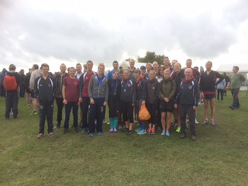
Harriers at the first cross country event of the season

First results out (hot on the press!) are that the senior women team won Silver Medal, consisting of Katie Morgan, Emma Navesey and Siobhan Amer. This is a great start to the cross country season for the Harriers, looking for greater prospects from the cross country league, Sussex County Championships and Sussex Masters championships that are to be held later in the season.

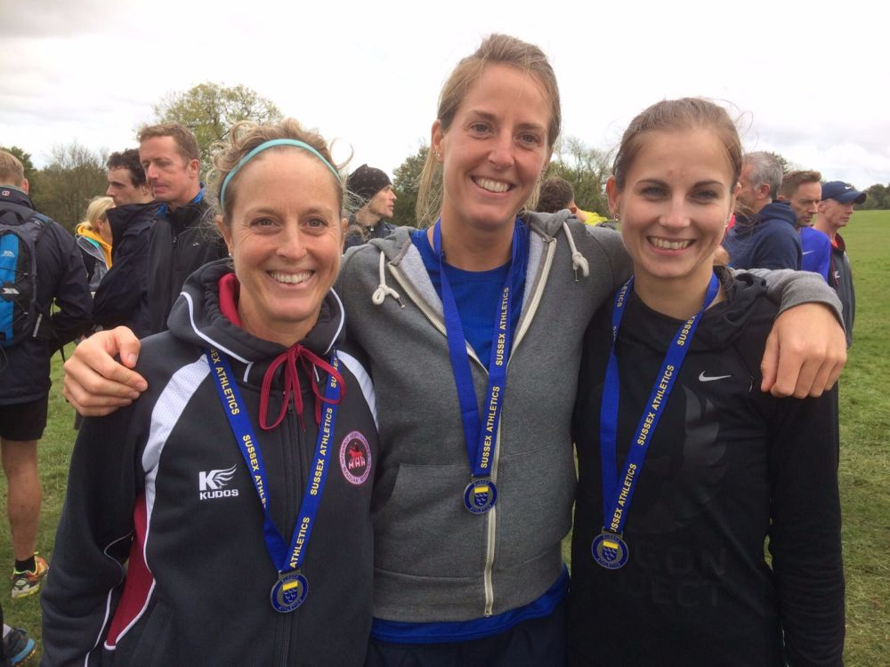

The silver winning trio (from left to right) of Siobhan Amer, Katie Morgan and Emma Navesey

Last weekend The Harriers ran in the Barns Green Half marathon which included the Sussex County Half Marathon Championships. Two Harriers gained individual medals: James Skinner and Samantha Ridley both gaining bronze medals: James in the Men’s V40’s and Samantha is the Women’s V50’s.
Also, the Harriers won the Men’s Gold medal in the senior Men’s event. The gold medallist were James Skinner, Matt Cook and Marcus Kimmins.

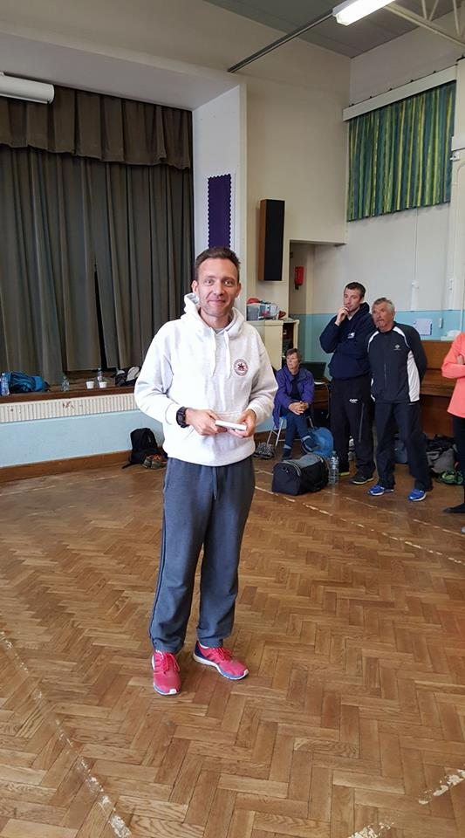
James Skinner – winner of the Lewes 10 mile race.
James Skinner was back to winning ways this weekend with a victory in the Lewes 10 which is held on the South Downs. The course he said was muddy and despite being misdirected, secured his victory in 1 hour 5 minutes and 7 seconds. James also won an age category as well as Marion Hemsworth.

Phil Payne and Kim Lo both ran in the Downs Link 38 mile race on Sunday which follows the dis-used railway lines from Martha's Hill in Guildford to Shoreham by Sea. Kim was 3rd lady finisher in a time of 5 hours 41 minutes. Phil getting slightly behind Kim in a time of 6 hours and 23 minutes enjoying the scenery.

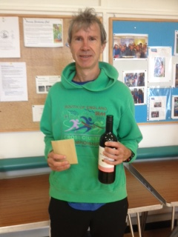
Paul Cousins ventured back to his roots and ran in the Hanney 5 mile race in Oxfordshire. On a fast and flat course he managed 20th overall position and was 3rd Vet 50 in a time of 29 minutes and 56 seconds.

Paul Cousins at the Hanney 5

