Inter-Counties XC and Sports Hall League

Five Haywards Heath Harriers took part in the combined Inter-Counties and South of England Masters Cross Country Championships that were jointly held 10 December in Oxford.
In the Inter-Counties event Arun Khursheed and Jonathan Beckett competed for Sussex in the under 15’s and under 17’s events respectively.
Arun finished is a thirty-third place out of a field of one hundred and eleven runner, finishing in 13 minutes and 11 seconds (a full minute behind the winner) one place behind training partner Finlay Blythe. The Sussex team finished in fourth team out of eleven.
Jonathan finished his race in forty-ninth place out ninety-nine runners in a time of 15.47 and was the fifth Sussex finisher in his race.
In the Men’s Masters race which combined ages from forty upwards in five year age bandings. On a new course the men’s event was two laps taking in the long climb up Shotover Hill which is a similar climb akin to Lancing Hill in the Sussex cross Country League.
It was great to see Haywards Heath Harriers getting a Vet Men’s 60 age group team to the event and much more of a surprise when they took a silver medal on count-back as they had the same number of points as the winning team, Barnet & District AC. Led home by Paul Cousins in fifth place and backed up by Tim Hicks in fourteenth and Carl Bicknell in thirty-second place.
Local mid-Sussex athletes running in the masters event for Brighton and Hove Athletic Club were Craig Halsey (Bolnore Village) Louis Taub (Burgess Hill) and Matt Bristow (Hassocks) Brighton and Hove AC winning gold in the Vets 40 team race with Craig Halsey taking the bronze medal in the individual men’s 40 race.
Full HHH Results were:
Inter-counties:
Under 15 Boys: Arun Khursheed 13.11;
Under 17 Men: Jonathan Beckett 15:47.
Masters MV60-69: 2nd team 51 points
MV60-64: 5th Paul Cousins 40:15; 13th Tim Hicks 44:38; 28th Carl Bicknell 53:57.

Sussex Sports Hall League
A few weeks back on Saturday 10th December, the young junior Harriers competed at Worthing Leisure Centre at the Sussex Sports Hall League. In a very competitive competition against other Sussex clubs, the Harrier youngsters had their work cut out. No results have been received for this event.

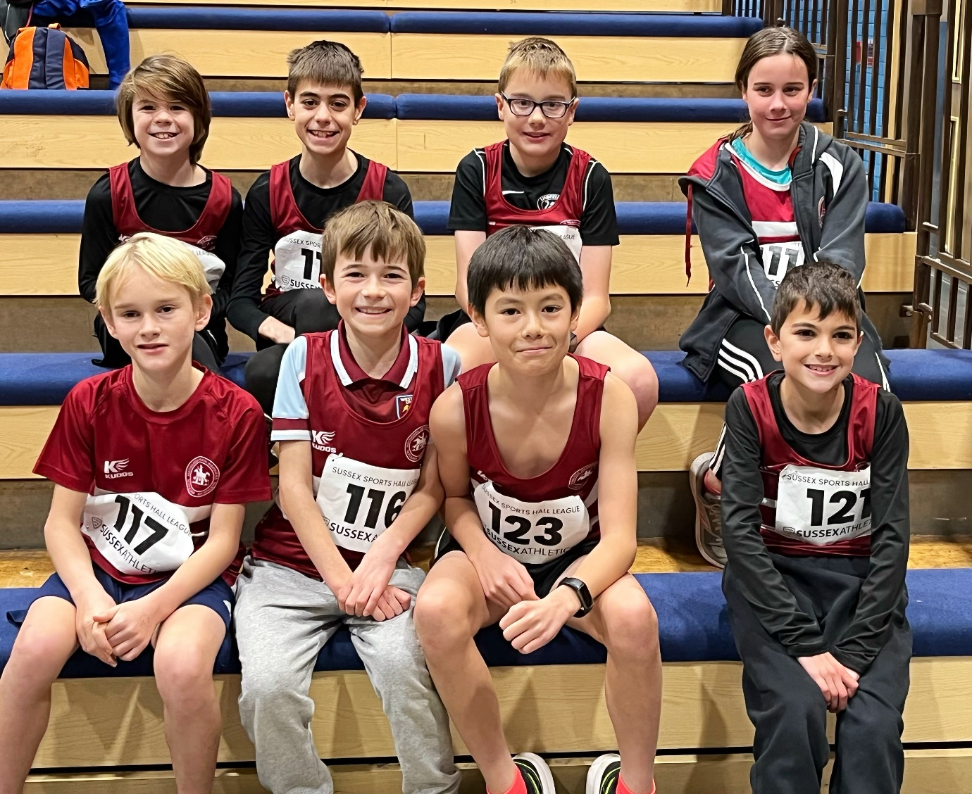
Young Harriers team at the Sussex Sports Hall League in December 2022.

