Harriers win Silver Plate!

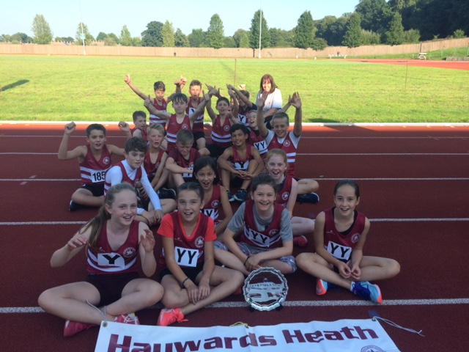
The Under 13’s at Crawley.

After a great season of athletics, the Under 13’s finished off at the K2 Sports Centre at Crawley at the weekend with one of the largest teams that Haywards Heath Harriers could muster. The team came 5th out of 10 teams with some terrific athletics amongst them. They won the Silver Plate trophy as they were the top team of the 5 smallest clubs in Sussex Under 13 League. Harriers team manager, Linda Tullett said: “We’re so proud of them, and for all they have achieved this season.” For many of the youngsters, this has been their first taste of athletics competition outside of the school environment.

Results were as follow:

Boys:
Charlie Parveen: 1st 75m ‘A’ in 10.68 secs;
Charlie Bonwick-Adams: 2nd 75m ‘B’ in 11.02 secs; 4th 1000m ‘A’ in 3 min 19.42 secs.
Archie Hale: 4th 150m ‘A’ in 22.00 secs; 4th Long Jump ‘A’ 4.03m.
Alex Stubbs: 2nd 150m ‘B’ in 22.35 secs.
William Spensley: 4th 600m ‘A’ in 1 min 52.38 secs; 2nd 75mH ‘A’ in 14.37 secs.
George Bonwick-Adams: 4th 600m ‘B’ in 1 min 56.48 secs; 6th Shot Putt ’A’ 5.51m.
Sebastian Dell’Aira Bromley: 6th 1000m ‘B’ in 3 min 31.06 secs.
Ben Brennan: 2nd 75mH ‘B’’ in 16.48 secs.
Ben Taylor: =7th High Jump ‘A’ 1.15m; 7th Discus ‘A’ 9.44m.
Jonathan Beckett: 6th High Jump ‘B’ 1.00m.
Alex Booth: 3rd Long Jump ‘B’ 3.74m.
Henry Francis: 5th Shot Putt ‘B’ 4.50m; 5th Discus ‘B’ 7.52m.
4 x 100m Relay: 3rd HHH ‘A’ in 56.76 secs.
4 x 100m Relay: 3rd HHH ‘B’ in 60.16 secs.
Non-scoring:
75m: Thomas Pearce: 11.74 secs, Philip Williamson: 12.03 secs, Ben Brennan: 12.15 secs.
600m: Jonathan Beckett: 2 min 07.00 secs, Harvey Gwynn: 2 min 09.37, Noah Perrett: 2 mins 09.57 secs.
Long Jump: Thomas Pearce: 3.62m, Harvey Gwynn: 3.07m, Noah Perrett 2.84m.

Girls:
Grace Dobson: 9th 75m ‘A’ 12.63 secs; 5th 1000m ‘B’ in 4 min 01.98 secs.
Erin Gaston: 7th 75m ‘B’ 13.26 secs; 8th Shot Putt ‘A’ 4.12m.
Amy Rutherford: 9th 150m ‘A’ in 25.62 secs; 7th High Jump ‘A’ 1.10m.
Maia Bliss-Tomlinson: 7th 150m ‘B’ in 25.22 secs; 7th Long Jump ‘B’ 3.05m.
Phoebe Whiting: 6th 600m ‘A’ in 2 min 01.38 secs; 8th Long Jump ‘A’ 3.48m.
Bethany Hilton: 8th 600m ‘B’ in 2 min 19.58 secs.
Maya Dell’Aira Bromley: 9th 1000m ‘A’ in 3 min 59.75 secs; 5th High Jump ‘B’ 1.00m.
Imogen Reed: 9th 70mH ‘A’ in 15.96 secs; 5th Shot Putt ‘B’ 3.80m.
4 x 100m Relay: 9th HHH ‘A’ in 66.28 secs.
4 x 100m Relay: 6th HHH ‘B’ in 68.92 secs.

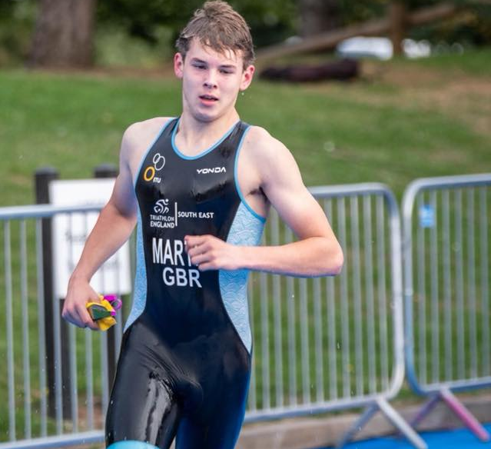
Joseph Martin - on his way to a silver medal.
Joseph (Jojo) Martin continued his successful summer with a silver medal at the UK School Games (team triathlon). With a strong swim and a great bike, he finished up with a solid run to finish 3 days of fun competition.
On Sunday 26th August, the Tom Lintern Medal Meeting at Crawley was held at the K2. Harriers results were as follows:
Arun Khursheed U11: 4th 75m in 12.09 secs; 1st 150m in 23.08 secs (pb); 1st 600m in 1 min 57.13 secs.
John Palmer V50: 6th 100m in 15.16 secs; 6th 200m in 31.03 secs.
Karen Thompson V50: 4th 200m in 34.50 secs (pb).
Adam Dray U17: 3rd 800m in 2 mins 12.34 secs; 2nd 1500m in 4 mins 18.33 secs.

Last Friday at the Withdean Stadium in Brighton, the Under 15 Harriers were in action in their final track league of the year. They finished 9th place.

The results are as below:
Boys:
Harvey Alcock: 300m 8th ‘A’ in 48.1 secs; 1500m 6th ‘A’ in 5 mins 27.0 secs.
Tom Spensley: 300m 7th ‘B’ in 51.0 secs.
Ethan lambert: 100m 5th ‘A’ in 13.3 secs; 200m 6th ‘A’ in 27.4 secs; Long Jump 9th ‘A’ 4.08m.
Louis Henry: 100m 8th ‘B’ in 16.2 secs; Long Jump 6th ‘B’ 3.12m.
Ryan Armstrong: 800m 7th ‘A’ in 2 mins 29.5 secs.
Lio Robinson: 80mH 6th ‘A’ in 18.0 secs; Javelin 6th ‘A’ 23.89m.
4 x 100m Relay: HHH 9th in 58.4 secs (Robinson, Lambert, Henry & Armstrong).
4 x 300m Relay: HHH 7th in 3 mins 40.4 secs (Alcock, Armstrong, Henry & Robinson).
Girls:
Harriet Dray: 800m 8th ‘A’ in 2 mins 42.5 secs.
Lily Bliss-Tomlinson: 200m 8th ‘A’ in 30.4 secs.
Rosie Beckett: 1500m 6th ‘A’ in 5 mins 55.4 secs; Long Jump 9th ‘A’ 3.23m.
Emma Vince: Javelin 6th ‘A’ 9.63m.
Abigail Pendlebury: Long Jump 9th ‘B’ 2.63m.
Hannah Taylor: Shot Putt 8th ‘A’ 5.08m.
4 x 100m Relay: HHH 8th in 62.9 secs.
4 x 300m Relay: HHH 5th in 3 mins 39.0 secs.

The Kings Head Canter, which is a 5km road race at Chiddingly, took place on Bank Holiday Monday, 3 Harriers ran in this 5k road race. James Skinner was 2nd overall in a time of 15 minutes and 54 seconds, Russ Mullen was 17th finisher in 17 minutes and 56 seconds and Emma Navesey was 3rd Harrier home in 40th place and was 7th lady in a time of 19 minutes and 23 seconds.

At the Fittleworth 5, which is one of the West Sussex Fun Run League races that are held across the region, Harrier Jack Chivers, was the first runner home for the Harriers in 21st position in a time of 33 minutes and 13 seconds. Richard Bates continued with his aim of running all the league races this year and finished this one in 264th position in a time of 52 minutes and 7 seconds.

'If you would like to get involved in coaching at the club, and join a lively team, there are volunteer opportunities available. We need help with Junior and Senior Sprints coaching. Our main training evening is Tuesday.
Expenses will be paid, and qualification costs covered. For further information contact our Head Coach, Mike Essex at email address:
michaelessex@btinternet.com.'

