At the Gunpowder Trot, the final of this year’s West Sussex Fun Run League events was held at Denne Park near Horsham. On the 4.5 mile cross country 441 runners from 18 different running clubs from Mid Sussex took part in this fun run event. The Harriers took ten runners to the event, with Julian Boyer first home for the club. Richard Bates (furthest left in the photo below) has now completed all sixteen of the West Sussex Fun Run League races this year and has earned himself one of the respected tee-shirts that those who complete all the races are entitled to.

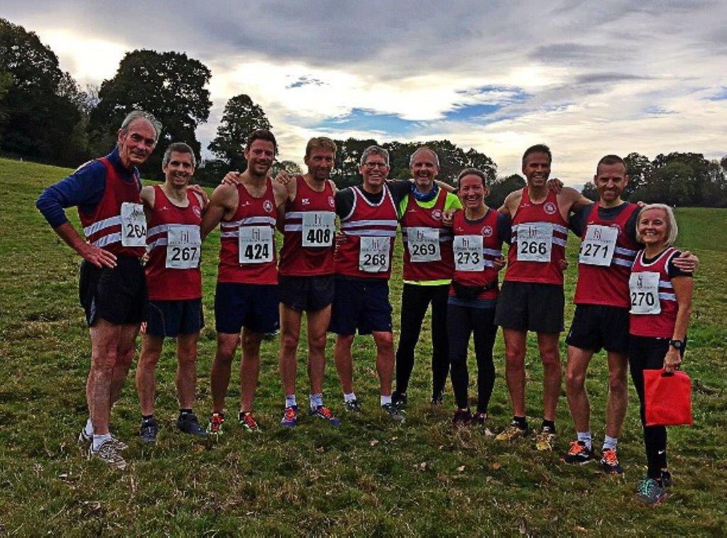
Harriers at the Gunpowder Trot (left to right: Richard Bates, Julian Boyer, Mark Green, Marcus Kimmins, Phil Scott, Michael Parish, Gemma Morgan, Barry Tullett, Nicolas Skov and Sarah Banks.

Results were: 14th Julian Boyer 28:25, 15th Marcus Kimmins 28:30, 19th Mark Green 28:48, 31st Nicolas Skov 29:39, 44th Barry Tullet 30:23, 106th Phil Scott 33:40, 148th Gemma Morgan 35:35, 197th Sarah Banks 37:38, 325th Michael Parish 44:34, 334th Richard Bates 45:08.

Other Harrier Results:

Michael Burke ran at the Around The Albion Marathon at the Amex Stadium at Brighton on the 28 October. The marathon was organised by Sussex Trail Events consisted of running laps around the outside of the stadium. Michael’s time was 4 hours 4 minutes and 50 seconds.

Kat Barrett ran in the Snowdonia Marathon on 26 October and finished in 4 hrs 02.36.

At the Age UK Leeds Abbey Dash 10km race on Sunday 4 November, Russ Mullen finished in 34:43 and Emma Navesey in 38:15.

Julian Boyer ran at the Preston Park parkrun last weekend and finished in 8th place equalling his all-time pb of 18:33. This was a notable parkrun for Julian as this was his 100th parkrun.

Steve Dallman finished in second place at the Sussex Marathon on 7 October in a time of 3 hours 41 minutes and 53 seconds. Steve said, “The course is hilly and has the reputation as a physical and psychological test! If you want a challenge, like running up or down hills and enjoy the scenic countryside, why not consider this next year?”

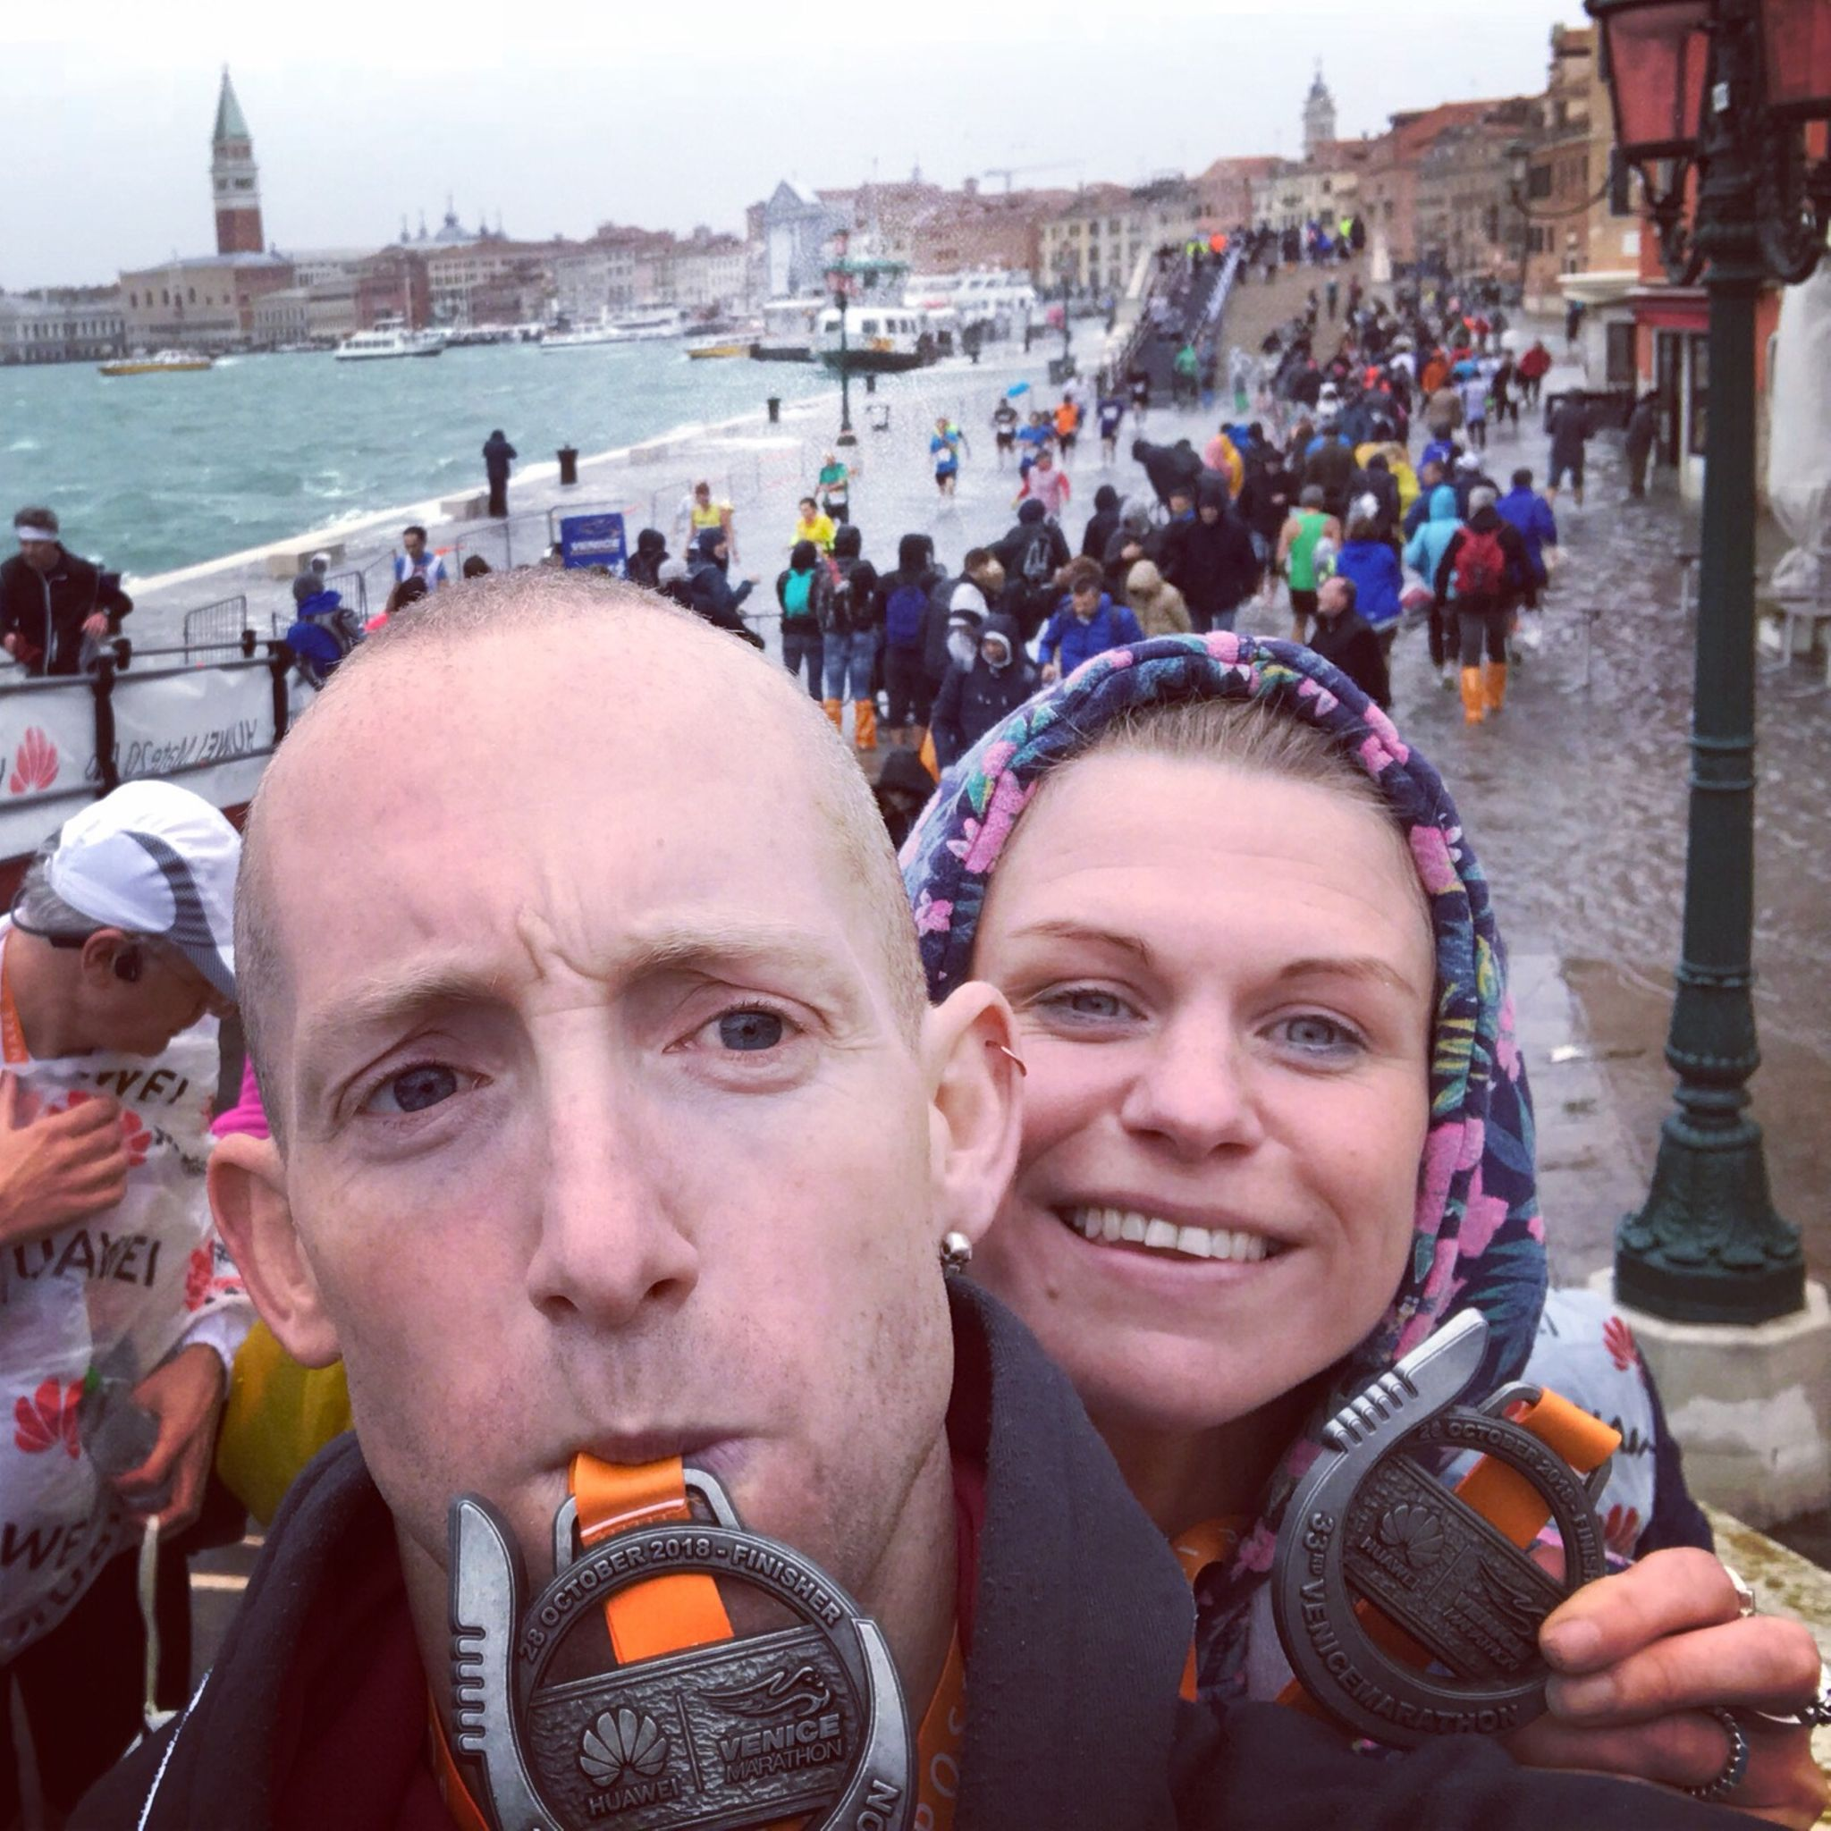
Phil Payne and Kim Lo at the Venice Marathon.

Phil and Kim ran the Venice Marathon on the 28 October. The organisers said it was the worst conditions that the marathon had been held in. The streets of Venice were partially flooded by the sea and the runners had to get their feet wet during the race. The high tide along the final stretch of the race meant participants had to jog through ankle-deep water to complete the course. Kim, though, finished the marathon in 3 hours 32 minutes and 34 seconds, Phil finished in 4 hours and 6 seconds.
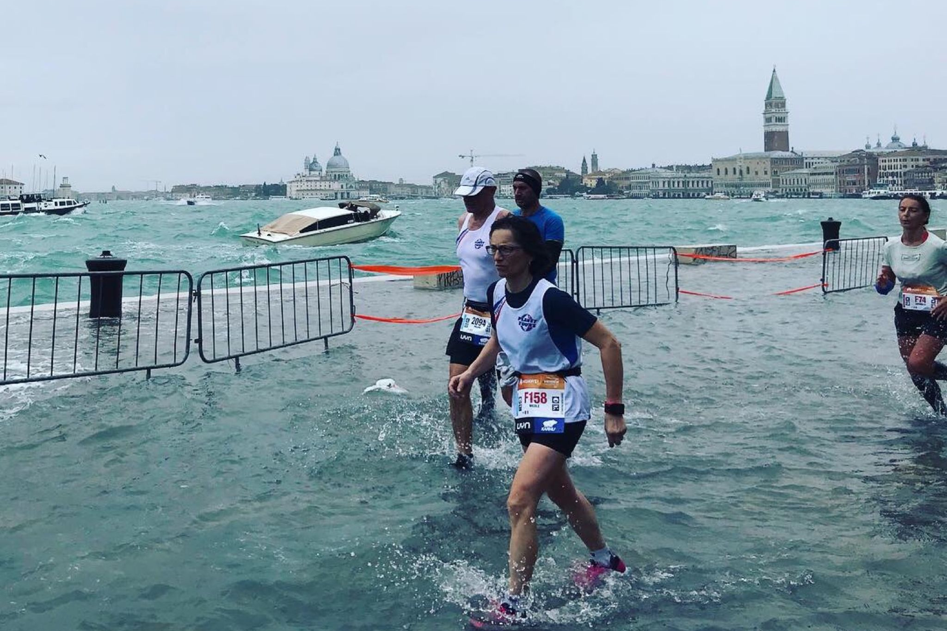
Runners running through the flooded streets in the Venice Marathon.

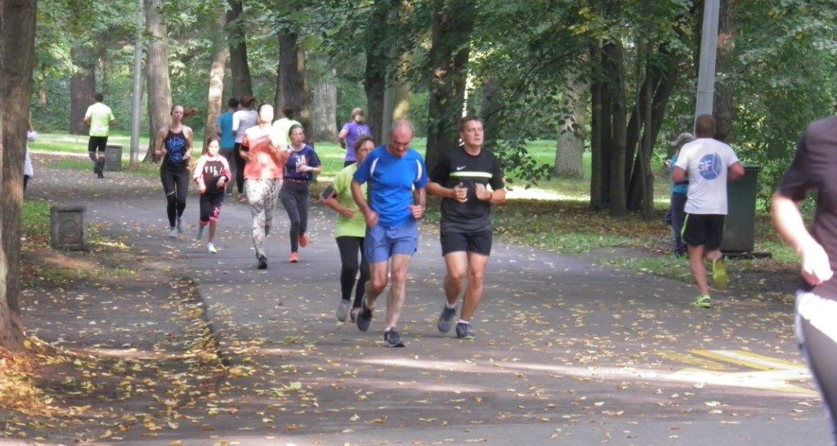
Richard Bates at St Petersburg parkrun.

Richard Bates: Subject: PARK RUN ST PETERSBURG
This is not the best photo but it is me running in September in the St Petersburg Parkrun on a rather nice day, on the lovely Yelagin Island in a river setting. The course was one lap, mainly on a fine gravel surface in a nature park and Anna the organiser said about 100 runners were the limit. When I arrived at the start - I was greeted 'are you from England' and I thought do I look obvious but I was the oldest for sure and first in age group but rather disappointed on a flat course with my time. It appeared the course had been re-arranged the week I ran to an out/back course because another activity was taking place on another part of the Island. Ironically, this was the same when I was in Australia but this was due to the fact that the run went alongside a creek and there was only one bridge crossing! However, food for thought about adapting a local Parkrun - maybe. I was not the only Brit in St Petersburg, a couple from East London who seemed to be Parkrun Tourists were there but they sped off during the run and after it seemed they had to dash away - to catch a plane! They had been in Finland the previous week. In the winter Parkrun start at 10am due to the dark and it is possible that snow and ice is on the ground there now.

St Petersburg is a fantastic place to visit for the weekend and Yelagin Island is easy to find via the Metro system and consider taking a ship from Helsinki which is a floating Hotel and Visa free if you stay 3 days. I found details of this run posted on Southampton Parkrun News -posted by Gareth Jones which was posted in November 2014 when just 36 runners took part.

Richard Bates also ran at the Titsey Trail on the 7th October in a time of 66 minutes and 17 seconds

Richard said he was looking forward to completing the Grand Slam of WSFRL runs this weekend and getting the T-Shirt!

Parkrun Roundup:

Clair parkrun: 1st Ben Gibson 17:33, 2nd Jamie Gibson 18:07, 7th Ryan Armstrong 20:18, 15th Sebastian Dell’Aira-Bromley 21:44, 21st Ewan Kemsley 22:13, 37th David Harper 23:42, 40th Noah Seymour 24:01, 41st Rob Watts 24:04, 44th Mark Sykes 24:11, 49th Marcus Kimmins 24:17, 50th Eric Hepburn 24:19, 52nd Clare Kenward 24:28, 54th David Harbage 24:35, 101st Claire Annesley 28:29, 112th Michael Parish 29:39, 123rd Maureen Rae 30:53.

Tilgate parkrun: 5th Nathan Buckeridge 18:37 (pb), 41st Ian Dumbrell 21:45, 131st Kath Buckeridge 24:41.

Brighton and Hove parkrun: 25th James Bennett 19:20.

Horsham parkrun: 272nd Peter Cobbett 29:40, 459th Jenny Denyer 39:44.
Exeter parkrun: 6th Jonathan Hall 18:16.

Lancaster parkrun: 7th Andy Hind 19:30, 253rd Carys Hind 32:22.

Preston park parkrun: 4th Paul Cousins 18:11, 8th Julian Boyer 18.33 (equalled pb), 17th Barry Tullett 19:12, 112th Ian Tomkins 22:54 (pb).

Lancing Beach Green parkrun: 41st Carole Walters 24:37, 76th Terence Watson 28:33, 79th Holly Glaister 29:00.

