HARRIERS COMPETE IN THE MID SUSSEX MARATHON WEEKEND

Last weekend was the Mid Sussex Marathon weekend. The weekend comprised of 3 races over three days making up the distance of a marathon. The first race was on Saturday at the East Grinstead 10 Mile race. This was then followed by the Haywards Heath 10 Mile race on the Sunday and culminating in the Burgess Hill 10 kilometres race on Bank Holiday Monday.

Harriers who completed all 3 races with the total time for all 3 races combined were:
5th Andy Hind: 2 hours 52 minutes and 50 seconds.
7th Tom Mullen in 3 hours and 35 seconds.
20th Matt Quinton: 3 hours 21 minutes and 51 seconds.
48th Carl Bicknell: 3 hours 42 minutes and 46 seconds.

Individual Results from East Grinstead 10 Mile Race:
8th Andy Hind 1 hr 06.07.
12th Tom Mullen 1 hr 09.15.
40 Matt Quinton 1 hr 18.10.
53rd Phil Scott 1 hr 20.41.
108th Carl Bicknell 1 hr 26.42.
307th Matt Howells 1 hr 50.04.

Results from the East Grinstead One Mile race:
1st Sam Parson 5.00.
2nd Sam Fernley 5.03.
3rd Isabelle Charles 5.49.
4th Rowan Kirby 5.46.
5th Koji Stephenson 6.49.

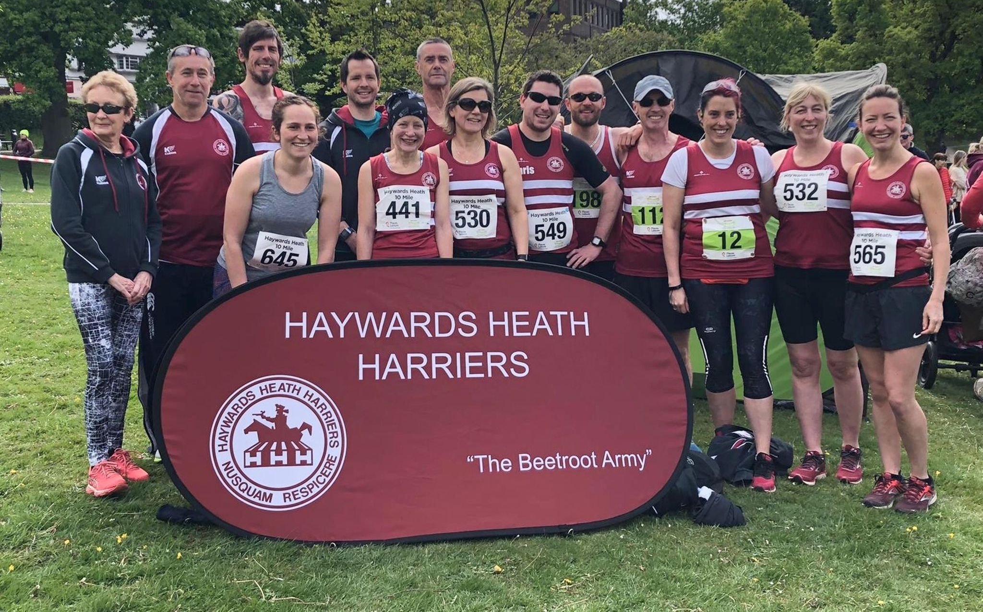
Haywards Heath team at the Haywards Heath 10 Mile Race.

Results from the Haywards Heath 10 Mile race:
8th Andy Hind 1 hr 05.34.
12th Tom Mullen 1 hr 07:01.
13th Emma Navesey 1 hr 07.55 (1st lady).
19th Robin English 1 hr 11.27.
41st Matt Quinton 1 hr 16.37.
42nd Ian Dumbrell 1 hr 16.42.
54th Richard Haynes 1 hr 18.47.
58th Maresa Pitt 1 hr 19.37.
94th Carl Bicknell 1 hr 23.30.
112th Andrew Wilson 1 hr 24.39.
128th Gemma Morgan 1 hr 26.19.
159th Lydia Levy 1 hr 29.17.
176th Gary Johnson 1 hr 31.20.
189th Shelagh Robinson 1 hr 31.54.
197th Chris Glanfield 1 hr 32.41.
276th Claire Annesley 1 hr 41.55.
277th Sarah Hamilton 1 hr 41.56.
330th Carys Hind 1 hr 48.22.

Results from the Haywards Heath 1 Mile Race:
1st Archie Guppy 4:51.
2nd Sam Fernley 4:52.
3rd Sam Parsons 4:58.
4th Jacob Roderick 4:59.
5th Ryan Rothe 5:17.

Results from the Burgess Hill 10k race:
8th Andy Hind 41.09.
15th Dave Warren 42.50.
22nd Tom Mullen 44:19.
36th Harvey Alcock 46.39.
44th Matt Quinton 47.04.
107th Carl Bicknell 52.34.
468th Mims Davies 1 hr 25.02.

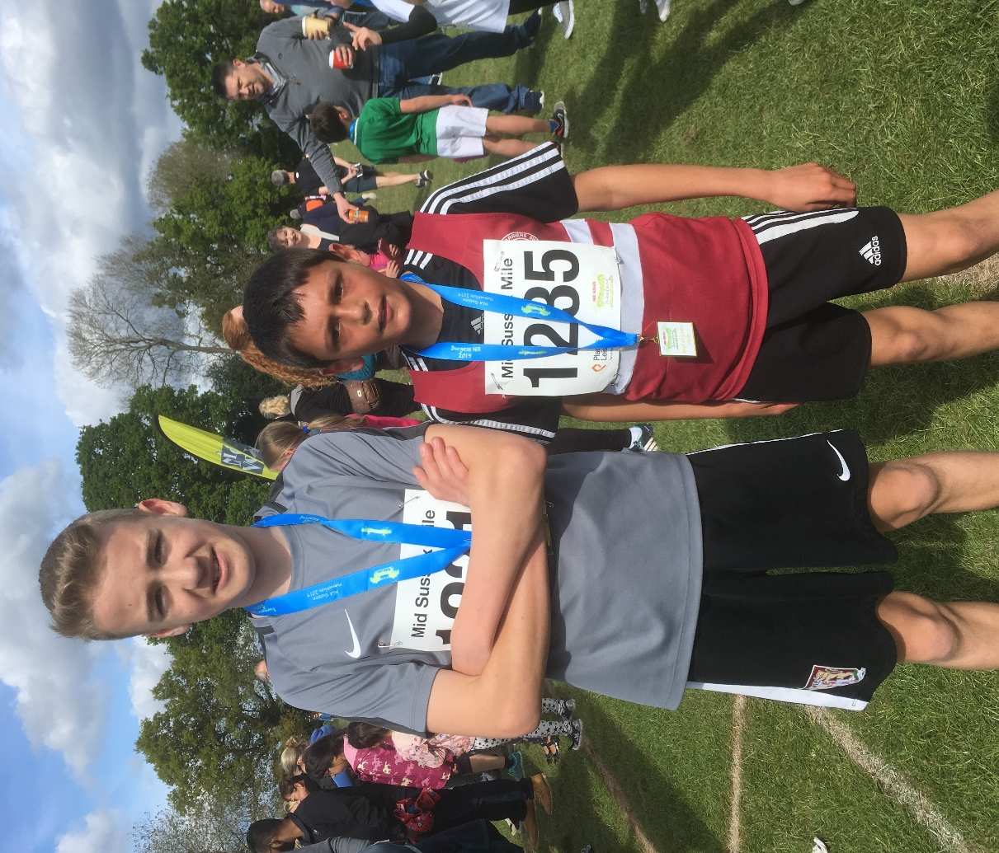
Sam Fernley and Arun Khursheed at the Burgess Hill mile race.

Results from the Burgess Hill One Mile race:
1st Sam Fernley 5:44.
2nd Arun Khursheed 5:46.
3rd Archie Turner 5:53.
4th Jonathan Beckett 6:26.
5th Rosie Gasson 6:26.
9th Rosie Beckett 6:46.

Other Harrier results:

William Davies also ran in the London Marathon last weekend.in a super 4 hr 37 minutes and 02 seconds.

On Sunday the 5th of May was the Three Forts Challenge. Greg Hilton finished in 4 hours and 44 minutes.

Oliver Farr ran in the Newport Marathon on 5 May. This was his 34th marathon. His finishing time was 3 hrs 53.

Bluebell Leatherhead 10k on 5 May – Phil Payne finished in 2nd place in a time of 37:51 and Kim Lo won the ladies race in 42 mins 54 secs.

Phil Payne runs a new Harrier 3 Peaks Marathon Fell Race record of 4 hours 9 minutes (Saturday 27th April). This was a new club record by almost exactly one hour to the second!

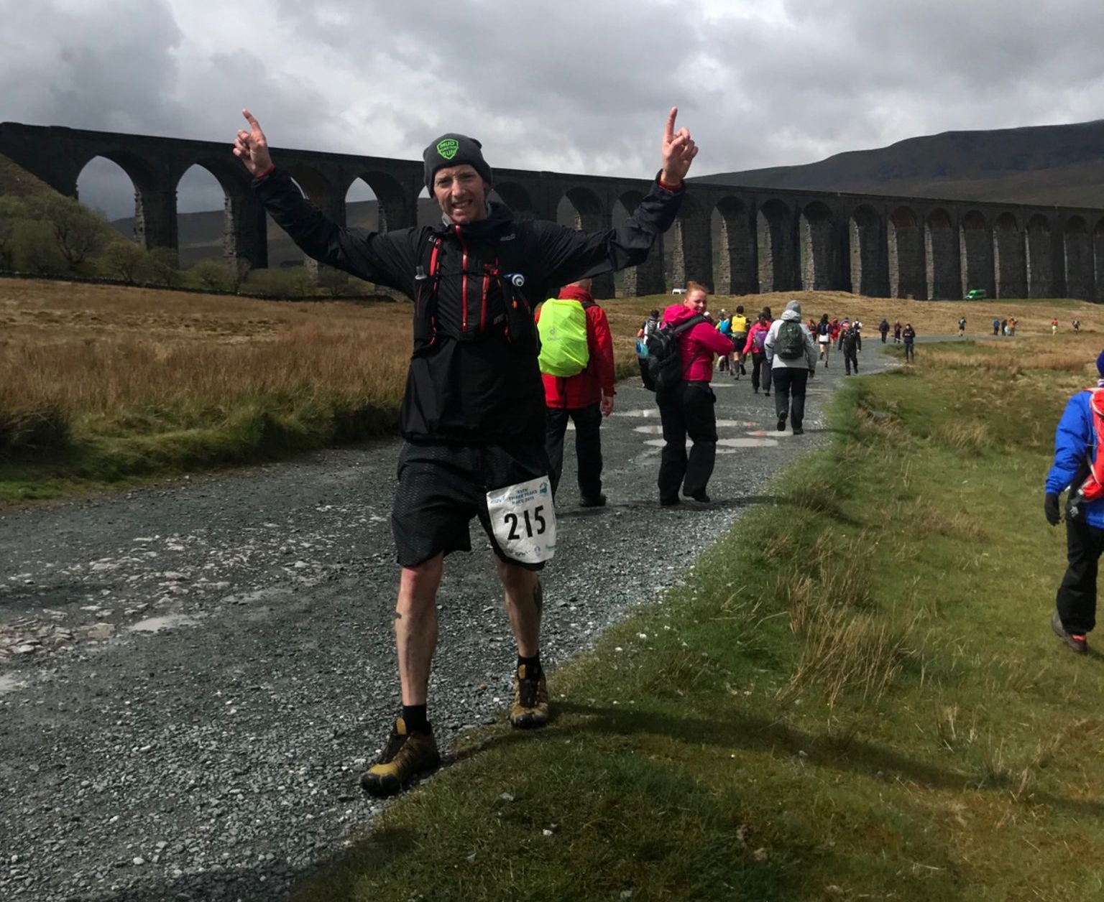
Phil Payne at the Three Peaks.

