Athletics:

On 16 July was the Southern Athletic League which was held at Crawley’s K2 sports centre. Haywards Heath Harriers were combined with Lewes Athletics Club in this track and field league.

There were lots of great results by the harriers who took part. Notably **Kleri Tantele**, who is new to the club and she took part in no less than four throwing events and obtaining personal bests at each event.

**Jonathan Beckett** also ran his first track five thousand metres race and finished in a superb third place overall in under seventeen minutes. He then went on to run in the steeplechase event and finished in second place in the race! **Harry Goatcher** also competing for the first time for the Harriers competed in the long jump event.

There was good team support from **Lucie Venables** and **Helen Diack** who both completed in multi-events.

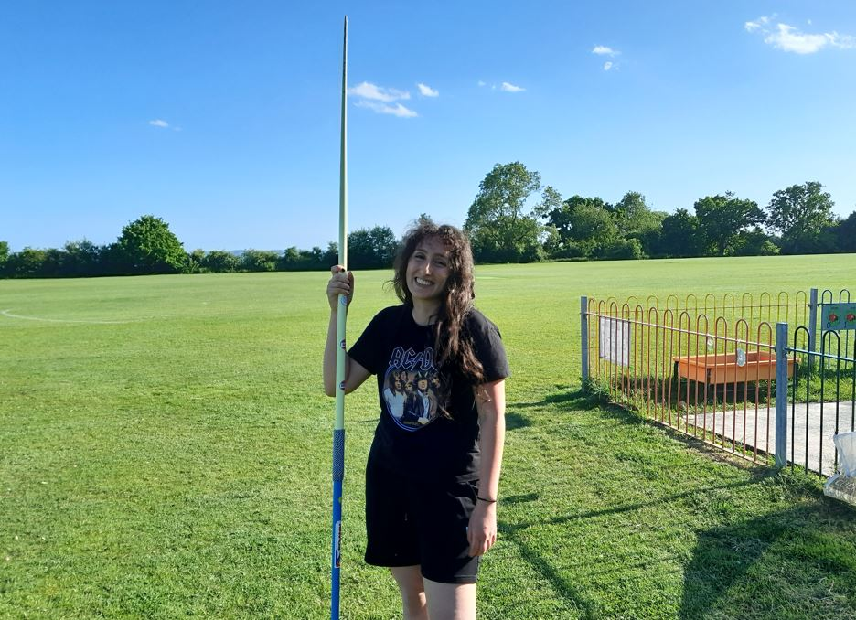

**Kleri Tantele.**

Results were:

**Mark McLoughlin**: 6th 800m ‘A’ string 2 mins 33.2 secs.

**Tim Popkin**: 4th 800m ‘B’ string 2 min 42.3 secs; n/s 1500m 5 mins 46.3 secs; n/s 2000m s/c 9 mins 57.7 secs.

**Sam Fernley**: 1st 1500m ‘B’ string 4 mins 25.0 secs.

**Jonathan Beckett**: 3rd 5000m ‘A’ string 16 mins 59.3 secs (pb); 2nd 2000m s/c ‘A’ string 9 mins 14.5 secs.

**Russ Mullen**: 1st 5000m ‘B’ string 17 mins 13.7 secs.

**Lucie Venables**: 2nd 100mH ‘A’ string 21.3 secs; 2nd 400mH ‘A’ string 89.5 secs; 3rd Long Jump ‘A’ string 4.03m; 4th Triple Jump ‘A’ string 8.61m; 2nd Javelin ‘B’ string 14.71m.

**Tim Hicks**: 2nd 2000m s/c ‘B’ string 9 mins 17.0 secs.

**Helen Diack**: 5th High Jump ‘A’ string 1.10m; 1st Triple Jump ‘B string 7.93m.

**Harry Goatcher**: 3rd Long jump ‘A’ string 5.59m (pb).

**Kleri Tantele**: 5th Shot Putt ‘A’ string 6.01m (pb); 4th Discus ‘A’ string 17.32m (pb); 1st Hammer ‘A’ string 13.02m; 2nd Javelin ‘A’ string 26.22m (pb).

**Other Results**

**Greg Hilton** took part in the Eiger Thirty-Five kilometres race on July 16th. The Eiger race is a mountain ultra trail race in the Swiss Alps and is part of the UTMB World Series. Greg finished in 58th place out of a field of 213 runners in a time of 7 hours 12 minutes and 56.6 seconds.

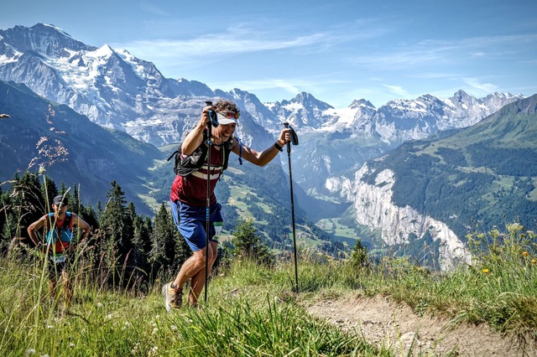

**Greg Hilton.**

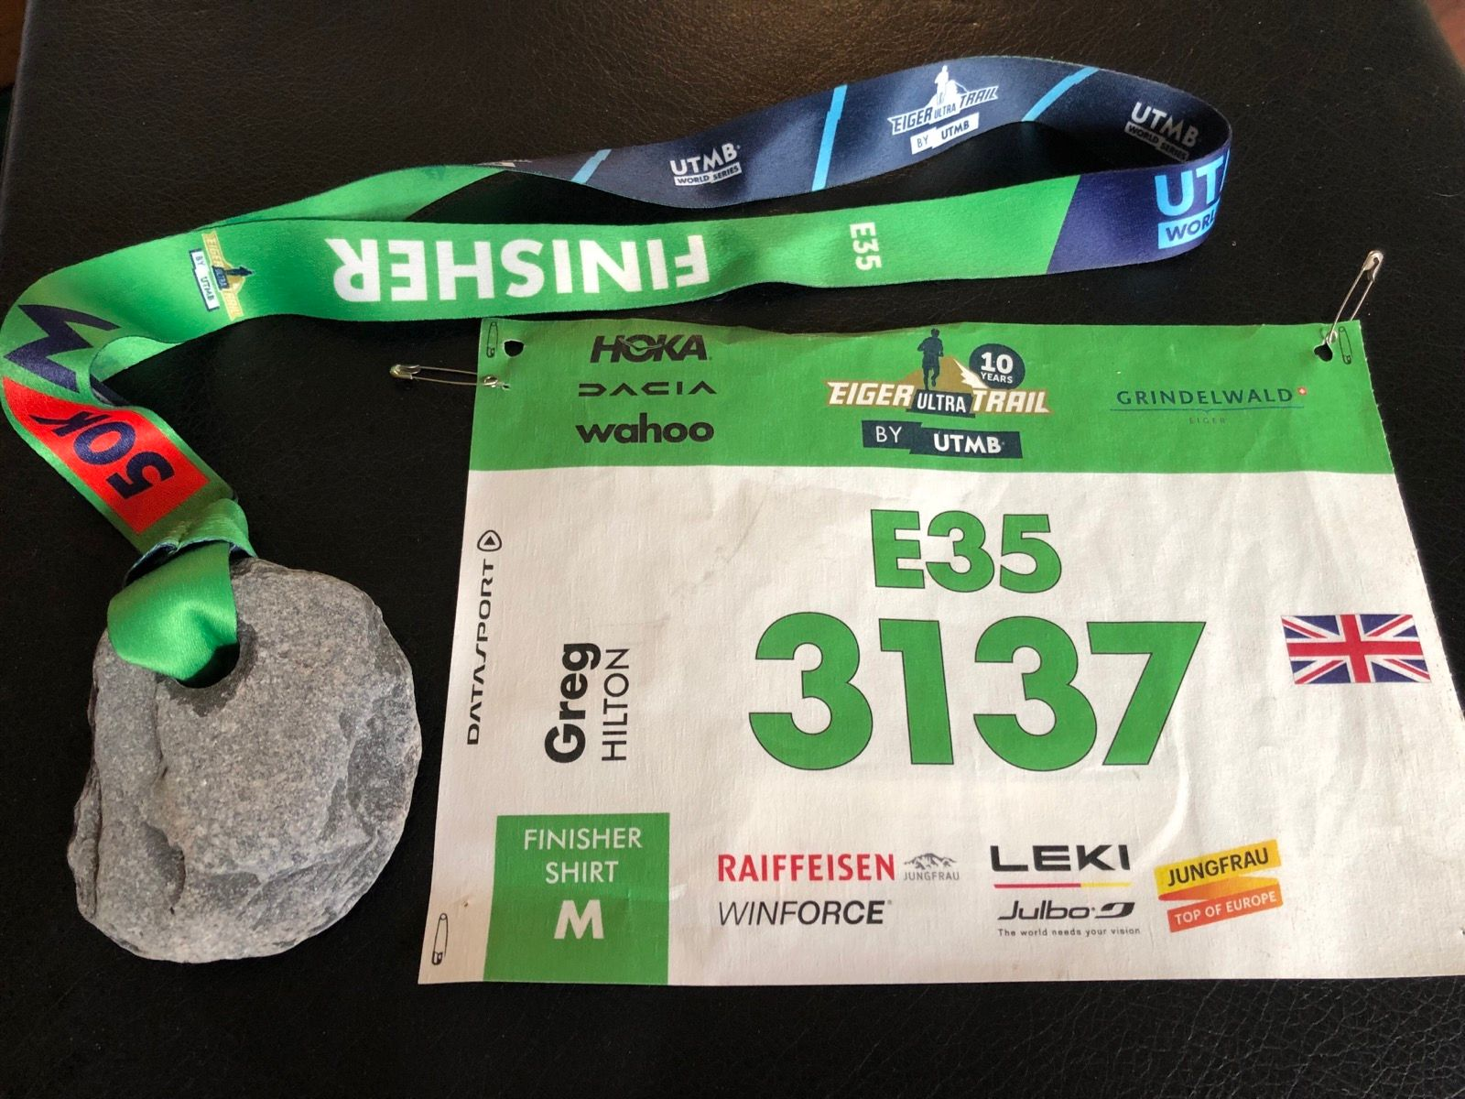

**Greg’s race number and also the Eiger Finisher Stone**

**Sam Fernley** ran at the Worthing Track Night 2 on 26 July. He ran in the 1500 metres race and finished in thirteenth position overall with a personal best of 4 minutes 24.54 secs. **Arun Khursheed** finished in seventeenth place with 4 mins 36.30 secs.

**Oliver Farr** ran his 82nd marathon on 6 August along the River Thames at the Thames Meander Marathon. He finished this marathon in four hours and forty-seven minutes.

**RUN SERIES**

**(By Michael Parish)**

**The Run Series** have two half marathons on their books with Run Reigate and Run Gatwick. This year they looked at an inaugural 10km trails run at Gatton Park, Redhill. The first took place on 20th February with a winter run and a summer evening run followed on 28th July 2022.

Gatton Park is a private school situated in extensive grounds just under the North Downs. The run consists of either a 5km or 10km run (two loops of the 5km). It starts at the back of Gatton House taking path and trails to the large lake and a ford. As you exit the lake you go up hill to a farm area and school grounds. This drops you back into the trails going past the horse stables and back to the finish or second loop.

Both 10km runs were run by two Haywards Heath Harriers, **Oliver Farr** and **Michael Parish**, both have had multiple attendances at Run Reigate Half Marathon and Michael has the same with Run Gatwick after taking part in the inaugural run.

Oli had a great run crossing the finish line 27th at 52:01, followed by Michael who was 106th at 01:04:26 achieving 6th in his age category.

Results: 1st Adam King, Stubbington Green Runners, 38:29; 2nd Rob Wigley, Reigate Priory Athletics Club, 00:39:13; 3rd Matt Woosnam, unaffiliated, 00:43:02.

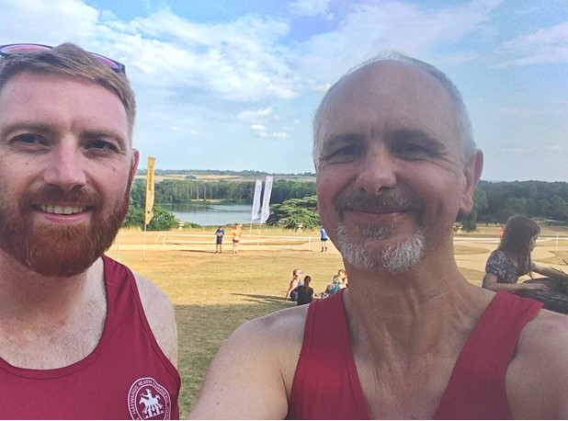

**Oliver Farr and Michael Parish.**

**Parkrun round-up**

This week we see that many of the Harriers have been travelling around Britain as parkrun tourists.

Clair parkrun: 1st **Harvey Alcock** 18:11; 5th **David Adams** 20:11; 10th **James Bennett** 21:21; 14th **Dave Warren** 22:03; 15th **Sam Atkin** 22:13; 21st **Katie Reed** 23:35; 25th **Annabel Axford** 24:28; 71st **Rohan Barnes** 29:12; 74th **Andy Henry** 29:27.

York parkrun: 30th **Pete Francis** 20:03.

Horsham parkrun: 39th **Dominic Roberjot** 21:46; 165th **Lynne Roberjot** 26:07.

Hoblingwell parkrun: 19th **Carl Bicknell** 26:30.

Tilgate parkrun: 3rd **Daniel Moll-Morgan** 18:08; 264th **Michael Parish** 32:23; 272nd **Caroline Gumm** 32:53.

East Grinstead parkrun: 7th **Simon Robinson** 22:41.

Reigate Priory parkrun: 48th **Jason Robinson** 23:35; 153rd **Shelagh Robinson** 28:46.

Glossop parkrun: 5th **Julian Boyer** 19:50.

Tooting Common parkrun: 254th **Michael Essex** 27:16.

East Brighton parkrun: 82nd **Emma Pryor** 30:03; 86th **Steven Heath** 30:56.

Uckfield parkrun: 25th **Abigail Redd** 24:00; 26th **James Smyth** 24:23; 86th **Julie Essex** 33:30.

Ifield Mill Pond parkrun: 4th **Arun Khursheed** 20:27.

Chalkwell Beach parkrun: 13th **Barry Tullett** 19:40; 184th **Linda Tullett** 32:10.

Edgbaston Reservoir parkrun: 20th **Sam Fernley** 18:39.