Middy Report 08.10.17

Harriers in Autumn Marathons, Half Marathons and 10kms.
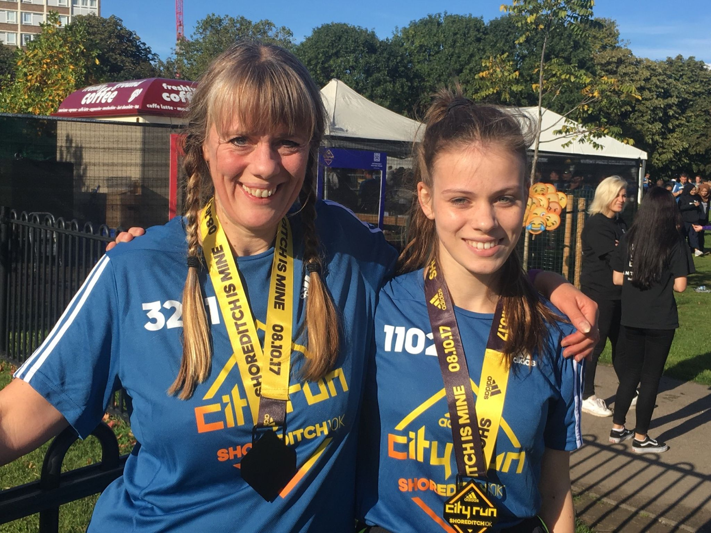

Amy Mitchell (HHH) and her mother Alison (CRC) at the Shoreditch 10km.

This weekend the autumn marathon season has arrived and for Haywards Heath Harriers. several Harriers were taking part in an autumn marathon whilst others were doing half marathons. Marathons were taking place in York, Bournemouth and as far as Chicago in the USA.

At Chicago, in hot and humid conditions, Sam Ridley decided to run with a group of friends and finished in 3 hrs 52 mins 45 secs. Meanwhile, at Bournemouth, Peter Harding finished his marathon in 3 hrs 27 mins 48 secs and James Bennet in 3 hrs 48 mins 35 secs. At York, Matt Cook ran a big pb by nearly 5 minutes in a fabulous 2 hrs 46 mins 50 secs.

Meanwhile, at the Oxford Half Marathon, James Collins ran a super personal best (pb) of 1 hr 14 mins 25 secs and at the Royal Parks Half Ben Duncan ran 1 hr 21 mins 31 secs. At Peterborough Half Marathon, Russ Mullen ran 1 hr 15 mins 51 secs and Emma Navesey a big pb of 1 hr 31 mins 34 secs. At the Bournemouth Half, Matt Quinton ran 1hr 36 mins 27 secs, Sarah Banks finished 1 hr 44 mins 13 secs; Gary Johnston 1 hr 53 mins 23 secs and Chris Glanfield 1 hr 58 mins 23 secs.

At the Shoreditch 10km Amy Mitchel ran a superb pb of 46 mins 41 secs and her mother Alison (who runs for CRC – Crawley Run Crew) finished in a big pb of 58:33. At Petts Wood 10km, Phil Payne ran 38 mins 11 secs.

Cross Country:
The previous weekend (30th September), at the Goodwood Relays which hosted the Sussex Cross Country Championships, the Harriers came away with several team and individual honours. The biggest success for the Harriers were the number of teams that they managed to put out which was 13 in all. The majority of athletes coming from the senior and vets teams whereas they were short on the number young athletes competing.

Medal success came in the Men’s Vet 40’s race where the Harriers were the top Sussex team getting the gold medal in a time of 58:23 (the team consisting of Rob Watts, Ben Duncan, Julian Boyer and Marcus Kimmins). In the senior ladies, the Harriers A team won silver in 48:18 (the team consisting of Emma Navesey, Siobhan Amer and Katie Morgan).

Individual successes came from Cliff Comber (fastest V60 in 16:47) and Marcus Kimmins (3rd fastest V40 in 13:51).

In the U/15’s Boys race, the young and improving Harriers Boys team came 13th out of 21 teams in 32:26 (the team consisting of Adam Dray, Ryan Armstrong, Patrick Steadman).

Full results were as follows:
Boys U15 were13th in 32:26 (Adam Dray 9:33, Ryan Armstrong 11:12, Patrick Steadman 11:41).

Senior ladies:
Harriers A team 3rd in 48:18 (Emma Navesey 15:32, Siobhan Amer (V35) 16:56, Katie Morgan 15:50).
Harriers B team in 54:10 (Hannah Gibson 18:04, Amy Mitchell (U20)18:00, Darja Knotkova-Hanley (U17) 18:06.
Harriers C team 15th in 57:42 (Sarah Banks 19:06, Kath Buckeridge 19:42, Jasmine Mamoany (U17)18:54).

Vet ladies (O/35), Harriers A team were 4th team out of 9 teams with 53:53 (Georgina Mugridge 18:55, Gillian Forrest 18:07, Kim Lo 16:51).
Harrier’s B team (O/35) were 8th in 64:36 (Jacqueline Barnes 19:46, Michelle Holdstock 22:33, Justine Tanner 22:17).
In the ladies V45 Harriers had an incomplete team (Linda Tullett 24:04, Jenny Denyer 29:31).

Senior Mens:
Harriers A team 6th in 53:59 (James Collins 13:14, Ben Gibson 13:24, Phil Hardaway 13:26, Russ Mullen 13:55).
Harriers B team 14th in 56:46 (Matt King 13:59, Joseph Martin 13:31, Tom Mullen 14:38, Phil Payne 14:38).
Harriers C team 18th (mixed ages) 62:18 (Dan Blain 14:40, James Bennett 15:44, Richard Cole 16:59, Rob Watts 14:55).

Vet men (O/40’s), Harriers A team 1st in 58:23 (Rob Watts 14:27, Ben Duncan 14:38, Julian Boyer 15:27, Marcus Kimmins 13:51).
Harriers B team 8th in 79:40 (Andy Dray 15:57, Mark Sykes 19:49, Rupert Purchase 24:22, Mike Essex 19:32).
Vet men (O/50’s), Harriers A team 5th in 65:39 (Barry Tullett 15:23, Phil Scott 16:39, Carl Bicknell 18:42, Paul Cousins 14:55).
Vet men (O/60’s), Harriers A team 5th 62:19 (Cliff Comber 16:47, John Morgan 22:48, Richard Bates 22:44).

U/15 Boys, Harriers 13th out of 21 teams in 32:26 (Adam Dray 9:33, Ryan Armstrong 11:12, Patrick Steadman 11:41).

