Gunpowder Trot

**By Michael Parish.**

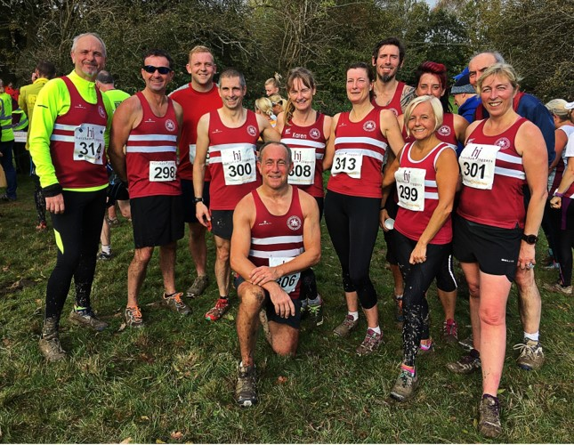

**Left to right: Michael Parish, Bryan Tiller, Robert Comber, Julian Boyer, Ian Dumbrell, Karen Thompson, Katherine Buckeridge, Andy Hind, Sarah Banks, Carys Hind, Richard Bates, Sarah Hamilton.**

HERE WE are back in November when we celebrate Guy Fawkes and his great attempt to blow up the houses of Parliament with gunpowder.   It’s the time of the year where we have bonfires and light the night sky with fireworks.   But for a small running club in Horsham there is a different celebration.

Saturday 3rd November Horsham Joggers set up their “Gunpowder and Trot”, an 8km cross country run around the countryside of Horsham.   This is part of the West Sussex Fun Run League run by the 18 registered athletics club also open non-affiliated runners.

The day before saw severe weather with 80 mile an hour winds and a lot of rain.   Emergency services were called to trees and power lines down along with flooded and blocked roads.   But the following day the sun came out and runners from all over the county turned up for the run.

A cross country run with the amount of rain that fell the previous day was going to be fun, it’s what you do cross country for, isn’t it?   If the answer is yes, then this wasn’t going to disappoint on any level.

The first part of the run goes up a very steep hill and then across country through open fields and woodland, there is a part on tarmac footpaths where you turn back towards the start line.   The entrance to each field was without doubt the best with a large area of mud to get through that was deep and slippery.   The greatest challenge wasn’t speed but staying on your own two feet.

Coming back towards the finish line gave the opportunity for a great finish.   The hill at the begging was now the downward run to the end.   There was some great running from Lewes AC with two across the finish line in the first five with Toby Meanwell (Lewes AC) 26:06, Matt Bradford (Lewes AC) in 26:44, Stewart Gregory (Portslade Hedgehoppers) in 27:50, Liam Briscoe (Fittleworth Flyers) in 28:09 and Phil Payne (Haywards Heath Harriers) in 28:20.   It was a great end to the 2019 season.

Harriers results are: 5th Phil Payne 28:20, 11th Mark Green 29:15th Andy Hind 29:40, 24th Julian Boyer 30:38, 48th Ryan Armstrong 32:25, 55th Jack Chivers 32:51, 63rd Kim Lo 33:20, 103rd Ian Dumbrell 35:35, 108th Bryan Tiller 35:51, 160th Karen Thompson 38:01, 191st Katherine Buckridge 39:33, 204th Sarah Banks 39:58, 276th Sarah Hamilton 44:38, 290th Michael Parish 45:35, 330th Carys Hind 49:39 and 352nd Richard Bates 51:32.   Special thanks to Julian Boyer for making all the arrangements for the 2019 season for Haywards Heath Harriers.

**Sussex Sports Hall League.**

At the Sussex Sports Hall Athletics League held at Horsham on the 3 November where the under 11’s, the under13’s and the under 15’s were all in action. There were lot of great results with the young Harriers achieving many first and second places and also the youngsters doing many non-scoring events. Results were as follows:

**Girls results:**

**Girls Under 11’s**

Emma McMahon: 4th ‘A’ string 2 lap sprint 26.4 secs, 3rd ‘A’ string Speed Bounce 48, 4th ‘A’ string Standing Long Jump 1.57m.

**Girls Under 13’s**

Siobhan McMahon: 2nd ‘A’ string 2 Lap race 23.5 secs, 2nd ‘B’ string Speed Bounce 71, 4th ‘A’ string Standing Long Jump 2.00m.

Mae Robinson: 5th ‘B’ string 2 Lap race 24.6 secs, equal 1st ‘A’ string Speed Bounce 74, 5th ‘B’ string Standing Long Jump 1.71m.

Maia Bliss-Tomlinson: 4th ‘A’ string 4 Lap race 53.8 secs, 4th ‘B’ string Shot Putt 4.63m, 5th ‘A’ string Vertical Jump 42.

Kitty Gandarez: 4th ‘B’ string 4 Lap race 57.6 secs, 5th ‘A’ string Shot Putt 4.94m.

Megan Eyre: 3rd ‘A’ string 6 Lap race 82.5 secs, 3rd ‘B’ string Vertical Jump 39.

Relay: 8 Lap Parlauf: 5th HHH 1 min 48.1 secs.

Relay: 4 x 2 Lap relay: 3rd HHH 1 min 41.9 secs.

**Boys results:**

**Boys Under 11’s**

Charlie Stay: 5th ‘A’ string 2 lap sprint 25.2 secs, 3rd ‘A’ string Standing long Jump 1.79m, 1st ‘A’ string Speed Bounce 54.

Noah Seymour: 3rd ‘B’ string 2 lap sprint 26.2 secs, 2nd ‘B’ string Speed Bounce 44.

Josh Batchelor: 4th ‘B’ string Standing Long Jump 1.55m.

Relay: 4 x 1 Lap relay: 4th HHH 52.5 secs.

**Boys Under 13’s**

Jonathan Parkin: 4th ‘A’ string 2 lap sprint 23.4 secs, 3rd ‘A’ string Vertical Jump 43, 4th ‘A’ string Standing Long Jump 2.09m.

Jack Bannister: 3rd ‘B’ string 2 lap sprint 24.0 secs, 2nd ‘B’ string Vertical Jump 37, 2nd ‘B’ string Speed Bounce 71.

Nye Sim: 3rd ‘A’ string 4 lap sprint 50.8 secs.

C. Crouch: 4th ‘B’ string 4 lap sprint 54.0 secs, 2nd ‘B’ string Shot Putt 6.21m.

Arun Khursheed: 1st ‘A’ string 6 lap race 79 secs, 3rd ‘B’ string Standing Long jump 1.93m.

Oscar French: 2nd ‘B’ string 6 Lap race 83.5 secs.

George Bonwick-Adams: 2nd ‘A’ string Shot Putt 6.41m, 2nd ‘A’ string Speed Bounce 72.

Relay: 8 Lap Parlauf: 3rd HHH 1 min 38.3 secs.

Relay: 4 x 2 Lap relay: 3rd HHH 1 min 36.5 secs.

**Boys Under 15’s**

Charlie Parvin: 1st ‘A’ string 2 lap sprint 21.6 secs, equal 2nd ‘A’ string Speed Bounce 75, 1st ‘A’ string Standing Long Jump 2.42m.

Sam Fernley: 4th ‘A’ string 4 lap sprint 47.5 secs, 1st ‘B’ string Speed Bounce 73, 1st ‘B’ string Standing Long Jump 1.98m.

Relay: 8 Lap Parlauf: 3rd HHH 1 min 34.3 secs.

**Non-scoring:**

2 Lap race: Oliver Skinner 25.2 secs, M. Crouch 28.2 secs, Josh Batchelor 28.7 secs, Ben French 29.3 secs.

4 x 1 Lap Relay: HHH 51.5 secs.

Standing Long Jump: Nye Sim 1.89m, Oscar French 1.79m, M Crouch 1.25m, Ben French 1.33m, Oliver Skinner 1.60m.

Speed Bounce: Ben French 37, Josh Batchelor 45, M Crouch 32, Oliver Skinner 45.

.