YOUNG HARRIERS EXCEL AT SOUTH OF ENGLAND CHAMPS

On Saturday 11 January and Sunday 12 January was the South of England AA Indoor Track and Field Championships at Lee valley.

Two athletes from Haywards Heath Harriers took part in these championships: Jonathan Parkin.and Arun Khursheed both competing in the Under 13 age group. Both lads were successful winning all their events.

Jonathan also achieved a Championship Best Performance in the High Jump with a new record of 1 metre 40 centimetres eradicating the previous best performance by 6 centimetres. He also set a big personal best in the Shot Putt with a putt of 7 metres and 16 centimetres.

Arun Khursheed won the Under 13 800 metres in a time of 2 minutes 32.58 seconds.

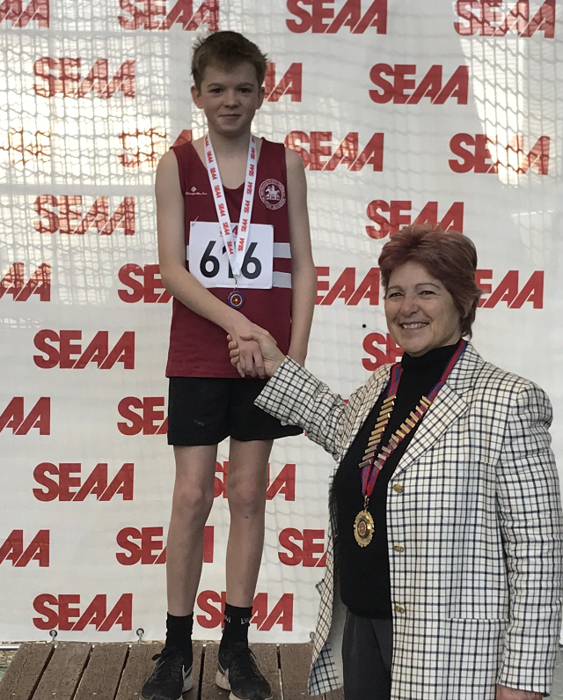

Jonathan Parkin.

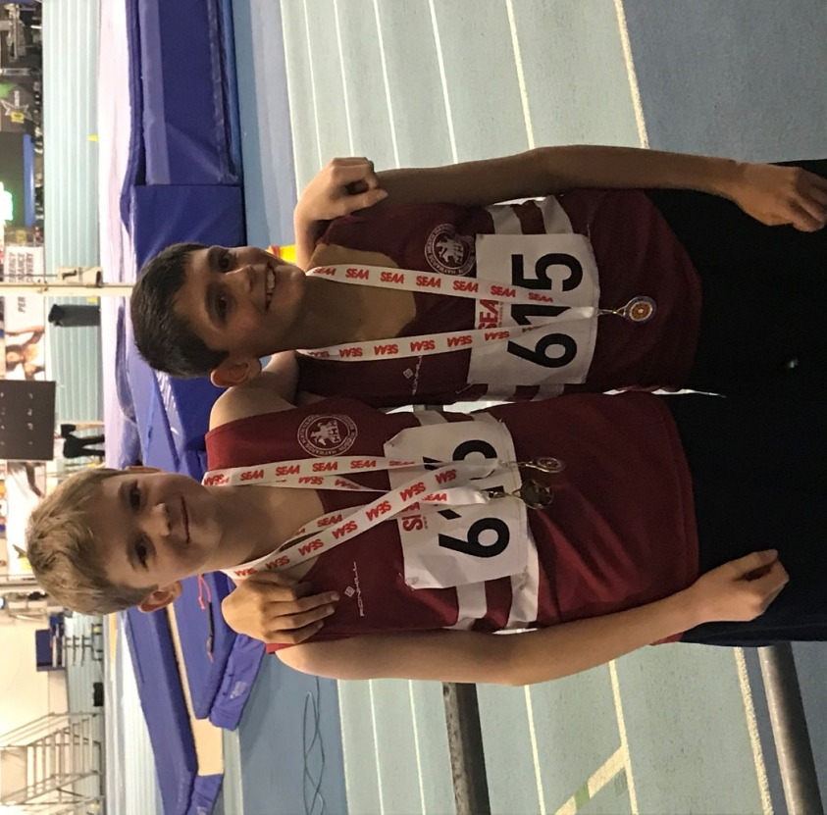

Jonathan Parkin and Arun Khursheed.

SUSSEX CROSS COUNTRY CHAMPIONSHIPS.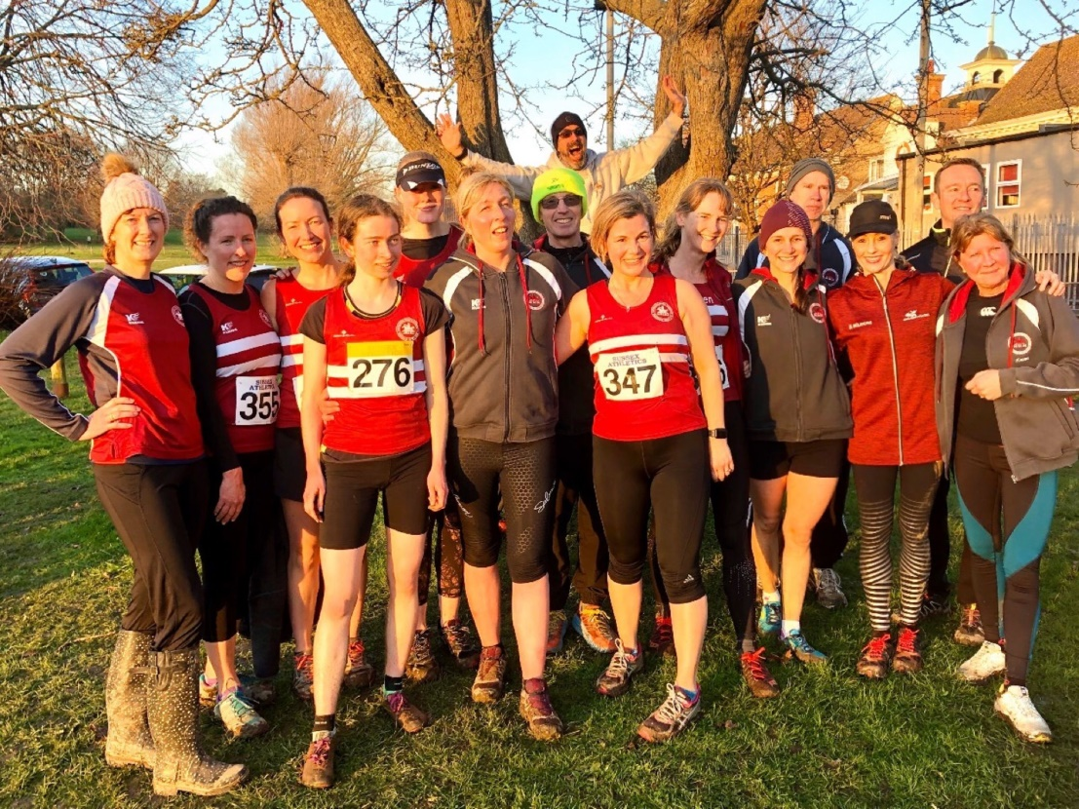
Haywards Heath Harriers Cross Country Runners at Bexhill.

Sussex County Cross Country Championships were held at Bexhill. After the rains of last month, the ground conditions were fair to say good and fairly dry (Bexhill is known for being really, really muddy!). But last week were good conditions for the runners taking part.

Harriers did very well at Bexhill. The senior ladies A team were fourth team overall. The Harriers had nearly three teams taking part in the senior women’s race!! Jac Barnes having a super run in the senior ladies race. Russ Mullen led the senior men home in twenty sixth place.
In the under 13 boys race, the young Harriers won a super silver team medal with Arun Khursheed, Jacob Roderick and Jonathan Beckett in top thirteen places.
Arun Khursheed was also third overall in the Under 13’s race. Darja Knotkova-Hanley finished in a great eighth place in the senior women’s race (her first race of stepping up into the seniors age category). Darja also beating some notable opposition (scalps) on the way. All the youngsters had good placings overall in their races.

Results were as follows:
Under 13 Boys: 3rd Arun Khursheed 12:13, 11th Jacob Roderick 12:37, 13th Jonathan 12:39, Beckett, 25th Finlay Blythe 13:16, 27th Oscar French 13:18, 51st Oscar Dalgleish 14:52.

Under 15 Boys: 21st Sam Fernley 17:20, 28th Rory Dalgleish 18:10
Under 17 Girls: 17th Rosie Beckett 24:16.

Senior Womens: 8th Darja Knotkova-Hanley 44:20, 29th Sam Ridley 52:36, 35th Jac Barnes 55:01,36th Gemma Morgan 55:52, 38th Karen Thompson 56:32, 41st Kath Buckeridge 58:19, 44th Teresa Mockridge 62:25, 45th Jenny Turner 64:00, 46th Claire Annesley 66:20, 47th Shelagh Robinson 66:38, 48th Sarah Hamilton 67:33

Senior Men: 26th Russ Mullen 39:13, 45th Marcus Kimmins 41:50, 60th Paul Cousins 43:37, 61st Michael Burke 43:40, 67th Rob Watts 44:53, 81st Greg Hilton 49:16, 89th Paul Turner 51:36, 97th Carl Bicknell 55:00.

OTHER HARRIER RESULTS

The Hangover Five.
The first race of the year for Haywards Heath Harriers was the Hangover 5 which was held on 1 January.
Marcus Kimmins had a great run, finishing in 4th place overall.

The Harries results were as follows:
4th Marcus Kimmins in 32:31, 45th Ryan Armstrong 37:19, 102nd Mark Sykes 42:06, 177th Amanda Soper 45:41, 182nd Gemma Morgan 46:02, 198th Graham Kenward 46:36, 206th Clare Kenwood 47:03, 373rd Richard Bates 58:31.

