Athletics:
(By Linda Tullett)
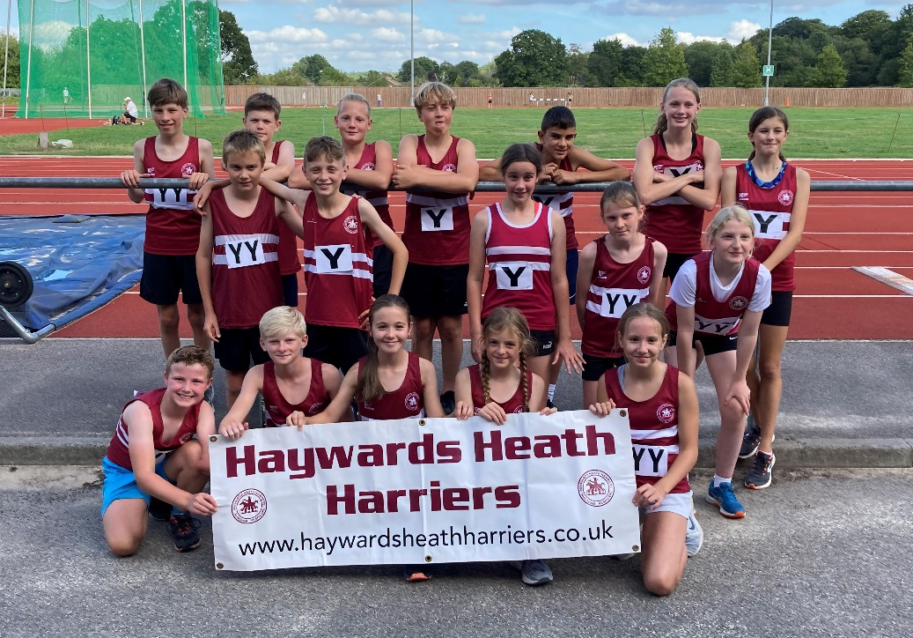
Haywards Heath Under 13 athletics team.
The previous weekend saw two league athletics finals for the junior members of Haywards Heath Harriers. On the evening of Friday 2nd September, the Under 15’s took part in their League Cup Final at Withdean Stadium, Brighton where the club finished in 7th place. The team was somewhat depleted from the previous league fixtures, but those who did compete ran extremely well and gained valuable points.
On Sunday 4th September, the Under 13’s took part in their Sussex League final at K2, Crawley where they finished an incredible 5th place out of the 11 competing teams, with many of the athletes making their club debut. Almost a full team of athletes turned out, and several picking up points in events they did not usually compete in. A great team effort and a positive end to the season.
Results were as follows:
Sussex Under 15 League Cup Final

Girls
100m A String 3rd Lucy Barker 13.8
B String 4th Annabelle Scutt 15.2

200m A String 4th Lucy Barker 28.9
B String 5th Maggie Goodman 32.5
N/S Annabelle Scutt 31.7

Discus A String 5th Anya Cole 13.46
B String 4th Lois Cole 10.82
N/S Alexandra Young 11.75

Shot A String 7th Lois Perrett 4m44

Javelin A String 8th Anya Cole 9m68
B String 5th Lois Perrett 9m04

High Jump A String 5th Anya Cole 1m30

Boys

100m A String 7th Ollie Stay 13.6
B String 7th Ben Baker 14.2

200m A String 7th Ollie Stay 28.0
B String 7th Ben Baker 29.6

300m A String 7th Arun Khursheed 43.6

800m A String 8th Sam Harper 2:36.5

1500m A String 3rd Arun Khursheed 4:36.4

High Jump A String 4th Sam Harper 1m35

Long Jump A String 8th Ben Baker 4m07
B String 8th Arun Khursheed 3m67

Discus A String 4th Ollie Stay 15m66

4 x 100m 6th Ollie, Ben, Arun, Sam 57.0

Match Result
1 | Crawley |  | 412.5
2 | Brighton & Hove |  | 341
3 | Chichester |  | 263
4 | Eastbourne |  | 240
5 | Worthing |  | 225
6 | Lewes |  | 159
7 | Haywards Heath |  | 97.5
8 | Horsham BS |  | 77

Sussex Under 13 League Final

Girls

75m A String 6th Anna Duncan 11.00
B String 3rd Megan Kemp 11.87
150m A String 5th Anna Duncan 22.42
B String 3rd Megan Kemp 23.40
600m A String 7th Annabel Parkin 2:03.28
B String 8th Naia Myles 2:31.91
1000m A String 6th Olivia Byers 3:28.85
B String 4th Annabel Axford 3:36.85
Long Jump A String 6th Jessica Diack 3m16
B String 5th Lorna Cole 3m03
High Jump A String 8th Naia Myles 1m15
B String 6th Annabel Axford 1m10
Shot A String 7th Jessica Diack 4m52
B String 6th Lorna Cole 4m16
Discus A String 4th Annabelle Parklin 12m97
B String 4th Olivia Byers 8m97
4 x 100m A String 6th Annabelle, Anna, Megan, Jessica 61.01
B String 6th Olivia, Lorna, Annabel, Naia 71.83

Boys

75m A String 6th Charlie Stay 10.88
B String 7th William Kean 12.49
150m A String 4th Ollie Stay 21.71
B String 4th Cian Gaston 23.49
600m A String 5th Rafael Selby 1:57.18
B String 7th Aaron Heawood 2:29.72
1000m A String 6th Henry Cotton 3:23.17
B String 7th Bill Davey 3:43.0
75mH A String 7th Rafael Selby 16.27
Long Jump A String 9th Bill Davey 3m03
B String 7th Jacob Harper 2m68
High Jump A String 7th Aaron Heawood 0.95m
Shot A String 6th William Kean 5m76
B String 6th Jack Diack 3m41
Discus A String 4th Cian Gaston 15m45
B String 1st Henry Cotton 15m27
Javelin A String 9th Jack Diack 8m25
B String 8th Jacob Harper 8m01
4 x 100m A String 7th Cian, Ollie, Henry, Rafael 60.01
B String 5th Jack, Jacob, William, Bill 65.44

Match Result
1 | Brighton & Hove |  | 470.5
2 | Crawley |  | 416
3 | Chichester |  | 358.5
4 | Eastbourne |  | 303.5
5 | Haywards Heath |  | 272
6 | Horsham BS |  | 251
7 | Lewes |  | 195.5
8 | Hy Runners |  | 166
9 | East Grinstead |  | 162
10 | Worthing |  | 153
11 | Phoenix |  | 65

West Sussex Fun Run League
Late results in for the Highdown Hike on 3 August were as follows:
11th Andy Hind 26:06; 16th Phil Payne 26:53; 78th Abigail Redd 31:29; 106th James Smyth 33:04; 154th Kath Buckeridge 35:24; 183rd Sarah Hamilton 38:09; 254th Caroline Gumm 43:21; 256th Katherine Woolhouse 43:32; 263rd Carys Hind 44:17; 283rd Richard Bates 47:13; 315th Rupert Purchase 56:24.

Other Harrier results:
Mark Davies ran in the 17th Rye Summer Classic 10km race and finished in 43rd position in a time of 50 minutes and 2 seconds on 12th August.
Two Haywards Heath Harriers competed in the Maverick series on Saturday 3rd September: Daniel Moll-Morgan won the Maverick Half Marathon in a time of 1 hour 45 minutes and 9 seconds. Daniel said there were three hills and had to walk parts as was so steep. Kim Lo finished also ran in the Maverick series and finished the Maverick Ultra in 6 hours 41 minutes and 13 seconds and was the fourth veteran woman in the 40 year age group.
Sean Duff ran a super personal best at the Big Half in London on Sunday 4 September. He finished in a time of 1 hour 22 minutes and 55 seconds. Also taking part was Sam Ridley, who finished as fifth veteran woman in the 55 year age group in 1 hour 41 minutes. Sean also ran another person best time in the mid-week Battersea Park 10 kilometres race. His time was a full two-minute improvement on his previous best finishing in a new time of 37 minutes and 14 seconds.
Oliver Farr ran his 83rd and 84th marathons (on his way to a hundred marathons!). Number 83 was at the Phoenix Track wars on Friday 2nd September where he finished in a time of 4 hours 46 minutes. Number 84 was at the Garmin New Forest Marathon on 11 September finishing in 4 hours and 28 minutes.

At the 24th Kings Head Canter, Russ Mullen finished in sixth position overall in 17 minutes and 12 seconds on 29 August.
Parkrun round-up!
Clair parkrun:1st Will Grey 17:35 (pb); 3rd Harvey Alcock 18:09; 16th Simon Robinson 21:49; 18th Noah Perrett 22:01; 38th Annabel Axford 24:37; 41st Katie Reed 24:50; 75th Andy Henry 28:02; 98th Mark Sykes 31:21; 109th Katherine Woolhouse 33:25.
Lymington parkrun: 9th Pete Francis 21:25.
Dulwich parkrun: 8th Daniel Moll-Morgan 16:40.
Netley Abbey parkrun: 84th Sarah Hamilton 27:13.
Tilgate parkrun: 4th Jonathan Beckett 17:58 (pb); 11th Arun Khursheed 19:02: 20th Marcus Kimmins 20:21; 23rd Paul Cousins 20:32: 39th Barry Tullett 21:50; 45th Julian Boyer 22:23; 71st Adam Beckett 23:47; 99th Kath Buckeridge 25:20; 135th Toby Wiles 26:40; 139th Shelagh Robinson 26:46; 140th Carl Bicknell 26:46; 188th Michael Parish 28:16 (pb); 190th Greg Hilton 28:18; 218th Bethany Hilton 30:19 (pb); 261st Rosie Beckett 33:08 (pb); 266th Linda Tullett 33:18.
Hove Prom parkrun: 8th Sam Fernley 18:48 (pb).
Lancing Beach Green parkrun: 41st Ian Tomkins 25:46.
North Yorkshire Water Park parkrun: 3rd Russ Mullen 18:00 (pb).
*************************************************************
HAYWARDS HEATH Harriers are holding a #RunandTalk session on Thursday
22nd September 2022 at 19:00.
Taking place from the Courtyard, next to the Harvester in Beech Hurst Gardens, RH16 4BB, it consists of a 5km conversational run to highlight good physical and mental health.
The run can be anything from 1km to 5km and doesn’t need to be run, you can walk, walk/run or run. The aim is to get people active promoting good physical and mental health. There will be an opportunity at the end to have a coffee and a conversation with other runners, members of Haywards Heath Harriers and their Mental Health Champion. If you want to book your place or ask any questions, then email MichaeldaParish@gmail.com.

