Middy Report 12.11.17

Two Haywards Heath Harriers endurance runners ventured to one of the most unusual endurance events held on the planet. Marion Hemsworth and Julia Essex travelled to the Himalayas for their Himalayan Adventure

Julie Essex (left) and Marion Hemsworth

Julie Essex and Marion Hemsworth have just returned from what they describe as their biggest running challenge ever. They completed the Himalayan 100 mile stage race, coming 16th and 22nd respectively. Half the competitors did not in fact finish the race, which involved doing five consecutive days of running different distances to make the total of 100 miles. The race took place at altitude in the Darjeeling district of North East India near the border with Nepal. Altitude and tricky terrain meant running very quickly became walking – slowly! Julie and Marion encountered all sorts of difficulties from lack of sleep to broken down buses, but overall they returned with limbs intact, though minus a couple of toe nails. Would they recommend the event to others? Just know what you are taking on and make sure you are happy to survive on a diet of rice and dhal, they said!

The Gunpowder Trot event of the West Sussex Fun Run League was held over at Horsham for what was a rather muddy affair last weekend. Harriers were also represented by two new recruits to the club, Andy Hind and Mark Green as well as all the regular runners for the club.

Results were as follows:
14th Andy Hind 30:06, 20th Mark Green 30:31, 23rd Julian Boyer 30:40, 57th Matt Howells 33:59, 69th Phil Scott 34:54, 96th Mark Armitage 36:35, 114th Carole Walters 37:18, 136th Kath Buckeridge 39:02, 153rd Mark Sykes 40:09, 189th Sarah Hamilton 42:48, 245th Richard Bates 47:24.

At Bexhill last Saturday, saw the Sussex Brooks Cross-Country League take place. The Harriers struggled to get out their top team for the men’s and women’s events. With Chris Smith and John Kettle missing from the senior men’s event and Kim Lo and Siobhan Amer missing from the ladies’ squad the Harriers team points scores were not as good as the cross-country meeting in September at Goodwood.

Results were as follows:

Senior Men’s race:
15th James Skinner 28:56, 20th Phil Hardaway 30:01, 22nd Ben Gibson 30:06, 32nd Marcus Kimmins 30:42, 40th Russ Mullen 31:09, 55th Paul Cousins 32:01, 60th Rob Watts 32:22, 73rd Will Herbert 32:54, 77th Tom Mullen 33:07, 98th Julian Boyer 34:09, 102nd Barry Tullett 34:43, 115th James Bennett 36:19, 116th Tim Hicks 36:24, 124th Phil Scott 36:45, 147th Michael Essex 42:02, 149th Graham Kenwood 43:11.

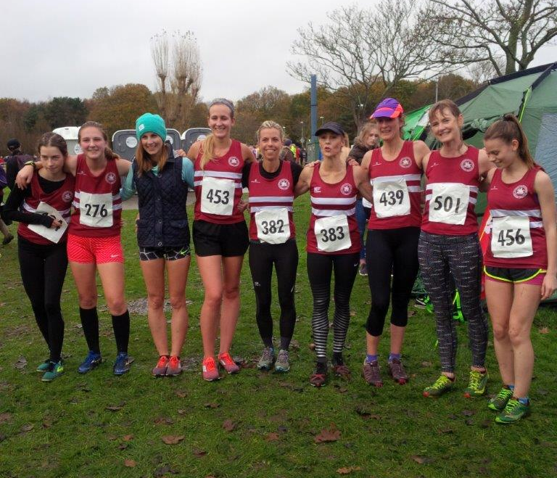
Senior ladies and Under 17 Girls

Senior ladies and Under 17 Girls race:
18th Kate Morgan 20:50, 30th Emma Navesey 21:19, 66th Hannah Gibson 23:32, 70th Gillian Forest 23:41, 73rd Jasmine Mamoany 23:46, 76th Amy Mitchell 23:52, 80th Samantha Ridley 24:01, 86th Darja Knotkova-Hanley 24:26, 95th Karen Thompson 24:58, 98th Kath Buckeridge 25:13, 121st Sarah Hamilton 28:42, 127th Linda Tullett 32:56, 131st Jenny Denyer 40:00.

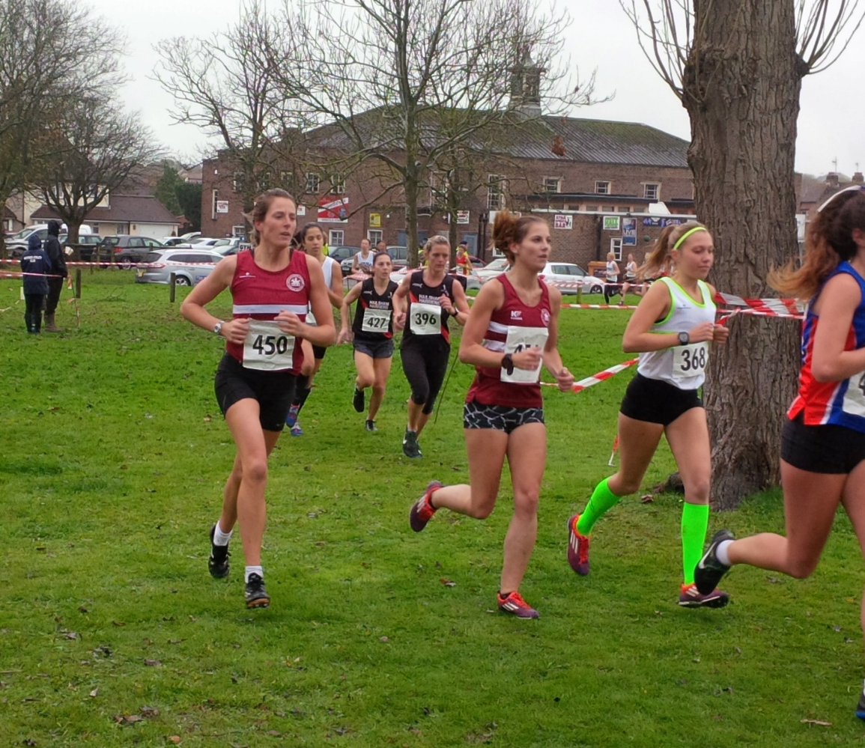
Katie Morgan (left) and Emma Navesey

Under 15 Boys race:
7th Adam Dray 13:42, 53rd Ryan Armstrong 16:03, 54th Patrick Stedman 16:07, 58th Harvey Bashford 16:46, 59th Ewan Kemsley 16:49.

Under 15 Girls race:
34th Isobel Russell 18:30.

Under 13 Boys race:
38th Sebastian Dell Aira Bromley 13:16, 40th Oliver Mamoany 13:24, 42nd Alex Todd 13:32, 52nd Johnathan Beckett 13:59,
Under 13 Girls race:

18th Anna Contreras 13:56.

Under 11 Boys race:
18th Harvey Gwynn 8:08, 24th Harry Russell 8:18.

Under 11 Girls race:
9th Maia Bliss-Tomlinson 8:50.

Poppy Hal Marathon also held at Bexhill last Saturday, Harrier’s Matt King came a brilliant 6th place in a personal best time of 1 hr 24 mins 08 secs. Also running the Poppy Hal Marathon was Jason Russell who finished in 25th position in a time of 1 hr 31 mins 07 secs.

Last week on Saturday 5th November was the Sportshall League which was held at Horsham. Many youngsters from the club took part. Results were as follows:

Girls u/11.
2 Lap Sprint: ‘A’ race: 4th Mae Robinson 25.4 secs, ‘B’ race: 4th Maia Bliss-Tomlinson 26.5 secs.
4 x 1 Lap Relay: 4th Haywards Heath 54.3 secs.
Speed Bounce: ‘A’ 5th Imogen Reed: 42, ‘B’ 2nd Millie Fairbrother:42.
Standing Long Jump: ‘A’ 3rd Mae Robinson 1m87, ‘B’ 4th Maia Bliss-Tomlinson 1m80.

Girls u/13.
2 Lap Sprint: ‘A’ race: 4th Anna Piper 24.1 secs, ‘B’ race: 3rd Hannah Taylor 24.3 secs.
4 Lap Race: ‘A’ race: 4th Ella Greenslade 55.3 secs, ‘B’ race: 3rd Millie Somerville 56.7 secs.
6 Lap race: ‘A’ race: 2nd Phoebe Whiting 1min 25.0 secs, ‘B’ race: 5th Jessica Bashford-Dickens 1min 37.6 secs.
8 Lap Parlauf: 4th Haywards Heath 1min 50.8 secs.
4 x 2 Lap Relay: 4th Haywards Heath 1min 38.7 secs.
Vertical Jump: ‘A’ Abigail Pendlebury: 41, ‘B’ Jessica Bashford-Dickens: 30.
Speed Bounce: ‘A’ 4th Aisling Yates Kneen: 68, ‘B’ 3rd Anna Piper: 65.
Shot Putt: ‘A’ 4th Millie Francis: 6m15, ‘B’ 4th Martha Hayes: 5m93.
Standing Long Jump: ‘A’ 4th Isobelle Deeble: 1m94, ‘B’ 4th Millie Somerville: 1m78.

Girls u/15:
2 Lap Sprint: ‘A’ race: 5th Hattie Collins 25.8 secs.
4 Lap Race: ‘A’ race: 5th Emma Vince 54.7 secs.
Standing Long Jump: ‘A’ 5th Hattie Collins 1m97.
Shot Putt: ‘A’ 5th Emma Vince: 4m62.
Speed Bounce: ‘A’ 5th Hattie Collins: 71.
Vertical Jump: ‘A’ 5th Emma Vince: 37.

Boys u/11:
2 Lap Sprint: ‘A’ race: 4th Oscar Clarke 25.8 secs, ‘B’ race: 5th Noah Perrett 26.0 secs.
4 x 1 Lap Relay:4th Haywards Heath 50.5 secs.
Speed Bounce: ‘A’ Equal 3rd: Thomas Pearce: 48, ‘B’ Equal 3rd: Jack Twibell: 43.
Standing Long Jump: ‘A’ 5th Oliver Cooper 1m63, ‘B’ 5th Oscar Clarke 1m58.

Boys u/13:
2 Lap Sprint: ‘A race: 4th Alex Booth 25.0 secs, ‘B’ race: 4th Charlie Handel 26.6 secs.
4 Lap Race: ‘A’ race: 5th Tom Swainston 55.8 secs, ‘B’ race: 5th George Bonwick-Adams (u/11) 54.8 secs.
6 Lap race: ‘A’ race: 4th Charlie Bonwick-Adams 1 min 20.5 secs, ‘B’ race: 4th James Manns 1 min 23.5 secs.
8 Lap Parlauf: 5th Haywards Heath 1 min 45.1 secs.
4 x 2 Lap Relay: 4th Haywards Heath 1 min 41.5 secs.
Shot Putt: ‘A’ 3rd James Manns 5m34, ‘B’ 4th Teddy Sturgess 3m60.
Vertical Jump: ‘A’ 2nd Alex Booth:45, ‘B’ 5th Teddy Sturgess: 37.
Standing Long Jump: ‘A’ 5th Alex Booth: 1m87, ‘B’ 5th Charlie Handel: 1m 62.
Speed Bounce: ‘A’ Equal 2nd: Charlie Bonwick-Adams (u/11): 70, ‘B’ Equal 1st George Bonwick-Adams (u/11): 68.

Boys u/15:
4 Lap Race: ‘A’ race: 6th Harvey Bashford-Dickens 53.1 secs.
Speed Bounce: ‘A’ 4th Harvey Bashford-Dickens: 69.
Vertical Jump: ‘A’ 5th Harvey Bashford-Dickens: 40.

Non-Scoring:
2 Lap Race1: 6th Brooke Bashford (u/11) 29.6 secs.
2 Lap Race2: 6th Erin Gaston (u/11) 28.9 secs).
2 Lap Race 4: 4th Imogen Reed 26.9 secs, 6th Millie Fairbrother (u/11) 27.3 secs.
2 Lap Race 7: 4th Seamus Cannon (u/11) 26.0 secs.
2 Lap Race 8: 1st Thomas Pearce (u/11) 24.6 secs.
2 Lap Race 9: 2nd Jack Twibell (u/11) 25.0 secs, 5th Oliver Cooper (u/11) 27.4 secs.
2 Lap Race 12: 2nd Isobelle Deeble (u/13) 24.4 secs, 6th Jessica Bashford-Dickens (u/13) 28.5 secs.
2 Lap Race 13: 2nd Martha Hayes (u/13) 24.9 secs.
2 Lap Race 14: 2nd Aisling Yates-Kneen (u/13) 25.9 secs. 3rd Millie Francis (u/13) 26.1 secs.
Speedbounce: U/11 Girls: Erin Gaston: 36, Brooke Bashford-Dickens: 28, Maia Bliss-Tomlinson: 49, Mae Robinson: 47, Molly Sturgess: 42.
Speedbounce: U/11 Boys: Seamus Cannon: 35, Oliver Cooper: 33, Noah Perrett: 36, Oscar Clarke: 43.
Standing Long Jump: U11 Girls: Molly Sturgess: 1m48, Millie Fairbrother: 1m30. Imogen Reed: 1m47, Erin Gaston: 1m33, Brooke Bashford-Dickens: 1m15.
Standing Long Jump: U11 Boys: Noah Perret: 1m56, Thomas Pearce: 1m90, Jack Twibell 1m61, Seamus Cannon 1m41.

