Middy Report 13 May 2018

**Harrier Records Tumble!!**

Over the last weekend, several Harriers records were broken. One of them was a long-standing record that had been held by Rodney Burrows in the Vet Men’s 45 age group 5000 metres that had lasted since 1985 which was broken during the Sussex Track and Field Championships which were held at K2 in Crawley last Saturday and Sunday.

On the Saturday, in the Men’s 5000 metre race, James Skinner broke a long-standing Vet 40 Harrier record that was held by Rodney Burrows since 1985. James ran a super race and finished in a time of 15 minutes and 40.16 seconds and improving the old record by over 8 seconds. This run ranks James as number one in the UK in the Vet 45 age group!!

Meanwhile, on Sunday Darja Knotkova-Hanley came first in the Under 20 age group 3000 metres race in a new club record of 10 minutes and 29.68 seconds demolishing all other opposition as the race included the under 17’s age group too. Darja knocked 10 seconds off her previous record in Eltham on 14 April. Darja said that she felt she could have gone faster if there was someone to push her but that she was happy with the win. More results next week.

Another club record went at the Hastings 5 mile race on Sunday, where Emma Navesey ran a scintillating 30 minutes and 32 seconds, knocking off 71 seconds from the Senior women’s record and became the fastest ever female in the Harriers over the 5 mile distance by 46 seconds.

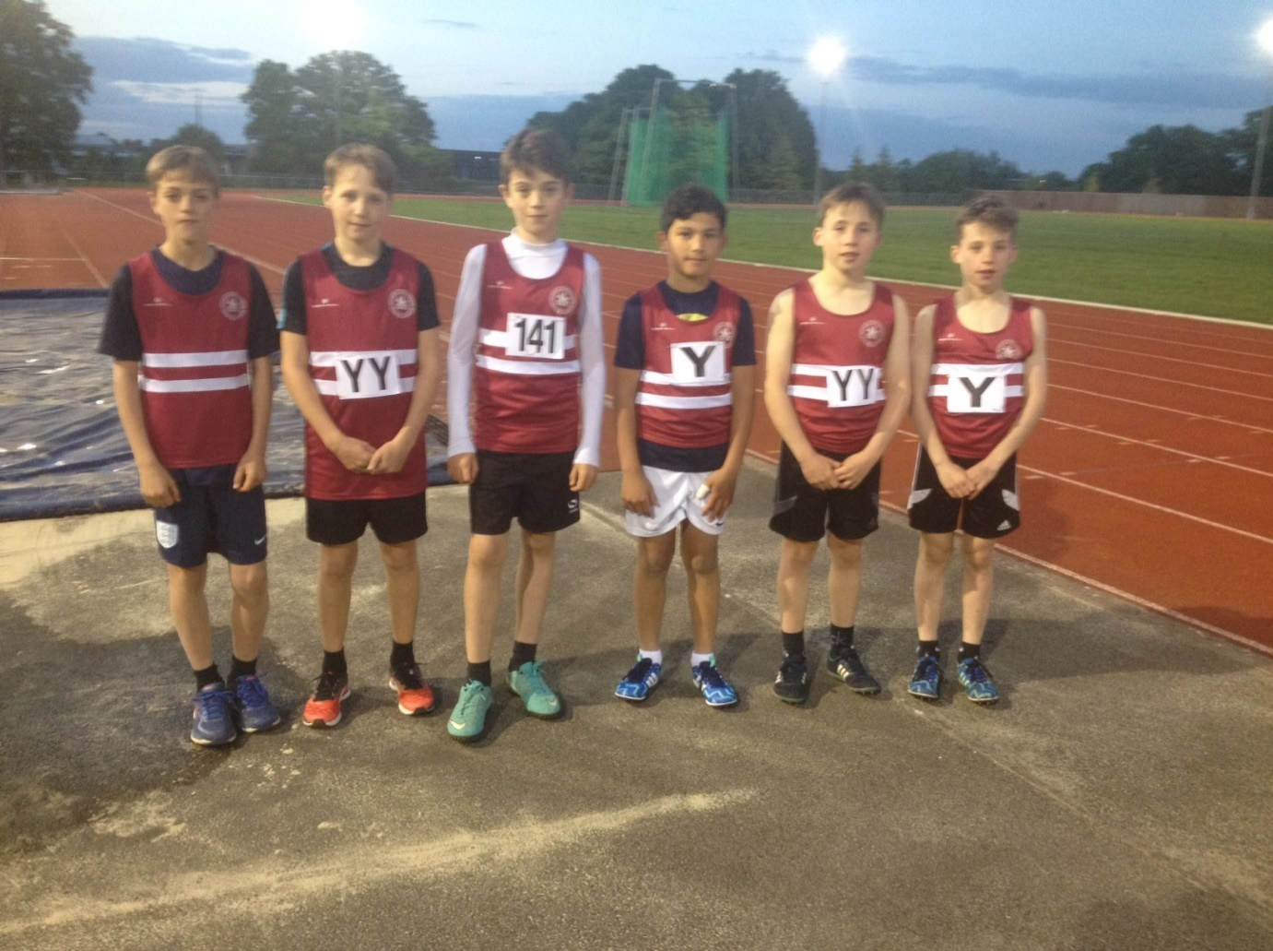

**Under 13 Boys at the Under 13 Track and Field League: left to right: Alex Todd, Archie Hale, Harvey Gwynn, Alex Stubbs, George Bonwick-Adams and Charlie Bonwick-Adams.**

Last Thursday was the Sussex Under 13 Track & Field League that was held at K2 (Crawley). There were many good performances and the youngsters enjoyed the competitive spirit during the evening. The most notable performance was by Charlie Bonwick-Adams when he broke the Under 13 Boys 1000 metres record in a super time of 3 minutes 17.1 seconds. Other great performances included the 4 x 100m Boys relay race in style. The Results were as follow:

Boys:

75m A race: 2nd Charlie Parvin 10.7 secs; 75m B race: 1st Alex Stubbs 10.9 secs.

150m A race: 4th Alex Stubbs 22.6 secs; 150m B race: 2nd Archie Hale 22.4 secs.

600m A race: 4th Alex Todd 1 min 53.4 secs; 600m B race: 3rd George Bonwick-Adams 1 min 55.0 secs.

1000m A race: 3rd Charlie Bonwick-Adams 3 min 17.1 secs (new Harrier Record); B race 4th Jonathan Beckett 3 min 43.3 secs.

High Jump A: 5th Jonathan Beckett 1m 05.

Long Jump A: 3rd Alex Todd 3m 85; B 3rd Charlie Bonwick-Adams 3m 64.

Shot Putt A: 3rd George Bonwick-Adams 4m 80.

Javelin A: 4th Dino Draper 12m 42.

4 x 100m relays: 1st Haywards Heath Harriers 57.8 secs.

Girls:

75m A race: 4th Mae Robinson 12.0 secs; 75m B race: 4th Erin Gaston 12.8 secs.

150m A race: 5th Mae Robinson 24.5 secs; 150m B race: 5th Darcie Rothwell 26.8 secs.

600m A race: 4th Ella Chatfield 2 min 17.1 secs.

1000m A race: 3rd Phoebe Whiting 3 min 38.5 secs; B race 2nd Maia Bliss-Tomlinson 4 min 01.1 secs.

Long Jump A: 4th Maia Bliss-Tomlinson 3m 25; Long Jump B: 4th Erin Gaston 2m 79.

4 x 100m relays: 5th Haywards Heath Harriers 66.8 secs.

Non-scoring:

Boys:

600m Stanley Holmes 1 min 59.8 secs; Ethan Williams 2 min 08.5 secs; Harvey Gwynn 2 min 09.3 secs.

4 x 100m relay: 66.5 secs.

Long Jump: Archie Hale: 3m 26; Seamus Cannon 2m 44.

Non-scoring:

Girls:

75m Darcie Rothwell 12.9 secs.

Also, on Sunday, was the inaugural Gatwick Half Marathon. Many Harriers ventured to Crawley for this new Half Marathon event. First home was Michael Burke in 1 hr 27 mins 14 seconds. First lady home was Sam Ridley in a time of 1 hr 39 mins 36 secs.

Other results were as follows: Mark Green 1 hr 29 mins 40 secs; Oli Nelms 1 32 mins 57 secs; Dave Warren 1 hr 35 mins 03 secs; Richard Haynes 1 hr 36 mins 27 secs; Matt Quinton 1 hr 37 mins 40 secs, Maresa Pitt 1 hr 42 mins 08 secs; Mike Scholes 1 hr 42 mins 08 secs; Tom Mullen 1 hr 42 mins 09 secs, Carl Bicknell 1 hr 44 mins 23 secs; Oli Farr 1 hr 47 mins 05 secs; Sarah Banks 1 hr 47 mins 26 secs; Bryan Tiller 1 hr 48 mins 27 secs; Chris Glanfield 1 hr 49 mins 42 secs; Amanda Soper 1 hr 50 mins 56 secs; Lydia Levy 1 hr 52 mins 19 secs; Andrew Wilson 1 hr 55 mins 14 secs; Marion Hemsworth 1 hr 55 mins 21 secs.

At the Isfield 10km race, Phil Payne finished in second place in a time of 40 minutes 43 seconds and Kim Lo finished finished as first lady in 45:45.

At the Hastings 5 mile race on Sunday, Emma Navesey set a new harrier record of 30 minutes and 32 seconds to finish third lady. Russ Mullen was first Harrier home in 6th place in 28:02/. Other results at Hastings were:

Ben Duncan 29:11; Jack Chivers 30:43; Phil Scott 36:05; Naomi Cikalo 38:20; Karen Thompson 38:41; Gail Lelliott 47:23 Peter Cobbett 49:02.

At Portslade, the Hedgehoppers 5 mile race over the Sussex Downs. Not many harriers at this West Sussex Fun Run League event. Julian Boyer was the first home in 33 mins 21 secs and Richard Bates finished in 52 mins 15 secs.…

On Saturday at the Bewl Water Half Marathon, Ian Dumbrell finished in 2 hours 00 minutes and 27 seconds.

The last race of the Mid Sussex Marathon weekend was the Burgess Hill 10 km. This final race of the 3 mid Sussex series which incorporated the East Grinstead 10 mile race and the Haywards Heath 10 mile and the Burgess Hill 10 km race combined together to form a marathon time over the 3 races over the May Bank Holiday weekend. The Burgess Hill results were as follows:

Alex McGregor first harrier man home in 13th place in 43 mins 28 secs; Mark Green 43 mins 32 secs; Peter Harding 43 mins 34 secs; Katie Morgan 43 min 42 (1st lady); Dave Warren 47 min 48 secs; Graham Jenner 49 min 14 secs; Matt Quinton 50 min 29 secs; Ian Dumbrell 53 min 38 secs; Chris Avison 54 min 00 secs; Bruce Girvan 54 mins 52 secs; Gina Hobson 59 mins 47 secs; Andrew Wilson 61 mins 20 secs; Damita Ewen 66 mins 05 secs, Abigail Redd 66 mins 05 secs; Justine Tanner 71 mins 13 secs; Amy Mitchell 79 mins 45 secs;

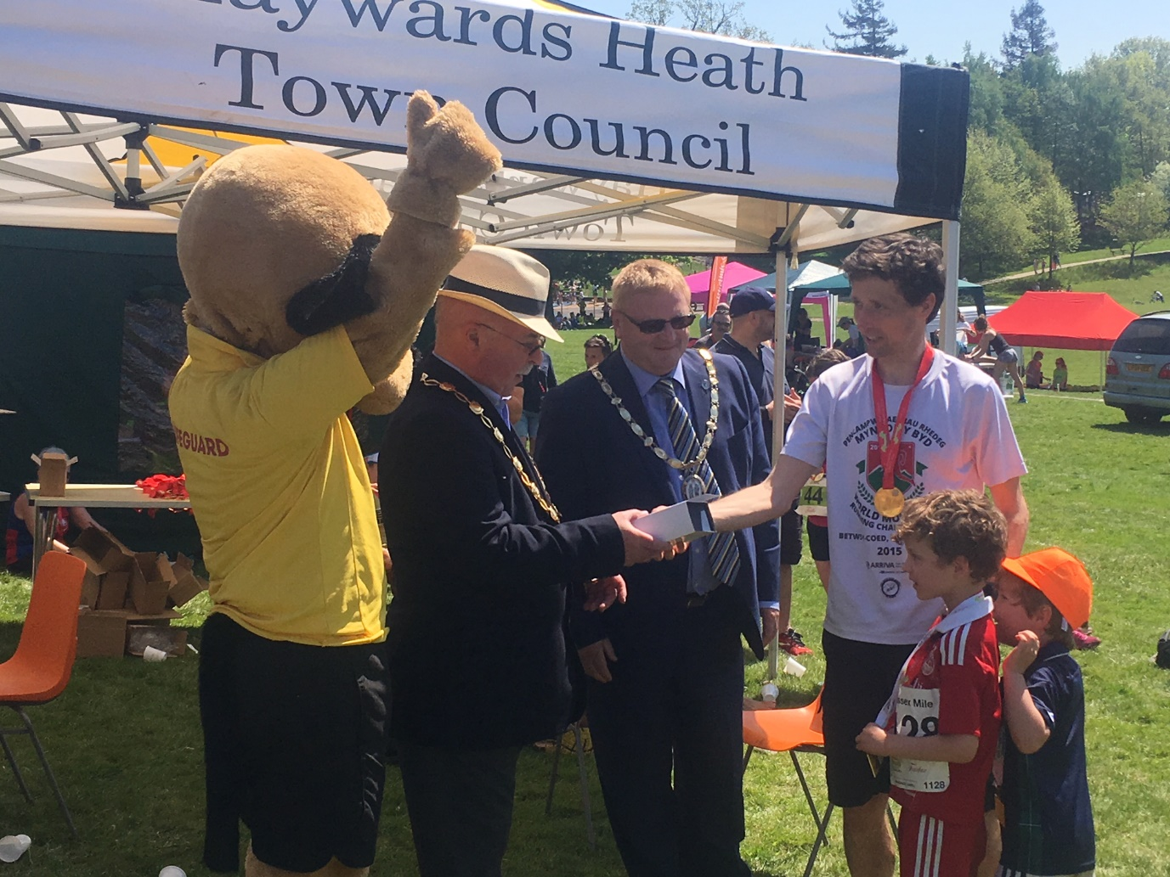

**Chris Smith – winner of the Haywards Heath 10 mile race.**

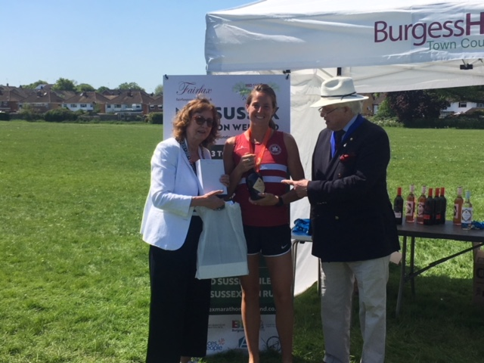

**Katie Morgan – winner of the Mid Sussex marathon.**

. 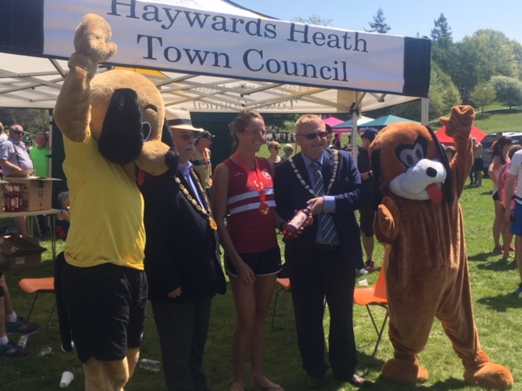

**Katie Morgan receiving another award.**