BALE STRIKES GOLD!
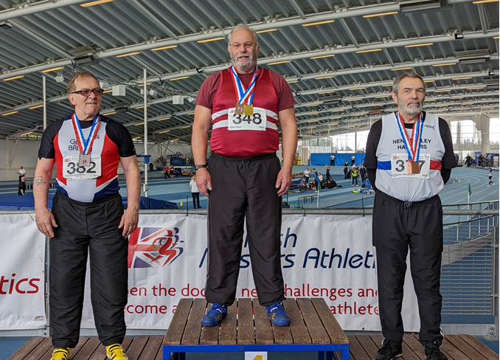
Mike Bale (348) with his two gold medals.

Mike Bale competed in the British Masters Indoor Championships and Winter Throws Competition as Lee Valley on 5th and 6th of March.

Mike competed in four throwing events in the veteran men’s sixty-five age group and won two gold medals for his efforts.

On the Saturday he threw the discus 27.24 metres, finishing in 4th place which he was disappointed with. Then he won gold with the Weight with 12.12 metres. It was the first time he had competed under floodlights.

On the Sunday he threw a personal best with 32.85 metres for a second gold in the Hammer with a new personal best and club record and followed this up by another personal best and club record in the Shot with 8.21 metres for fifth place.

Other Harriers Results:

Carl Bicknell ran at the Dorney Lake Half Marathon on 6 March in a time of 1 hour 38 minutes and 55 seconds. It was Carl’s fastest half marathon since 2015! Carl was also the first over 60 male finisher in the race.

Oliver Farr ran his 68th marathon at the Thames Meander Marathon on 12 March. He finished it in 4 hours 15 minutes. Oliver’s aim is to complete one hundred marathons.

Arun Khursheed at Parliament Hill.

Arun Khursheed competed in the largest race for his age group to date when he ran in the Under 15’s boys age group in the Saucony English National Cross-Country Championships at Parliament Hill on 26 February. The conditions were the muddiest they have been for years. Arun finished in 285th place out of 413 runners in a time of 18 minutes and 20
seconds.

British Masters Cross Country Championships

The final cross-country event of the season was the British Masters Cross Country Championships which was held at Tunbridge Wells last Saturday 12 March.

It was good to see a group of Harriers taking part in this event. With the best cross-country runners from around the country taking part, it was going to be a great challenge than usual. On a testing course of long and short hill climbs and plenty of soft ground underfoot, engaging ditches and sharps turns, it was an energy sapping race!

Harriers at the British Masters Cross Country Championships: L-R Tim Hicks, Barry Tullett, Kath Buckeridge, Carl Bicknell, Sarah Hamilton & Paul Cousins.

The Harriers sent along six runners to take part in this event.

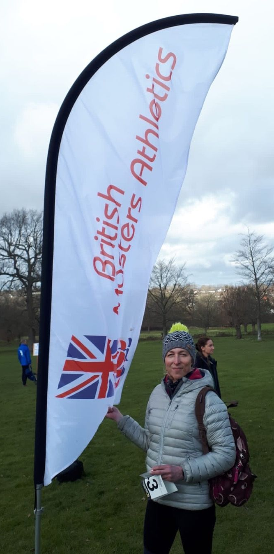
Results were as follows:

Men’s 8km race:
Paul Cousins 37:46 112/174 overall, 18/37 M55-59

Barry Tullett 38:44 124/174 overall, 23/37 M55-M59

Tim Hicks 40:41 147/174 overall, 20/30 M60-64

Carl Bicknell 45:14 162/174 overall, 26/30 M60-64

Women’s 6km race:

Kath Buckeridge 35:27 68/89 overall, 16/18 F50-54

Sarah Hamilton 37:43 75/89 overall, 17/18 F50-54

Sarah Hamilton with the British Masters flag.

Harrier’s Parkrun Round-up:

Southampton parkrun: 44th James Bennett 19:33.

Tilgate parkrun: 8th James Collins 18:24; 15th Arun Khursheed 19:43; 67th Jack Chivers 23:52; 174th Michael Parish 28:31; 175th Marion Hemsworth 28:33; 194th Caroline Mackey-Khursheed 28:54.

Clair parkrun: 1st Ian Kenton 18:25; 2nd Sam Fernley 18:40; 3rd Jonathan Beckett 19:15; 4th Harvey Alcock 19:55; 14th Katie Reed 22:56; 19th Jason Robinson 23:35; 29th Bob Adams 24:25; 37th Annabel Axford 25:31 (first parkrun); 43rd Howard Booth 26:35; 60th Sarah Banks 28:19; 62nd Shelagh Robinson 28:28; 80th Oliver Francis 30:31; 111th Carl Bicknell 41:34.

Preston Park parkrun: 76th Eric Hepburn 22:41.

Hove Prom parkrun: 50th Abigail Redd 21:31; 57th James Smyth 21:55; 68th Abby Ross 22:21.

Millennium Country parkrun, Forest of Marston Vale:71st Emma Pryor 28:52

