Harriers shining Gold, Silver and Bronze.

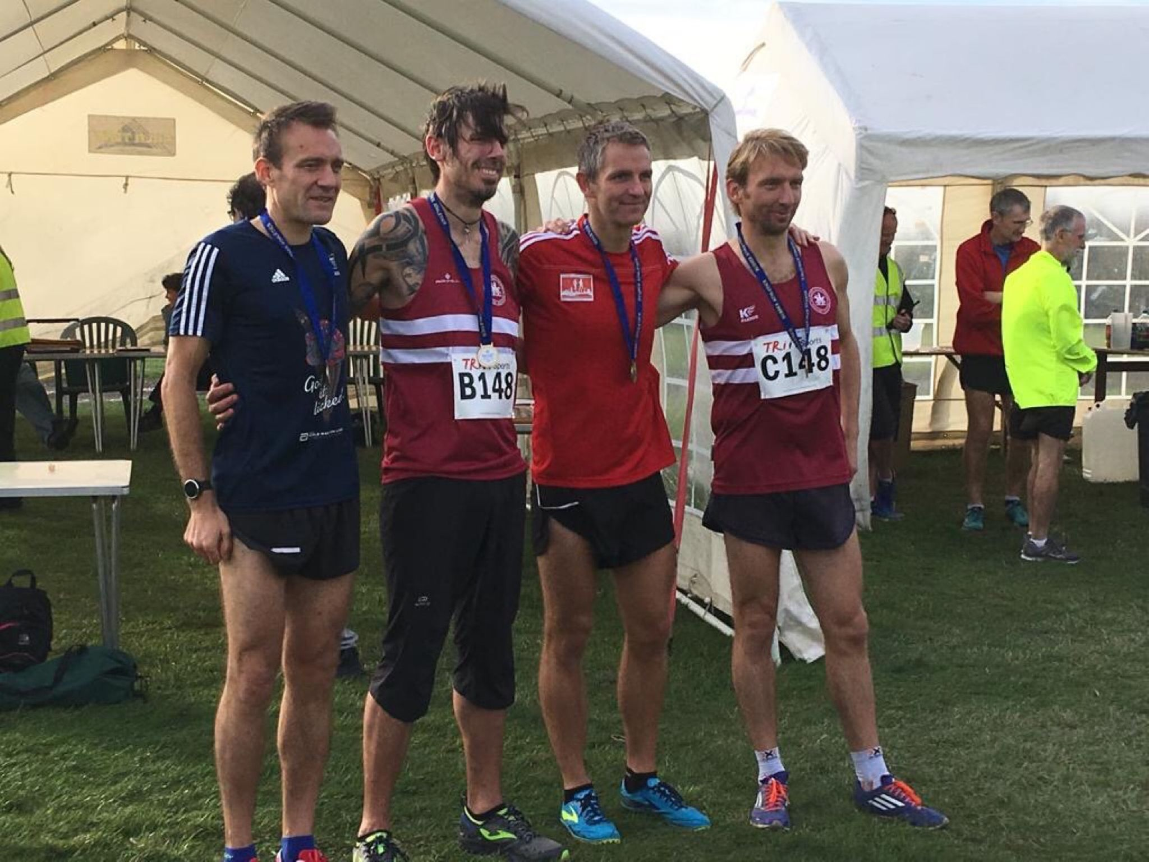
Gold Medal Team winners: V40! (James Skinner (fastest), Andy Hind, John Kettle (2nd fastest) and Marcus Kimmins.

The cross-country season got well under way with the first meeting of the season at Goodwood for the Sussex Cross Country Relays on Saturday 13th of October. The Harriers fielded a total of 15 teams with 47 harriers taking part in most if age groups from the youngsters up to the veteran runners in the club.

The Harriers are making their presence known in Sussex by taking 4 county team medals, with the Men’s Vet 40 age group winning gold for the third year in a row!! The senior ladies took silver with the Vet 45 ladies and Vet 50 men both getting bronze team medals.

There were also 6 individual medals – James Skinner (gold over 40), John Kettle (silver over 40), Adam Dray (silver under 17), Joseph Martin (bronze under 17), Emma Navesey (silver senior women) and Paul Cousins (bronze over 50).

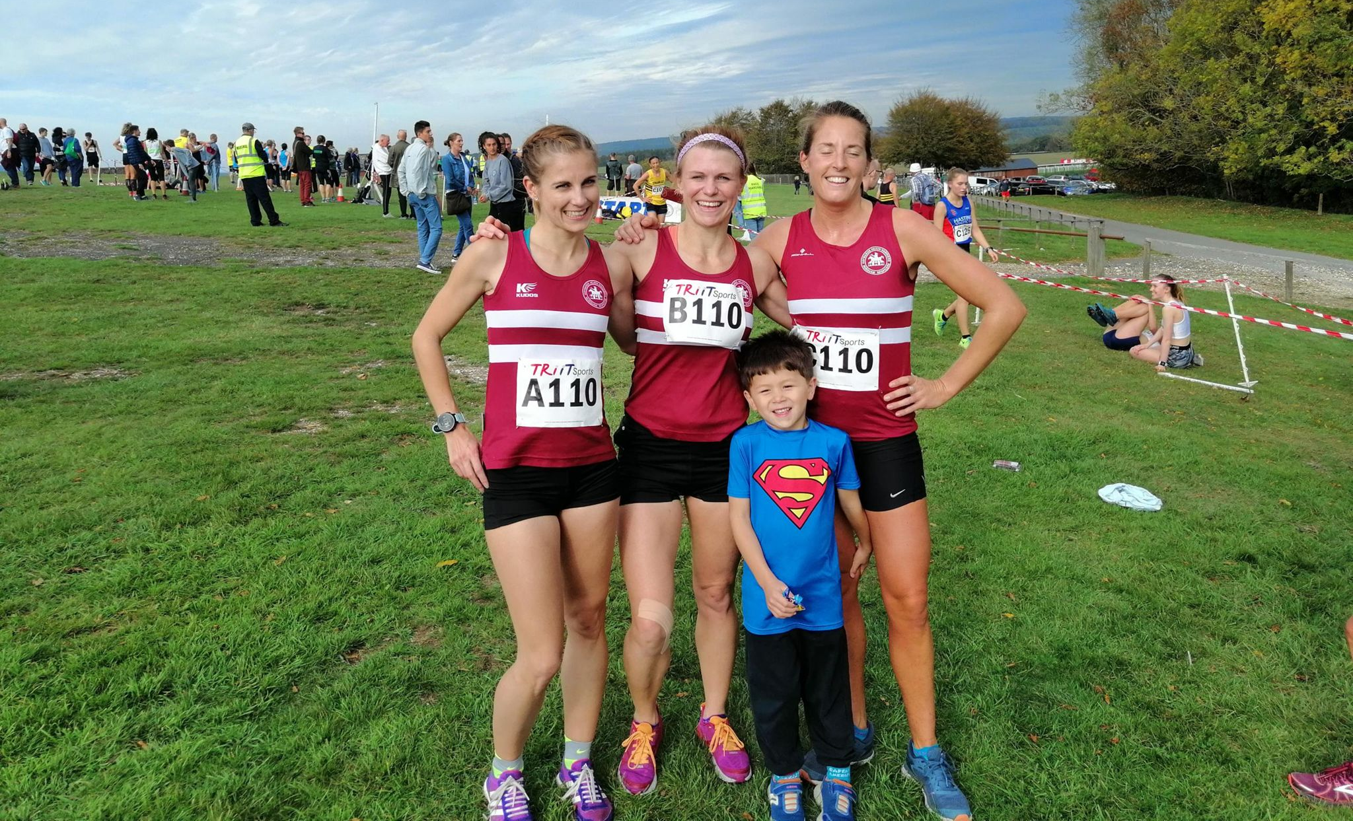
Silver ladies: Emma Navesey, Kim Lo and Katie Morgan (Emma 3rd fastest senior lady) plus an ardent young Harrier supporter!!

Young Johnathan Beckett at the Sussex Relays at Goodwood.

Results were as follows:
Girls U13: 12th HHH 39:47 (Phoebe Whiting 12:53, Ella Chatfield 13:23, Maia Bliss-Tomlinson 13:31).
Boys U13 10th HHH ‘A’ 32:47 (Rory Dalgliesh 10:37, Jonathan Beckett 11:06, Sam Fernley 11:04). 20th HHH ‘B’ 35:11 (Harry Russell 11:37, George Bonwick-Adams 11:50, Lewis King 11:44).
Girls U15: 11th HHH 38:39 (Rosie Beckett 12:01, Harriet Dray 11:51, Lily Bliss-Tomlinson 14:47).
Boys U15: 12th HHH ‘A’ 33:40 (Ryan Armstrong 10:56, Patrick Steadman 11:13, Ewan Kemsley 11:31). Uncomplete team HHH ‘B’ (Louis Henry 14:14. Ethan Lambert 13:03).
Senior Women: 2nd HHH ‘A’ 47:31 (Emma Navesey 15:19, Kim Lo 16:22, Katie Morgan 15:50). 14th HHH ‘B’ 55:43 (Jasmine Mamoany 18:36, Isobel Russell 17:53, Kath Buckeridge 19:14).

Vet 45 Women: 3rd HHH 62:56 (Karen Thompson 19:07, Claire Annesley 21:54, Sarah Hamilton 21:55).
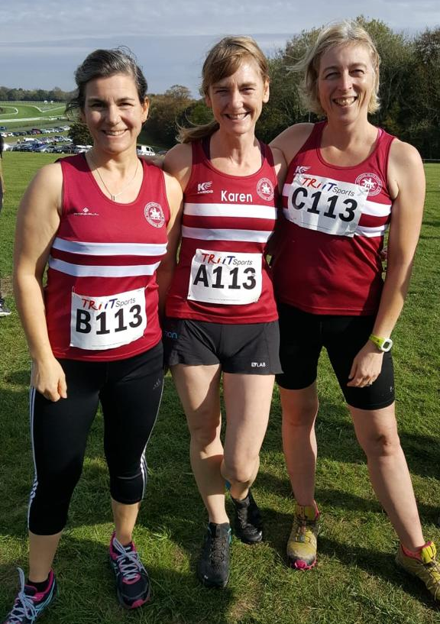
Chuffed to bits – the Vet 45 LadiesTeam Bronze medallists

Vet 55 Women: Uncomplete team HHH (Jenny Denyer 30:04).
Senior Men: 10th HHH ‘A’ 54:37 (Adam Dray 12:57, Russ Mullen 14:19, Phil Hardaway 13:50, Ben Gibson 13:31). 23rd HHH ‘B’ 63:21 (Joseph Martin 13:13, Andy Dray 16:18, Richard Cole 17:12, Dave Warren 16:38).
Vet 40 Men: 1st HHH 55:44 (James Skinner 12:50, Andy Hind 15:13, Marcus Kimmins 14:07, John Kettle 13:32). HHH non-scoring team 69:13 (Dave Warren 15:50, Tim Hicks 16:32, Dave Harper 18:01, Carl Bicknell 18:50).
Vet Men 50: 3rd HHH 62:39 (Julian Boyer 15:11, Barry Tullett 15:40, Mark McLoughlin 17:19, Paul Cousins 14:29).

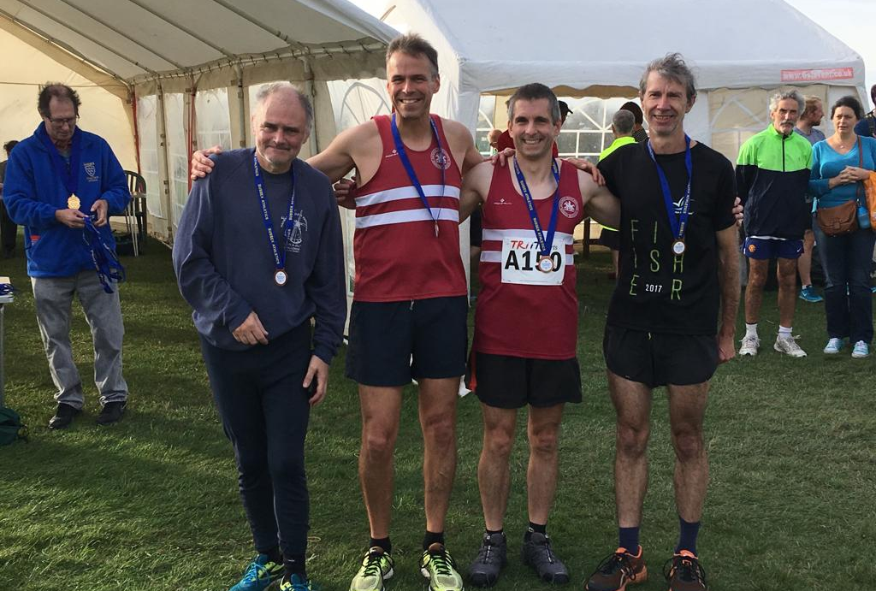
Bronze for V50 Team men Mark McLoughlin, Barry Tullett, Julian Boyer and Paul Cousins.

Great Walstead 5 on Sunday the 14th of October.
Haywards Heath Harriers were hosting last weekend the Great Walstead 5 mile cross country race which forms part of the West Sussex Fun Run League. The venue has changed from previous years, where the event was previously held at the Hickstead racecourse. This year, the event was being held in the grounds of Great Walstead School near Haywards Heath. 18 clubs tool part with 293 finishers. First place went to Alex Rawlinson of Portslade hedgehoppers who finished in 31 minutes and 55 seconds. First lady over the line was Jade Elphick also of Portslade Hedgehoppers in a time of 35 minutes and 49 seconds.

The West Sussex Fun Run League events take place at locations over the county run by local running clubs. All fun run league races are between 5km and 10km and cost just £3 to enter. Most events also have an accompanying junior race of no more than 1 mile and costing £1 entry. The emphasis is on the fun run element in all our races!
The WSFRL is made up of 18 member clubs from around Sussex. Each club holds an annual event which is open to any runner regardless of whether they are affiliated to the league. Many of the races are run over the stunning South Downs.

Senior results: 9th Andy Hind 33:54, 125th Jasmine Mamoany 44:09, 128th Kath Buckeridge 44:22, 229th Richard Bates 54:41.

Juniors: 1st Ryan Armstrong 4:48, 2nd Harvey Alcock 4:49; 3rd Arun Khursheed 4:52, 4th Finlay Blythe 5:01, 7th Noah Seymour 5:42, 8th C. Crouch 5:44, 9th Jamie McDowell 5:44, 11th Lucy Barker 5:51, 15th Kitty Gandarez 6:22, 21st Isobel Redd 7:04, 25th Jack Diak 7:32, 27th Rory Watts 7:38, 30th Nellie Watts 7:44, 33rd Lois Perrett 8:23, 42nd Jessie Diak 9:07,

Last weekend a group of Harriers took part at the Hove Prom 10 kilometres race. Results were as follows:8th Russ Mullen 35:16, 46th Emma Navesey (and 3rd lady) 39:41, 48th Marcus Kimmins 39:42, 52nd Jack Chivers 39:47, 163rd Carl Bicknell 47:40, 180th Karen Thompson 48:41, 305th Peter Cobbett 57:49.
Other Harrier results were: 20th Matt Quinton 41:10,

Sasha Hall-Jones ran the Yorkshire marathon on 14th October and finished in 3:55:28 - a new personal best – well done to you Sasha!

Darja Knotkova-Hanley who finished first lady at the Lewes 5 miler on 7 October. At the Lewes Downland 10 mile event on the same day, Ben Duncan finished in 9th place in a time of 1 hour 7 minutes and 50 seconds. Carl Bicknell finished in 96th place in a time of 1 hour 27 minutes and 28 seconds. Peter Cobbett finished in 180th place in at time of 1 hour 55 minutes and 47 seconds.

