Middy Report 18.03.18

**Harrier shine for Sussex at the English Schools, Inter-Counties X-Country Championships and at the Sportshall South-East Regional event.**

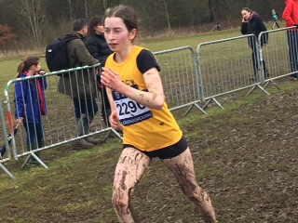

**Darja Knotkova-Hanley at the Inter-Counties Championships at Loughborough.**

Darja Knotkova-Hanley had a fine run at the Inter-Counties Cross Country at Loughborough on 10th March. In a muddy course she finished in a super 38th position out of 278 runners in the Under 17 Girls race. Adam Dray also had a good run in the tough conditions and finished in 160th place out of 303 finishers in his race in the Boys Under 15 age group.

Darja also ran last weekend at the English Schools Championships at Leeds and finished in 74th position out of 323 finishers in the Senior Girls race. She was the second Sussex finished in the race.

In the Intermediate Boys race, Joseph Martin was also the second Sussex finisher in 53rd place out of 339 finishers in the Intermediate Boys race.

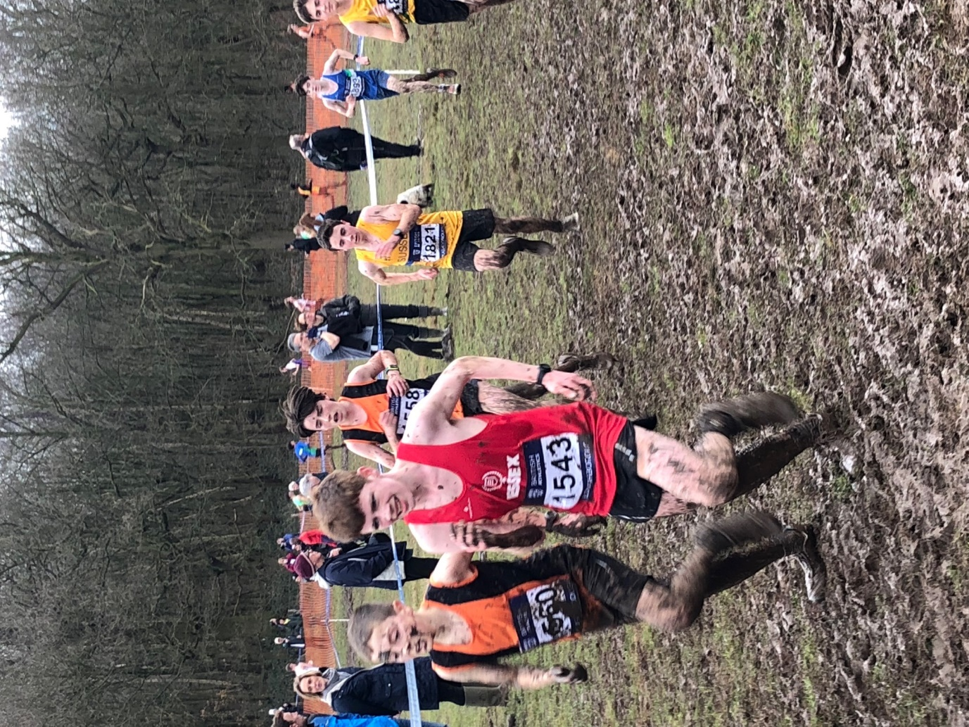

**Adam Dray at the Inter-Counties Cross-Country Championships at Loughborough.**

At the Sportshall South East Regional Final on 4th March at Burgess Hill, three Haywards Heath Harriers represented Sussex at the event. The athletes were Charlie Bonwick-Adams, Millie Sommerville and Alex Booth. The competition was against 6 other counties for the Under 13 and Under 15 age groups. The young athletes did well and enjoyed the experience of competition at a higher level!

Last Sunday, the Hasting Half Marathon was one of the few half marathons to take place across the country due to the wintry weather that was affected by the “Beast from the East.” Haywards Heath Harriers were represented 10 runners. Ben Gibson was the first home in 11th place overall in a time of 1 hour 17 minutes and 6 seconds. Katie Morgan was the 6th lady to finish overall in a personal best time of 1 hour 27 minutes and 41 seconds, knocking nearly 5 minutes off her previous best time. Julian Boyer also had a cracking run and knocked over 4 minutes off his previous best time with a new best of 1 hr 26 mins 22 seconds.

Other Harrier results were: Darren Bird 1 hr 25 mins 38 secs, James Bennett 1 hr 33 min 30secs, Matt Quinton 1 hr 34 mins 56 secs, Dan Apps 1 hr 44 mins 28 secs, Oliver Farr 1 hr 46 mins 42 secs, Mark Armitage 1 hr 48 mins 53 secs, Kath Buckeridge 1 hr 51 mins 52 secs.

On Sunday, the Balcombe Bull Run was held at Balcombe, Mid Sussex. The course is held annually over a 7.1 km hilly cross-country course. The conditions were muddy, icy and windy. Ian Dumbrell was first Harrier home in a super time of 38 minutes and 33 secs. Also running the same event was Phil Scott who finished in 38 mins 48 secs and Amy Mitchell, who finished in a marvellous time of 44 mins and 2 secs. Other Harrier finishers were: Patrick Kenward 39 mis 14 secs, Graham Kenward 39 mins 58 secs,

…

Parkrun roundup:

Clair parkrun: Alex McGregor 19:45 (pb).

Other results;

Lydd Half Marathon last week, Ian Dumbrell finished in a time of 1 hr 49 mins 12 secs.

Also, last week at the Inverness Half Marathon 11.03.18. Graham Kenward 1 hr 53 mins 0 secs, Clair Kenward 1 hr 52 mins 54 secs.