Harriers Back In Racing Mode
West Sussex Fun Run League:
(By Michael Parish)
ON 11th SEPTEMBER 2022 Crawley’s Saints and Sinners Athletics Club took up the reigns for the next fixture in the West Sussex Fun Run League calendar. The club hosted their annual five-mile trails run through the heart of Tilgate Forest.
Haywards Heath Harriers had six new members entering their first race for the club.

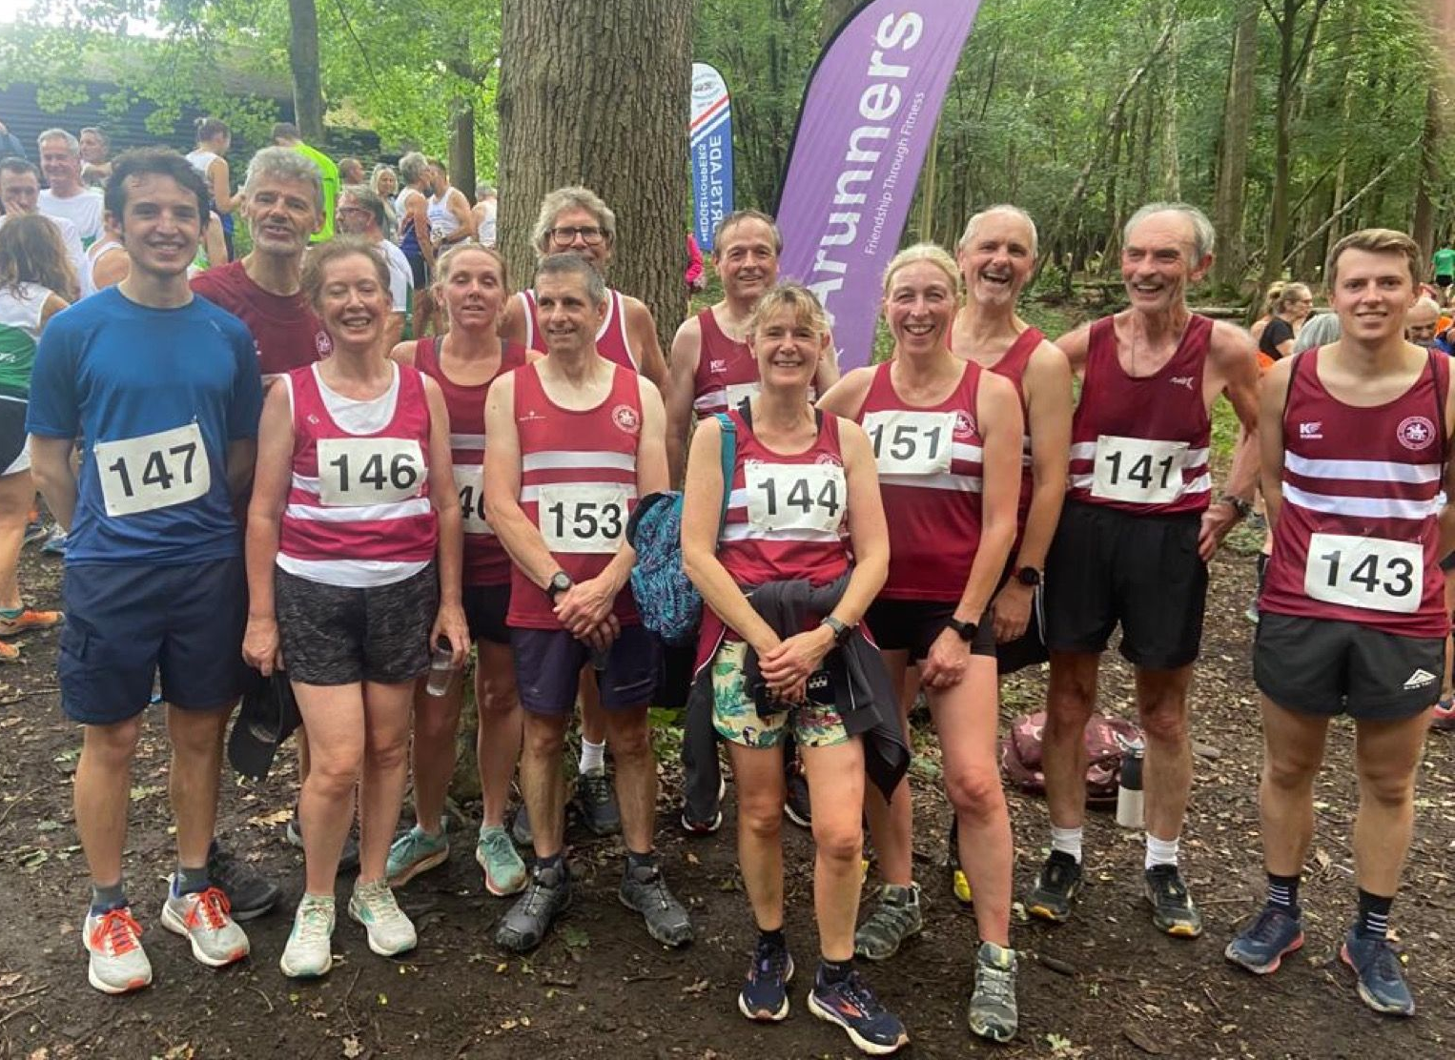
L-R: David Adams, John (Bob) Adams, Tracy Adams, Abigail Redd, Julian Boyer, Phil Scott, Richard Jobling, Caroline Gumm, Sarah Hamilton. Michael Parish, Richard Bates and Ollie Fyfe.
Congratulations to Richard, Jane, Ollie and the Adams family: Tracy, David and Robert who all successfully completed their first race for the Harriers.
The Tilgate Forest fun run race is a five-mile trail run, best described as undulating and is outstanding, as you run on the soft floor of the forest, running across one of the bridges across the A23 and around up to Parish Lane before dropping back to the finish line.
There is a small clearing just off the K2 Leisure Centre, where the 16 Athletics Clubs that makes up the West Sussex Fun Run League set their club flags.
Standing on the start line, in the forest with the ceremonial placing of the flags, we held a two-minute silence for Her Majesty Queen Elizabeth II before the start of the run.
Haywards Heath Harriers had fourteen athletes running. There was great running from George Adams, Ollie Fyfe and David Adams who were the first Harriers across the finish line, also from Abigail Redd and again from Michael Parish, Sarah Hamilton and Caroline Gumm running together.
Results were: 1. Liam Briscoe, 29:11, Fittleworth Flyers; Fin Sutcliffe, 29:37, Worthing Harriers; Michael Hore, 29:52, Horsham Joggers.
21st Ollie Fyfe 35:29; 32nd David Adams 36:31; 53rd Abigail Redd 38:55; 83rd Julian Boyer 41:20; 97th John (Bob) Adams 43:03; 105th Jayne Brewer 43:39; 132nd Phil Scott 45:40; 143rd Richard Jobling 46:24; 170th Michael Parish 50:01; 177th Sarah Hamilton 50:56; 214th Caroline Gumm 58:39; 222nd Tracy Adams 60:05; 234th Richard Bates 62:25.
Other Harrier results:
Three Harriers took part in the Reigate Half Marathon on Sunday 18 September. Ian Kenton was first home in seventh place in a super time of 1h17m48s. Michael Burke was next home in twenty-fifth place in 1h23m56s followed by Michael Parish in six hundred and eightieth place in 2h22m38s.
Andy Hind, Jack Chivers and Josh Franks all ran in the Great North run on Sunday 11 September one of the most popular half marathons in the world – a must do for the budding marathon runner! Andy finished in 1h24m20s, Jack in 1h44m30s and Josh in 1h56m51s
Harrier’s parkrun roundup:
Clair parkrun.
Today’s Clair Parkrun took place at a historic time, nine days after the sad passing of Queen Elizabeth II, two days before her state funeral, and midway through the queen’s lying-in-state in Westminster Hall. Thousands of people queued for up to twelve hours to pay their respects. Our thoughts are with the queen’s successor, King Charles III, and the royal family.
On a chilly, sunny morning, 127 runners tackled our hilly course, including 13 first timers. First man home was James Skinner with an incredible sub seventeen-minute time of 16.55, and first lady was Kirsty Armstrong who went sub twenty with a time of 19.50.
We welcomed visitors from Wollongong, near Sydney, and Eastleigh.
There were 25 PB’s, including a great effort from Chris Jones who bettered his five year PB by twenty seconds with a time of 21.16, and William Grey with a new PB for a second successive week. William’s time was 17.24.
Many thanks to our 17 volunteers; it can never be repeated too often that Parkrun wouldn’t happen each week without your enthusiastic support.
Stuart Ferguson
Run Director
Clair parkrun: 1st James Skinner 16:55 (Vet men 50 record); 3rd Will Grey 17:24 (pb); 6th Russ Mullen 18:19; 7th Sam Fernley 18:58; 8th Harvey Alcock 19:18; 9th Andy Hind 19:37; 12th David Adams 20:25; 19th Julian Boyer 21:10; 24th Simeon Wishlade 21:45; 29th Simon Robinson 22:17; 42nd Bob Adams 24:24; 103rd Tracy Adams 33:24.
Ashton Court parkrun: 106th Jason Robinson 24:04; 222nd Shelagh Robinson 27:38.
Belfast Victoria parkrun: 26th James Bennett 19:30.
Horsham parkrun: 100th Eric Hepburn 24:38; 154th Greg Hilton 26:38
Tilgate parkrun: 52nd Jack Chivers 21:46.
Tonbridge parkrun: 47th Abigail Redd 21:45; 69th James Smyth 22:36.
Reigate parkrun: 114th Michael Parish 28:38.
Wendover Woods parkrun: 51st Kath Buckeridge 26:25; 54th Carl Bicknell 26:28.
********************************************************************
HAYWARDS HEATH Harriers are holding a #RunandTalk session on Thursday
22nd September 2022 at 19:00.
Taking place from the Courtyard, next to the Harvester in Beech Hurst Gardens, RH16 4BB, it consists of a 5km conversational run to highlight good physical and mental health.
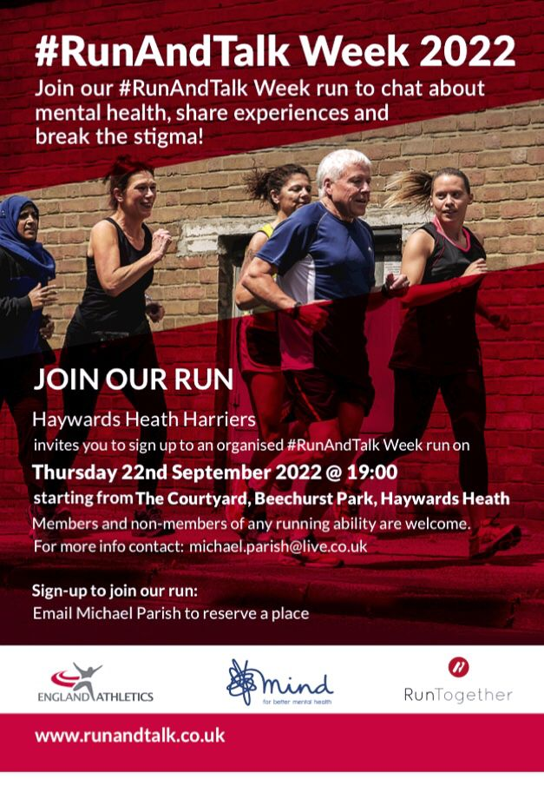
The run can be anything from 1km to 5km and doesn’t need to be run, you can walk, walk/run or run. The aim is to get people active promoting good physical and mental health. There will be an opportunity at the end to have a coffee and a conversation with other runners, members of Haywards Heath Harriers and their Mental Health Champion. If you want to book your place or ask any questions, then email Michael.parish@live.co.uk

