Emma Navesey Smashes Harriers Marathon Record.

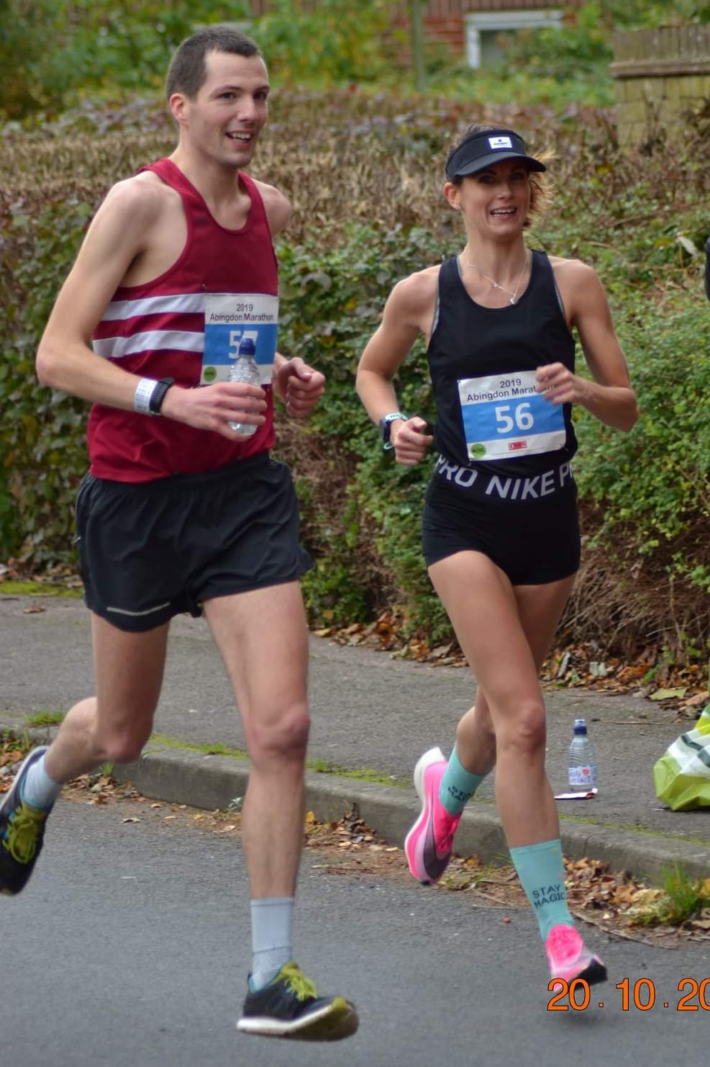
Emma Navesey and Russ Mullen.

Last Sunday saw two Harriers records fall. Firstly, senior lady Emma Navesey ran in the Abingdon Marathon. Paced by her partner Russ Mullen running in her first ever attempt at the marathon distance she ran a super race and finished as first lady in a time of 2 hours and 57 minutes and 3 seconds. Emma broke the Harriers senior ladies marathon record by a staggering 10 minutes. The previous record was held by Ann Lyall (Sinnett) with 3 hours 7 minutes and 56 seconds in the London Marathon in 2007.

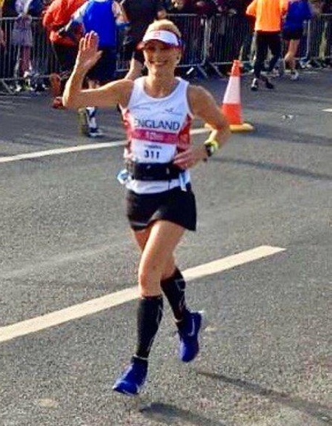
Sam Ridley.

Sam Ridley ran in the Asda Foundation Yorkshire Marathon which incorporated the England Marathon Masters event where she was competing against other top runners in a home countries international event and she finished in sixth in her age group in a personal best by seven minutes in a time of 3 hours 19 minutes and 37 seconds. Sam broke her own Harriers age 50 veterans record in the process.

At the Hove Prom 10 kilometres race last Sunday, James Skinner had a tremendous run finishing in second place overall in the race in 32 minutes and 42 seconds which also was a new personal best for him.

Other Harrier results from this race were:
19th Will Herbert 36:24, 91st Chris Russell 41:59, 169th Karen Thompson 46:54, 189th Oliver Farr 47:46, 409th Peter Cobbett 60:48.
Great Walstead Five mile Race.
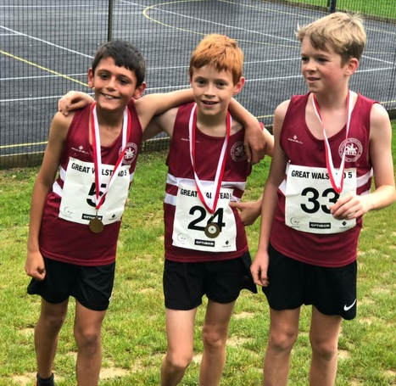
Arun Khursheed, Finlay Blythe and Jonathan Parkin at the Great Walstead Junior race.

On 13th October was the second Great Walstead Five which was held in the grounds of Great Walstead School, near Haywards Heath. The race was part of the West Sussex Fun Run League and was organised by Haywards Heath Harriers. The senior course was held on a two lap course on the trails around the grounds of the school and the surrounding countryside which was made more slippery by the relentless rain of the previous night! The kids race was held on a much shorter course of nearly a mile. There was lots of exciting racing overall and everyone had a good time. There were 312 finishers in the senior’s race and 30 finishers in the kids race.

Boys results:
1st Arun Khursheed (Haywards Heath Harriers) 5:45, 2nd Thomas Edwards (Worthing Harriers) 5:51, 3rd Jonathan Parkin (Haywards Heath Harriers) 6:05.
Girls results:
1st Lucy Kirby (Brighton & Hove AC) 6:48, 2nd Libby Kirby (Brighton & Hove AC) 8:16, 3rd Anya Cole (Haywards Heath Harriers) 8:24.

Other Harrier results of the Junior race:
5th Finlay Blythe 6:25, 20th Esme Cole 9:34, 21st Eleanor Spensley 9:35.

In the senior race, first across the line was Adam Vaughan (Lewes AC) in 32:38, second was Alex Rawlinson (Portslade Hedgehoppers) in 33:08 and third was Phil Payne (Haywards Heath Harriers) in 33:10. The first 3 ladies were Jade Elphick (Portslade Hedgehoppers) 37:01, Kirsty Armstrong 39:19 and Geraldine Moffat (Portslade Hedgehoppers) 39:50.

Other Harrier results were as follows:
15th Harvey Alcock 35:52, 19th Sam Atkin 36:42, 25th Ryan Armstrong 37:16, 51st Tom Spensley 41:09, 62nd Richard Cole 42:19, 67th Bryan Tiller 42:45, 136th Carl Bicknell 47:58, 162nd Kath Buckridge 49:44, 187th Shelagh Robinson 52:16, 279th Richard Bates 65:39.

At the Lewes Downland 10 mile race on Sunday 6 October, Harrier Chris Smith smashed the course record with a time of 58 minutes and 15 seconds on the very hilly course held on the South Downs near Lewes. Other Harrier finishers were Marcus Kimmins in 10th place in 1 hour 07:50, Rob Watt in 29th place in 1 hour 12.42, Shelagh Robinson in 217th place in 1 hour 43:52.

In the five mile race at Lewes, Karen Thompson finished in 12th place in 40 minutes and 10 seconds. Teresa Mockridge finished in 22nd place in 42:42 and Richard Bates finished in 63rd place in 55:02.

Results from the Sussex Cross Country League on 28 September at Goodwood racecourse.

A great turnout by the Harriers at the Sussex XC relays. The ladies Harriers out numbering the men with their turnout. There were great performances by many especially the young under 13 Boys who came away with a gold team medal and the Vet Men 40 who got a bronze team medal. Young Arun Khursheed running the fastest lap by an under 13 boy and Tim Hicks second fastest in the Vet 60 age group and senior woman Darja Knotkova-Hanley running the third fastest lap in the senior women’s race. The Harriers are looking good for the Sussex Cross Country league this winter.

Full relay results:
Under 17 Girls: 7th HHH 55:51 (Isobel Russell 20:26, Lara Berzins 16:59, Rosie Beckett 18:26).

Senior Women: 8th HHH 52:35 (Darja Knotkova-Hanley (third fastest lap overall 14:56, Gemma Morgan 18:32, Kath Buckeridge 19:07,

Women Vet 45: 5th HHH 61:13 (Jacqueline Barnes 17:52, Shelagh Robinson 22:30, Claire Annesley 20:51).

Under 13 Boys: 1st HHH 31:11 (Arun Khursheed 9:50 (fastest lap overall), Jacob Roderick 10:39, Jonathan Beckett 10:42).

Under 15 Boys: 14th HHH 32:29 (Sam Fernley 9:53, Alex Todd 11:04, Seb Dell’Aira Bromley 11:32).
Non scoring under 15 Boys : HHH 32:44 (Arlo Merchant 10:59, Jonathan Parkin 11:14, Arun Khursheed 10:31).

Under 17 Boys: 6th HHH 47:12 (Ryan Armstrong 15:15, Ewan Kemsley 17:00, Harvey Alcock 14:57).

Senior Men: 7th HHH 61:22 (Matt King 13:49, Tim Hicks 16:02 (2nd fastest V60 lap), Chris Russell 16:11, Julian Boyer 15:20).

Men’s Vet 40: 3rd HHH 58:29 (John Kettle 13.31, Michael Burke 14:33, Andy Dray 16:27, Marcus Kimmins 13:58).

Other Harrier Results:

Michael Parish at the Cardiff Half Marathon on 6th October. Michael finished in 2 hours and 20 minutes and 4 seconds. Michael starting his run 28 minutes after the first runners crossed the start line!

Tom Mullen also ran in the Yorkshire Marathon last Sunday and finished in a time of 3 hours 7 minutes and 23 seconds.

At the Bank of Chicago Marathon on 13 October, Matt Cooke smashed his personal best time with 2 hours 37 minutes and 1 second. Oliver Farr also ran and finished in 4 hours 02 minutes 26 seconds. Ex Harrier Rich Sutor also finished in a personal best of 2 hours 59 minutes and 55 seconds 0 the first time Richard has broken the magical 3 hours barrier.

At the Oxford Half Marathon on Sunday 13 October, Lydia Levy ran a personal best of one hour 45 minutes and 12 seconds. Other Harriers running were Jamie Gibson who finished in one hour and 23 minutes and 33 seconds.

