HARRIERS TURN OUT FOR SUSSEX CROSS COUNTRY LEAGUE

A great turnout by the Haywards Heath Harriers at Sussex Cross Country League at Ardingly on 12 November. This was the second year that the Harriers have organised this event in recent times at the Ardingly Showground.
After a period of rain falling in Sussex and the rest of the country, the ground at Ardingly was surprisingly not muddy as was expected. This did not annul the fact the hills were still part of the cross-country course next to the showground.
The junior members of the club did well to get runners out in most of their age groups.
There were eighteen men and ten women competing in the final two races of the day.

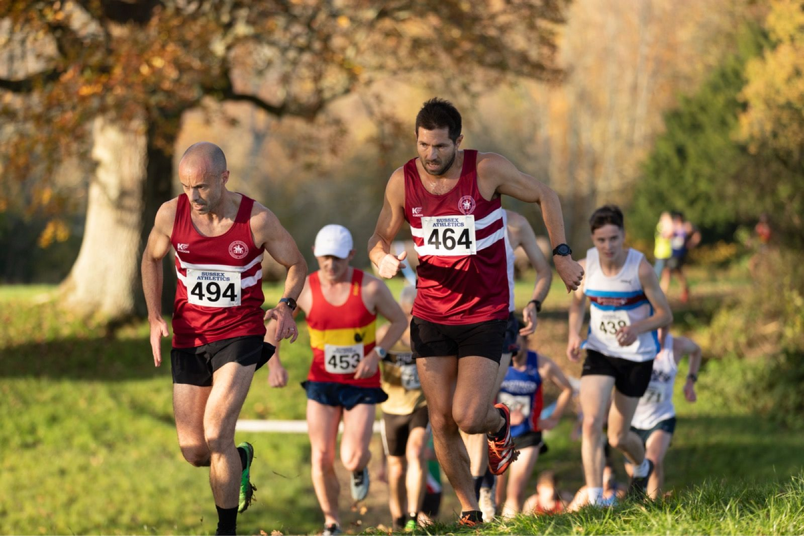
Jamie Topping (494) and Chris Turner (464) at Ardingly Cross Country.

Harrier’s results were:
Under 11 Boys: 6th Ethan Rowen 8:08; 30th Marcos Selby 9:05; 42nd Rohan Barnes 9:28.
Under 11 Girls: 12th Leila Warncke 9:11; 31st Coco Rhodes 11:23.
Under 13 Girls: 23rd Olivia Byers 13:53; 39th Anna Duncan 14:41; 48th Naia Myles 17:12.
Under 13 Boys: 48th George Plenty 13:48; 55th Olly Raison 15:14.
Under 15 Boys: 8th Arun Khursheed 15:23.
Under 17 Men: 11th Jonathan Beckett 18:52.
Senior Women: 55th Julie Kamel 24:01; 67th Kim Lo 24:48; 73rd Sam Ridley 25:27; 98th Jayne Brewer 27:15; 107th Jacqueline Barnes 28:45; 110th Sarah Hamilton 29:18; 114th Shelagh Robinson 29:56; 124th Caroline Mackey-Khursheed 31:05; 134th Carys Hind 33:23; 136th Katherine Woodhouse 34:07.
Senior Men: 27th Chris Turner 30:31; 41st Ben Gibson 31:34; 45th Jamie Topping 31:43; 53rd Russ Mullen 32:01; 54th Ian Kenton 32:05; 74th Will Herbert 33:21; 89th James Moffat 34:12; 93rd Andy Hind 34:18; 94th Matt King 34:20; 116th Tim Miller 36:04; 123rd Greg Hilton 36:30; 148th Mike Dickinson 38:42; 151st Tim Hicks 38:48; 169th Phil Scott 41:53; 174th Josh Franks 42:40; 178th Bob Adams 43:23; 184th Mark Sykes 44:56.

Road Racing
At the Brighton 10 Kilometres race on 20 November. Will Herbert was the first Harrier home in thirty-six minutes and fifteen seconds and Emily Hague first Harrier lady in 41 minutes and 55 seconds.
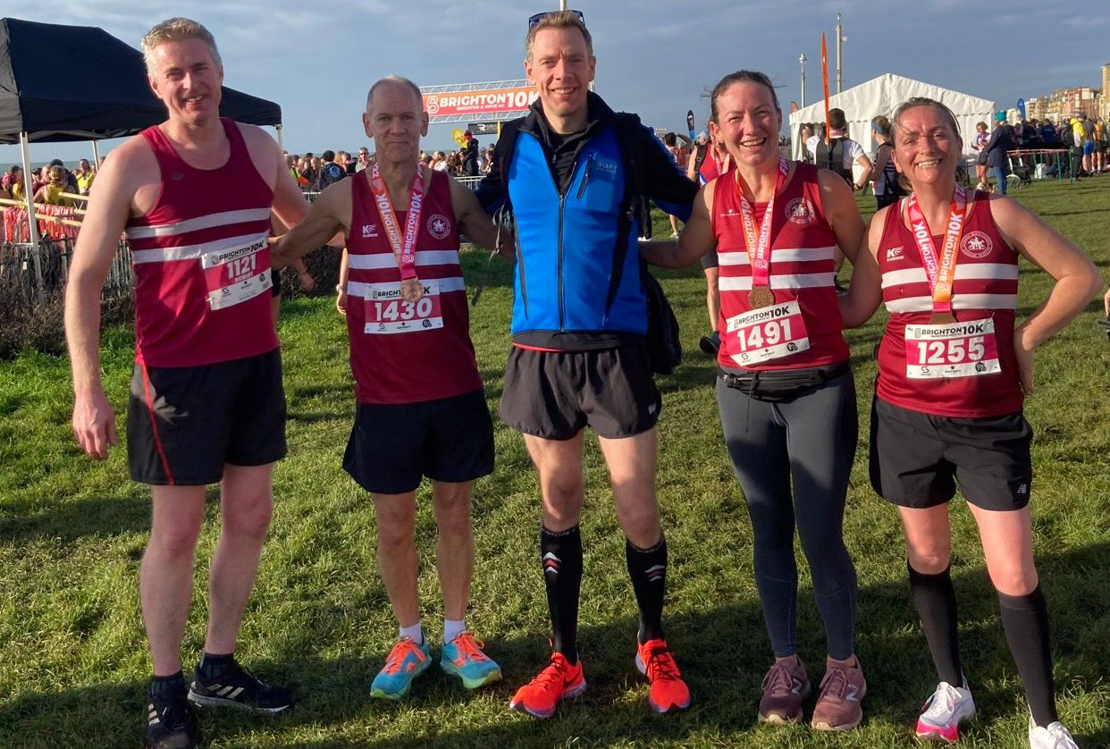
(L-R); Rob Watts, Eric Hepburn, Matt Cook, Gemma Morgan and Caroline Mackey-Khursheed.
The race was very competitive this year due to an inter counties competition between Sussex, Essex, Hertfordshire, Kent, Berkshire and Hampshire. There were no Harriers in the inter-county competition this year but local lad, Jack Gumm (Bath University), finished in a super fourth place overall in a time on thirty-one minutes and fifteen seconds and was first Sussex man home. Sussex finished third in this team event.
Harrier’s results were:
81st Will Herbert 36:15; 115th Daniel Moll-Morgan 37:22; 137th Matt Cook 37:57; 191st Rob Watts 41:37; 247th Emily Hague 41:55; 415th Phil Scott 46:31; 419th Gemma Morgan 46:49; 482nd Eric Hepburn 48:38; 548th Mark Davies 50:14; 606th Richard Jobling 51:35; 684th Caroline Mackey-Khursheed 53:19; 752nd Sarah Hamilton 54:37; 1069th Caroline Gumm 64:09;
Sussex Sports Hall League
On Sunday 30th October was the first round of the Sussex Sports Hall League which was held at Horsham. The team finished in seventh place out of eight teams. The Harriers results were as follows:
Boys u/11:
1 Lap Sprint: ‘A’ race: 4th Ethan Rowen 14.30 secs.
1 Lap Sprint: ‘B’ race: 4th Caspar Roderick 14.90 secs.
4 Lap: ‘A’ race: 6th Harley Mills 65.4 secs.
4 Lap: ‘B’ race: 1st Ethan Rowen 60.4 secs.
6 Lap Parlauf: 5th Haywards Heath: 1 min 36.4 secs.
4 x 1 Lap Relay: 6th Haywards Heath: 60.60 secs.
Standing Long Jump: ‘A’ 6th Caspar Roderick 1m65,
Standing Long Jump: ‘B’ 4th Harley Mills 1m53.
Vertical Jump: ‘A’ 6th Caspar Roderick 35.
Vertical Jump: ‘B’ 6th William Roderick 23.
Speed Bounce: ‘A’ 3rd Harley Mills 49.
Speed Bounce: ‘B’ 2nd William Roderick 46.
Girls u/13:
2 Lap: ‘A’ race: 7th Jessie Diack 28.80 secs.
4 Lap: ‘A’ race: 6th Lucy Roderick 66.10 secs.
Standing Long Jump: ‘A’ 6th Jessie Diack 1m88.
Standing Triple Jump: ‘A’ 6th Lucy Roderick 4m12.
Standing Triple Jump: ‘B’ Lorna Cole 3m58.
Vertical Jump: ‘A’ 7th Jessie Diack 44.
Vertical Jump: ‘B’ 6th Lorna Cole 27.
Speed Bounce: ‘A’ 5th Lucy Roderick 70.
Speed Bounce: ‘B’ 6th Lorna Cole 51.
Boys u/13:
4 Lap: ‘A’ race: 2nd Charlie Stay 56.0 secs.
4 Lap: ‘B’ race: 5th Jack Diack 65.90 secs.
Standing Long Jump: ‘A’ 1st Charlie Stay 2m29.
Standing Long Jump: ‘B’ 4th Jack Diack 1m61.
Vertical Jump: ‘A’ 6th Jack Diack 30.
Speed Bounce: ‘A’ 3rd Charlie Stay 74.
Girls u/15:
2 Lap: ‘A’ race: 6th Alex Young 30.40 secs.
Standing Long Jump: ‘A’ 4th Anya Cole 2m00.
Standing Long Jump: ‘B’ 6th Alex Young 1m70.
Standing Triple Jump: ‘A’ 3rd Anya Cole 6m14.
Vertical Jump: ‘A’ 3rd Anya Cole 53.
Speed Bounce: ‘A’ 6th Alex Young 51.
Boys u/15:
Standing Long Jump: ‘A’ 4th Elliot Lister 2m14.
Vertical Jump: ‘A’ 5th Elliot Lister 44.

Other Harrier Results:
Ollie Farr ran his 89th marathon in the Running Tribe Series race number 11 on Saturday 26 November and finished in 5 hours 24 minutes and 5 seconds. This follows his marathon last week (marathon number 88) at the Phoenix Autumn Marathon at Sunbury-on-Thames where he again, finished in 4 hours 44 minutes and 30 seconds.

