By Michael Parish and Paul Cousins

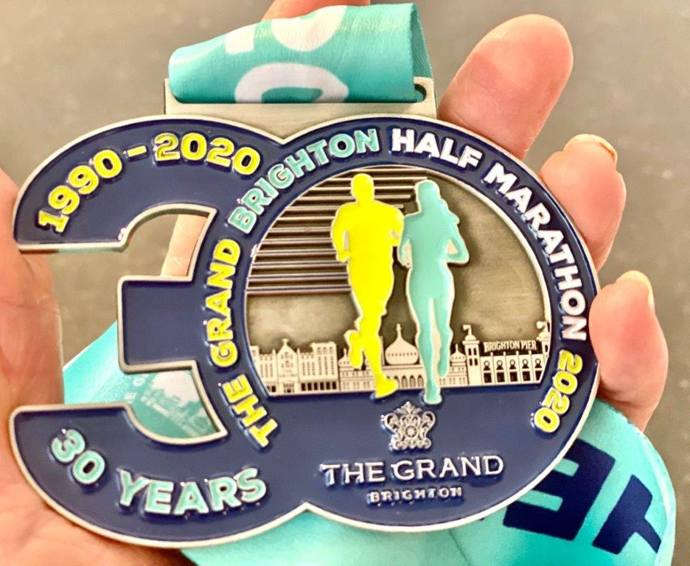

**The Brighton Half Marathon finishers medal.**

Brighton Half Marathon was thirty years old last Sunday and in true coastal fashion, the weather brought also its own surprise. In what can only be described as “windy conditions” the runners bravely fought against the winter weather. Finishing times were much slower than previous years. There were over seven thousand six hundred runners who finished the race. For Haywards Heath Harriers, twenty runners travelled south for this annual event.

The race started on Madeira Drive just down from the Palace Pier. At the Sea Life Centre the run turned right and started uphill on Marine Parade with the wind blowing from behind. It wasn’t until Roedean when the race turned back towards Brighton that runners turned into the full force of the wind.

There was a respite when the route turned from Marine Parade onto Old Steine and looped around The Level. But it wasn’t long before the runners were back on Kings Road running into the wind up to the second turning point at Hove Lagoon. Once this part of the run was complete the wind was behind the runners down to the British Airways i360, Palace Pier and the finish line.

This was a tough and draining 13.1 mile race fighting with the elements. First place went to Kevin Moore 01:09:05, Brighton and Hove AC; 2nd Neil Boniface 01:09:17; 3rd Paul Martelletti 01:09:40; 4th Simon Heath 01:09:41, Brighton Phoenix; 5th Matthew Rees 01:09:45, Swansea Harriers. Amazing results from all five runners

Ben Gibson was the first home for Haywards Heath Harriers in 25th place overall.

Results from the Brighton Half Marathon were:

25th Ben Gibson 1 hr 17 mins 07 secs, 42nd Russ Mullen 1 hr 19 mins 57 secs, 49th Matt Cook 1 hr 20 mins 22 secs, 93rd Marcus Kimmins 1 hr 23 mins 14 secs, 129th Mark Green 1 hr 25 mins 02 secs, 146th Darren Bird 1 hr 25 mins 44 secs, 165th Sam Atkin 1 hr 26 mins 32 secs, 338th Tim Mellor 1 hr 31 mins 44 secs, 540th Tim Miller 1 hr 36 mins 48 secs, 553rd Barry Tullett 1 hr 37 mins 07 secs, 642nd Richard Cole 1 hr 38 mins 15 secs,

664th Sam Ridley 1 hr 38 mins 11 secs, 1167th Carl Bicknell 1 hr 44 mins 46 secs,

1433rd Liz Earley 1 hr 48 mins 01 secs, 1683rd Joshua Franks 1 hr 48 mins 26 secs,

2550th James Bennett 1 hr 58 mins 47 secs, 2847th Sarah King 1 hr 55 mins 06 secs,

5424th Chris Glanfield 2 hrs 13 mins 33 secs, 5551st Michael Parish 2 hrs 19 mins 55 secs,

5816th Linda Tullett 2 hrs 21 mins 52 secs, 5823rd William Davies 2 hrs 25 mins 50 secs.

The event was sponsored by The Grand Hotel and Sussex Beacon providing specialist care for people living with HIV. Some of Haywards Heath Harriers were running in aid of The Beachy Head Chaplaincy, who provide a literally life-saving service patrolling one of the highest suicide spots in Sussex, specialising in crisis intervention and suicide prevention. Total amount raised was £1,550. This was in partnership with Sussex Police and partly under the England Athletics #RunAndTalk programme encouraging good mental health through running and ending mental health social stigma.

**Sussex Indoor Athletic Championships**

At the Sussex Indoor Athletics Championships on 15 and 16 of February at Carlshalton. Haywards Heath Harriers had four young athletes competing.

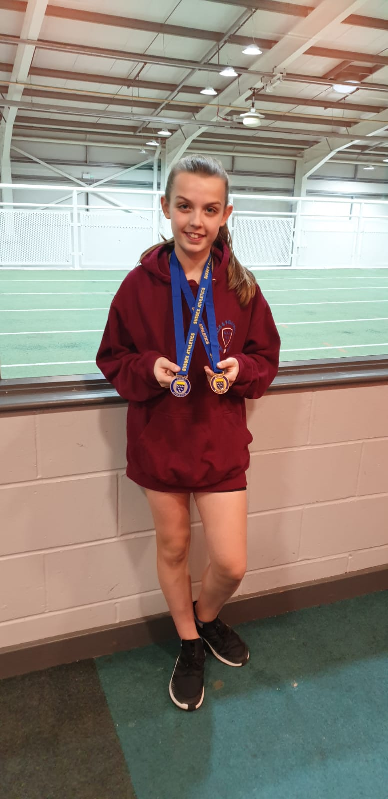

**Siobhan McMahon with her silver and bronze medals.**

Siobhan McMahon competed in the under 13 girls and secured a Bronze in 60metres with a time of 8.75 seconds and a Silver in the Long Jump with a jump of 4.35 metres.

Jonathan Parkin competed also in the under 13 boys 60 metres race and finished in fourth place in 8.83 seconds.

In the under 15 boys events, brothers Charlie and George Bonwick-Adams were both competing. Charlie finishing in fourth place in the 60 metres in a time of 8.51 seconds, whilst brother George competed in the under 15 boys Long Jump finishing with a super silver with a jump of 3.51metres.

**Sussex Sportshall League**

The Sussex Sportshall League at Tanbridge House took place on 9 February. There was a great turnout by the girls and boys at this meeting with several first places being achieved by Haywards Heath Harriers.

Results were as follows:

**Under 11 Girls:**

Amelia Ewen: 3rd 2 Lap Sprint ‘A’ 24.8 secs, 4th Speed Bounce ‘B’ 25.

Isobel Redd:4th 2 Lap Sprint ‘B’ 27.0 secs, 4th Standing Long Jump ‘B’ 1.37m.

Emma McMahon: 4th Speed Bounce ‘A’ 49, 4th Standing Long Jump ‘A’ 1.50m.

4 x 1 lap relay: 4th HHH 53.8 secs.

**Under 13 Girls:**

Siobhan McMahon: 3rd 2 lap Sprint ‘A’ 23.7 secs, 3rd Speed Bounce ‘A’ 76, 1st Standing Triple Jump ‘A’ 6.53m.

Maggie Goodman: 4th 2 Lap Sprint ‘B’ 24.9 secs, 5th Vertical Jump ‘A’ 34, 4th Standing Triple Jump ‘B’ 4.71m.

Megan Eyre: 5th 4 Lap Sprint ‘A’ 52.0 secs, 3rd Speed Bounce ‘B’ 69, 4th Shot Putt ‘A’ 5.82m.

B. Crouch: 4th 4 Lap Sprint ‘B’ 55.1 secs, 4th Shot Putt ‘B’ 4.02m, 5th Vertical Jump ‘B’ 32.

4 x 2 lap relay: 4th HHH 1 mins 41.5 secs.

**Under 11 Boys:**

Oscar Dalgliesh: 3rd 2 Lap Sprint ‘A’ 23.7 secs, 2nd Standing Long Jump ‘B’ 1.85m.

Charlie Stay: 4th 2 Lap Sprint ‘B’ 25.0 secs, 4th Standing Long Jump ‘A’ 1.86m, 2nd Speed Bounce ‘A’ 54.

Ben Baker: 2nd Speed Bounce ‘B’ 50.

4 X 1 Lap relay: 3rd HHH 48.7 secs.

**Under 13 Boys:**

Jonathan Parkin: 4th 2 Lap Sprint ‘A’ 23.6 secs, 4th Shot Putt ‘A’ 6.56m, 2nd Vertical Jump ’A’ 45.

Charlie Bonwick-Adams: 3rd 2 Lap Sprint ‘B’ 24.0 secs, 1st Speed Bounce ‘B’ 76.

Jacob Roderick: 4th 4 Lap Race ‘A’ 51.9 secs.

Oliver Downey: 4th 4 Lap Race ‘B’ 54.8 secs, 4th Vertical Jump ‘B’ 32.

Arun Khursheed: 2nd 6 Lap Race ‘A’ 1:18.8 secs, 3rd Standing Triple Jump ‘A’ 6.11m.

Oscar French: 2nd 6 Lap Race ‘B’ 1:25.4 secs, 4th Standing Triple jump ‘B’ 5.22m.

George Bonwick-Adams: 2nd Shot Putt ‘B’ 6.54m, 2nd Speed Bounce ‘A’ 79.

8 Lap Parlauf: 4th HHH 1:44.0 secs.

4 X 2 Lap Relay: 4th HHH 1:38.0 secs.

**Under 15 Boys:**

Charlie Parvin: 3rd 2 Lap Sprint ‘A’ 21.7 secs, 3rd Speed Bounce ‘A’ 76 2nd Standing Long Jump ‘A’ 2.42m.

Sam Fernley: 4th 4 Lap Race ‘A’ 46.7 secs, Equal 1st Speed Bounce ‘B’ 73, 4th Standing Long Jump ‘B’ 1.96m.

Rory Dalgliesh: 2nd 4 Lap race ‘B’ 48.1 secs, 4th Standing Triple Jump ‘A’ 6.48m, 4th Shot Putt ‘A’ 6.40m.

8 Lap Parlauf: 1st HHH 1:31.5 secs.

**Non-Scoring:**

**2 Lap Race**: Oliver Skinner 25.3 secs, Sam Harper 25.6 secs, Jacob Harper 28.9 secs, Emma McMahon 26.7 secs, Lois Perrett 28.5 secs, Ben Baker 25.1 secs, Lucas Lupton-Jones 26.5 secs, Austen Herbert 24.4 secs, George Bonwick-Adams 24.7 secs, Ollie Stay 25.1 secs, Jack Bannister 25.5 secs, Noah Perrett 26.0 secs.

**4 X 1 Lap Relay:** HHH 50.2 secs, HHH 57.5 secs.

**Speed Bounce:** Lois Perrett 37, Ben French 44, Oliver Skinner 45, Lucas Lupton-Jones 40, Sam Harper 46, Oscar Dalgleish 47, Jacob Harper 32, Austin Herbert 49, Tommy Gray 52, Oliver Downey 66, Noah Perrett 60, Ollie Stay 72.

**Standing Long Jump:** Lois Perret 1.35m, Oliver Skinner 1.72m, Ben French 1.39m, Lucas Lupton-Jones 1.25m, Austin Herbert 1.63m, Ben Baker 1.74m, Jacob Harper 1.15m, Sam Harper 1.58m.