Harriers shine at the Sussex Athletics Championships

**Athletics:**

The **Sussex County Athletics Championships** also held at Crawley on the weekend of 14 and 15 May. This feast of athletics has been long in the waiting after covid restrictions for the past two years. The youngsters showing their prowess with lots of personal bests at the championships.

**Kleri Tantele** was the top Harrier finishing first and winning a gold medal the Senior Women’s Javelin. Silver medals were also awarded to **Lucy Barker** in the Under 15 Girls one hundred metres final and **Helen Diack** in the Senior women’s Triple Jump.

For two members of Haywards Heath Harriers, it was a family affair with mother, daughter and son all competing at the same Championships! **Helen** (mother) competing in the triple jump, daughter (**Jessica**) in the Under 13 Minithon (150 metres sprint, Long Jump and Shot Putt) and **Jack** also in the Minithon (High Jump, 800 metres and Shot Putt). Jessica finishing in eighteenth place and Jack in twenty-first place.

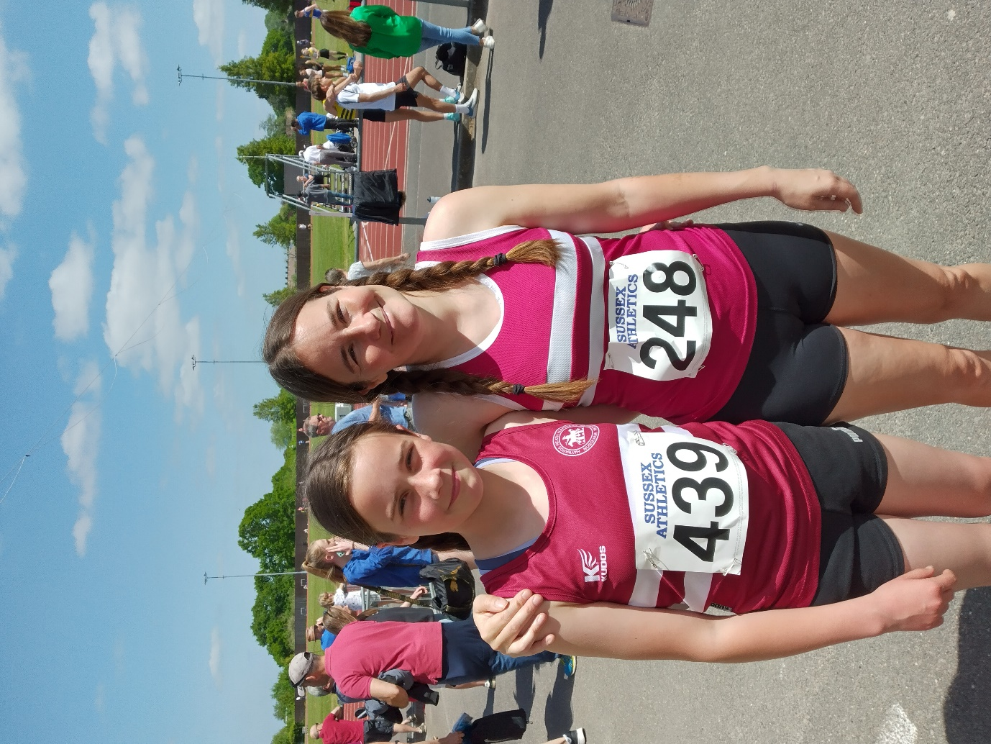

**Jessica (left) with her mother (Helen)**

**100m U15W**

Final 2nd 13.55 Lucy Barker * Heat 1st 13.54 (pb)

Final 5th 13.74 Siobhan McMahon Heat 3rd 13.70 (pb)

**150m U13G**

Final 7th 24.99 (pb) Jessica Diack

**200m U17M**

Heat 5th 27.03 Ho Wan Orin Tang

**800m U13G**

Final 6th 2:52.5 (pb) Annabelle Parkin

**800m U13B**

Final 10th 3:16.88 (pb) Jack Diack

**1500m U17M**

Race 1 7th 4:42.8 (pb) Jonathan Beckett

Race 2 8th 4:25.91 (pb) Sam Fernley

**1500m U15B**

Final 4th 4:35.24 (pb) Arun Khursheed

Final 5th 4:39.09 (pb) Finlay Blythe

**High Jump U13 G**

Final 8th 1m10 (pb) Annabelle Parkin

**High Jump U13B**

Final 4th 1m05 (pb) Jack Diack

**Long Jump U17M**

Final 6th 4m67 Ho Wan Orin Tang

**Long Jump U13G**

Final 6th 3m17 (pb) Jessica Diack

**Triple Jump SW**

Final 2nd 7m62 Helen Diack *

**Shot U13B**

Final 12th 2m91 (pb) Jack Diack

**Shot U13G**

Final 11th 4m60 (pb) Jessica Diack

Final 12th 4m56 (pb) Annabelle Parkin

**Javelin SW**

Final 1st  25m78 (pb) Kleri Tantele *

* = Medal Awarded

**Other Harrier Results:**

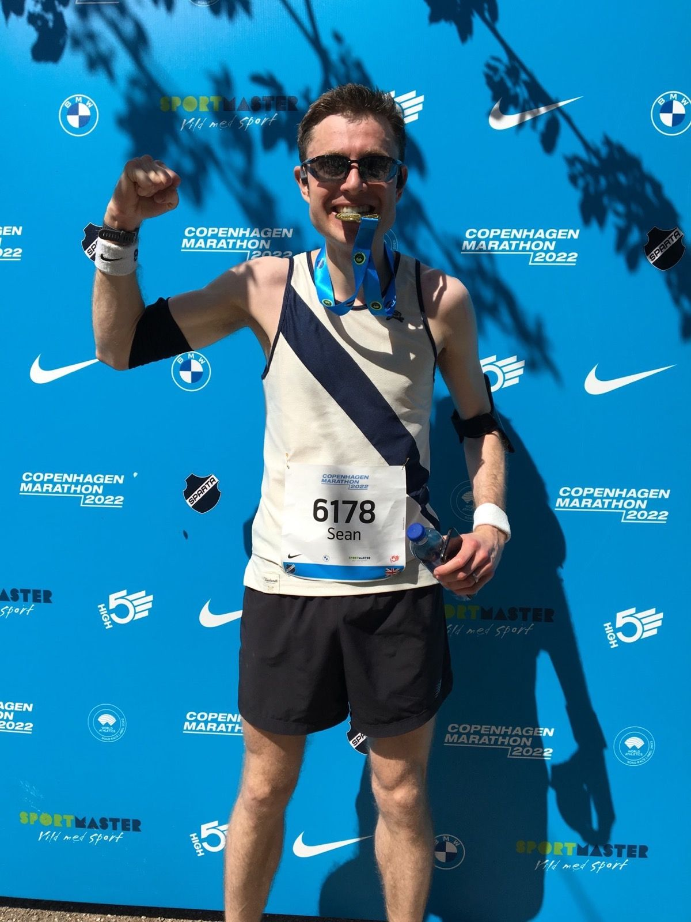

**Sean Duff with his marathon medal.**

**Sean Duff** ran in the Copenhagen Marathon on 15 May, breaking his personal best time by five minutes with a new best time of 3 hours and 5 minutes and 36 seconds.

**Oli Farr** completed his seventy fourth marathon on Saturday 14 May at the Winnie-The-Pooh Run. He completed the marathon in 5 hours and 10 minutes.

**Pete Francis** and **James Bennett** both ran in the Manchester Half Marathon on Sunday. Pete was first home in a personal best time of one hour 26 minutes and 18 seconds. James finished in 1 hour 30 minutes and 53 seconds.

**Abby Ross** ran in the Bognor 10k race on 22 May and finished in a time of 44 minutes and 39 seconds.

At the Horsham 10km race, **Jack Chivers** finished in a time of 44 minutes and 37 seconds and **Carl Bicknell** in 48 minutes and 41 seconds.

**Parkrun round-up:**

Clair parkrun: 1st **Will Grey** 17:56 (pb); 2nd **Ben Duncan** 17:59 (pb); 4th **Marcus Kimmins** 19:08; 7th **Andy Hind** 19:54; 8th **Alex Todd** 20:02 (pb); 12th **Oliver Francis** 20:54; 19th **Simon Robinson** 22:42; 30th **Viggo Skov** 23:34 (pb); 31st **Katie Reed** 23:44; 32nd **Jason Robinson** 24:08; 33rd **Howard Booth** 24:17; 35th **Carl Bicknell** 24:20; 45th **Gemma Morgan** 25:43; 47th **Annabel Axford** 26:01; 56th **Kath Buckeridge** 26:52; 61st **Ian Dumbrell** 27:19; 80th **Shelagh Robinson** 29:54.

Brighton & Hove parkrun: 150th **Sarah Hamilton** 25:41.

Finsbury parkrun: 103rd **James Smyth** 24:36.

Tilgate parkrun: 52nd **Jack Chivers** 22:52; 95th **Ryan Armstrong** 24:58; 156th **Michael Parish** 28:31.

Parke parkrun: 86th **Emma Pryor** 33:53.

East Brighton parkrun: 5th **Paul Cousins** 20:57; 6th **Barry Tullett** 20:59; 7th **Julian Boyer** 21:00; 45th **Linda Tullett** 34:14.

Warwick Racecourse parkrun: 8th **Pete Francis** 18:44.