Middy Report 24.09.17

Harriers Shine at Barns Green Half Marathon and 10km races.

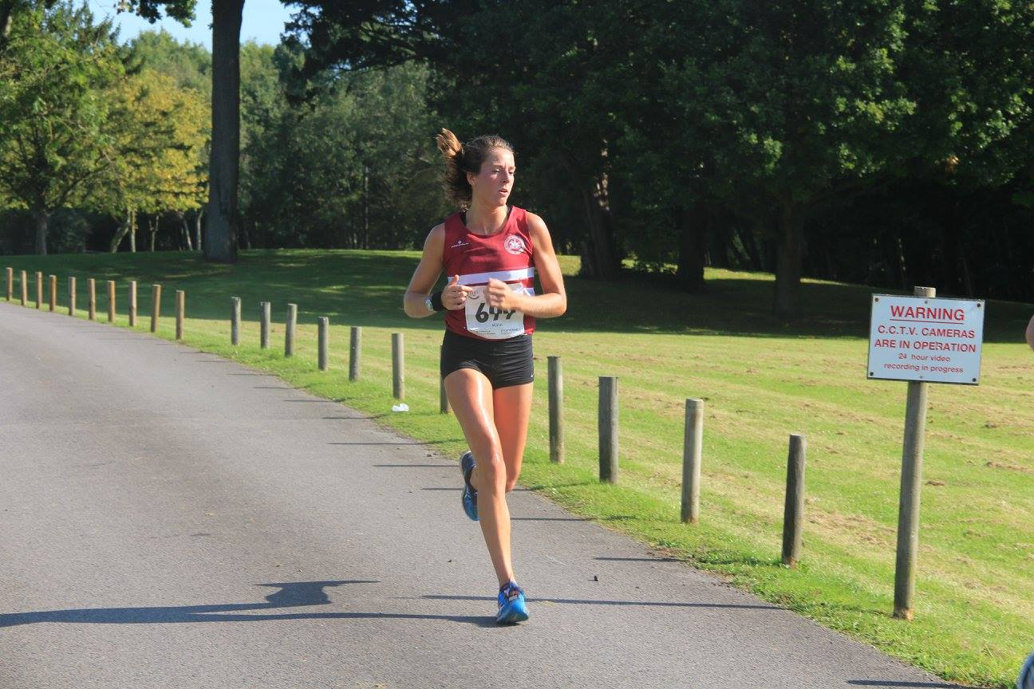

Katie Morgan 4th senior lady.

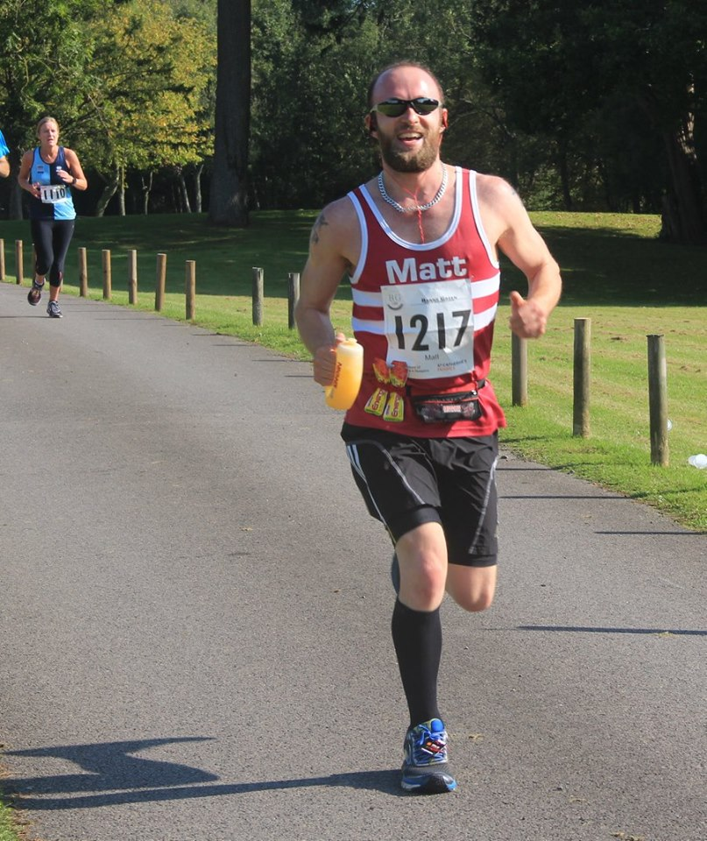

Matt Quinton.

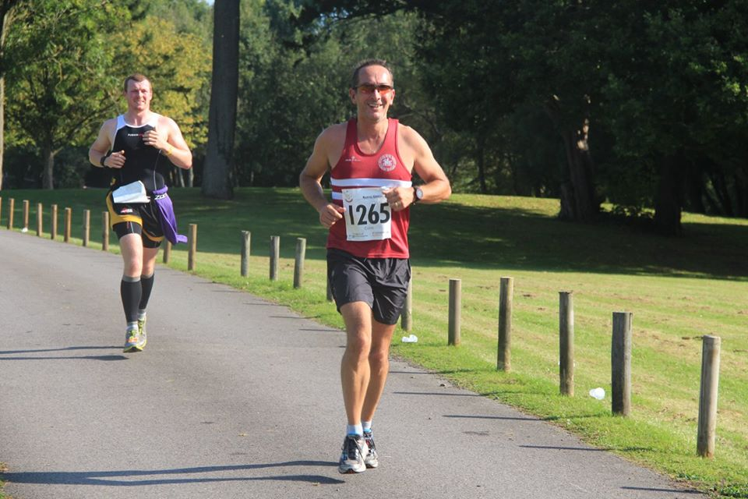

Colin Brackenbury.

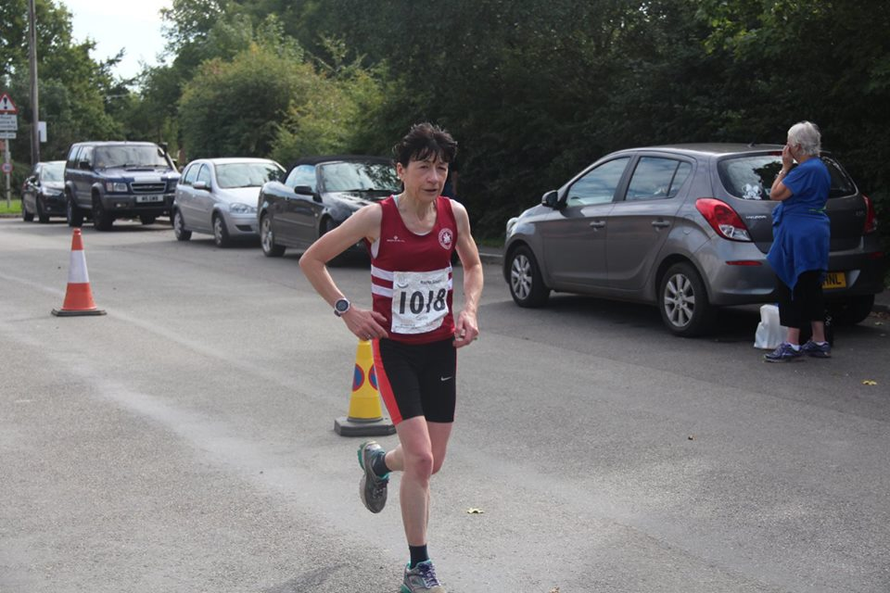

Carole Walters.

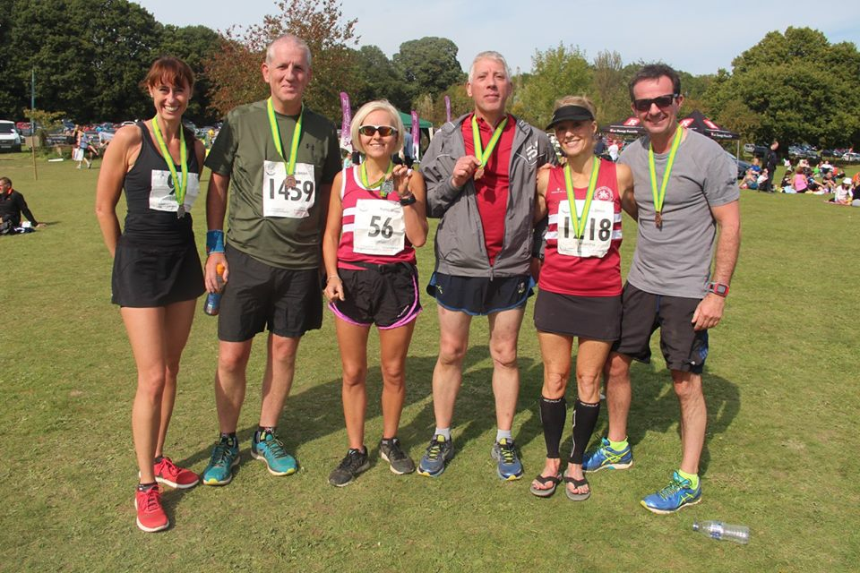
Runners from Haywards Heath Harriers and St Francis Running Club meet together.
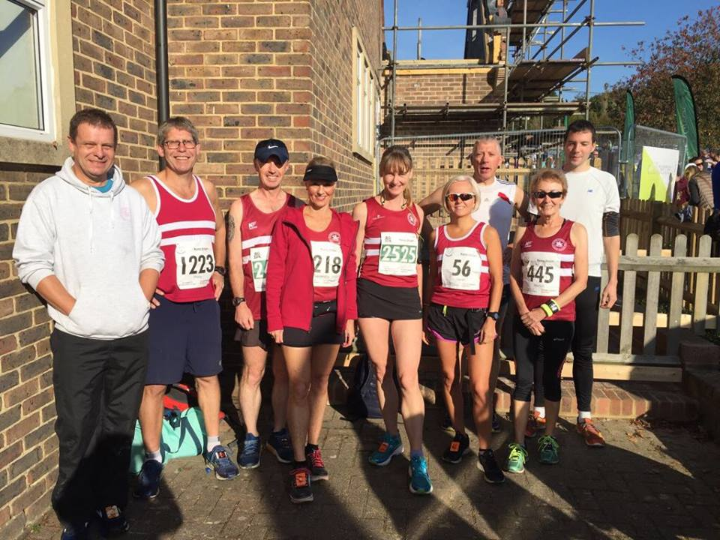

Harriers at Barns Green.

On Sunday, the Harriers were busy at the Barns Green Half Marathon and 10km races.
In the 10km they were represented by Russ Mullen who came 3rd place in 37 minutes and 25 seconds. Other Harriers were Darja Knotkova-Hanley 72nd in 48:26, Carl Bicknell 90th in 49:54 and Karen Thompson 128th in 52:22.

In the Half Marathon, 22 Harriers finished the race. James Skinner leading the pack home in 7th place overall in 1 hr 15 minutes and 38 seconds. Katie Morgan was 10th lady to finish.
The rest of the Harrier results are: 17th Matt Cook 1 hr 21:05, 25th Marcus Kimmins 1 hr 22:32, 26th Rob Watts 1 hr 22:59, 74th Matt King 1 hr 29:14, 108th Katie Morgan 1 hr 32:37, 118th James Bennett 1 hr 33:18 155th Matt Quinton 1 hr 36:28, 157th Will Herbert 1 hr 36:54, 199th Phil Scott 1 hr 39:38, 235th Colin Brackenbury 1 hr 42:09, 310th Samantha Ridley 1 hr 45:52, 341st Carole Walters 1 hr 47:49, 381st Graham Jenner 1 hr 49:45, 503rd Sarah Banks 1 hr 55:36, 518th Marion Hemsworth 1 hr 56:04, 627th Bryan Tiller 2 hrs 01:05, 702nd Graham Kenward 2 hr 03:19, 768th Gary Johnson 2hrs 08:08, 889th Justine Tanner 2 hrs 15:04, 896th Peter Cobbett 2 hrs 15:56, 919th Michelle Holdstock 2hrs 17:03, 1122nd Jenny Denyer 3hrs 04:51.

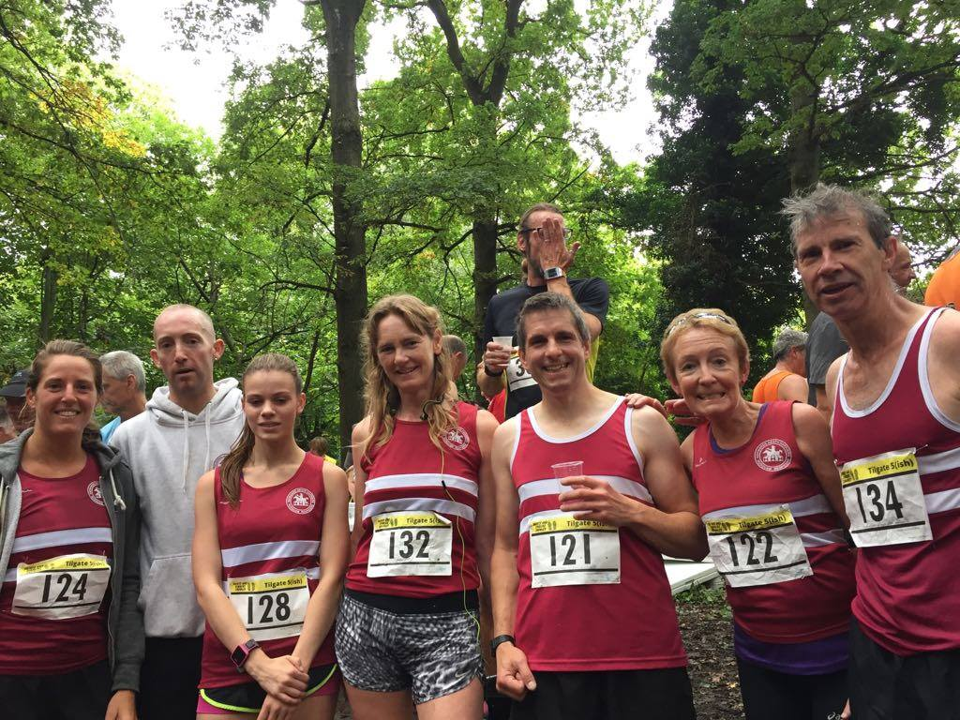

Harriers at the Tilgate 5

Last week also the Tilgate 5 mile race was held at Crawley in Tilgate Forest. After a great rain down pour the day before the forest trail was turned to mud in many places. 16 Harriers finished the course, with Katie Morgan (4th lady) and Phil Payne 7th man), making light of the slippery conditions in 7th place in 32:59. He was followed home by the following runners: in 11th Nick Jarvis 33:47, 17th Dan Blain 34:30, 18th Paul Cousins 34:35, 29th Julian Boyer 35:54, 34th Katie Morgan 36:26, 57th Phil Scott 39:16, 106yth Amy Mitchell 44:04, 120th Karen Thompson 45:13, 170th Marion Hemsworth 48:56, 214th Justine Tanner 53:36, 215th Michelle Holdstock 53:36, 227th Richard Bates 55:10, 241st Rupert Purchase 57:18, 265th Penny Rae 59:46, 302nd Jenny Denyer 1:11:45.

In the Reigate Half, Chris Glanfield finished in 109th position in 1 hr 52 minutes and Michael Burke finisher in 109th in 1 hr 30:02.

Last weekend, Carl Bicknell and Steve Navesey both ran in the Centurion Running Chiltern Wonderland 50 miler trail race. Both runners finished together in 12 hrs and 27 minutes.

Also, last weekend, Klara Price and Michelle Pearce both completed the Weymouth 70.3 Ironman.

Matt King also ran his fastest parkrun at Worthing in 17 minutes 04 sec.

