Harriers At The South Downs Way Relay

Trail Running

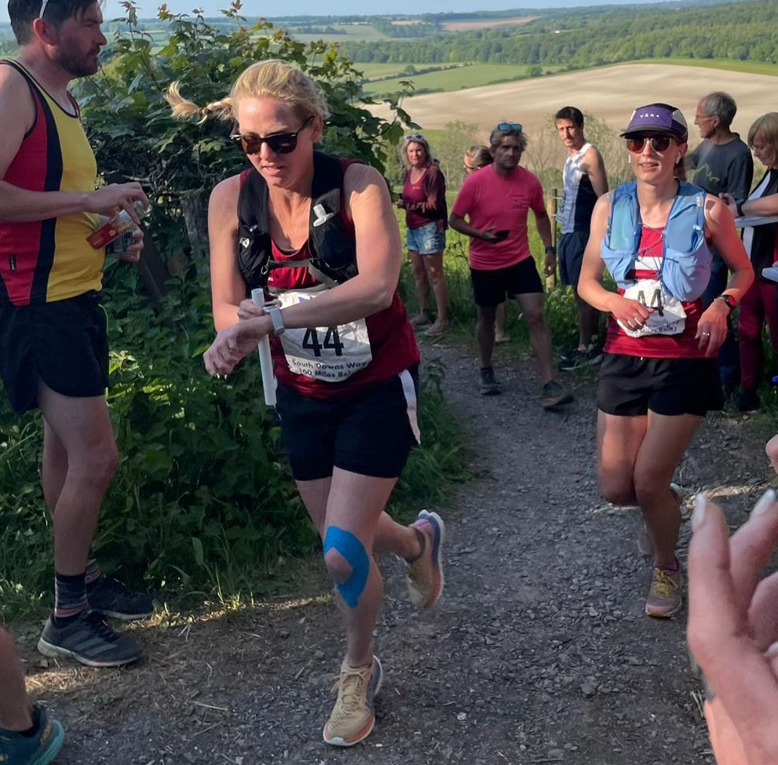
Change-over for the Women’s team with Hanne Boggon handing over to Abigail Redd.
Saturday 3rd June was the South Downs Way Relay, a one day relay event taking the place over the length of the South Downs. Starting at Beachy Head near Eastbourne and ending in Winchester, the runners covered about a hundred miles of hilly, rugged terrain in the height of the summer.

The Harriers have been taking part in this very popular inter club event for many years and also have the privilege of having three teams being able to compete.

Apart from the distance covered, there are also cut-off points for the teams along the course so that the event finishes before darkness overtakes at the end of the day.

The Harriers sent three teams to this epic annual event which consists of six runners per team who each in turn run three legs over the whole day from a range of distances from four miles to nine miles in length. With super back-up by the drivers, navigators and also supporters at different points along the one hundred mile route.

The Harriers had three teams: an A team (mixed male and female runners), a male Vets team (over 40) and a Women's team. All three of the Haywards Heath Harriers teams finished with the Vets team coming home first, then the ‘A’ team followed by the Women's team.

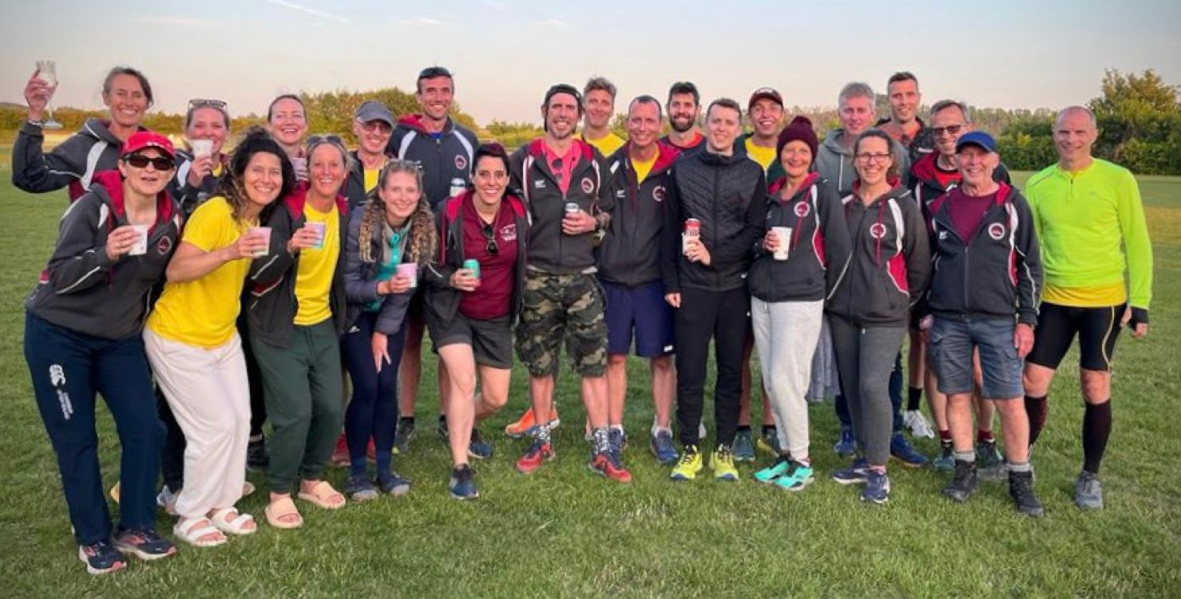
Celebrating a job well done - the Harriers teams at the end of the South Downs Way Relay 2023
The Vets were quickest and were less than a minute from their predicted time of twelve hours and twenty minutes.
The start was a little chilly at Beachy Head early in the morning, but soon warmed up into a lovely day for running (despite the heat later in the day). It was a great day out for everyone with the drivers of three minibuses and navigators on each team doing a great job.
From the early start, it was a long day out until they reached home nearer to midnight!
South Downs Way Relay results:

Haywards Heath Harriers Men’s Vet team: 3rd in category 12 hours and 19 minutes and 2 seconds.
Haywards Heath Harriers Women’s team: 9th in catagory14 hours and 31 minutes and 25 seconds.
Haywards Heath Harriers ‘A’ Team (mixed male and female): 19th in category 13 hours 39 minutes and 51 seconds.

Athletics

Southern Athletics League

Southern Athletics League at Lewes on Sunday 18th June. This is a joint club competition where Haywards Heath Harriers are joined to Lewes athletics Club for the whole season.

Lio Robinson achieved a new personal best throw of over thirty one metres in the javelin and Annie Close setting herself a personal best in the four hundred metres flat race with a seventy second run.

Men’s results:
Lio Robinson: 2nd 100m ‘B’ string 12.2 secs; 2nd Javelin ‘B’ string 31.78m (pb); n/s 200m 24.8 secs.
Sam Fernley: 4th 1500m ‘A’ string 4 mins 35.8 secs.
Russ Mullen: 2nd 5000m ‘A’ string 16 mins 20.5 secs.
Tim Popkin: 3rd 2000m s/c ‘B’ string 10 mins 05.0 secs; n/s 800m 2 mins 46.7 secs.
4 x 100m Relay: 1st HHH/Lewes 47.8 secs.

Women’s results:
Annie Close: 3rd 400m ‘B’ string 70.5 secs; 3rd 100mH ‘A’ string 22.3 secs; 1st Long Jump ‘A’ string 4.65m; 2nd Triple Jump ‘A’ string 9.74m;
Lucie Venables: 4th 800m ‘B’ string 3 mins 12.7 secs; 3rd 400mH ‘A’ string 88.3 secs; 3rd Long Jump ‘B’ string 3.66m;
Kleri Tanteli: 6th Shot Putt ‘A’ string 6.12m; 4th Discus ‘A’ string 17.23m; 1st Hammer ‘B’ string 15.42m; 2nd Javelin ‘A’ string 24.19m.
4 x 100m Relay: 1st HHH/Lewes 55.0 secs.

Sussex Vets Track and Field League
The first of the track and field league took place on the evening of Monday 22nd May. Haywards Heath Harriers joined up with Lewes Athletics Club for this league event.

There were lots of personal bests achieved on the night. Kirsty Armstrong also setting a new vet women’s 45 age club record in the 800 metres race taking over thirty seconds off Irene Parsley record that was set back in 1998.

Women’s results:
Jacqueline Barnes: 200m 37.7 secs (pb); 800m 3 mins 12.7 secs.
Kirsty Armstrong: 800m 2 mins 36.3 (pb).
Gemma Morgan: 3000m 12 mins 53.7 secs (pb); Javelin 9.46m (pb).
Lindsey Blain: 3000m 12 mins 48.0 secs (pb); Long Jump 2.64m (pb).
Helen Diack: Long Jump 3.50m; Discus 14.79m.

Men’s results:
Ian Tomkins: Discus 18.26m; Shot Putt 7.82m.
Mike Bale: Discus 26:01; Shot Putt 7.11m.
James Smyth: Long Jump 3.74m; 200m 30.1 secs.
Andy Dray: Long Jump 3.52m; 200m 27.9 secs.
Ian Kenton: 800m 2:09.8 secs (pb).
Russ Mullen: 3000m 9 mins 31.7 secs.
Julian Boyer: 3000m 10 mins 57.5 secs.
Paul Cousins: 3000m 11 mins 10.4 secs.

Non-scoring:
3000m: Jamie Topping 9:35.60; Josh Franks 12:05.40; Tim Hicks 12:25.40.
Discus: Martin Delbridge 13.04m.
Shot: Martin Delbridge 5.57m

West Sussex Fun Run League
The West Sussex Fun Run League mid-week race held at Littlehampton on Wednesday 7th June, called “The Beach Run.”
The HaywardsHheath Harriers results were as follows:
33rd Julian Boyer 31:46; 90th Paul Cousins 35:04; 161st Gemma Morgan 38:42; 186th Eric Hepburn 39:19; 194th Glen Hedges 39:35; 210th Lucy Anderson 40:17; 260th James Smyth 42:43; 263rd Richard Jobling 42:58; 321st Marion Hemsworth 46:58; 333rd Graham Kenward 47:53; 347th Katherine Woolhouse 48:42; 373rd Caroline Gumm 50:41; 414th Caroline Mackey-Khursheed 54:49; 431st Rupert Purchase 58:21; 435th Richard Bates 59:57.
Other Harrier Results:

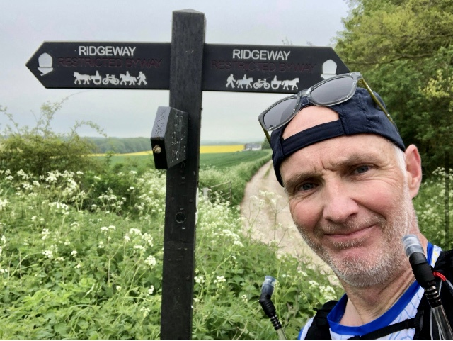
Simon Fitzpatrick – Ridgeway

Simon Fitzpatrick ran in the Ridgeway 40 in 7 hours and 58 minutes on Saturday 13th May.

At the Hackney Marathon on 21st May Simon Robinson and Gray Wilkinson ran in the half marathon. Simon finishing ahead of Gray in a time of one hour 41 minutes and 39 seconds to Gray, who finished in one hour 52 minutes and 32 seconds.
At the Run Gatwick 10k Michael Parish finished in one hour and 24 seconds.
At Worthing on the 4th June was the Worthing 10km race. The 10 km results were as follows:
11th Russ Mullen 34:28; 438th Hannah Gibson 49:58; 532nd Richard Jobling 52:19; 539th Sarah King 52:52; 745th Sarah Hamilton 57:13; 789th Emma Pryor 57:36; 971st Caroline Mackey-Khursheed 62:26.

