Middy report 26.08.18

At the Newick 10km on Sunday 26th August, eight Harriers took part in this undulating 10 kilometre race at Newick. Running her first road race was Isobele Russell. It was Isobele’s first long endurance race and she ran a super race to finish beating a lot of experienced runners.

Newick Results were as follows:
5th Jack Chivers 39:58; 13th Matt Quinton 44:14; 17th Richard Haynes 44:59; 18th Matt Howells 45:02; 36th Isobelle Russell 48:10; 46th Marisa Pitt 50:34; 55th Chris Glanfield 52:20; 94th Peter Cobbett 1 hours 00 minutes and 34 seconds.

Also, on Sunday, Phil Hardaway ran in the Arundel Castle 10 km race and finished in 4th place in a time of 36 minutes and 24 seconds.

Last Thursday was the Birthday Boys 5000m track races at the Withdean Stadium. The original race was created by two Brighton runners who decided to celebrate their birthday by holding a track race. The event has been held since 2008 and now has multiple races due to the demand by runners wanting to run a track race.

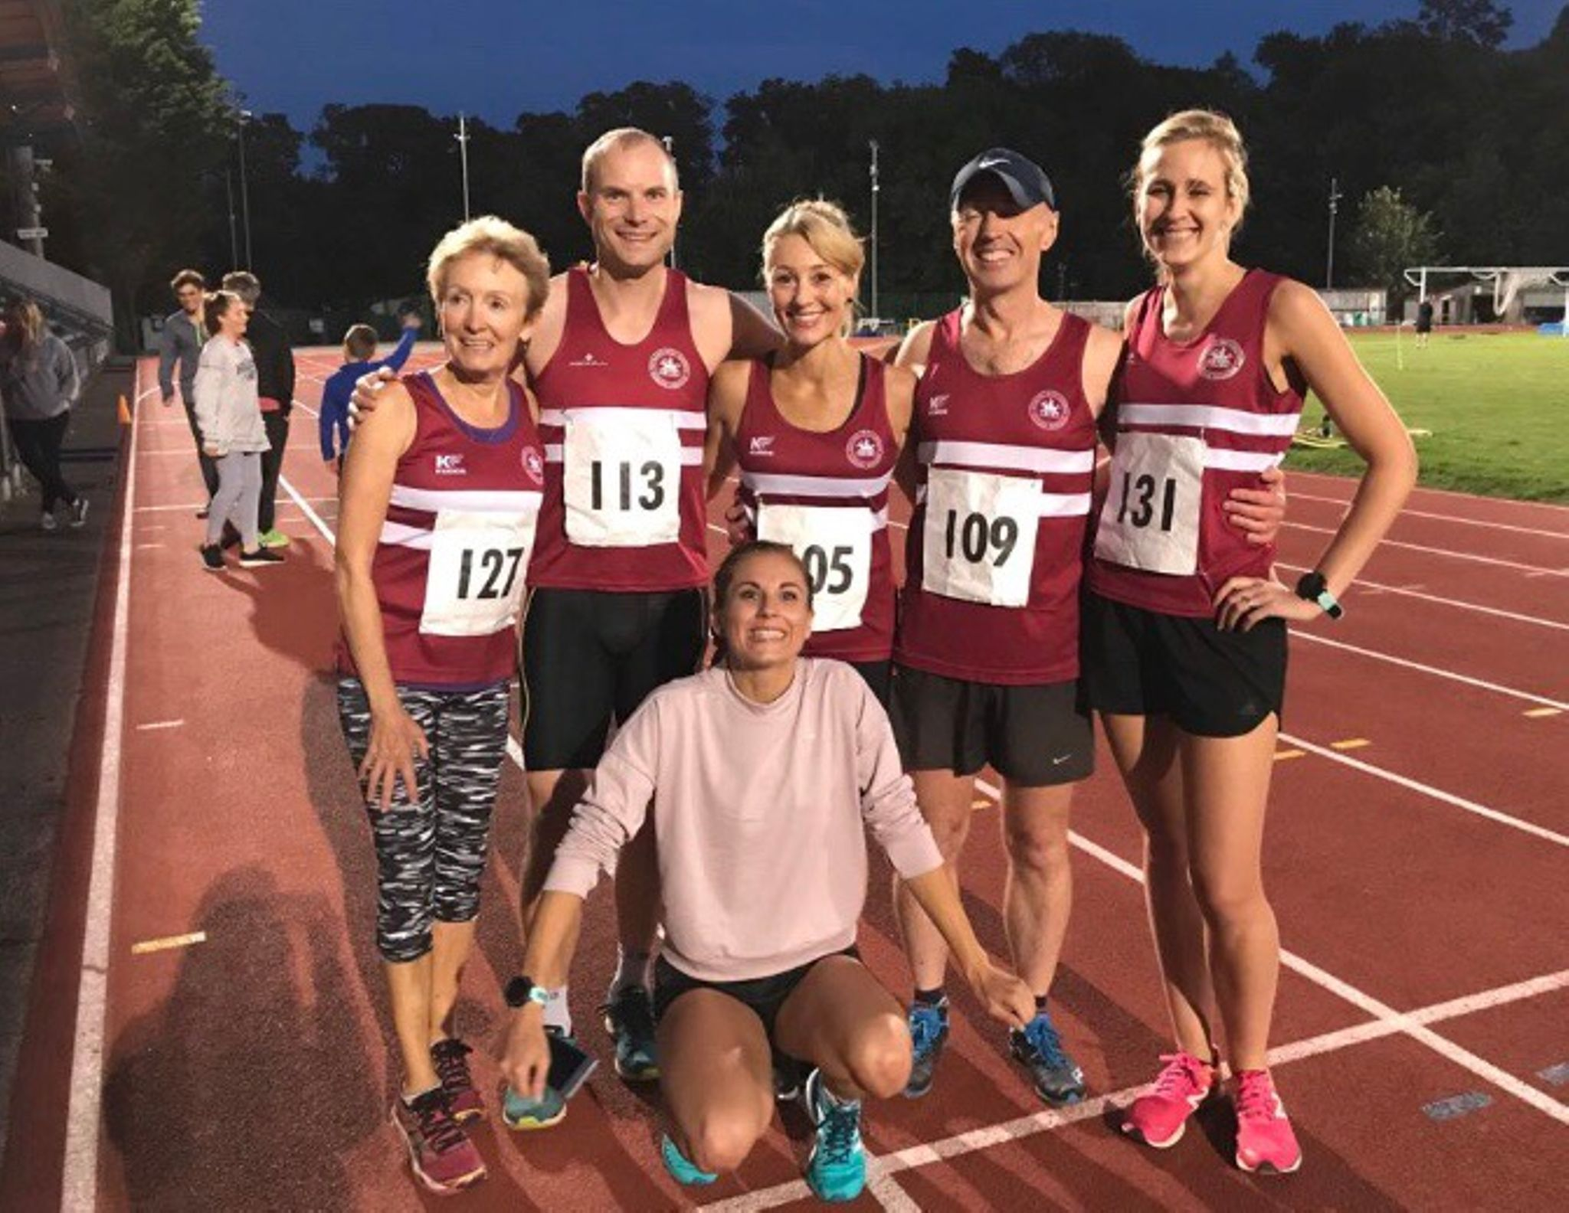
Harriers at the Birthday Boys 5000m (top from left-right): Marion Hemsworth, Dave Harper, Sam Ridley, Carl Bicknell, Hannah Gibson and Emma Navesey (bottom).

There were four races, seeded so that runners would be running against competitors of the same ability. James Skinner was Harriers top finisher in another Harrier Vet 40 club record and he is again the top UK Vet 45 and finished the race in a super time of 15 minutes and 30.0 seconds. Marion Hemsworth and Sam Ridley also getting club records for their age groups. For Marion Hemsworth, Sam Ridley, Hannah Gibson and Dave Harper, it was their first experience of running a race on a track.

Birthday Boys Results as follows:
Race 1: 4th Paul Cousins 17:34.8; 22nd Emma Navesey 18:29.3.
Race 2: 4th James Skinner 15:30.0; 8th Ben Gibson16:16.9; 11th Russ Mullen 17:18.5.
Race 3: 5th Julian Boyer 19:02.7; 12th Barry Tullett 19:30.7;
Race 4: 8th Hannah Gibson 21:17.3; 10th Carl Bicknell 21:29.7; 11th Sam Ridley 21:35.9; 12th Dave Harper 21:47.0; 26th Marion Hemsworth 25:46.0.

On 12 August, the Friston Forest Trail 5 mile race:
1st Jack Chivers 38:30.

At the Harting MT on Michael Burke came 9th position in 1 hour 7 minutes and 16 seconds; Matt Quinton came 43rd in 1 hour 18 minutes and 36 seconds; Bryan Tiller came 71st position in 1 hour 27 minutes and 25 seconds; Oli Farr came 86th position in 1 hour 30 minutes and 18 seconds.

At the Downland Challenge Ultra on 18th August, which is a 30 mile ultra race along the South Downs from Underhill Lane (near Ditchling) to Southease and back following the South Downs Way route. Michael Burke finished in 11th place in a time of 4 hours 12 minutes and 3 seconds. In 13th place was Steve Dalman in 4 hours 17 minutes and 49.1 secs.

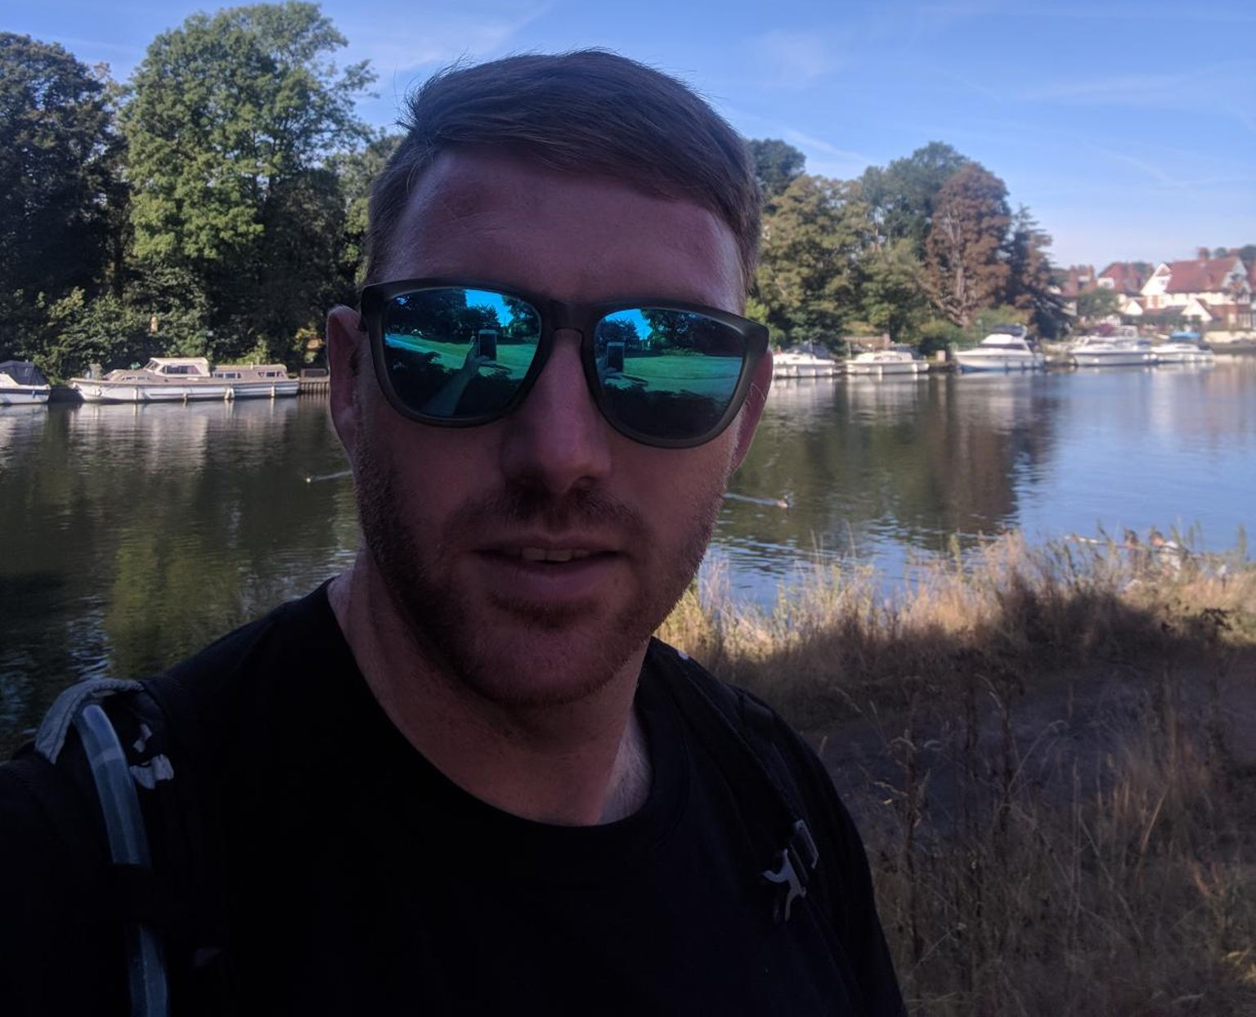
Oliver Farr at the Thames Meander Marathon.

On the 11th August, at the Thames Meander Marathon, Oliver Farr came 70th out of more than 100 runners in a time of 4 hours 13 minutes and 20 secs.

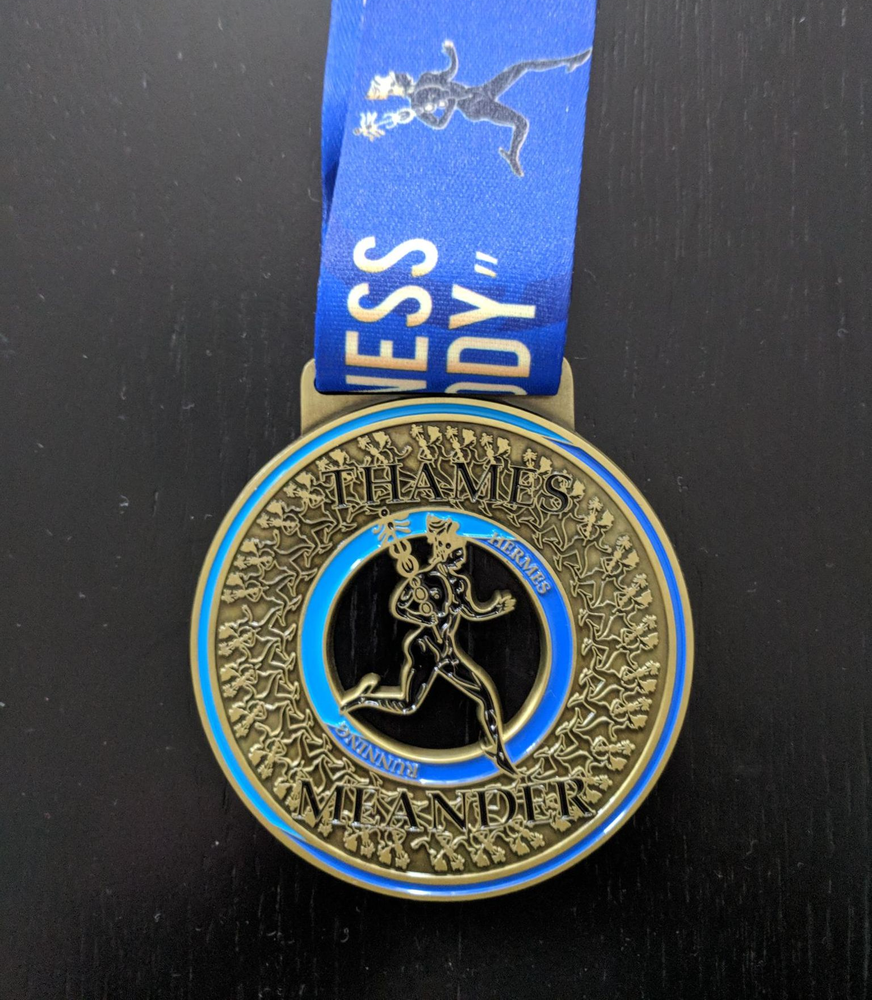
Oliver Farr’s medal.

Kim Lo and Phil Payne both ran at the Something Wild 10k race at
At Bridport on 12 August, both Phil and Kim ran in the Jurassic Park Coastal Half which was also a qualifier race for the 3 Peaks Fell race in Cumbria. Phil finished in 9th place in a time of 1 hour 54 minutes and 13 secs. Kim was 27th overall and 7th lady and her time was 2 hours 6 minutes and 12 secs.
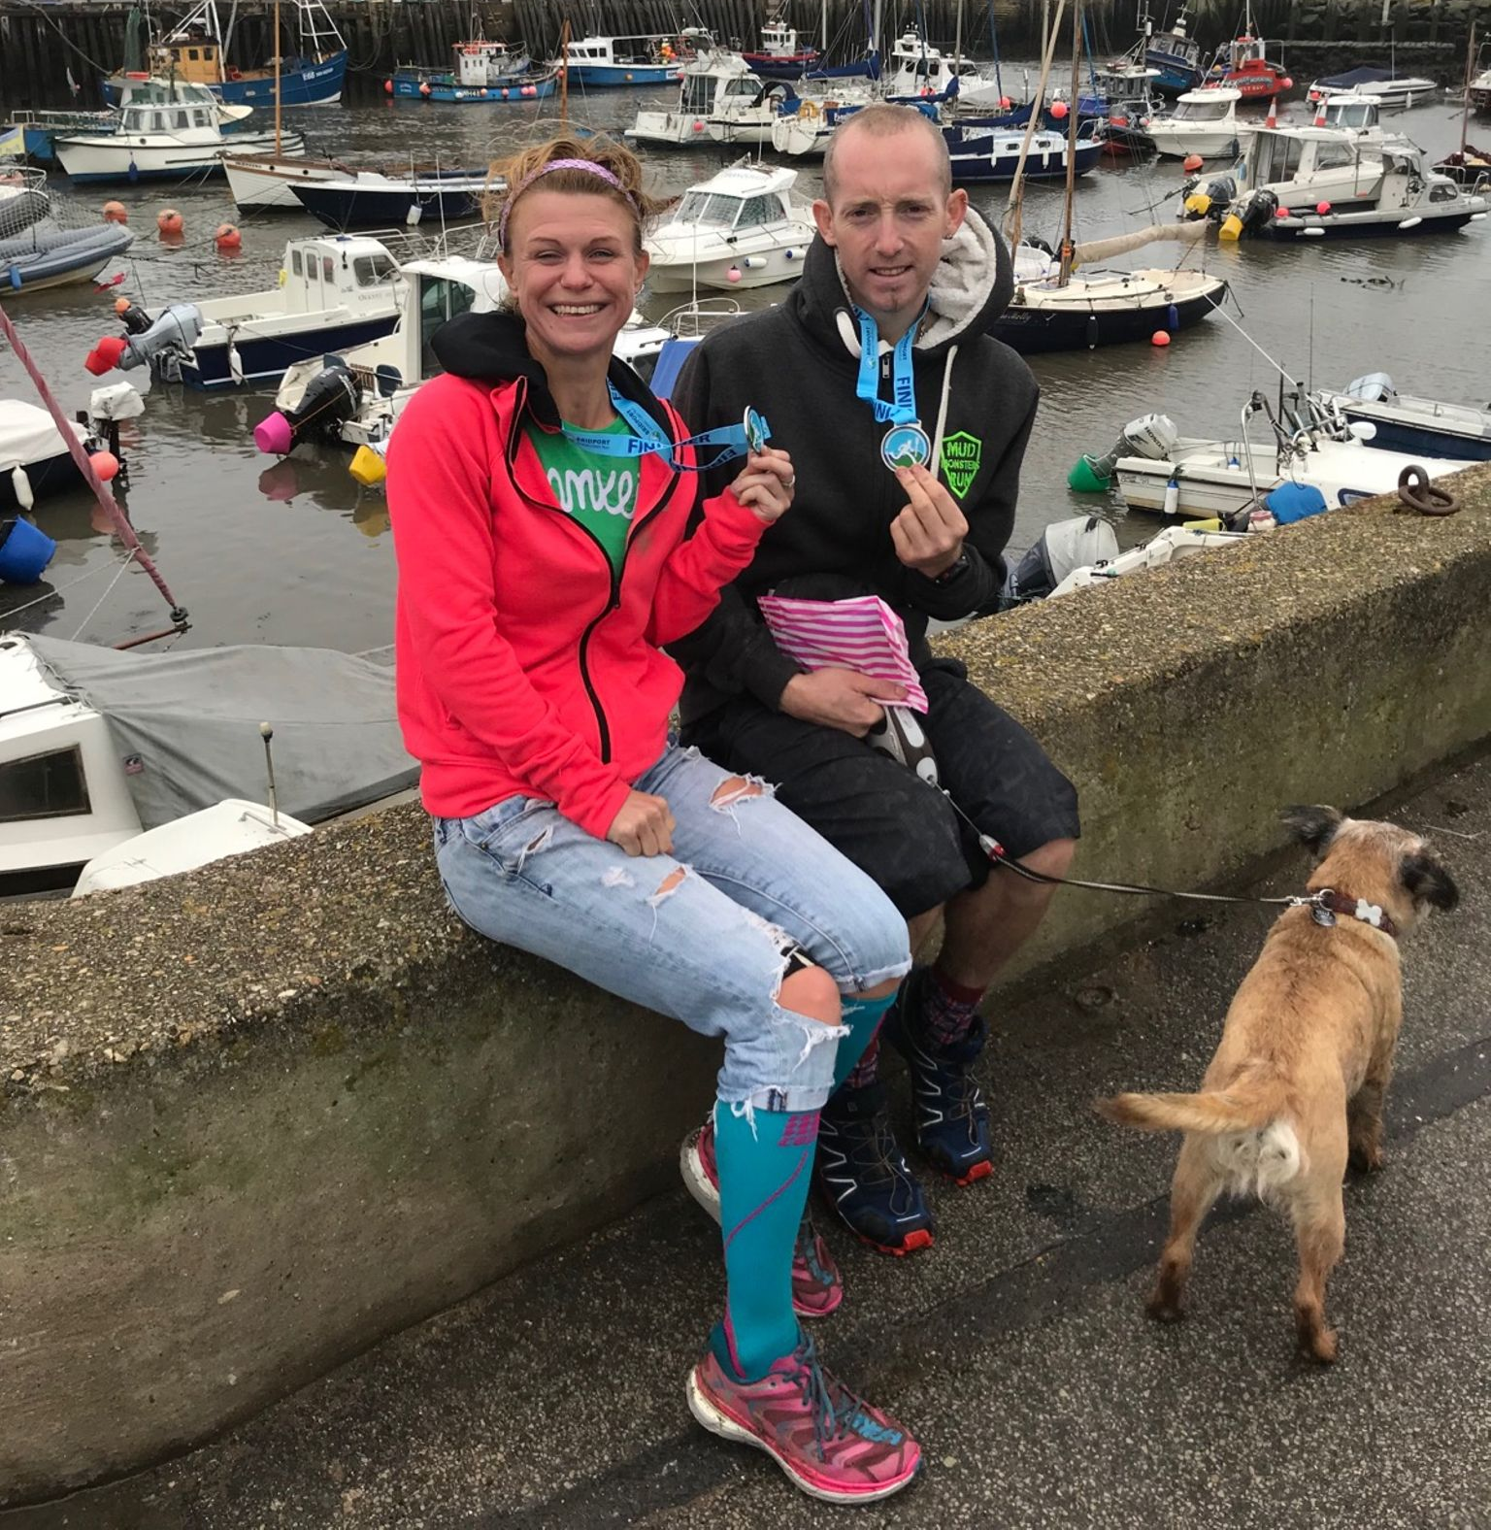
Phil Payne and Kim Lo after the Something Wild 10km race at Bridport.

'If you would like to get involved in coaching at the club, and join a lively team, there are volunteer opportunities available. We need help with Junior and Senior Sprints coaching. Our main training evening is Tuesday.
Expenses will be paid, and qualification costs covered. For further information contact our Head Coach, Mike at email address:
michaelessex@btinternet.com.'

