**By Michael Parish**

**WITH STORM Eunice practically at an end Gatton Park opened its doors for their Run Reigate inaugural 10km trails run on Sunday 20th February 2022. Run Reigate half marathon started in 2014 and five years later opened their second run with Run Gatwick half marathon. Adding to their portfolio is the new trails run.**

The route is situated just below the north downs at Reigate Hill, nestled between Redhill and Merstham in Surrey. It’s a five kilometre loop of the grounds landscaped by Capability Brown between 1762 and 1766 incorporating the beautiful lake. There is a Japanese Garden that was featured on Channel 4’s Lost Gardens and recently where the BBC Weather were filming due to their abundance of snowdrops. In order to complete the course athletes were required to complete two loops of the course.

With a lot of rain overnight and high wind warnings the run went ahead. First off were the CaniCross runners, with their dogs on leads around their waists’, with sweeping runs down to the lake and running across a ford feeding excess water from the large lake to smaller ones, before going uphill on the other side. Circling the Royal Alexandra and Albert School and going back out onto the trails. Parts of the course were extremely muddy with 200+ athletes running the 5km course twice.

In the line-up was some great efforts from Haywards Heath Harriers **Oliver Farr** 00:52:29, who is getting close to completing his personal challenge of 100 marathons and **Michael Parish** 01:02:06, who was born in Redhill.   1st Alex Mansfield 00:39:54; 2nd Joe Gale 00:40:17; 3rd James Wallage 00:40:35.

Haywards Heath Harriers results were Oliver Farr 00:52:29 & Michael Parish 01:02:06.

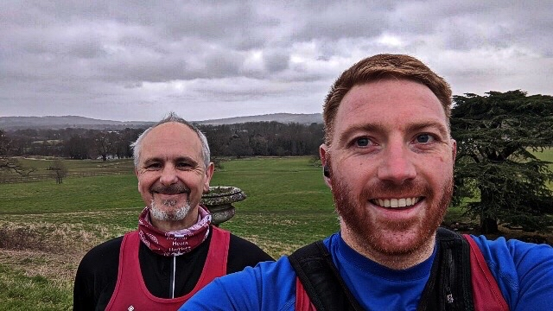

**Michael Parish (left) and Oliver Farr at the Run Reigate Trail Run 2022 at Gatton Park.**

**Cross Country**

The final of the Sussex Cross Country League races was held at Bexhill on Saturday 12 February.

In the under fifteen boy’s race, the young Haywards Heath Harriers team missed third place over the whole season by just one point from Crawley Athletic club. The team of **Jonathan Beckett, Finlay Blythe** and **Arun Khursheed** were consistent all season backed up by **Jacob Roderick** in the last race.

The senior women did very well and managed to successfully keep three teams going throughout the whole season. The senior men were not so successful but managed to just keep their A team in the top division with their B team being relegated to Division 3. The men’s team strength has always been because of their consistency to get runners out and this season it was unduly lost due to poor turn-out by the men in the final league race.

**Final Team Results after 4 League Races**

U13 Boys: 9th HHH;

U15 Boys: 4th HHH.

Senior women: **10th** HHH ‘A’; 15th HHH ‘B’; 21st HHH ‘C’.

Senior men were 5th equal with Crawley AC.

Women Vet team: 5th HHH

Men Vet team: 4th HHH.

**Final Individual results after 4 League Races:**

V35 women: 3rd **Julie Kamel**; V65 women; 2nd **Marion Hemsworth.**

M50: 3rd **Paul Cousins**; M60 3rd **Tim Hicks.**

**Individual results from the last race were as follows**:

U11 Girls: 13th **Annabel Axford** 8:57: 15th **Annabel Parkin** 9:12; 19th **Lucy Roderick** 9:28; 38th **Coco Rhodes** 14:41.

U11 Boys: 11th **Rafael Selby** 8:17.

U13 Boys: 20th **Noah Blythe** 13:52.

U15 Boys: 9th **Jonathan Beckett** 14:46; 10th **Finlay Blythe** 14:54; 11th **Arun Khursheed** 14:56; 29th **Jacob Roderick** 16:21.

U17 Men: 15th **Sam Fernley** 20:21.

Senior Women/Vet Women: 26th **Julie Kamel** 24:43; 31st **Lindsey Blain** 24:56; 49th **Hanne Boggon**  26:49; 57th **Jacqueline Barnes** 28:12; 59th **Katherine Buckeridge** 28:33; 65th **Ellen Mapperley** 29:40; 67th **Caroline Mackey-Khursheed** 29:48; 68th **Shelagh Robinson** 30:14; 75th **Carys Hind** 33:18.

Senior Men/Vet Men: 30th **Ian Kenton** 31:16; 36th **Andy Hind** 32:02; 55th **Paul Cousins** 35:13; 65th **Tim Hicks** 36:09; 66th **Barry Tullett** 36:11.

**Other Harriers Results:**

**Arun Khursheed** was the sole HHH runner at the National XC Champs held at the challenging Parliament Hill course on Saturday. Up against the best runners in the country, Arun ran 18:20 and achieved a creditable 284th out of 412 runners in his U15 4K race.

**Arun Khursheed @ National XC Champs**

**Brighton Half Marathon** was last Sunday. Haywards Heath Harriers had sixteen runners complete the run. Conditions were mainly good for endurance runners along the seafront but runners faced an oncoming wind in the latter part of the race as they headed towards the finish in Madeira Drive.

First home for the club was **Jamie Topping** in one hour nineteen minutes and forty one seconds.

Harriers’ results were as follows:

69th **Jamie Topping** 1:19.41; 100th **Jamie Gibson** 1:21.33; 120th **Marcus Kimmins** 1:22.25; 161st Darren Bird 1:24.30; 189th **Ewan Kemsley** 1:25.27 (pb); 191st **Sean Duff** 1:26.00 (pb); 382nd **Steve Dallman** 1:30.45; 411th **Barry Tullett** 1:31.44; 747th **Simeon Wishlade** 1:37.49; 1230th **Sam Atkin** 1:44.38 (pb); 2481st **Oliver Schofield** 1:53.32; 2873rd **Olivia Treharne** (pb) 1:57.21; 3979th **Liz Earley** 2:09.21; 3980th **Sarah King** 2:09.20; 3993rd **Hanne Boggon** 2:03.48 (pb); **Amy Lovejoy** 2:05.56 (pb).

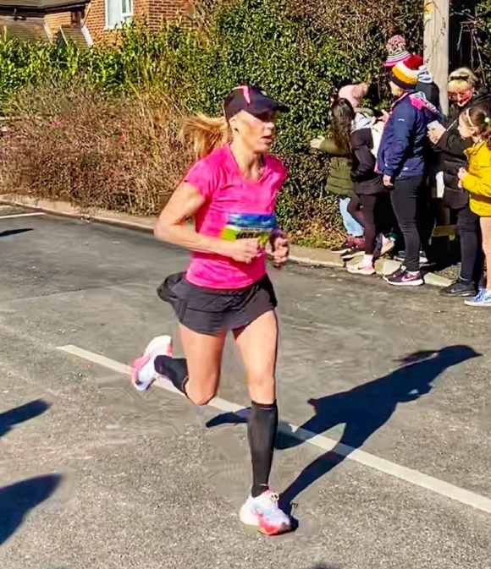

**Sam Ridley at the Wokingham Half Marathon**

**Sam Ridley** and **Daniel Moll-Morgan** both ran in the Wokingham Half Marathon on Sunday 27 February. Daniel finished in 327th position in a time of one hour twenty four minutes exactly and Sam finished in a super time (just outside her personal best) with one hour thirty four minutes and fifty five seconds and finished in sixth place in her age group. The race was a qualifier race for the British Masters Championships with the first three in age group to qualify.

**Harrier’s Parkrun Round-up:**

Royal Tunbridge Wells parkrun: 25th **Abigail Redd** 24:36; 43rd **James Smyth** 27:35.

Brandon Country Park parkrun: 50th **Emma Pryor** 29:31.

Clair parkrun: 3rd **Andy Hind** 19:48; 4th **Marcus Kimmins** 20:11; 14th **Katie Reed** 22:50; 16th **Pete Francis** 22:56; 18th **Eric Hepburn** 22:59 (pb); 21st **Bob Adams** 23:46; 22nd **Simon Robinson** 23:54; 25th **Mark Sykes** 24:16; 30th **Jason Robinson** 24:39; 54th **Howard Booth** 26:56; 65th **Jacqueline Barnes** 28:05; 96th **Caroline Gumm** 32:08 (pb).

Preston Park parkrun: 77th **Carl Bicknell** 23:40; 148th **Katherine Buckeridge** 25:41 (pb); 334th **Linda Tullett** 31:31.

Bognor Regis parkrun: 9th **James Bennett** 20:13.