SKINNER STORMS IT AT THE NEWICK 10K!

On Bank holiday Sunday at the hilly Newick 10km course, Haywards Heath’s James Skinner came first in 35:16 by nearly 2 minutes ahead of second place Alex Cruttenden (Brighton Phoenix) 37:07 and 3rd place went to Del Wallace (Arena) in 37:23. In the ladies race Feliciity Hannon (Clapham Chaser) came first in 40:52 followed by second place Katie Morgan (Haywards Heath Harriers) in 41:57 (pb) and third place was Laura Douse (Wadhurst Runners) in 44:53. Other Harriers finishers were: Matt Quinton 47th in 44:50, Phil Scott 50th in 45:07, Colin Brackenbury 60th in 46:16, Bryan Tiller 69th in 47:27, Naomi Cikalo 73rd in 47:55, Carole Walters 82nd in 49:08, Sarah Banks 103rd in 50:47, Oli Farr 106th in 51:11, Amanda Soper 111th in 52:20, Chris Glanfield 116th in 52:47, Amy Mitchell 122nd in 53:41, Marion Hemsworth 133rd in 54:55, Mark Sykes 143rd in 55:50, Gina Hobson 145th in 56:03, Peter Cobbett 165th in 58:18 and Richard Bates 194th in 1:06:11.

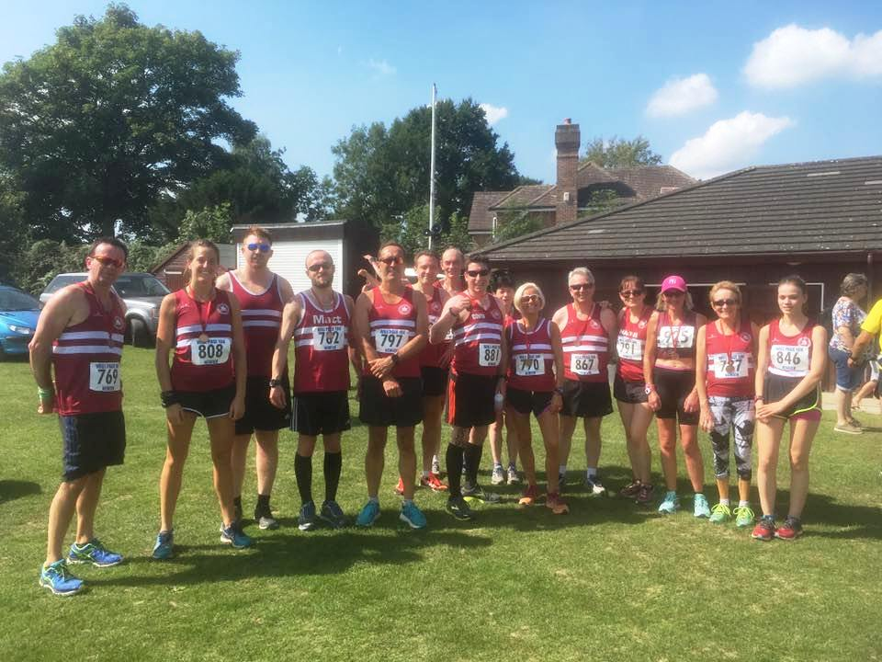

Harriers at the Newick 10km race.
On 20 August at the Hornets Stinger a number of Haywards Heath Harriers took in the 6 miles race which is a West Sussex Fun Run League event. The Haywards Heath Harriers were supported by Julian Boyer in 34th place in 47:53, followed by Phil Scott in 49th in 49:07, Bryan Tiller in 59th in 50:51, Richard Bates in 221st in 1hr 09:12 and Rupert Purchase bringing the rear end in with 274th in 1 hr 19:50.

Also on 20 August was the last of the Southern Athletic League meeting, which was held at Dartford. The Harriers who compete jointly with Lewes Athletic Club came 3rd out of 4 teams at this event. Harriers results were as follows:
Men: Simeon Cousins 2nd in ‘A’ string 200m in 23:31 secs, 1st ‘A’ string 400m in 51:6 secs; Daniel Holbrook 2nd in ‘B’ string 400m in 57.6 secs, 2nd in ‘B’ string 110m Hurdles in 22.57 secs, 3rd in ‘A’ string High Jump with 1m55; Tim Popkin 3rd in ‘B’ string 800m in 2:33.3, 3rd ‘B’ string Discus with 11m25.
Russ Mullen 2nd in ‘A’ string 5000m in 17.01.38; Paul Cousins 2nd in ‘B’ string 5000m in 17:50.01; Christian Lambert 2nd in ‘A’ string 110m Hurdles in 20.35 secs, 2nd in ‘B’ string Long Jump with 5m09.
Women: Brittany-Croyon-Kempster 3rd A’ string 100m in 16.38 secs, 3rd in ‘A’ string Long Jump with 3m83; Michelle Holdstock 3rd in ‘B’ string 100m 17.01 secs, 3rd ‘B’ string 400m in 84.88 secs, 3rd ‘A string 800m in 3min 17.32 secs, 3rd ‘A’ string 1500m in 7min 19.56 secs 3rd in ‘A’ string 3000m in 16min 22.09 secs; Jenny Denyer 3rd in Shot Putt with 5m75, 3rd ‘B’ string Discus with 15m26, 3rd in ‘B’ string Hammer with 19m02, 3rd ‘B’ string Javelin with 12m72.
Non-scoring: Herbert Langa 200m 25.11 secs (pb), 100m 12.64 secs; Christian Lambert 100m 12.8 secs; Rowden Watson 100m 12.91 secs, 200m 26.62 secs; Simeon Cousins 100m 11.77 secs (pb); 400m Tim Popkin 400m 66.98 secs.

At the Birthday Boys 5000m on 17 August at the Withdean Stadium (Brighton) James Skinner ran 16mins19.0 secs and Paul Cousins ran 17mins52.4 secs

James Bennett ran in the Dartford 10km on 28 August (Bank Holiday Monday) and completed the event in 19th place with a time of 42 mins 15 secs.

