Haywards Heath Harriers

Road Running

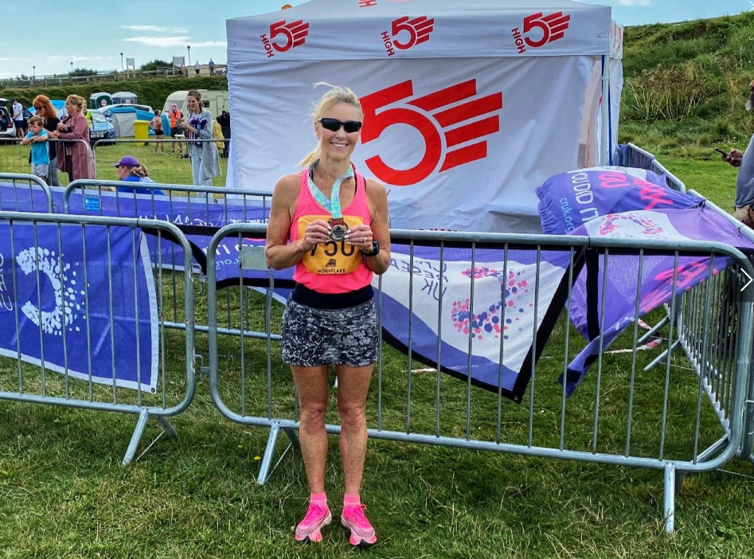
Sam Ridley at the Seaford Half

Jamie Topping ran in the London Vitality Half Marathon which started at Greenwich on 22 August. He finished in a super 1 hour 19 minutes 3 seconds. Tim Stannard also ran in the same race and finished in 1 hour 29 minutes and 30 seconds, which was a personal best time.

James Bennett ran in the Lydd Half Marathon on 15 August finishing in 1 hour 27 minutes and 35 seconds.

At the South Coast Run Half (half marathon) held at Seaford on 22 August, Sam Ridley finished 5th lady and 1st Over 50 in a time of 1 hour 40 minutes and 47 seconds in windy conditions along the sea front.

Steve Dallman finished in 8th place in the 10km event also at Seaford and finished in 47 minutes and 6 seconds.

Track and Field Athletics

A big well done to Mike Bale who competed at the BMAF Championships at Derby on the 21 August. Mike won a bronze medal is the Vet 65 age group in the Weight with a throw of 11.84 metres. He came fourth in the Hammer with 32.34 metres (pb and club record). He also threw the discus 28.59 metres (a pb and club record) and putt the Shot with 7.74 metres.

The last of the Southern Athletic League meetings was held at Hastings on the 14 August at the William Parker Community Athletics Arena.

Due to the summer holidays the final event always has a low number of athletes competing from all clubs however, the combined team of Haywards Heath Harriers and Lewes Athletic Clubs still managed to finish in third place.

Brighton & Hove finished in first place with 338 points, Hastings Athletic Club in second with 229.8 points, Haywards Heath Harriers and Lewes Athletic Clubs 131.1 points and Eastbourne Rovers Athletics Club in fourth with 55.4 points.

Harrier’s individual results were as follows:
Martin Dawson: n/s 400m 58.9 secs.
John Palmer: n/s 200m 31.1 secs, n/s 400m 72.8 secs.
Katherine Reed: 3rd ‘A’ string 800m 2 mins 56.3 secs; n/s 1500m 5 mins 52.8 secs (pb).
Sam Fernley: n/s 4 mins 41.4 secs.
Paul Cousins: 2nd ‘B’ string 5000m 19 mins 54.5 secs.

Final Sussex Track & Field Vets League of 2021

Final of the Sussex Vets Track and Field League was held at Lewes on Monday 26 July.
It was good to see many Harriers take part in this friendly track and field event. There were many personal bests set during this meeting.

Results were:
Oliver Francis: 100m 15.4 secs (pb); LJ 3.84m (pb); HT 10.02m (pb).
James Smyth: 100m 14.3 secs (pb); 1500m 5 mins 38.4 secs (pb); LJ 4.18m (pb).
Ian Dumbrell: 100m 14.7 secs (pb); LJ 3.49m (pb).
Lucy Venables; 100m 15.0 secs; 400m 72.6 secs; TJ 8.52m.
Abigail Redd: 100 17.0 secs (pb); 1500m 6 mins 14.7 secs; JT 9.00m.
Phil Payne: 400m 65.4 secs (pb).
Andy Dray: 400m 62.5 secs; HJ 1.45m.
Jacqueline Barnes: 400m 83.6 secs (pb); 1500m 6 mins 33.7 secs.
Marcus Kimmins: 1500m 4 mins 36.6 secs (pb); 5000m 17 mins 00.0 secs (pb)
Tim Popkin: 5 mins 29.0 secs.
Tim Hicks: 1500m 5 mins 38.4 secs; 5000m 21 mins 05.5 secs.
Paul Cousins: 5000m 19 mins 49.9 secs.
Julian Boyer: 5000m 18 mins 24.2 secs.
Ian Tomkins: HJ 1.20m; SP 8.42m (pb); HT 20.24m. (pb).
Helen Diack: HJ 1.15m; HT 13.12m.
Mike Bale: SP: 7.83m; HT 30.19m.

At the Crawley Open Meeting at K2 on August Bank Holiday Monday, Sam Fernley, Katie Reed and John Palmer all competed for the Harriers.

Sam ran in the 1500 metres and won his race in a new personal best time of 4 minutes and 31.42 seconds.
Katie also ran a super personal best in the 1500 metres race and finished in third place in 5 minutes and 49.12 seconds and also ran in the 800 metres in 2 minutes 55.58 seconds.

John Palmer also ran in the 100 metres race and finished in 15.11 seconds and 31.57 in the 200 metres and 71.37 seconds in the 400 metres race.

