DUMBRELL STEALS THE SHOW!
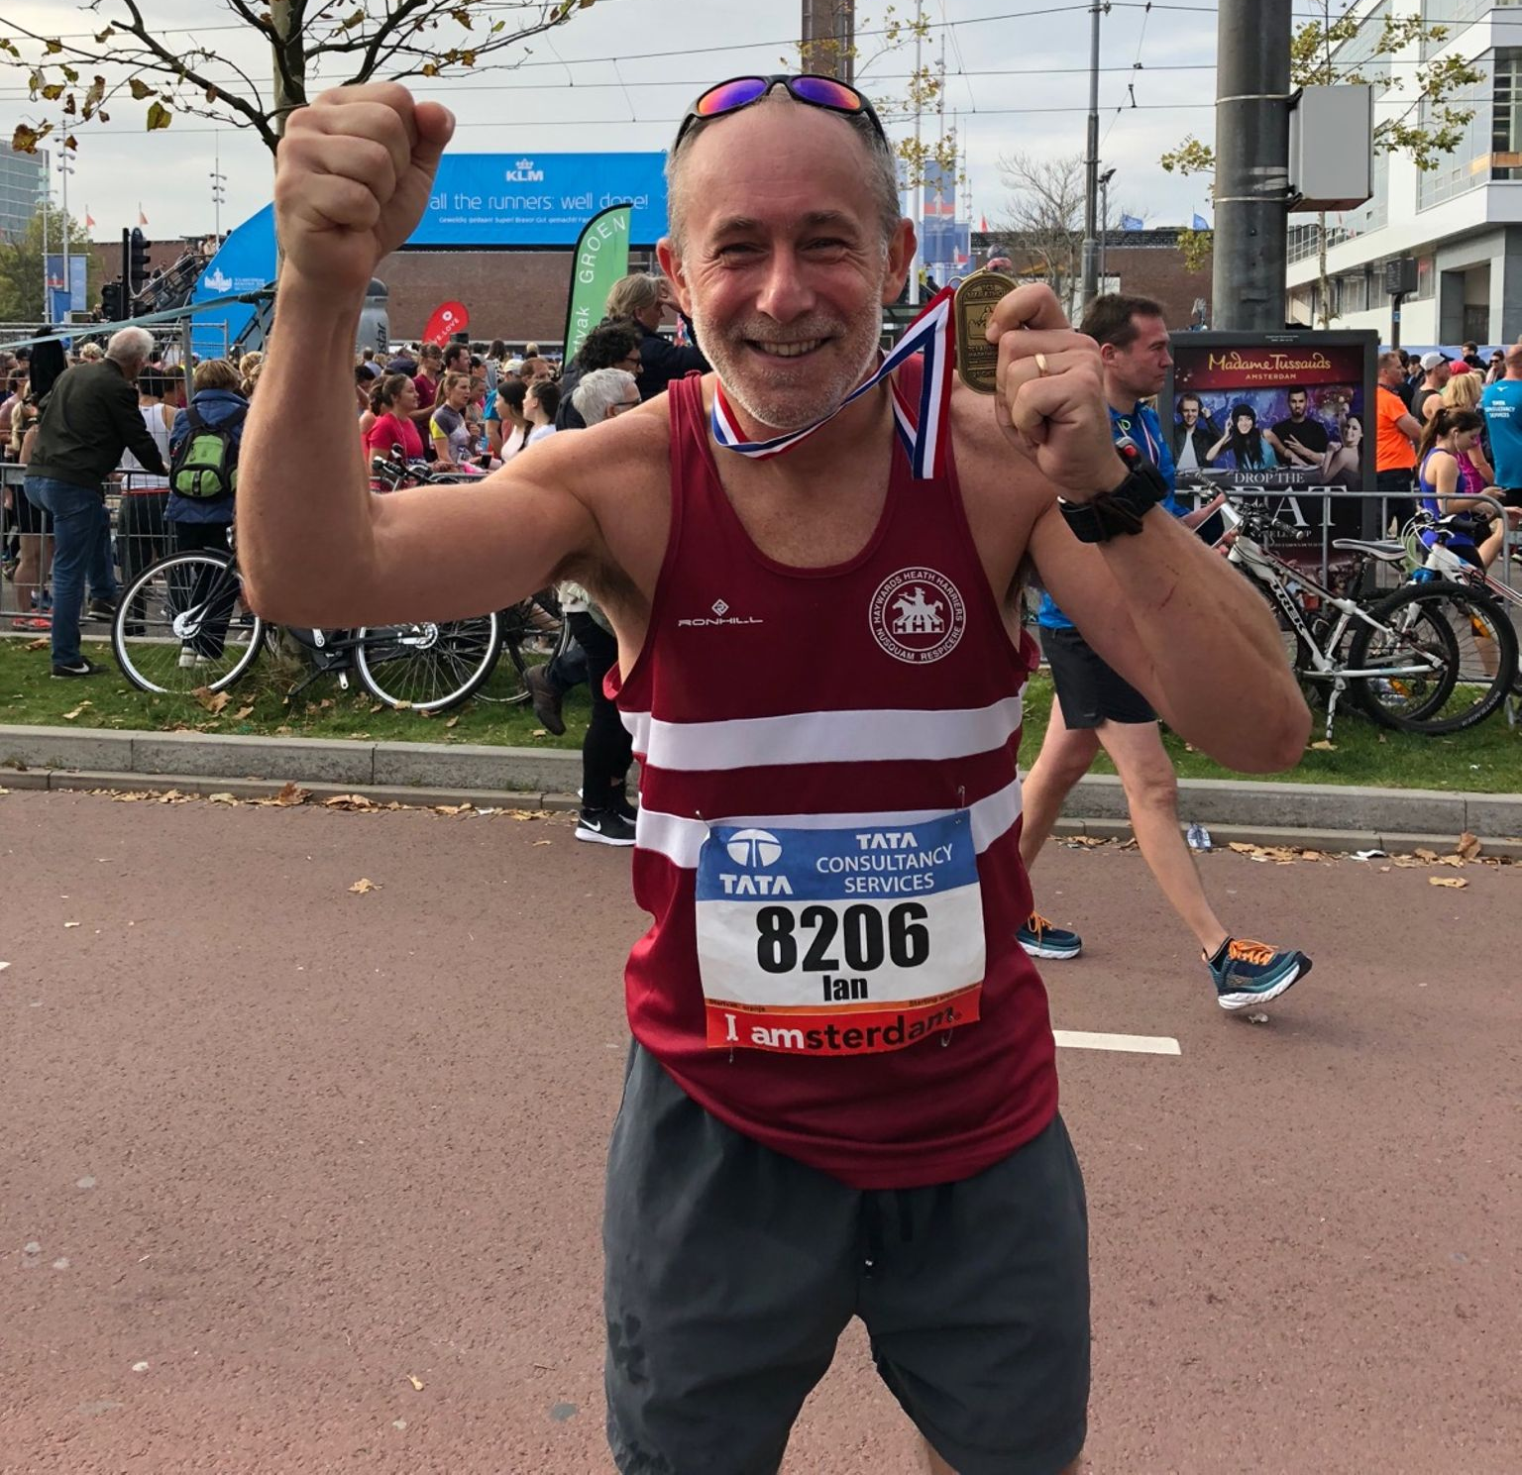
Ian Dumbrell at the Amsterdam Marathon.

A group of Harriers travelled over to Amsterdam for the full marathon and half marathon which was on the 21st October. One of the group, Ian Dumbrell, had a big smile and he had good reason to be happy. As a new Harrier this year, Ian ran a super personal best in the Amsterdam marathon in a super time of 3 hours and 37 minutes and 3 seconds, a 20 minute personal best for the distance!

Ian started running 5 years ago when a shoulder injury put paid to his rugby career. He turned up one Saturday morning at Clair parkrun feeling old, over-weight and very unfit. Ian says, ‘the atmosphere at parkrun is just so supportive, and the team of volunteers and regular runners make you feel like running is the very best thing. It gives you real confidence.’

Ian is now looking forward to running his 200th parkrun in couple of weeks and having joined Harriers at the beginning of this year wants to build on his sparkly new marathon PB with lots of racing in 2019!

Ben Duncan Also ran at the Amsterdam in the marathon. He finished in a super personal best of 2 hours 58 minutes and 48 seconds in 577th place which was his first time under the three hours marker. Ben now must be looking to run even quicker next time after his inspiring run. Another Harrier was Oli Farr who finished in 3 hours and 51 minutes and 2 seconds.

In the Amsterdam Half Marathon, Sarah Banks, finished in 1 hr 49 minutes and 34 seconds in 4171st position.

Harriers go for it at the Steepdown Challenge!!

The West Sussex Fun Run League race called the “Steepdown Challenge” is a five mile hilly race, that was run last Sunday at Lancing Manor. The course taking the runners up the trail paths from Lancing Manor Leisure Centre and onto the South Downs. Haywards Heath Harrier turned up en-mass for a great turn out by the club.

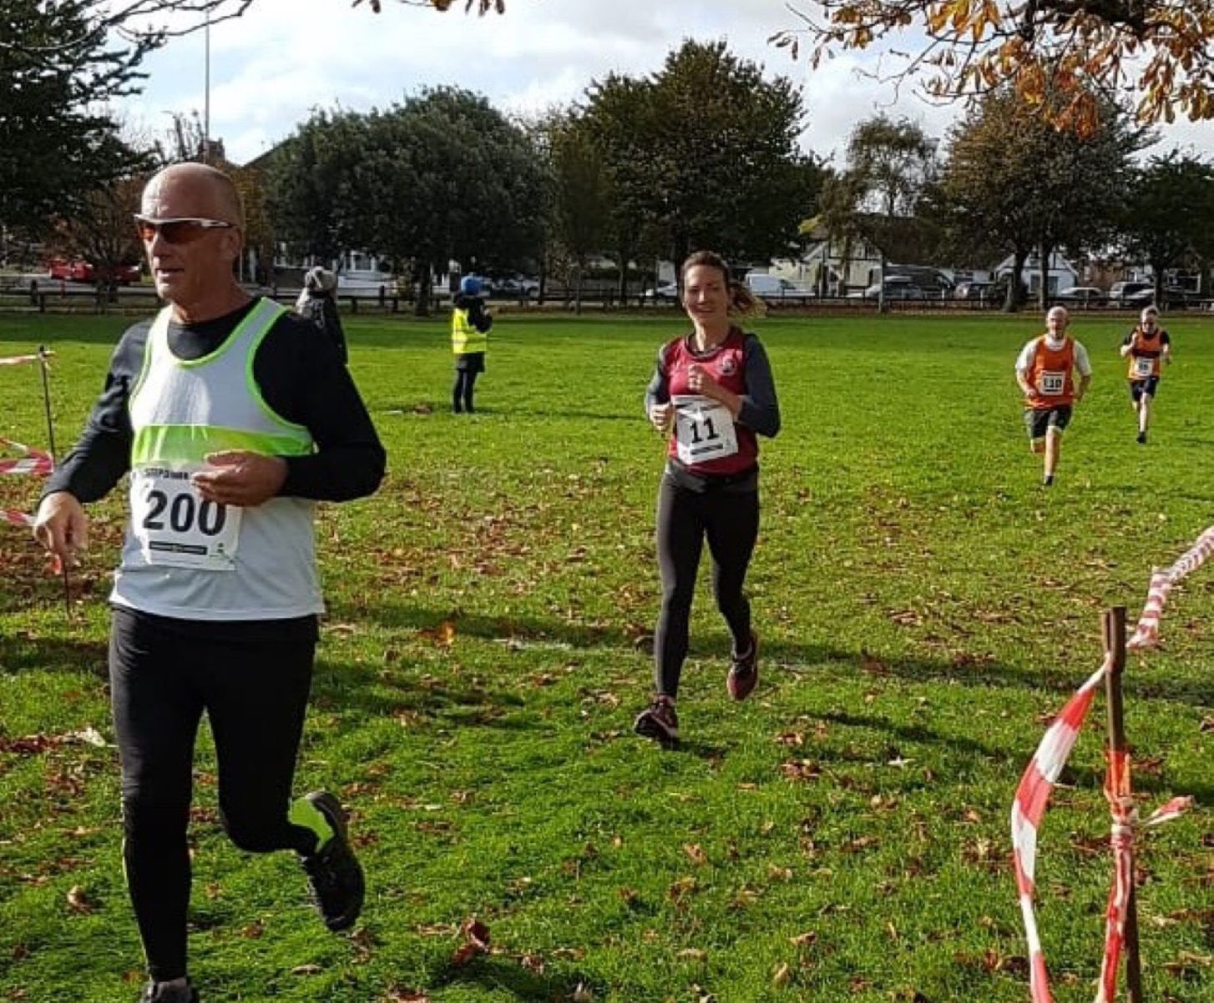
Gemma Morgan at Lancing for the Steepdown Challenge.

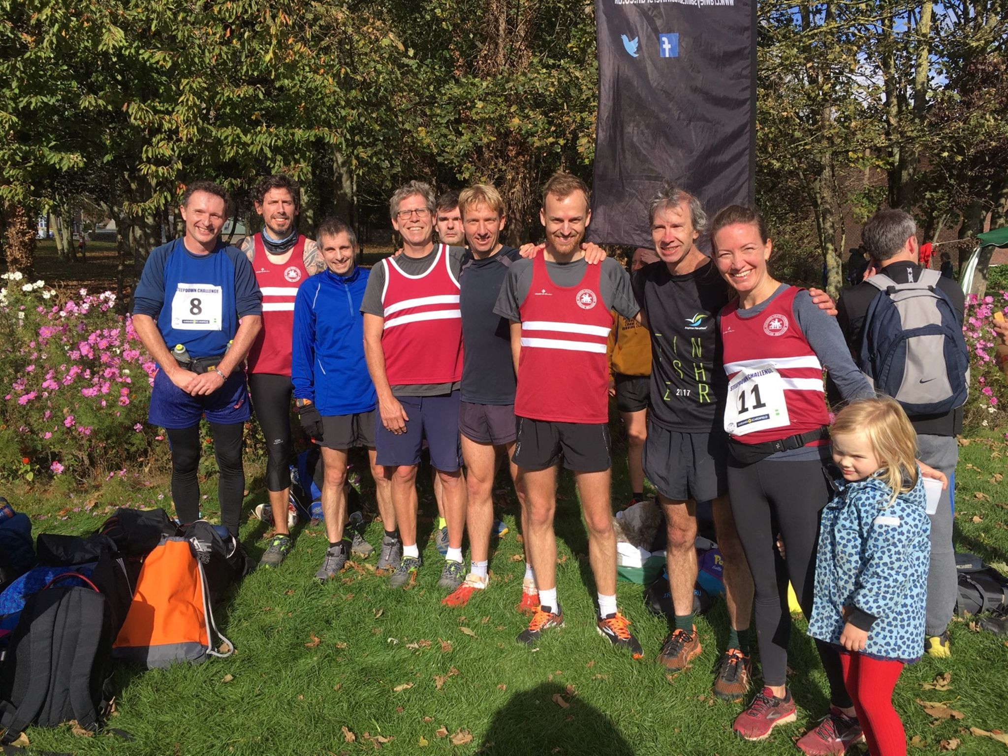
More of Harriers at Steepdown.

Results were:
2nd Marcus Kimmins 30:58, 5th Darren Bird 31:32, 9th Paul Cousins 32:25, 13th Andy Hind 33:05, 20th Julian Boyer 33:49, 25th Nicholas Skov 34:37, 37th Darja Knotkova-Hanley 35:40, 79th Phil Scott 39:02, 122nd Gemma Morgan 42:02, 134th Mark Armitage 42:48, 218th Richard Bates 50:47.

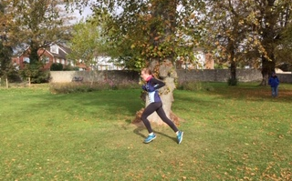
Rosie Beckett in the Junior race.

In the Junior race, Ryan Armstrong won his race in a time of 5 minutes and 27 seconds from second place, Jonathan Beckett, in 5 minutes and 37 seconds. Jonathan who is a Harrier but running today with his sister, Rosie, for Burgess Hill Runners in the fun run league. Rosie finishing as third place girl and 8th place overall in a time of 6 minutes and 22 seconds. Great running from all the young Harriers.

At the Beachy Head last Sunday, the Beachy Head Marathon and Beachy Head 10km race took place. Rob Watts led the team home in the marathon on this hilly course with over 3 thousand feet of climb! This is a marathon with a challenge. With the beautiful backdrop of the South Downs, the runners and walkers experience the testing of such a tough and enduring event as this.

The Beachy Head Marathon results were as follows:
67th Rob Watts 3 hrs 42 mins 04 secs, 240th Gregory Hilton 4 hrs 13 mis 38 secs, 1004th Sarah Banks 5 hrs 16 mins 56 secs, 1284th Steve Navesey 5 hrs 44 mins 56 secs, 1566th Shelagh Robinson 6 hrs 16 mins 00 secs.

In the Beach Head 10km race Ben Gibson finished in second place in 36 minutes and 27 seconds and brother Jamie finished in 5th place in 39 minutes and 19 seconds.

At the 7th K2 Crawley 10km race. Results were:
13th Jack Chivers 41:39, 15th Tim Miller 41:55, 25th Matt Quinton 44:03, 95th Carl Bicknell 51:36.

The previous weekend running included the Worthing 10km race took place. Harrier, John Kettle, was the first finisher though he was running for his first claim club which is Herne Hill Harriers. John ran a season’s best of 34:36. In 4th place was also Harrier, Will Herbert, who finished in 4th place in 36 minutes and 58 seconds knocking nearly 2 minutes of his previous best time.

On the 21st October, the Simply Health Great South Run took place at Bournemouth. The race was a 10 mile road race. Results were:
Bryan Tiller 1 hr 06 mins 42 secs.
Amanda Soper 1 hr 26 mins 28 secs.

