Gibsons steals the show

On a fresh Autumn morning on an undulating course around mid Sussex was the Barns Green Half Marathon and 10 Kilometre races. Harriers had runners in both events. Hannah Gibson ran a super race in the 10 Kilometre race to finish 3rd senior lady whilst her husband Ben, took 5th place in the Half Marathon overall. Katie Morgan also had a fine run and finished 4th senior lady in the Half Marathon. Siobhan Amer also ran a personal best in the Half and improved her club record for her age. Ian Dumbrell a recent newcomer to the club improved his half marathon best by more than 7 minutes. Gemma Morgan was really pleased when she also ran a super time in her half marathon.

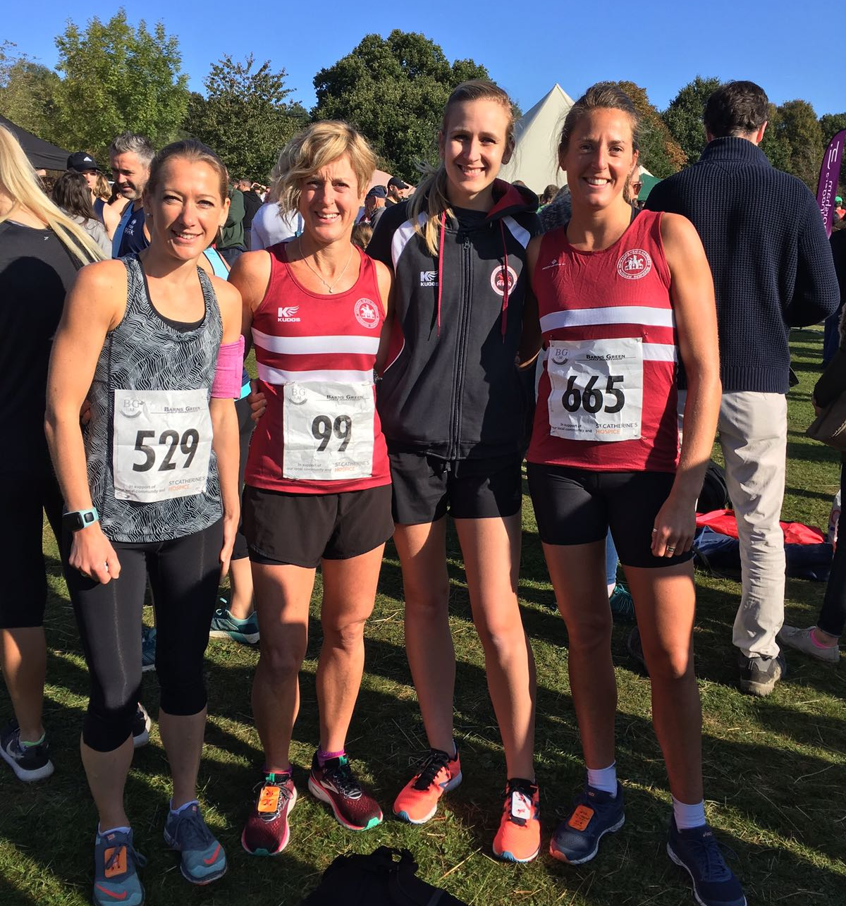
Harrier ladies at Barns Green Half Marathon: (left to right): Georgina Mugridge, Siobhan Amer, Hannah Gibson and Katie Morgan.

In the 10 Kilometre Race, Russ Mullen was the first Harrier home but had to take it steady after feeling unwell but still he managed to finish in 11th place overall.

Results of the 10 km race were:
11th Russ Mullen 38:32, 48th Hannah Gibson 45:13, 112th Eric Hepburn 48:57, 116th Chris Glanfield 49:44, 239th Justine Tanner 56:11, 546th Jenny Denyer 1:15:55.

Results of the Half Marathon were as follows:
5th Ben Gibson 1:16.18 seconds, 18th Paul Cousins 1:23.17, 74th James Bennett 1:29.45, 81st Katie Morgan 1:30.49, 125th Ian Dumbrell 1:35.54, 129th Siobhan Amer 1:35.44, 151st Matt Quinton 1:37.37, 169th Richard Haynes 1:38.49, 267th Georgina Mugridge 1:45.09, 273rd Maresa Pitt 1:45.43, 421st Gemma Morgan 1:52.11.

At the West Sussex Fun Run League on Sunday 23rd September held at Tilgate Forest near Crawley, the Harriers had one of their best turnouts for this league race this year. With ten runners taking part,

Results were as follows:
10th Darren Bird 33:06, 20th Julian Boyer 34:38, 33rd Dave Warren 36:31, 67th Ryan Armstrong 39:59, 74th Dave Harper 40:21, 127th Karen Thompson 44:32, 129th Carl Bicknell 44:55, 145th Michael Essex 46:05, 216th Michael Parish 52:55, 236th Richard Bates 55:03.

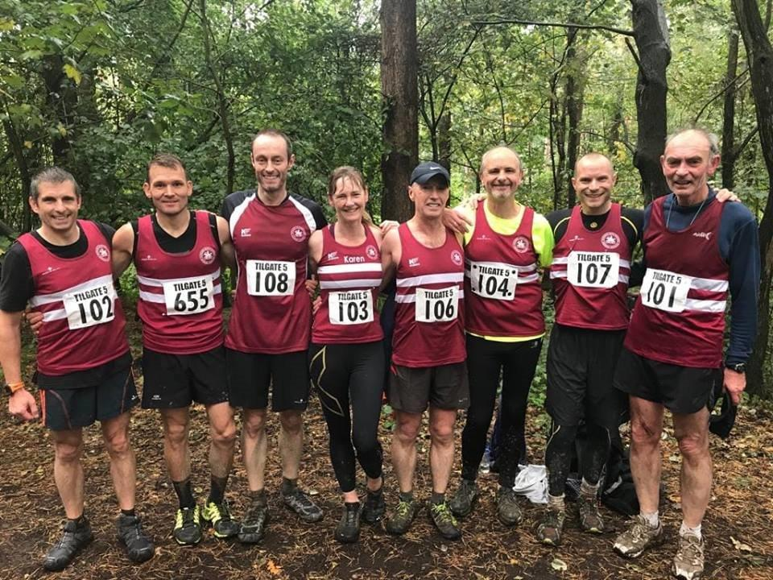
“The Beetroot Army” – Harriers at Tilgate Forest: West Sussex Fun Run League event.

At the Windlesham Whip race over a 4 mile course which is part of the West Sussex Fun Run League last Sunday 30th September, three Harriers competed at this event. Julian Boyer was first home for the club in 7th place with a strong run in a time of 26 minutes and 6 seconds. Next home was Barry Tullet in 18th place in a time of 27 minutes and 47 seconds and next was Richard Bates in 181st place in a time of 41 minutes and 52 seconds.

'If you would like to get involved in coaching at the club, and join a lively team, there are volunteer opportunities available. We need help with Junior and Senior Sprints coaching. Our main training evening is Tuesday.
Expenses will be paid, and qualification costs covered. For further information contact our Head Coach, Mike at email address:
michaelessex@btinternet.com.'

