Middy Report 31 March 2019

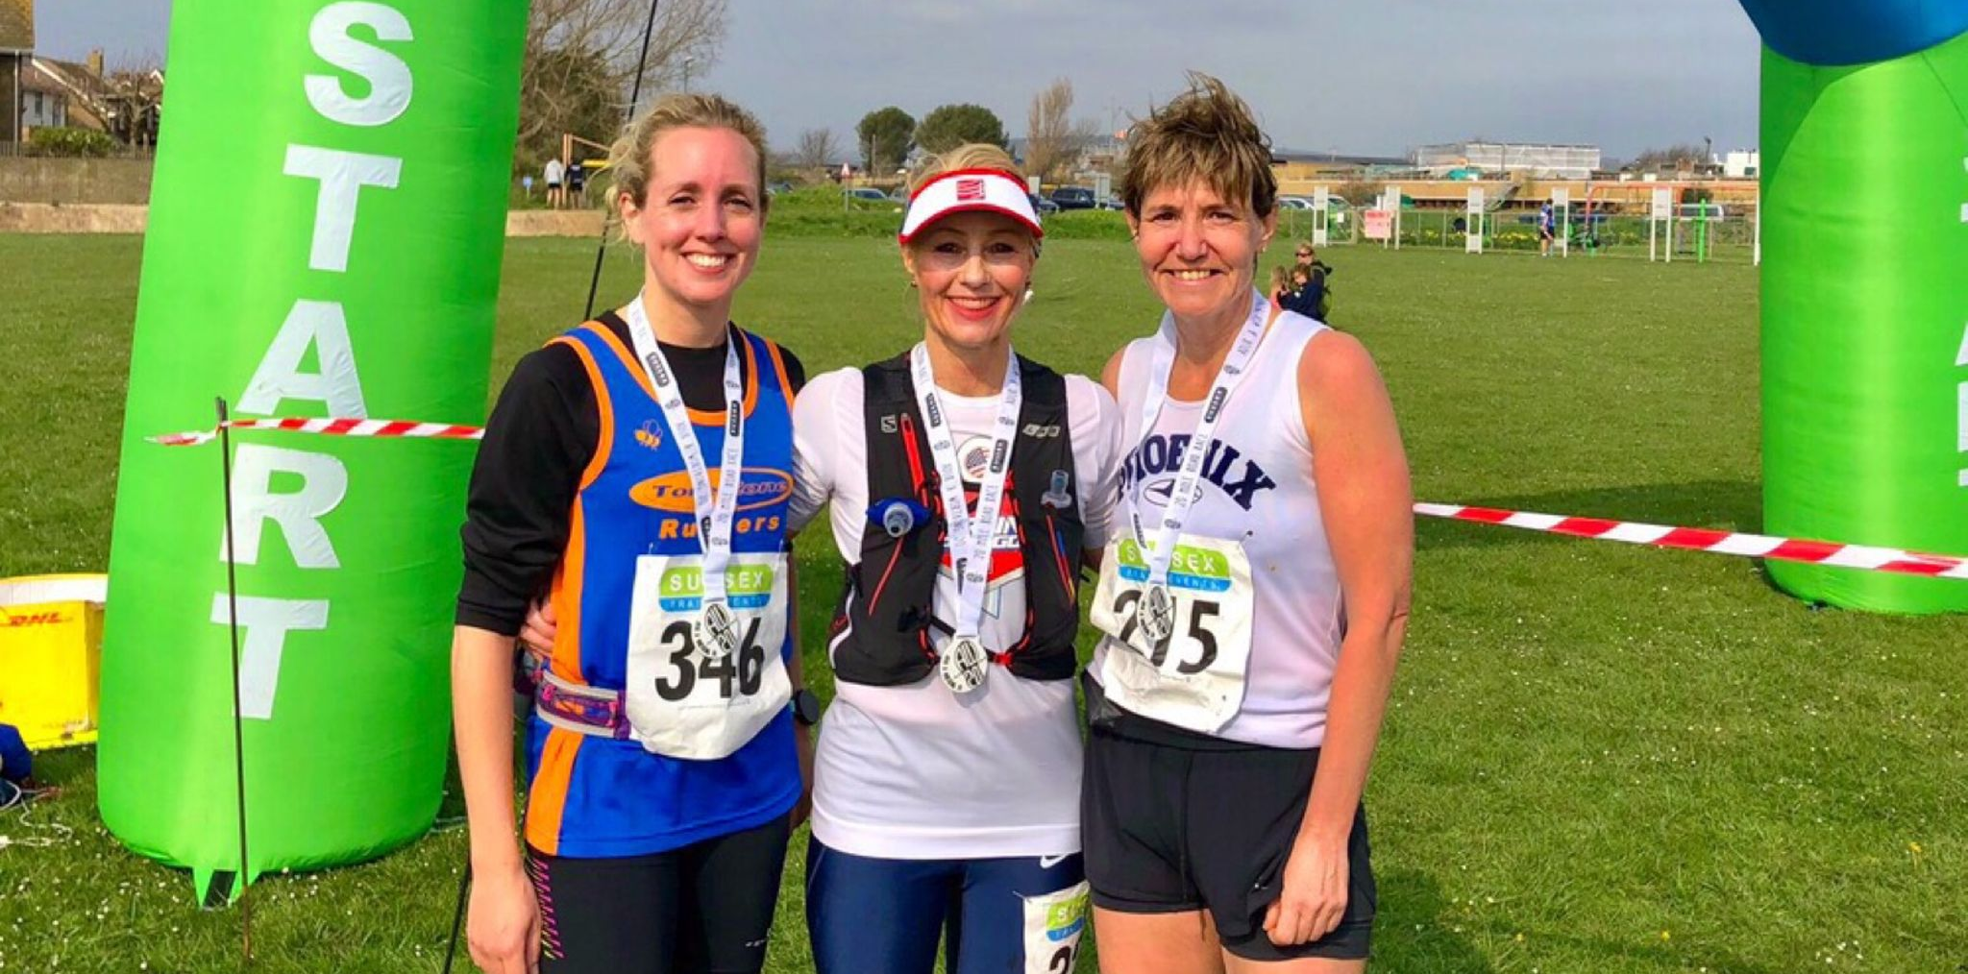
Sam Ridley (centre).

At the AW 20 mile trail race at Adur, near Worthing 2 Harriers ran at this event last Sunday 31st March. Sam Ridley came 37th in a time of 2 hrs 40 mins 38.4 secs. Naomi Cikalo also ran the same event and finished in 41st place in a time of 2 hrs 45 mins 32.5 secs.

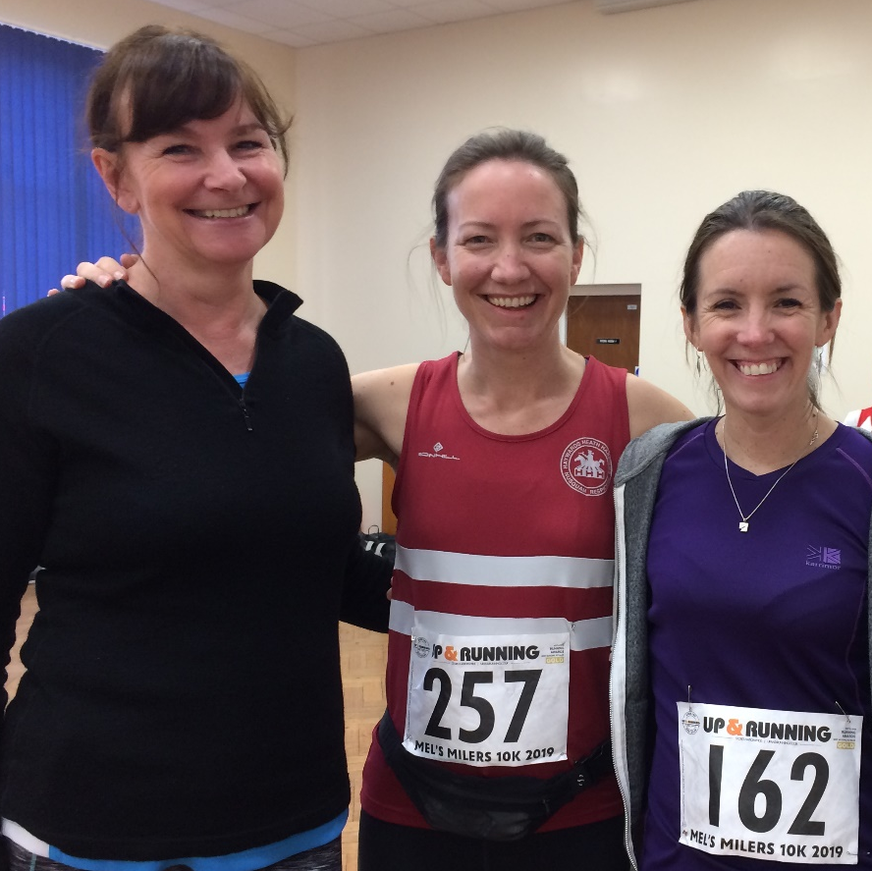
Sarah Heron-Smith with Gemma Morgan and Jane Harbage.

At Mel’s Milers 10km at Horsham on March 31st, 4 Harriers ran in this race starting and finishing in the grounds of Christs Hospital (near Horsham). Results were as follows:
49th Richard Haynes 44 mins 28 secs, 71st Maresa Pitt 46 mins 13 secs, 85th Gemma Morgan 47 mins 22 secs, 369th Jenny Denyer 1 hr 15 mins 35 secs.

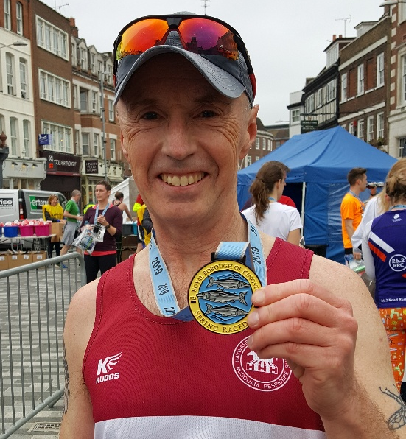
Carl Bicknell

Carl Bicknell ran in the Royal Borough of Kingston Spring Race on Sunday 31 March on a flat breezy course taking in the River Thames and Hampton Court Palace. He completed the unusual race distance of 13.25k in 64 minutes and 54 seconds.

Other Harrier results:

At the 5 mile Balcombe Bull run on Sunday 17 March, Andy Hind finished in 3rd place in 30:57 but was beaten by young Nathan Buckeridge also a Harrier (second claim).

Lydia Levy ran in the Richmond Half Marathon on 17 March and finished in a time of 1 hour 50 minutes and 50 secs.

At the Molyleman Trail Marathon at Lewes on 17 March, two harriers took part in this tough endurance event at Lewes. Michael Burke finished in 16th place in a time of 3 hrs 44 mins 50 secs. Liam Banham-Rayward finished in 145th place in 5 hrs 24 mins 33

At the Hastings Half Marathon on the 24th March many Harriers ran in this annual half marathon by the sea starting at St Leonards and following a clockwise route around the town. Harriers results were:
174th Jack Chivers 1 hr 34 mins 10, 193rd James Bennett 1 hr 35 mins 07 secs, 221st Matt Quinton 1 hr 36 mins 42 secs, 377th Naomi Cikalo 1 hr 42 mins 04 secs, 476th Oli Farr 1 hr 45 mins 24 secs, 671st Amanda Soper 1 hr 50 mins 23 secs, 1032nd Chris Glanfield 1 hr 58 mins 46 secs.

Hot off the press!
Haywards Heath Harriers very own Track & Field Meeting is being held on Thursday 25th April at K2, Crawley. Races for all ages from 9 upwards. Entries accepted in advance or on the night. Please see link below for further information regarding this event:

http://www.haywardsheathharriers.co.uk/

If you’re interested in learning to run, there is the J and M Running group which is linked to Haywards Heath Harriers. J & M are starting another Learn2Run course on 25th April for six weeks. For more information go to groups.runtogether.co.uk/JandMRunning or email Marion at marionhemsworth@aol.com.

