Middy Report for 25.02.18

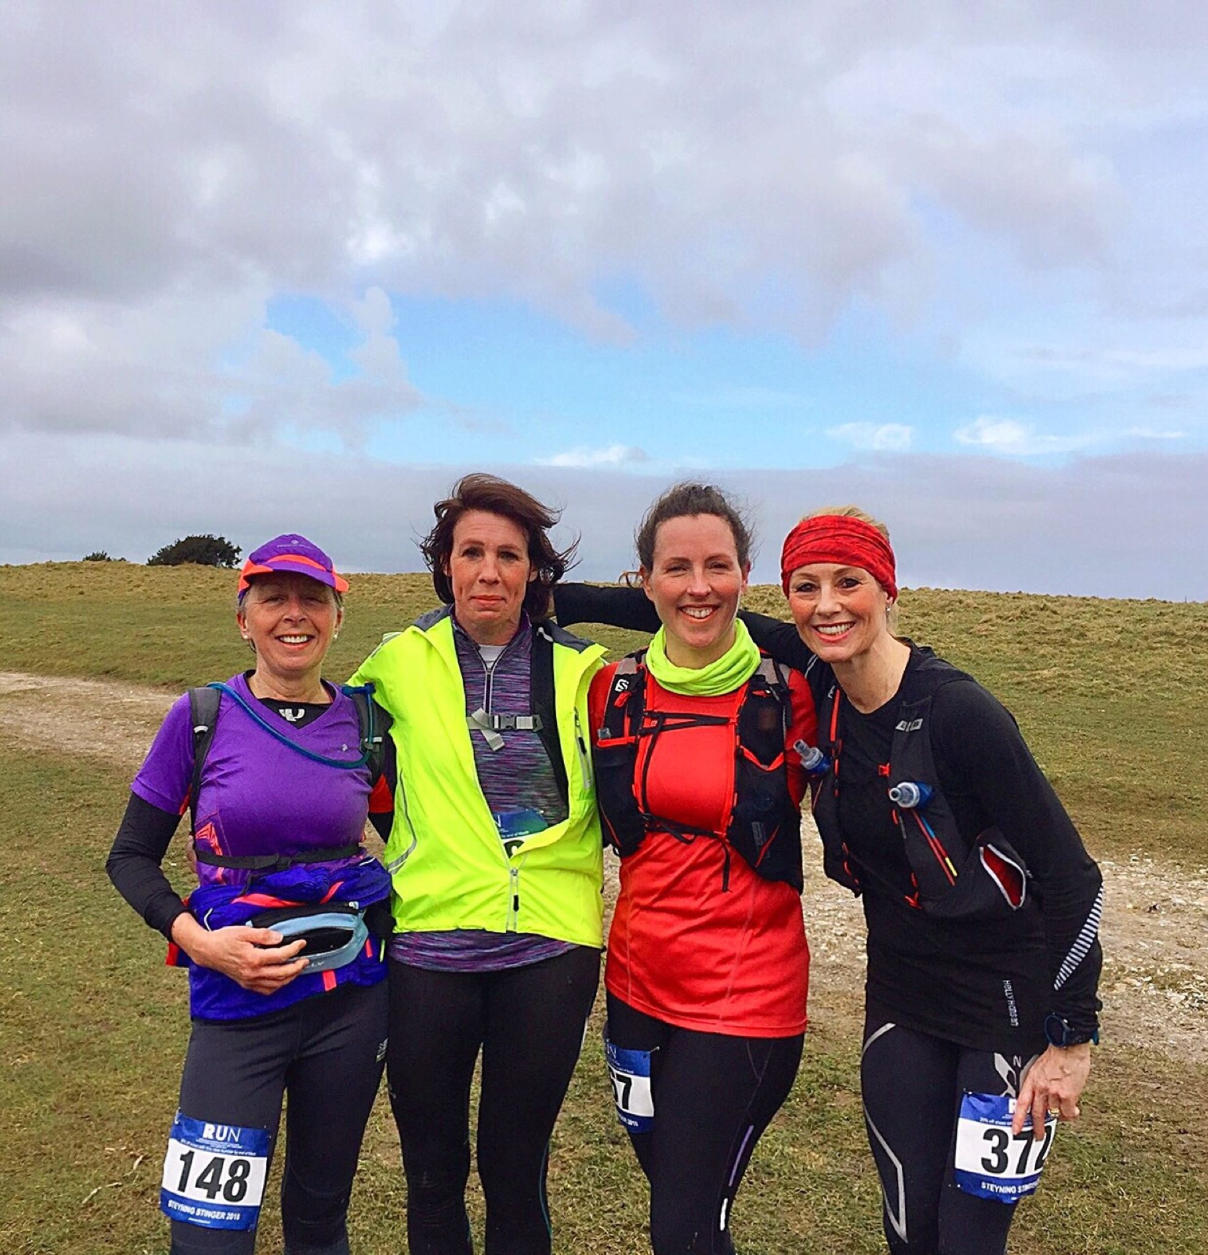

**Runners at the Steyning Stinger Marathon**

Last Sunday a handful of Harriers ventured to Steyning last Sunday for the Steyning Stiner Half and full Marathon. Sam Ridley (far right) and Shelagh Robinson (2nd from right) both ran the full marathon. Sam said that it was one of the toughest marathons that she had completed. The course was “muddy and very slippery.”

In the Steyning Stinger Half Marathon, four Harriers took part: Phil Payne, Carl Bicknell, Kath Buckeridge and Steve Navesey.

Results were from the Steyning Stinger Marathon: 10th Michael Burke 3 hrs 53 mins 55 ses, 97th Sam Ridley 4 hrs 55 mins 22 secs, 175th Shelagh Robinson 5 hrs 53 mins 41 secs.

Half marathon results were: 6th Phil Payne 1 hr 41 mins 44 secs, 119th Carl Bicknell 2 hrs 25 mins 59 secs, 139th Kath Buckeridge 2 hrs 29 mins 53 secs, 173rd Steve Navesey 2 hrs 39 mins 19 secs.

At the Eastbourne Half Marathon on Sunday, 5 Harriers took part. Matt King was first home and came a creditable 10th place on a tough course with a very big hill! Matt’s time of 1 hr 25 mins 07 secs. Other Harriers results were: Darren Bird 1 hr 26 mins 01 secs, James Bennett 1 hr 35 mind 56 secs, Matt Quinton 1 hr 38 mins 35 secs, Chris Glanfield 1 hr 50 mins 38 secs.

At the Brighton Half Marathon on the previous Sunday the 25th February, many personal bests were recorded by the Harriers. In a windy seaside half marathon at Brighton last weekend the Harriers again were besieged with a bagful of personal bests. This is showing that all the winters training out on the roads and in snow and ice are benefitting the runners and from the super coaching sessions from the club is now beginning to pay dividends and a nice harvest of results as we head from the end of the cross-country season in towards the beginning of the marathon season.

Russ Mullen was first Harrier home in 18th place in a new pb of 1 hour 14 minutes and 59 seconds. Emma Navesey was the first Harrier lady home in 9th place and in impressive 1 hour 27 minutes and 10 seconds (a big pb for her). Also, big personal best by Andy Hind and Hannah Gibson and first half marathons for Georgina Mugridge, Carys Hind and Mark Green.

Full Harrier results were:

Russ Mullen 01:14.59 (pb), Ben Gibson 01:15.14 (pb), James Collins 01:17.39, Marcus Kimmins 01:20.15, Jamie Gibson 1:20.35, Matt Cook 01:21.16, Ben Adams 01:25.37, Barry Tullett 01:25.38, Andy Hind 01:26.12 (pb), Mark Green 01:26.23 (pb), Emma Navesey 01:27.10 (pb), Jack Chivers 01:32.42, Hannah Chapman 01:33.21 (pb), Kat Barrett 01:42.57, Georgina Mugridge (PB) 01:43.21, Cary Hind 2:13.59.

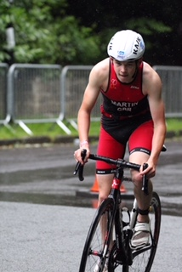

**Joseph Martin**

Also, new information hot off the press is that Joseph Martin has just been named in the England talent squad for the triathlon for age 15 to 18 age group category. Fingers crossed now for a successful season for Joseph!

Also, Joseph Martin and Darja Knotkova-Hanley have been selected to represent Sussex at the English Schools Cross Country Championships at Leeds on 17 March.

Also, congratulations go to James Skinner and Marion Hemsworth both have both been selected for the British Masters 10km to be held at the Simplyhealth Great Birmingham 10k on Sunday 6th May, where they will contest an opposition team. James will compete in the M45 age category and Marion will compete in the W65 age category. Well done both of you!

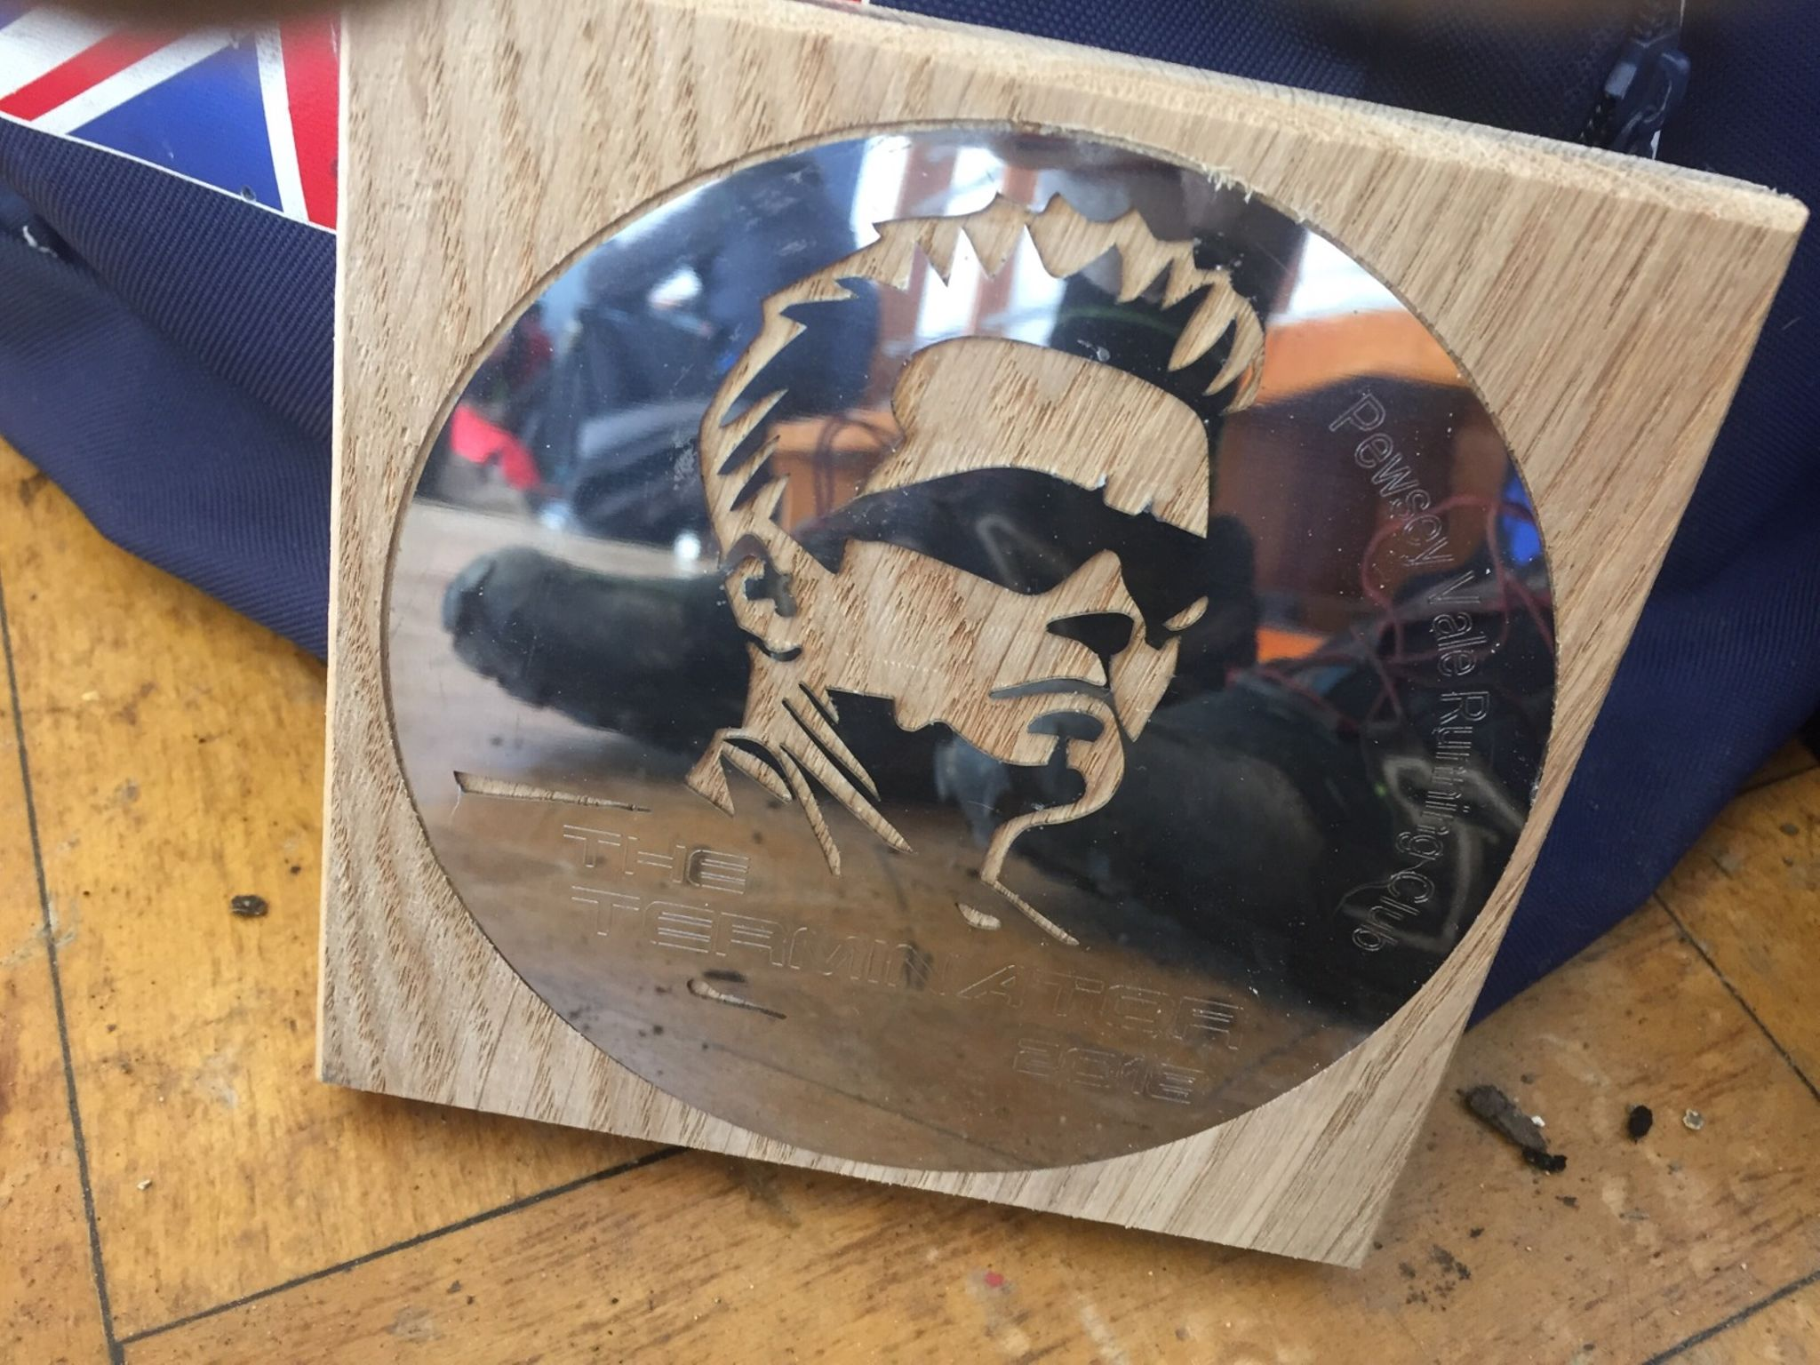

**Phil Payne and Kim Lo at the “Terminator”**

Both Phil and Kim entered this tough event and found that the competition there was rather hot! On a challenging course which involved obstacles, running through a river and running through mud!

Phil finished in 12th position in 1 hr 29 mins and 35 secs.Kim finished in 96th place overall in 1 hr 48 mins and 19 secs.

Haywards Heath Harriers Track and Field Open Meeting

Please note that the Haywards Heath Harriers Track and Field Meeting will be held at on Thursday 26 April 2018 at K2 leisure centre at Crawley. The first event will be starting at 6.00 pm. For an entry form please go to Haywards Heath Harriers web-site at: <http://www.haywardsheathharriers.co.uk/hhhevents.html>. (Entries are also accepted on the night!).