**By Michael Parish.**

**Running, Mental Health and Well-Being.**

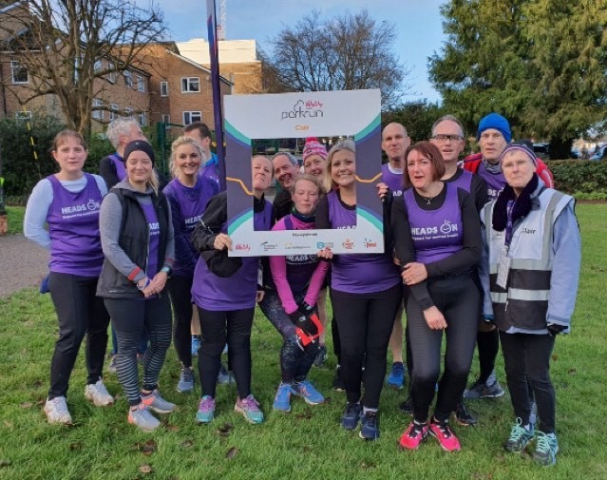

ON TUESDAY 10th December Michael Parish, Marion Hemsworth and Andy Hind from Haywards Heath Harriers met up with Jezza , a Peer Trainer and Alan Jones , a clinician who were co facilitating a session of “One Step At A Time ... Every Step Counts” which is a course teaching the benefits of running for mental and physical wellbeing.  The course is one of many produced by The Sussex Recovery College who's ethos is recovery through learning.

The students are now also part of Heads on Runners which brings together students and staff from The Sussex Partnership NHS Foundation Trust to enjoy running together in run groups, Parkrun and for those that wish more formal races.

The aim was to discuss the mental health benefits from group running and look at the options available for the current NHS group such as Parkrun, beginners running group J & M Running and Haywards Heath Harriers along with the differences between them. One of the aims was to bring both groups together on the Saturday for Clair Parkrun.

This was part of England Athletics #RunAndTalk programme created with the aim of improving mental health through running in England, supported by Mind, the mental health charity getting people talking about mental health and removing the stigma. Supporting people experiencing mental health problems to be physically active through running.

Heads On help people with mental health problems to feel supported and stay active. Living with mental health problems can be life changing, but they believe that with the right support extraordinary things can happen. Heads On say, “We do everything we can to make things better for the people who come to Sussex Partnership for help, providing funding for special projects, patient and family support, pioneering research and the transformation of your local mental health hospitals into more comfortable and welcoming environments.”

Saturday’s Parkrun was cold but dry with 163 runners taking part. Both groups worked together on the 5km endurance run ending the morning with coffee at Waitrose to discuss more about the charity and it’s work. Heads On intends to return to Clair Parkrun in March.

If you would like to know more or donate to Heads On then go to [www.headsoncharity.org](http://www.headsoncharity.org).

**Athletics**

**Jonathan Parkin Scales The Heights.**

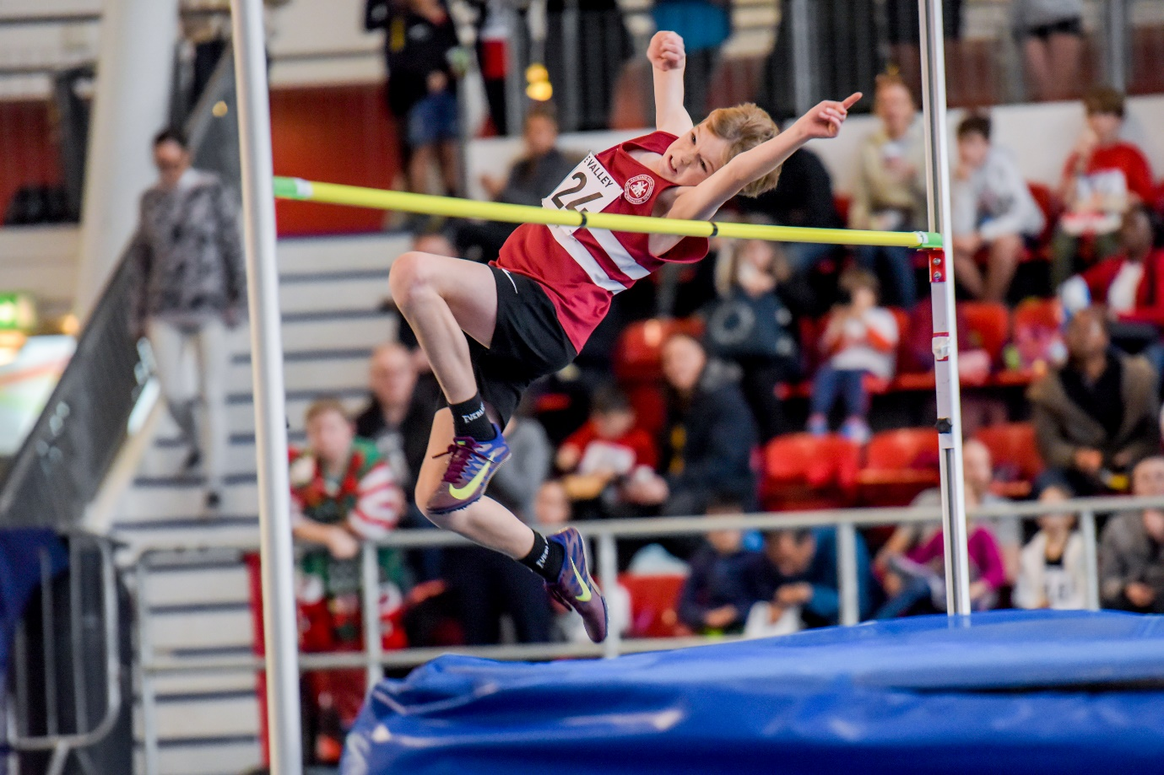

**Jonathan Parkin clearing 1.55m.**

AT Lee Valley on 21 December, Jonathan Parkin competed in the Lee Valley Minithon competition. Jonathan competed in the under 13 age group, His events were the 60 metres sprint race, the high jump and the long Jump. In the high jump he cleared one metre fifty five centimetres which was yet another club record for Jonathan. He ran 9.05 seconds in the 60 metres sprint and long jumped 3 metres and 90 centimetres. His jumping achievements now ranks Jonathan as equal eleventh in Britain in his age group.

**Indoor Sports Hall League.**

At the Sussex Indoor Sports Hall League at Tandridge House School on the 15 December at Horsham there was great jumping by Charlie Parvin in the Standing Long Jump and Charlie Stay in the speed bounce.

Harriers results were as follows:

**Under 11 Girl’s:**

Amelie Ewen: 2nd ‘A’ string 2 lap Sprint 25.0 secs, 3rd A’ string Speed Bounce 51, 4th ‘A’ string Standing Long Jump 1.74m.

Isobel Redd: 4th ‘B’ string 2 lap Sprint 26.7 secs.

Lois Perrett: 4th ‘B’ string Speed Bounce 41.

Anya Cole: 4th ‘B’ string Standing Long Jump 1.68m.

Relay: 4 x 1 Lap relay: 4th HHH 53.1 secs.

**Under 13 Girl’s:**

Siobhan McMahon: 3rd ‘A’ string 2 Lap Sprint 23.2 secs, 4th ‘A’ string Speed Bounce 66, 2nd ‘A’ string Standing Triple Jump 6.57m.

Lucy Barker: 2nd ‘B’’ string 2 Lap Sprint 23.3 secs, 3rd ‘B’ string 4 Lap race 52.6 secs, 3rd ‘B’ string Speed Bounce 65.

Holly Wilkinson: 4th A’ string 4 Lap race 53.7 secs, 4th ‘B’ string Shot Putt 5.21m, 3rd ’A’ string Vertical Jump 52.

B. Crouch: 5th A’ string 6 Lap race 84.4 secs.

Erin Gaston: 4th ‘A’ string Shot Putt 5.93m, 4th ‘B’ string Vertical Jump 38.

Mae Robinson: 4th ‘B’ string Standing Triple Jump 5.51m.

Relay: 8 Lap Parlauf: 5th HHH 1 min 48.0 secs.

Relay: 4 x 2 Lap relay: 4th HHH 1 min 38.3 secs.

**Under 11 Boy’s:**

Miller Hale: 3rd ‘A’ string 2 lap Sprint 24.6 secs, 2nd ‘B’ string Standing Long Jump 1.72m.

Charlie Stay: 4th ‘B’ string 2 lap Sprint 26.3 secs, 1st ‘A’ string Speed Bounce 52.

Noah Seymour: 4th A’ string Standing Long Jump 1.73m, 3rd ‘B’ string Speed Bounce 43.

Relay: 4 x 1 Lap relay: 4th HHH 50.4 secs.

**Under 13 Boy’s:**

Jonathan Parkin: 5th ‘A’ string 2 lap Sprint 23.0 secs, 2nd ‘A’ string Vertical Jump 49, 4th ‘A’ string Standing Triple Jump 5.81m.

Finlay Blythe: 5th ‘B’ string 2 lap Sprint 25.5 secs, 4th ‘B’ string Vertical Jump 34.

Oscar French: 4th ‘A’ string 4 Lap race 52.0 secs.

Oliver Downey: 3rd ‘B’ string 4 Lap race 54.6 secs.

Jacob Roderick: 3rd A’ string 6 Lap race 83.9 secs, 4th ‘B’ string Standing Triple Jump 4.69m.

Jonathan Beckett: 3rd ‘B’ string 6 Lap race 83.3 secs.

George Bonwick-Adams: 3rd ‘A’ string Shot Putt 6.92m, 1st ‘B’ string Speed Bounce 73.

C. Crouch: 2nd ‘B’ string Shot Putt 6.19m.

Jack Bannister: equal 2nd ‘A’ string Speed Bounce 75.

Relay: 8 Lap Parlauf: 3rd HHH 1 min 42.2 secs.

Relay: 4 x 2 Lap relay: 2nd HHH 1 min 35.3 secs.

**Under 15 Boy’s:**

Charlie Parvin: 3rd ‘A’ string 2 lap Sprint 21.6 secs, 3rd ‘A’ string Speed Bounce 75, 1st ‘A’ string Standing Long Jump 2.49m.

Archie Hale: 4th ‘B’ string 2 lap Sprint 22.7 secs, 1st ‘B’ string Standing Long Jump 2.06m, 4th ‘A’ string Shot Putt 5.88m.

Sam Fernley: 4th ‘A’ string 4 Lap race 47.1 secs, 1st ‘B’ string Speed Bounce 73, 4th ‘A’ string Standing Triple Jump 5.56m.

Louis Henry: 4th ‘B’ string 4 Lap race 52.0 secs, 4th ‘B’ string Standing Triple Jump 5.27m, 3rd ‘B’ string Shot Putt 5.11m.

Relay: 4 x 2 Lap relay: 2nd HHH 1 min 30.8 secs.

**Non-scoring:**

2 Lap Races: Lois Perrett 29.8 secs, Anya Cole 25.8 secs, Fenella Halsey 29.3 secs, Asher Fireman 26.8 secs, Ben French 28.8 secs, Cian Gaston 25.7 secs, Noah Seymour 26.1 secs, Ewan Wilkinson 26.6 secs, Sam Harper 25.9 secs, Noah Blythe 29.5 secs, Oliver Cooper 25.2 secs, Ruben Fireman 27.0 secs, Ollie Stay 24.7 secs, Jack Bannister 25.1 secs, C. Crouch 25.4 secs, Adam Beckett 26.5 secs.

4 x 1 lap relay races: HHH 50.4 secs, HHH 51.9 secs, HHH 56.0 secs.

Vertical Jump (under 13 girls): Mae Robinson: 46

Vertical Jump (under 13 boys): Jonathan Beckett 38.

Speed Bounce (girls under 11): Fenella Halsey 40, Anya Cole 48, Isobel Redd 43.

Speed Bounce (boys under 11): Noah Blythe 29, Ben French 41, Sam Harper 42, Ewan Wilkinson 39, Miller Hale 40, Asher Fireman 40, Cian Gaston 42.

Speed Bounce (girls under 13) Mae Robinson 71, Erin Gaston 67.

Speed Bounce (boys under 13) Adam Beckett 45, Oliver Cooper 60, Ruben Fireman 50, Finlay Blythe 61, Ollie Stay 63, Oliver Downey 59.

Standing Long Jump (under 11 girls): Fenella Halsey 1.24m, Lois Perrett 1.29m.

Standing Long Jump (under 11 boys): Sam Harper 1.44m, Cian Gaston 1.42m, Noah Blythe 1.27m, Ben French 1.26m, Ewan Wilkinson 1.35m, Asher Fireman 1.40m.

**Other Harriers results:**

Phil Payne finished 3rd in the Brutal 10 miles race on 28 December. He finished in one hour twenty three minutes and forty nine seconds.