Harriers duo Battle the South Downs Way 50.

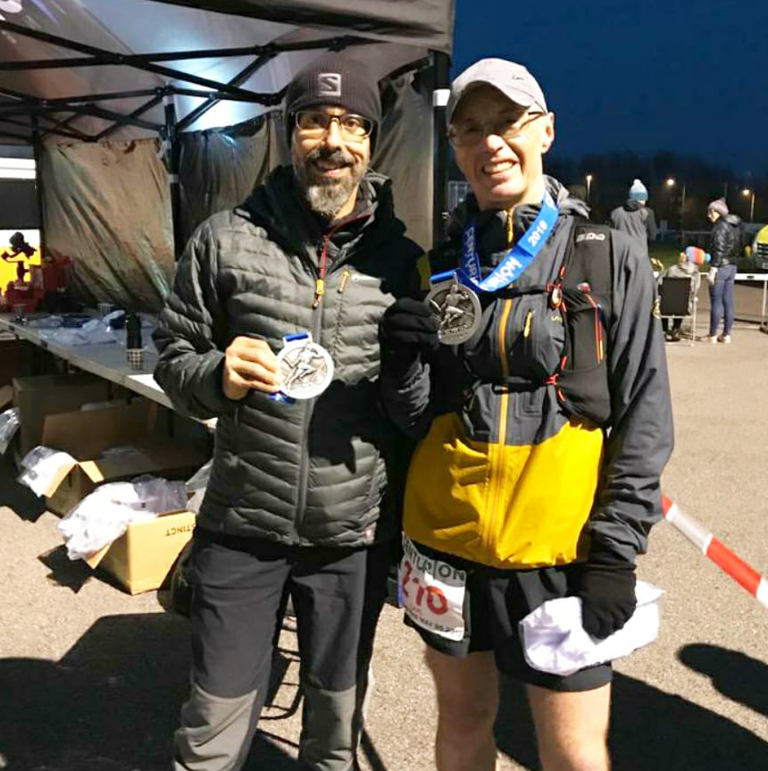
Michael Burke and Carl Bicknell

Two Harriers battled strong headwinds to take part in Centurion Running's South Downs Way 50, from Worthing to Eastbourne almost entirely on the South Downs Way. Michael Burke completed the route in a fantastic 58th place, in a 50-mile personal best time of 8h38m17s. Carl Bicknell fought off some mid-race queasiness to finish in 305th place in 11h41m38s.

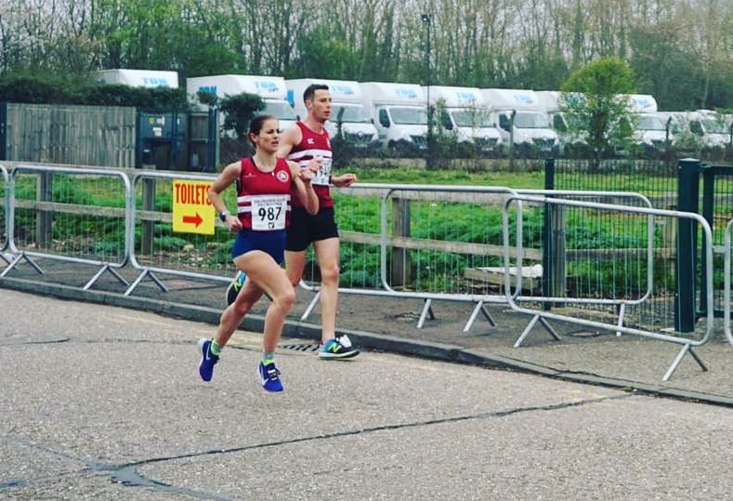
Emma Navesey and Ben Gibson at Paddock Wood Half.

Emma Navesey ran another superb race to finish in second place in the women’s race at the Paddock Wood Half Marathon on 7 April. Her time broke her own Harrier half marathon senior women’s record by a margin of some 23 seconds to run a new best time of 1 hour 22 minutes and 20 seconds. She was paced by Ben Gibson who ran 1 hour 22 minutes and 21 seconds. Other Harriers running were Russ Mullen who finished in 1 hour 18 minutes and 46 second, and Amanda Soper who ran 1 hour 51 minutes and 41 seconds.
Emma with her 2nd place trophy.

Cross-Country:
Arun Khursheed continued his marvellous form when he won the Sussex primary schools cross country championships last week. He was well backed up by Jacob Roderick who finished in third, Oscar French was in fifth place, Jonathan Parkin in eleventh place and Finlay Blythe in twelfth place. Mid Sussex won the team award. Well done young Harriers, you stormed it!

Summer must be near as the first of the track and field open meetings to be held in Sussex took place at K2 Leisure Centre at the Crawley Open Meeting on 7th April. Harriers were represented by some of their aspiring youngsters:

U13 Boys 75m Charlie Bonwick-Adams 11.26 seconds.
U13 Girls 75m Lucy Barker 11.61 seconds.
U13 Boys 150m George Bonwick-Adams 23.73 seconds.
U13 Boys 150m Charlie Bonwick-Adams 22.39 seconds.
U13 150m Girls Lucy barker 23.44 seconds.
U13 Long Jump George Bonwick-Adams 3.65m.
U13 Girls Long Jump 2.98m,

7 April at the Manchester Marathon, 3 Harriers finished this flat marathon, arguably the flattest marathon course in Europe. Kim Lo was the first home in 3 hours 23 minutes and 29 seconds. Oliver Farr was next home and he ran a personal best time in his 32nd marathon of 3 hours 49 minutes and 10 seconds. He was closely followed by Bryan Tiller also in a personal best time of 3 hours 53 minutes and 56 seconds. Well done guys!

Hot off the press!
Haywards Heath Harriers very own Track & Field Meeting is being held on Thursday 25th April at K2, Crawley. Races for all ages from 9 upwards. Entries accepted in advance or on the night. Please see link below for further information regarding this event:

http://www.haywardsheathharriers.co.uk/

If you’re interested in learning to run, there is the J and M Running group which is linked to Haywards Heath Harriers. J & M are starting another Learn2Run course on 25th April for six weeks. For more information go to groups.runtogether.co.uk/JandMRunning or email Marion at marionhemsworth@aol.com.

