**The Redwood Run**

**(by Michael Parish).**

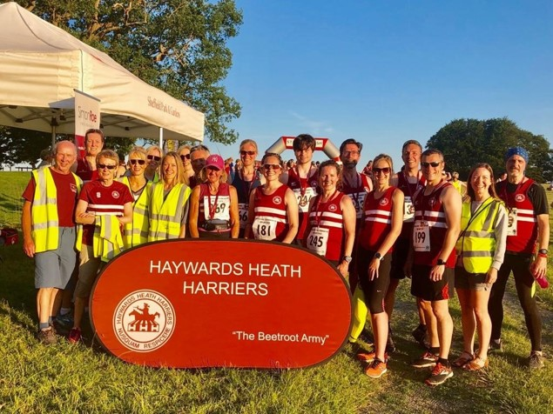

**Harriers at the Inaugural Redwood Run.**

Wednesday 3rd July was the inaugural Redwood Run at Sheffield Park National Trust property in Maresfield. The event, hosted by Haywards Heath Harriers, was managed by Marion Hemsworth and Ian Dumbrell and run under England Athletics rules. Sheffield Park is the second Sussex National Trust property to host running events with the Harriers already having the Willows as an established run at Wakehurst Place (part of Kew Gardens) in Ardingly.

The run was attended by the many runners from across Sussex as well as other clubs and non club runners. The route started from the front entrance to Sheffield Park Gardens and went around fields before entering the bottom of the National Trust property. It went around the cricket pitch and towards the lakes before coming up to the main exit for the park and gardens then turning back towards the bottom exit and back across the fields to the finish line.

The run was a real test of ability and muscle endurance running on grass, asphalt, flint and woodchip surfaces. Along the way there were field and kissing gates to get through and small bridges that elevated the runners above the areas being protected for wildlife. As with any National Trust property it was beautiful and scenic and a joy to run through.

The race was won by Ben Short of Horley Harriers in a time of thirty minutes and six seconds. The first female runner to finish was Claire Daniel of Hassocks Community runners in a time of thirty eight minutes and eleven seconds.

Race positions: 4th Jamie Gibson, 31.39; 5th Matt King, 32.27; 11th Gregory Hilton, 36.12; 15th Stephen McNulty, 36.52; 30th Mark Sykes, 39.52; 43rd Verity Coombes, 41.46; 46th Lydia Levy, 42.10; 63rd Amanda Soper, 44.13; 70th Kath Buckeridge, 44.42; 75th Kai Robinson, 45.04; 102nd Shelagh Robinson, 47.59; 169th Michael Parish, 53.26; 250th Maureen Rea, 63.53.

**Track & Field Results:**

At the Sussex Under 15 Track and Field League meeting at K2 in Crawley on 5 July, of the several Haywards Heath Harriers the athletes that took part, there were some super results with lots of personal bests by the youngsters from all the hard training they have been doing.

**Boys:**

Charlie Parvin: 100 ‘A’ string 4th 13.4 secs (pb), 3rd Long Jump ‘A’ string 4.47m (pb).

Louis Henry: 4th 100m ‘B’ string 15.6 secs, 6th Shot Putt ‘A’ string 4.45m.

Rory Dalgliesh: 2nd 300m ‘A’ string 44.3 secs, 1st 1500m ‘B’ string 4:52.2 secs (pb), 1st Long Jump ‘B’ string 4.26m (pb).

Sam Fernley: 1st 1500m ‘A’ string 4:48.6 secs (pb).

4 x 100m: 3rd HHH 56.7 secs.

**Girls:**

Amy Rutherford: 5th ‘High jump A’ string 1.20m.

On Saturday 15 June, the senior men and women were competing at Lewes with Lewes Athletics Club in the Southern Athletics League as a combined team. On a very hot day, they finished in first place out of five teams. The results were as follows:

**Men:**

Simeon Cousins: 1st ‘B’ string 100m 12.2 secs, 1st ‘B’ string 200m 24.1 secs.

Russ Mullen: 3rd ‘B’ string 5000m 19:45.3.

Tim Popkin: 1st ‘A’ string 2000m s/c 9:14.0.

Ethan Lambert: 1st ‘B’ string LJ 4.79m,

Mike Bale: 2nd ‘B’ string SP 6.44m, 4th ‘A’ string DT 18.54m, 2nd ‘A’ string Hammer 26.55m, 4th ‘A’ string JT 17.97m.

**Women:**

Lucie Venables: 3rd ‘A’ string 200m 31.6 secs, 2nd ‘A’ string 400m 74.6 secs, 1st ‘A’ string 100m Hurdles 21.1 secs, 1st ‘A’ string 400m Hurdles 85.40 secs.

Karen Thompson: 1st ‘A’ string 800m 3:12.3 secs, 2nd ‘B’ string HJ 1.25m, 3rd ‘B’ string JT 9.76m.

Emma Navesey: 1st ‘A’ string 3000m 10:38.7 secs.

Jenny Denyer: 4th ‘A’ string SP 5.40m, 3rd ‘A’ string DT 15.41m, 2nd ‘B’ string Hammer 16.31m, 4th ‘A’ string JT 12.22m.

**Non-scoring:**

John Palmer: 100m 15.0 secs, 200m 30.6 secs

Ethan Lambert: 100m 13.2 secs.

Tim Popkin: 800m 2:36.2 secs.

**Other Harrier results:**

Darja Knotkova-Hanley set a new 5000 metres personal best time of 18:44.07 (U20 Club Record) at the Open Meeting at Finsbury Park on 28th June.

At the Bewl 15 mile race on Sunday 7th July, 8 Haywards Heath Harriers ran in this undulating trail race. Chris Smith was first home in a wonderful third place in a time of one hour twenty nine minutes and nine seconds. Other Harrier results were:

74th Jack Chivers 1 hr 52 mins 00 secs, 189th Matt Quinton 2 hrs 4.mins 23 secs, 204th Siobhan Amer 2 hrs 4 mins 35 secs, 304th Oli Farr 2 hrs 15 mins 29 secs, 395th Amanda Soper 2 hrs 24 mins 26 secs, 475th Andrew Wilson 2 hrs 27 mins 23 secs, 515th Shelagh Robinson 2 hrs 35 mins 24 secs.