'If you would like to get involved in coaching at the club, and join a lively team, there are volunteer opportunities available. We need help with Junior and Senior Sprints coaching. Our main training evening is Tuesday.
Expenses will be paid, and qualification costs covered. For further information contact our Head Coach, Mike at email address:
michaelessex@btinternet.com.'

As the weather has now changed to autumn, so has the end of the track season finally ended in the last few weeks. Road running with marathons and half marathons have begun to take over with the cross country season not too far behind, starting next week with the Sussex County Cross Country Relays at Goodwood.

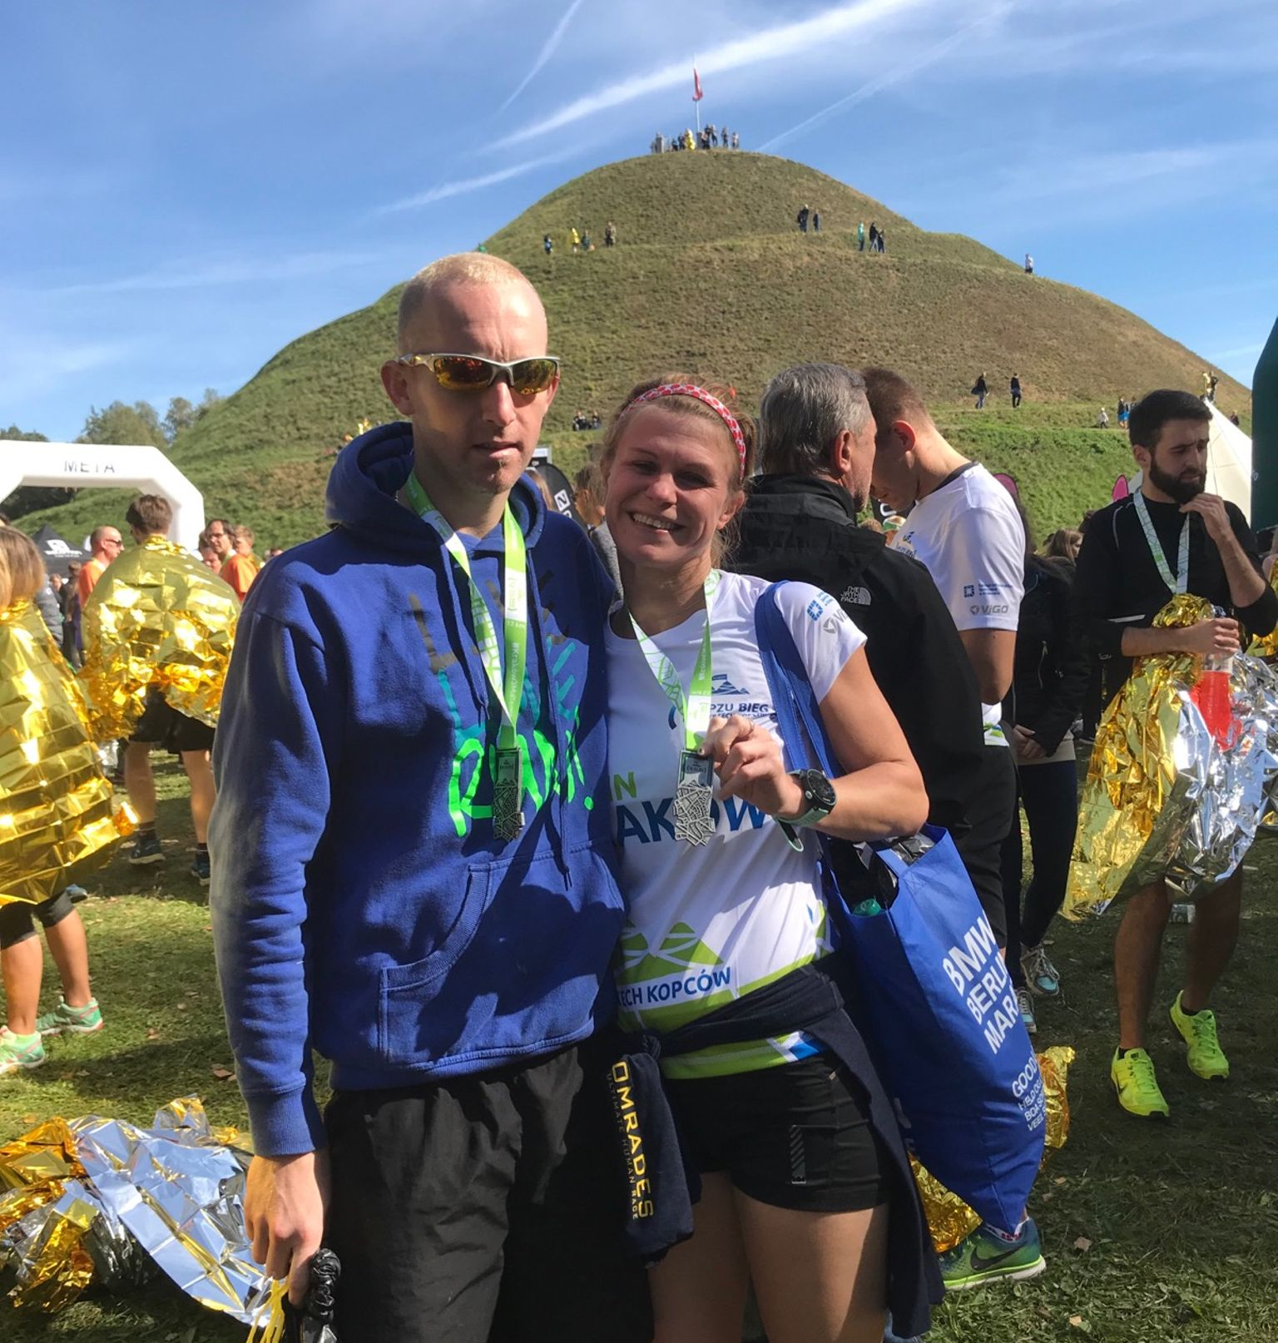
Phil Payne and Kim Lo.

Kim and Phil both ran last weekend in Poland at the Trzech Kopcow Krakow race - 3 mounds city ‘fell’ run 14th F 3rd F30 in 59:12, covering 1,032 feet in climb this was a testing course. Phil finished in 55:57.

At the Bright 10 mile race held in Brighton last Sunday were represented by 8 Harriers. Personal bests were broken galore in this fast and furious 10 mile road race. James Skinner in his first ever 10 mile road race was first home for the club in 53 minutes and 51 seconds ran himself into a new overall Harrier 10 mile record usurping the legendary David Peel’s record of 55 minutes and 20 seconds set back in 1984 by an amazing 1 minute and 29 seconds. He also knocked 8 minutes 13 seconds off the previous age Vet 45 to 49 record in the club!

Emma Navesey also ran herself into the Harrier record books when she finishes the race in a new personal best of 1 hour 4 minutes and 6 seconds bettering the previous senior women’s and overall club record that was set by Izzy Coomber in 2014 by 53 seconds, Izzy who previously held the record in a time of 1 hour 4 minutes and 59 seconds.

Results were as follows:
9th James Skinner 53 mins 51 secs (pb), 21st Russ Mullen 58 mins 40 secs (pb), 50th Will Herbert 1 hr 2 mins 09 secs (pb), 65th Emma Navesey 1 hr 4 mins 6 secs (pb), 122nd Jason Russell 1 hr 8 mins 52 secs, 156th Rob English 1 hr 10 mins 27 secs (pb), 364th Eric Hepburn 1 hr 20 mins 4 secs (pb), 668th Beth Quittenton 1 hr 30 mins 18 secs.

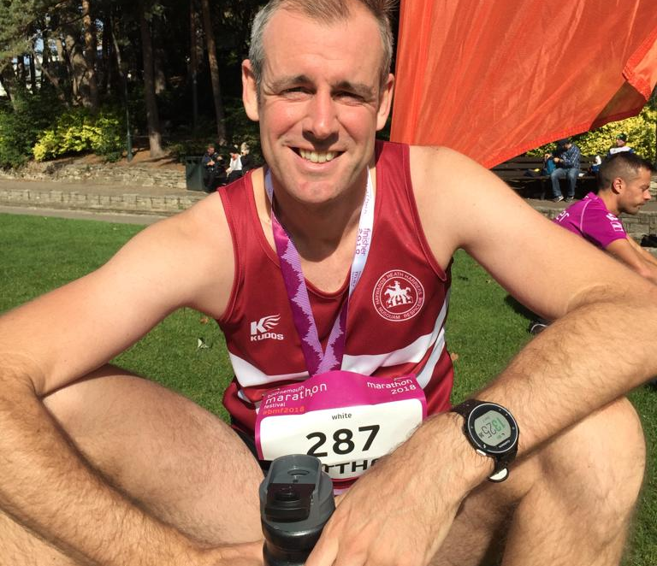
Matt King after his 3 hour 3 minute marathon.

At the Bournemouth Marathon on 7 October Sam Ridley had a great run and ran herself into a new club record for a V50 lady and a personal best time of 3 hours and 26 minutes and 51 seconds. She was also the first over 50 lady finisher.
Matt King also ran a personal best by over 14 minutes with a time of 3 hours and 3 minutes and 42 seconds. Naomi Cikalo was next to finish in 3 hours and 46 minutes and 31 seconds. Oliver Farr also ran a personal best time of 3 hours and 49 minutes and 23 seconds improving by exactly 4 minutes. Clare Kenward and husband Graham both ran in the marathon, Clare finishing in front of Graham in a new personal best time of 3 hours 55 minutes and 54 seconds to Graham’s time of 4 hours 15 minutes and 15 seconds.

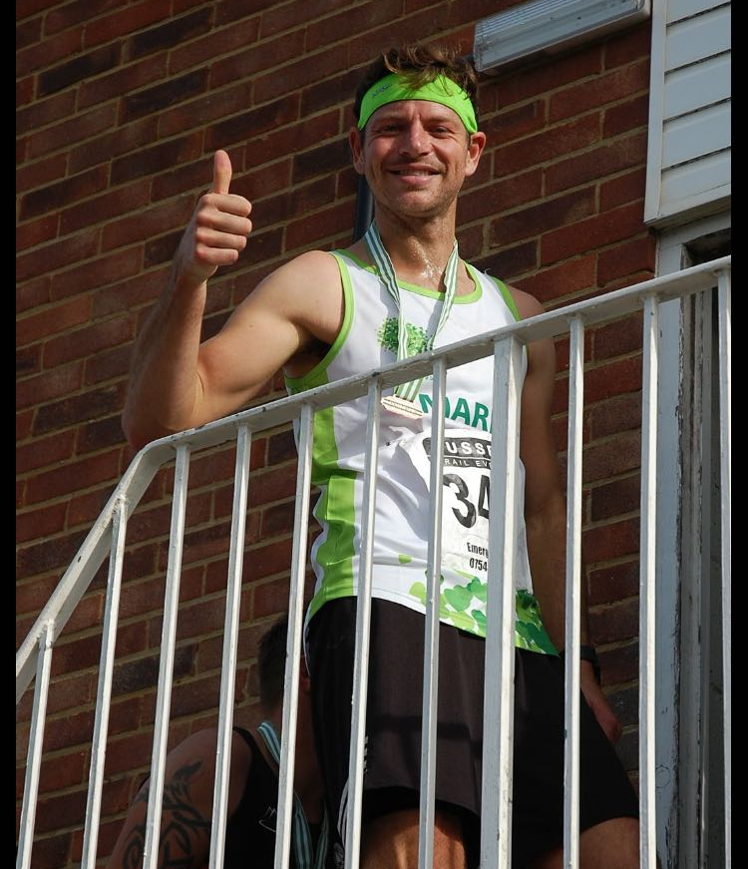
Ultra runner: Mark Green.
Mark Green ran in the Downs Link ultra which is an ultra race over 38 miles. Mark finished in 25th position in a time of 6 hours and 10 minutes and 41 seconds.

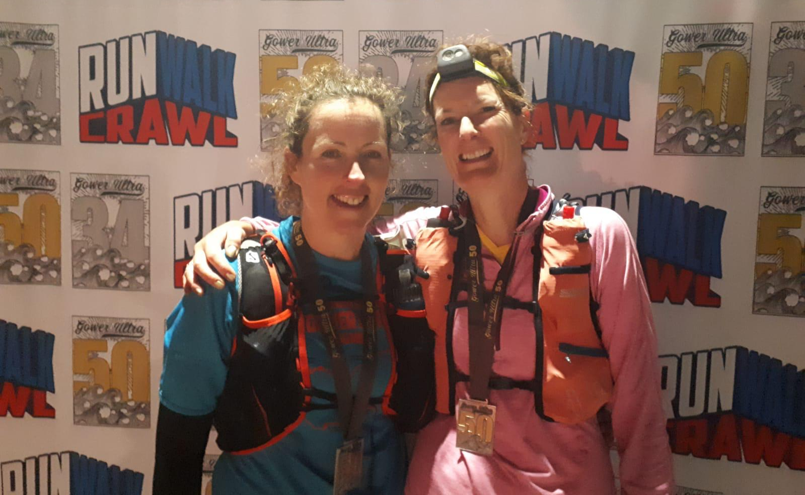
Ultra ladies: Shelagh Robinson and Kath Buckridge.
Shelagh Robinson and Kath Buckridge both ran in the Gower 50 which is a 50 mile ultra race in South Wales at the weekend.

In the 10km race at Bournemouth, the following Harriers finishers were:
132nd Matt Quinton in 43 minutes and 0 seconds with Chris Glanfield finishing in 467th place in 50 minutes and.35 seconds and Jacqueline Barnes finishing in 52 minutes and 18 seconds in 568th place.
In the Half Marathon, Matt Quinton and Chris both ran this race too. Matt finishing in 445th place in a time of 1 hour 38 minutes and 47 seconds and Chris finished in 1224th place in a time of 1 hour and 51 minutes and 48 seconds.

East Grinstead 10km on Sunday 30 September
Jack Chivers 38:47 was first harrier home in 38:47 and then followed by Sarah Hamilton in a big personal best of 55:31. Well done Sarah!!

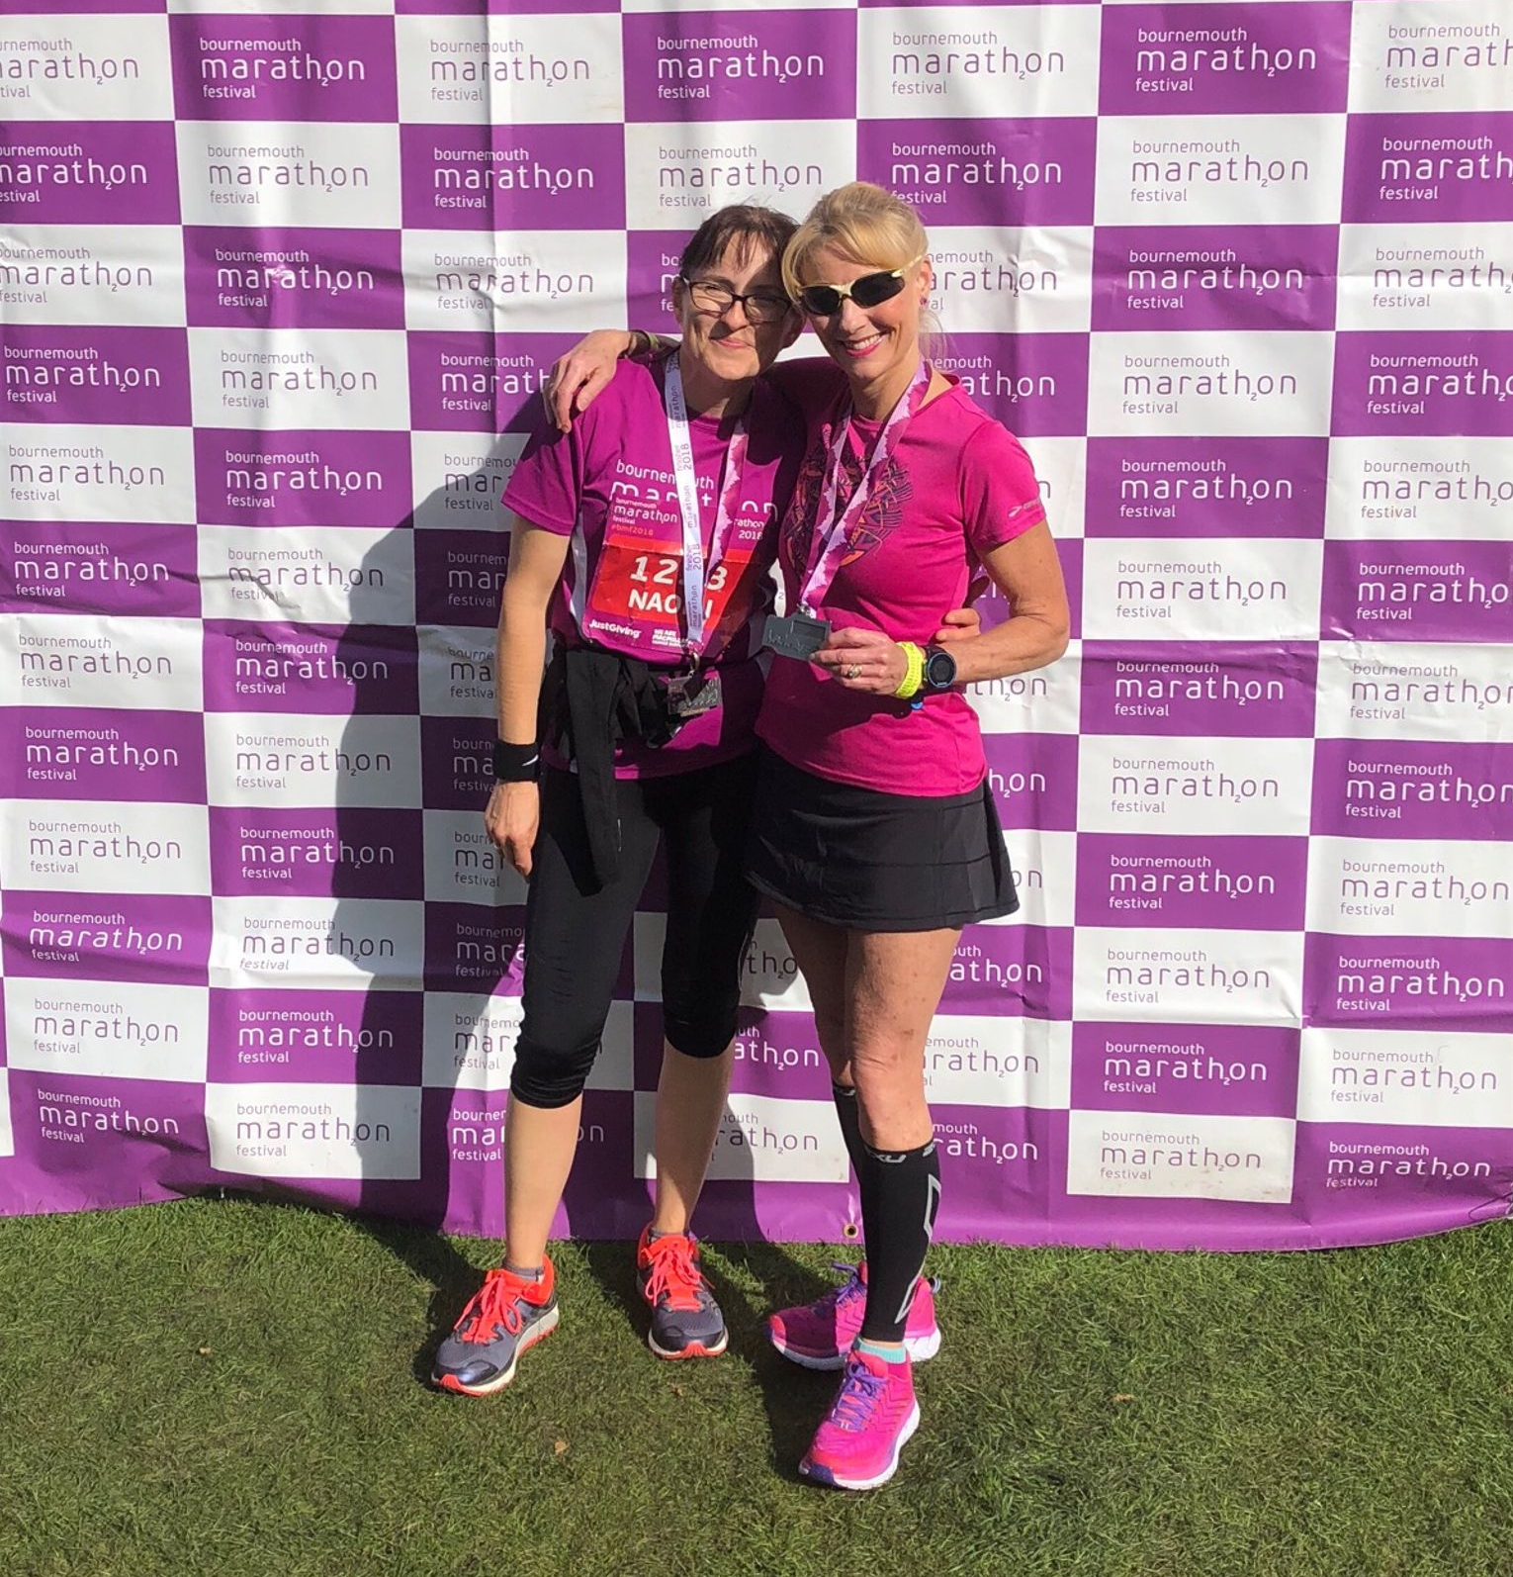
Naomi Cikalo and Sam celebrate at the Bournemouth Marathon.

