Middy report 09.07.17 and 16/7/17.

PHOENIX 10KM

Last Wednesday 12th July, a goodly number of Harriers took part in the Phoenix 10km on Brighton & Hove seafront. The Harriers came away with a bagful of Sussex county medals. They won 1st team place in Senior Men’s race with fine performances by Phil Radford in 10th place in 32.54, Russ Mullen in 18th in 33:51 and James Skinner in 21st in 33:58 together beating in the process Brighton & Hove City A.C. and Brighton Phoenix to get the gold. James Skinner won silver medal in the O/40’s race and Marion Hemsworth winning bronze in the O/60’s race. Other Harriers finisher were Ben Gibson 35th in 35:04, Ben Duncan 62nd in 37:04, Matthew King 63rd in 37:09, Tom Mullen 71st in 37:34, Oliver Gibson 91st in 38:45, Jason Russell 131st in 40:12, James Bennett 142nd in 40:35, Matt Quinton 158th in 41:42, Emma Navesey 177th in 42:16, Colin Brackenbury 230th in 44:04, Hannah Chapman 259th in 44:48, Bryan Tiller 284th in 45:36, Oliver Farr 329th in 47:28, Chris Glanfield 354th in 48:45, Sarah Banks 373rd in 49:10, Marion Hemsworth 436th in 52:29 and Peter Cobbett 471st in 54:39.

LEWES SAL

On Sunday 9th July, Haywards Heath Harriers ladies and men were combined as a team with Lewes Athletics Club in the Southern Athletics League at Lewes and won the team event. Super results all round especially in the Long jump with Christian Lambert jumping a huge personal best improving his previous best from 5m29 to 5m90 for 3rd place. Christian also ran in the 110mHurdles coming 2nd in the ‘A’ string with 23.7 secs and ran in the 100m non-scoring event in 12.4 secs.

**PICTURE: Lucie Venables**

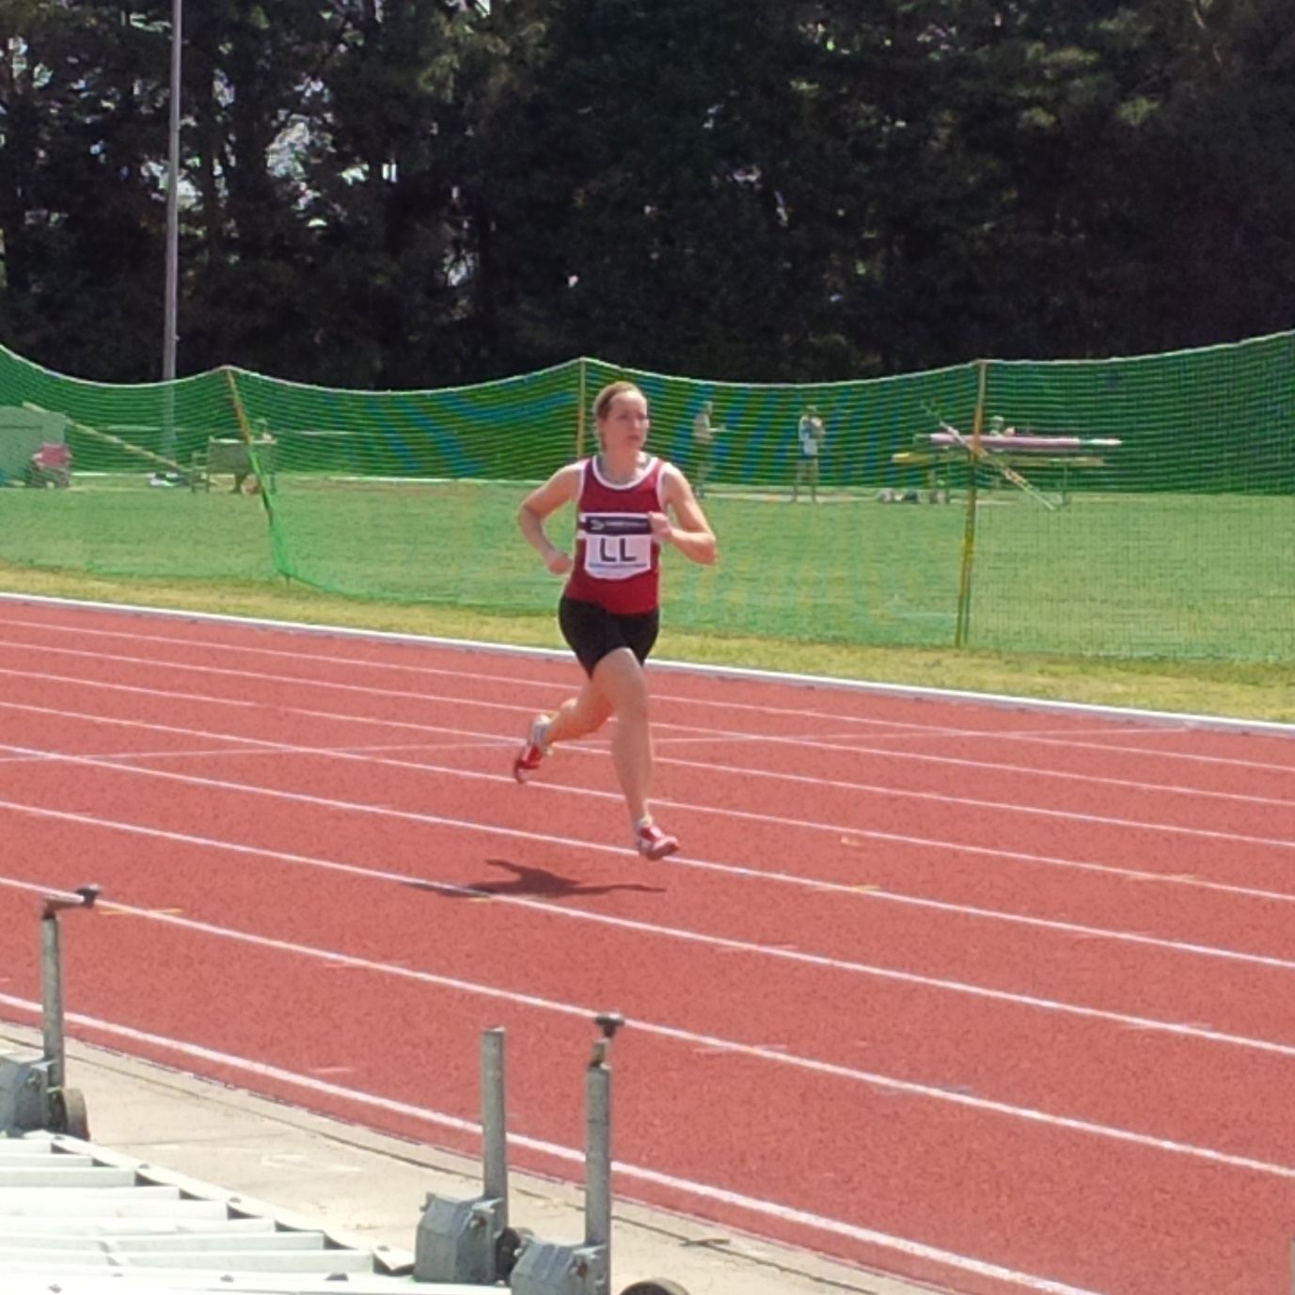

Other results from Harriers were: Simeon Cousins 2nd 200m ‘A’ in 23.1 secs (pb), 1st 400m ‘A’ in 53.8 secs.

Russ Mullen 2nd 800m ‘A’ in 2:13.3, 3rd 1500m ‘A’ in 4:42.6 secs and 1st 3000m ‘A’ in 9:22.7 secs.

Dan Blain 1st 1500m ‘B’ in 4:47.6 secs.

Tom Mullen ran n/s in the 1500m in 5:03.2 and 10:15.6 secs in the 3000m.

Ben Gibson in the 4:37.5 secs1500m and 1st 3000m ‘B’ in 9:45.7.

Paul Cousins 3000m s/c (1 lap short) 2nd in 10:16.6 secs.

Tim Popkin 2nd 3000m s/c (correct distance) in 13:20.0 secs, 800m n/s 2:29.1 secs.

Scott Ridley n/s 400m in 58.6 secs (pb).

In the Women’s events results were:

Katie Grant 2nd 100m ‘A’ in 13.6 secs, 1st 200m ‘A’ in 27.9 secs (pb)

Lucie Venables 1st 400m ‘B’ in 75.9 secs, 2nd 100mH in 20.7 secs, 2nd 400mH ‘A’ in 82.2 secs.

Jacqueline Barnes 1st 1500m ‘B’ 6:48.2 secs, 1st 5000m ‘B’ in 25:04.9 secs.

BEACH RUN

Last Wednesday, 12th July, was the Beach Run which is held at Littlehampton. The race is over 5 miles on an out-and-back course, heading eastwards on Littlehampton Beach. Harriers did well with 3 in the top ten.

**PICTURE: BEACH RUN (2 pics)**

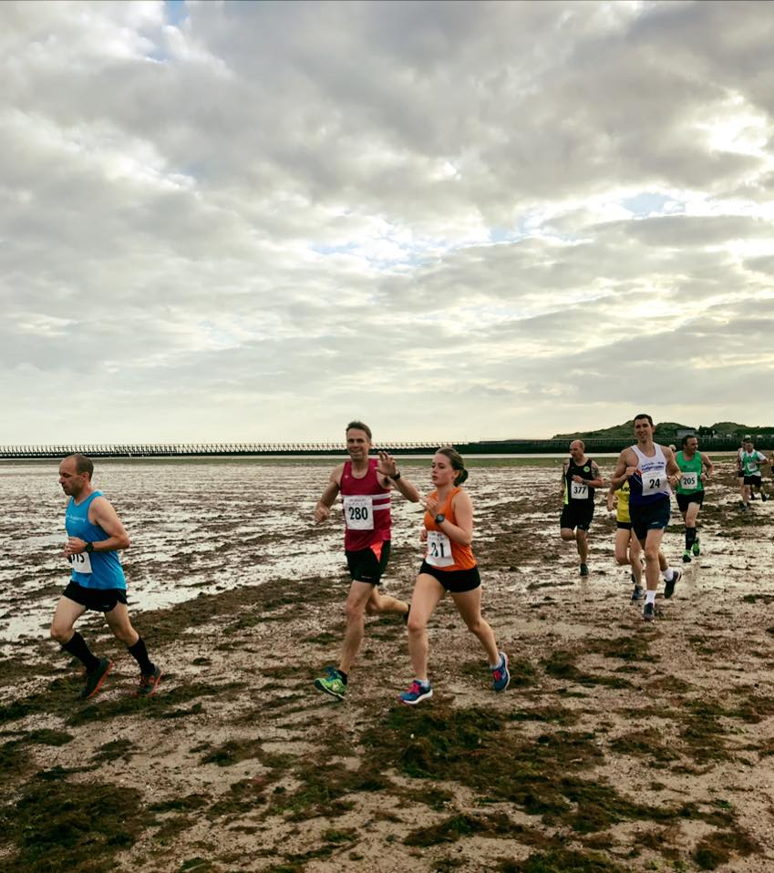

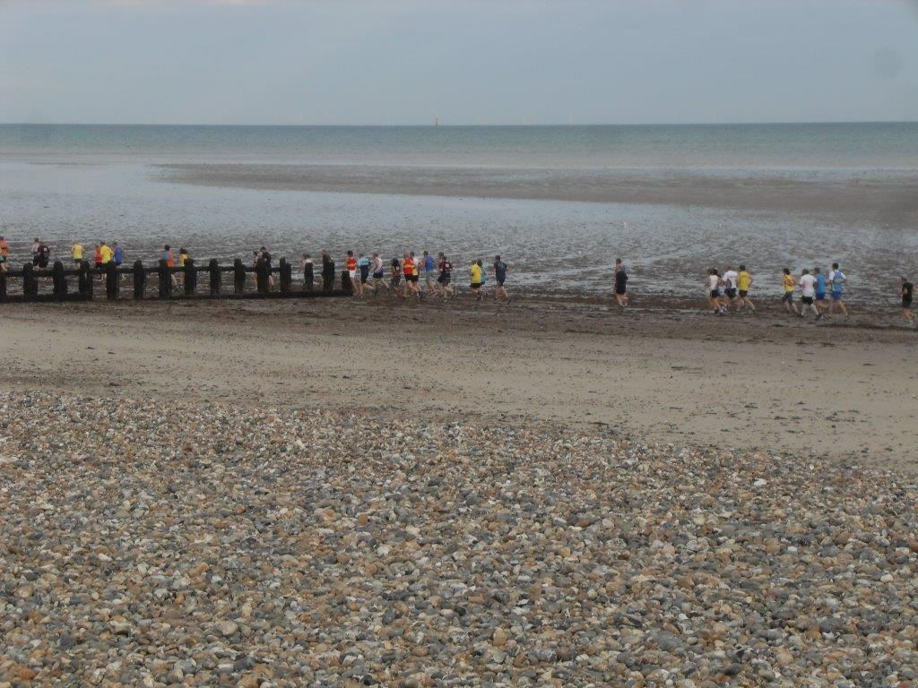

Harriers results were as follows: 4th Phil Payne in 29:19, 7th Paul Cousins in 30:13, 10th Nick Jarvis in 30:36, 27th Julian Boyer in 32:20, 46th Barry Tullett in 33:58, 84th Mark Armitage in 36:01 and 336th Richard Bates in 50:01.

QUAD-KIDS

**PICTURE: QUAD KIDS:**

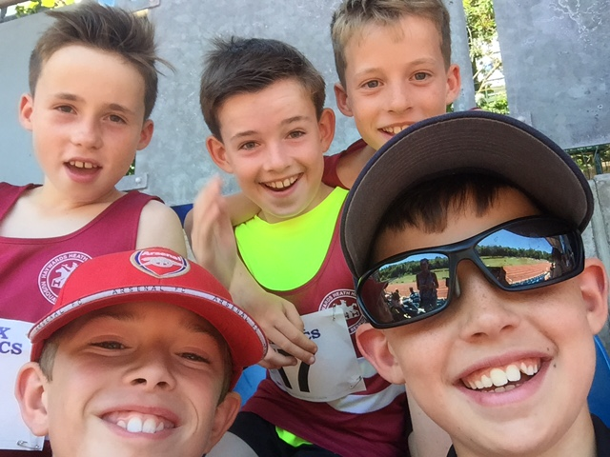

On Sunday 9th July, 9 U11 Haywards Heath Harriers took part in the Sussex U11 QuadKids Championships at Withdean Stadium, Brighton.  Competing in 4 events (150m, 600m, Vortex Howler and Standing Long Jump), the athletes scored points according to their times/distance and then the athlete with the highest points score won.  There was a fantastic performance in the Boys competition from Charlie Bonwick-Adams, who was the quickest on the day over the 600m in a time of 1.52, and finished in 5th place overall.  He was closely followed by brother George, who was the further thrower in the Vortex Howler competition with 34m70, and finished in 8th place overall.  Also competing was Thomas Pearce (15th overall),  Micah Papadopoulos (27th overall), Harry Russell (28th overall), Lewis King (34th overall) and Noah Perrett (36th overall).  In the Girls competition, Ruby Stedman finished 21st and Maia Bliss-Tomlinson 33rd.

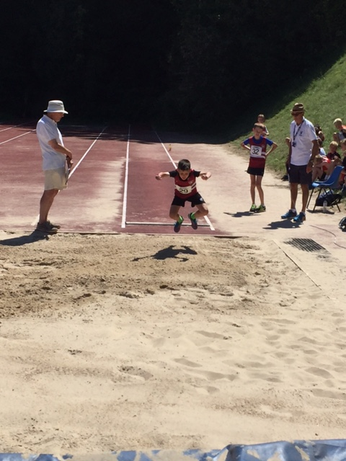

The individual results are as follows:

Charlie Bonwick Adams: 150m: 11.6 600m: 1.52, Vortex Howler: 26m10,Standing Long Jump: 1m84

George Bonwick-Adams: 150m: 12.8, 600m: 2.02, Vortex Howler: 34m70, Standing Long Jump: 1m76

Thomas Pearce: 150m: 12.0,  600m: 2.15, Vortex Howler: 24m90, Standing Long Jump: 1m87

Micah Papadopoulos: 150m: 12.8, 600m: 2.14, Vortex Howler: 27m30, Standing Long Jump: 1m46

Harry Russell: 150m 12.4,: 600m: 2.04, Vortex Howler: 13m00, Standing Long Jump: 1m69

Lewis King: 150m: 12.6, 600m: 3.01, Vortex Howler: 29m40, Standing Long Jump: 1m59

Noah Perrett: 150m: 13.3,  600m: 3.14, Vortex Howler: 20m60, Standing Long Jump: 1m56

Ruby Stedman: 150m: 13.2, 600m: 2.06, Vortex Howler: 14m20, Standing Long Jump: 1m73

Maia Bliss-Tomlinson: 150m: 12.8,  600m: ?, Vortex Howler: 9m30, Standing Long Jump: 1m67.

VETS LEAGUE

The Vets league took place last Monday evening at Lewes track. Haywards Heath Harriers joint with Lewes Athletics Club came 3rd out of 6 teams in Sussex.

Men’s results were as follows:

Mike Bale Javelin M50 4th 18m55, Discus M60 1st 29m16.

Julian Boyer M35 800m ‘B’ string 2:35.7 secs.

Phil Hardaway M35 4th ‘A’ string 10:21.6 secs, V35 4th ‘A’ string 200m 30.8 secs.

Tim Hicks 2nd ‘B’ string 11:21.5 secs.

Paul Cousins V50 1st 10:32.5 secs.

John Morgan V60 3rd 200m 37.2 secs, V35 3rd ‘A’ string Triple Jump 6m80.

Women’s results were as follows:

Helen Diack W35 3rd Discus ‘A’ string 14m22, V35 3rd Long Jump 3m66, W35 2nd ‘B’ string 200m 34.7 secs, W35 2nd Shot Putt 5m21.

Linda Tullett V50 Discus 3rd 10m16, V50 2nd Long Jump 2m39, W35 2nd 2000m walk 15:49.9 secs. W35 4th ‘B’ string 800m 3:46.9 secs.

Jenny Denyer V60 1st Discus 15m87, V60 3rd 200m 52.7 secs, V50 3rd Shot Putt 6m21, V50 2nd Pole Vault 1m40.

Abigail Redd W35 1st 2000m walk 12:47.6 secs, W35 3rd 5000m ‘A’ string 23:31.8 secs.

Non-scoring results:

Barry Tullett 800m 2:38.0secs.

ROUNDHILL ROMP

**PICTURE ROUND: HILL ROMP: group pic**

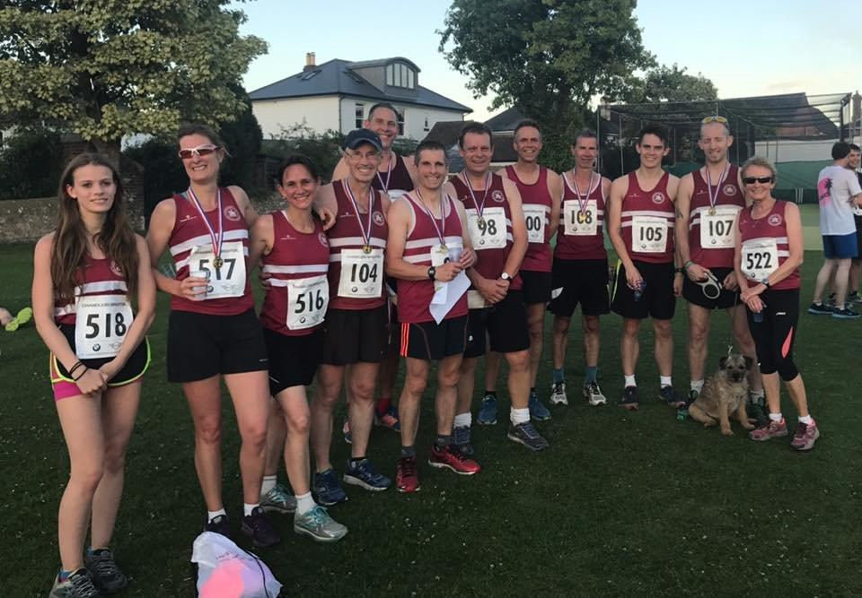

On 5th July, the Round Hill Romp fun run at Steyning took place. 18 Harriers took part in the 6 mile race on a very humid evening that included running up Round Hill with 500 feet of incline makes it arguably one of the tougher runs to do in Sussex. First home for Harriers was Phil Hardaway in 6th place with 38:40. Followed home by Phil Payne in 10th 39:24. Other Harriers to finish were Paul Cousins 22nd in 41:27 , Nick Jarvis 24th 41:34, Julian Boyer 61st in 45:09, Barry Tullett 81st in 47:09, Phil Scott 115th in 50:06, Carole Walters 126th in 50:51, Mark Armitage 134th in 51:17, Michael Essex 149th in 52:26, Amy Mitchell 154th in 52:36, Carl Bicknell 216th in 55:47, Graham Kenward 217th in 55:48, Katherine Buckeridge 230th in 57:03, Marion Hemsworth 263rd in 59:15, Jacs Barnes 276th in 60:02, Justine Tanner 319th in 64:47 and Michelle Holdstock 334th in 66:11.