ROAD RACING

James Skinner ran in the Essex 20 mile race on 1 March. Running for Sussex, it was James’ first twenty mile race. With his sights firmly set on running a fast time on the undulating course and with the wind playing havoc making it hard for the runners to achieve quick times, James finished in tenth place overall in a time of one hour fifty four minutes and fifty five seconds. A new overall cub record for James. The record was previously held by Rodney Burrows with one hour fifty nine minutes and twelve seconds back in 1983.

At the Surrey Half Marathon held at Woking on 8 March, Harrier, Peter Cobbett finished in 2604th place in a time of 2 hours 21 minutes and 17 seconds.

At the Cambridgeshire Half Marathon on 8 March, Lydia Levy finished in 3554th position in a time of 1 hour 48 minutes and 16 seconds. There were over 11,200 finishers in this race!

At the West Worthing 10km race on 15 March, Matt Quinton finished in 34th place in a time of 44:55.

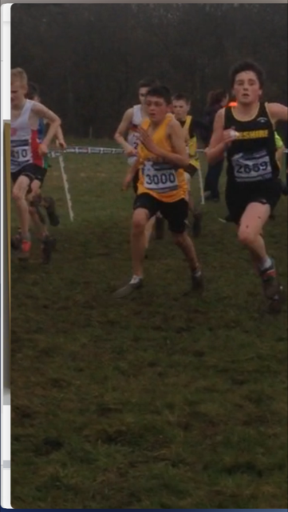CROSS COUNTRY

In Cross Country, two Harriers took part in the Inter Counties Cross Country event at Loughborough on 7 March.

Running for Sussex young Arun Khursheed finished in 162nd place in the Under 13’s Boys race. There were 293 finishers.

This was a super run from Arun, when you consider that Arun lost his running shoes in the mud and ran most of the race in his socks! (see photo on the left).

Our other Harrier taking part in the Senior ladies race for the first time was Darja Knotkova-Hanley. Darja also had a great run finishing in 121st in the race which had 257 finishers.

**Arun Khursheed (centre).**

At the Balcombe Bull Run on 15 March, Phil Payne finished in a fine third place in 29:26. Other Harriers results were:

5th Andy Hind 30:03, 6th Ryan Armstrong 32:29, 15th Kim Lo 34:40, 23rd Dave Harper 37:20, 31st Graham Kenward in 39:30, 32nd Phil Scott 39:35, 37th Oli Farr 40:44, 51st Andrew Wilson 44:34, 74th Karen Dumbrell 53:06, 75th Ian Dumbrell 53:07, 87th Carys Hind 55:27

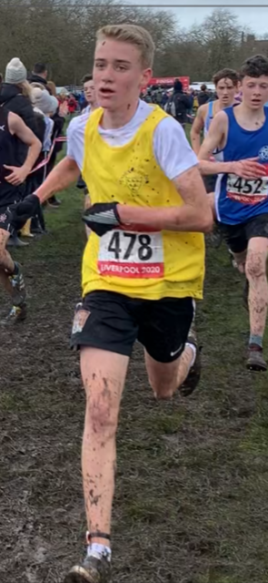

And more on CROSS COUNTRY

Fifteen year old SAM FERNLEY got a late call up to run for Sussex in English Schools Cross Country Championships at Sefton Park in Liverpool today. Sam finished in 211th place in the Junior Boys race out of a field of 334 runners in 16 minutes and 40 seconds.

Joseph Martin also ran in the Under 20’s race and finished in 105th position with 324 finishers in a time of 23 minutes and 19 seconds.

**#RunAndTalk**

**By Michael Parish**

**SUNDAY 15th March saw the first #RunAndTalk session of 2020 led by Michael Parish, Marion Hemsworth and Pauline Sutherland through J & M Running.**

**Sam Fernley.**

#RunAndTalk is an England Athletics programme supporting people to promote good mental health through running, starting conversations and ending stigma.

The sessions are also supported by Mind, the mental health charity.

The aim of the event is to encourage physical activity through running, whether that is supporting them to start running, returning to or continuing running. For new runners this is to run a mile.

Ten runners turned up to run 7km starting from The Bent Arms in Lindfield, down Hickman’s Lane and onto West Common Drive. The route then went up Oathall Road, Franklynn Road and down Northlands back towards The Bent Arms.

The event ended with a chat over coffee. We are aiming is to hold more events on a regular basis, so if you are either interested in coming along for a taster or interested in starting to run then please let us know you can find us on <https://groups.runtogether.co.uk/JandMRunning/> but watch out for the next event posters.

