The Middy Report
Our resident reporter, Paul Cousins works his editorial magic with another Harriers infused helping of the Middy report.
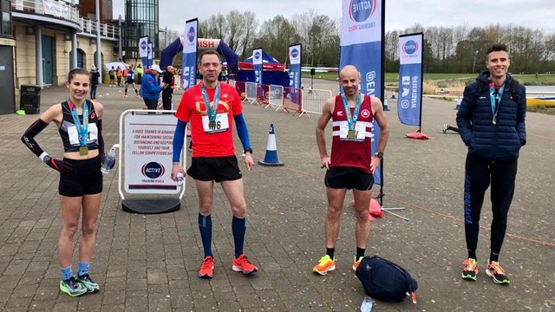
L/R | Emma Navesey, Matt Cook, Jamie Topping and Ben Gibson at Dorney Lake Marathon

For the w/c April 19
With the beginning of second major lockdown coming to an end athletics and road running events are beginning to start up again albeit at a very steady pace! Many athletes across the country have been able to so some exercise during the covid crisis but now are able to start to compete again much to their relief!
At Haywards Heath Harriers, we have been able to do covid-secure virtual race competitions through the last year for distances ranging from two kilometres to ten miles with a half a marathon on the South Downs due to happen shortly.
After such a long period when no public event racing has been held (since March 2020), there was a huge desire to get racing again.
Last week at the second Ardingly event where there was a junior one mile race followed by a number of five kilometre races throughout the day, operating in a covid-secure environment. All the athletes were set off in small groups. As the runners had the chip attached to their numbers it meant that each runner was given an accurate time for their run.
Amongst the Harriers there were many club records and personal bests (pb’s) set at the Ardingly event, namely in the junior mile race with the Noah Blythe in the under 11 boys and Jonathan Parkin in the under 13 boys and in the five kilometres races with Ryan Armstrong in the under 17 boys, Harvey Alcock in the under 20 men, Emma Singer in the veteran women 40 and Sam Ridley in the veteran women 55 age groups.
Harriers results were as follows:
Junior mile:
5:21 Jonathan Parkin (pb) (Harriers under 13 Boys record), 6:00 Sam Harper (pb), 6:01 Noah Blythe (pb) (Harriers under 11 Boys record), 7:20 Cian Gaston (pb), 7:47 Jacob Harper (pb).
5km results:
16:42 Russ Mullen, 17:05 Harvey Alcock (pb) (Harriers under 20 Mens record), Ryan Armstrong 17:42 (pb) (Harriers under 17 Boys record), 17:53 Will Herbert (pb), 18:11 Sam Fernley (pb), 18:21 Ewan Kemsley, 18:57 Tim Miller, 19:01 Finlay Blythe (pb), 19:22 Barry Tullett, 19:37 Emma Singer (pb)(Harriers vet 40 Womens record), 19:55 Tim Hicks, 20:25 Sam Ridley (pb) (Harriers vet 55 Womens record). 20:27 Chris Faulkner (pb), 20:30 Andy Dray (pb), 20:48 James Smyth (pb), 20:57 Arun Khursheed, 21:09 David Harper (pb)
On Saturday 17th April was the Sussex Coast Trail series Marathon. Greg Hilton ran 4 hours 25 minutes for this arduous trail marathon held over the South Downs from Eastbourne along the Seven Sisters and up and around the Long Man of Wilmington climbing over 4000 feet and back to Eastbourne. Tim Hicks ran in the half marathon at the same event and finished in 2 hours 7 minutes.
On 3rd April, Ben Gibson, Matt Cook and Jamie Topping all ran at the Dorney Lake Marathon near Windsor. Ben was first home finishing time was a super 2 hours 35 minutes and 40 seconds knocking off 8 mins 10 secs from his previous best finishing in 17th position. Also, Ben had broken an ancient Harriers record held by Tom Burke since 2003 when Tom ran 2 hours 36 minutes and 35 seconds in the Flora London Marathon.
Matt Cook had a more steady race and finished in 2 hours 46 minutes and 40 seconds.
Jamie Topping also had a super run, knocking nearly ten minutes off his personal best with a time of 2 hours 55 minutes and 55 seconds and finishing under three hours barrier for the first time.

