Fernley breaks Harrier record.

At the Ardingly PB 5k event on 12 May at the South of England Showground, there was a large Harriers turn-out as athletic and road race competitions begin to get going again after a fifteen month dearth of competitive running.

Runners were keen to get racing again amid covid restrictions. Runners being set off in waves of runners with gaps of fifteen seconds between each wave.

Parkrun
Parkrun has also decided to delay the mass start of parkruns in the UK until late June when they will look to see if they can open up parkruns again en-mass. Part of the reason for the delay is
Sam Fernley at the Ardingly Showground

because just under half of the landowners have given their permission for events to go ahead and
parkrun don’t want over-crowding at these events. Running is a healthy exercise and also is a great natural stress burner, and it would be greatly beneficial for society for these parkruns to start up again.

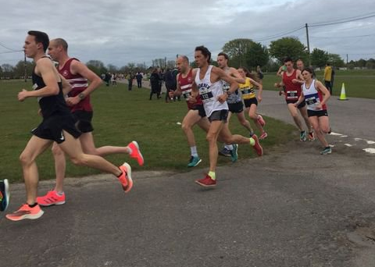
Harriers get into the mix with other runners at the Ardingly Showground.

Ben Gibson was first Haywards Heath Harrier to finish in 16 minutes and 21 seconds. There was a notable performance by young Sam Fernley who is fifteen years old who ran a fifty second personal best and also a new Harriers under 15 record to record 17 minutes and 20 seconds.

Full Harrier results were:

Ben Gibson 16:21, Ben Duncan 16:47, Jamie Topping 17:16, Sam Fernley 17:20, Matt King 17:23, Russ Mullen 17:36, James Moffat 17:50, Andy Hind 17:59, Jonathan Beckett 18:39, Arun Khursheed 18:42, Barry Tullett 19:18, Tim Hicks 19:53, Adam Dray 20:23, James Smyth 20:33, Chris Russell 21:25, Jenny Martin 25:22.

Tim Miller and Ivan Catterwell both ran at the Three Forts Half Marathon last Sunday 23 June. This rugged, hilly off road half marathon is over the South Downs starting from Hill Barn, Worthing, and following an anti-clockwise loop onto the South Downs Way and up to Cissbury Ring and back down to Hill Barn. Tim finishing slightly ahead of Ivan in 1 hour 42 minutes and Ivan finishing in 1 hour 53 minutes.

Ben Duncan ran a super personal best at the Dorney Lake Half Marathon on Saturday 22 May in a time of 1 hour 18 minutes and 43 seconds finishing in twelfth place.

On Sunday 23 May was the Rye Ten Miler with four Harriers taking part. Darren Bird finishing in a super seventh place in 1 hour 5 minutes and 13 seconds followed by Bryan Tiller in 44th place in 1 hour 16 minutes and 8 seconds, 45th Lindsey Blain in 1 hour 16 minutes and 9 seconds and Paul Turner in 75th position in 1 hour 22 minutes and 44 seconds.

