Haywards Heath Harriers Athletics Round-up

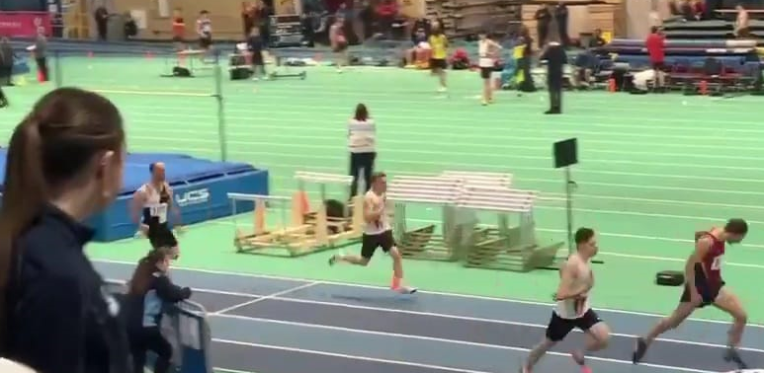
Lio Robinson finishing in second place

Eighteen-year-old Lio Robinson, competed in the Cardiff Met Grand Prix on 22 January in his first experience of an indoor athletics competition. He competed in the 60 metres and 200 metres races. He finishes third in his heat of the 60 metres in a time of 7.73 seconds setting a new Harrier Under 20 record and followed it by a super second place in the 200 metres in 25.05 second. Both times were personal bests for Lio.
Haywards Heath Harrier veteran, Mike Bale, competed at the Basingstoke & Mid Hants AC Winter Throws competition at Basingstoke on 18 February. Mike finished in first place in the Hammer Throw with a throw of 31.11 metres. He then had two second places, one in the Shot Putt with a throw of 7.35 metres and the other in the Discus Turn with 26.24 metres.

West Sussex Fun Run League
WEST SUSSEX Fun Run League suffered disappointment on their first run of the season with Goring Road Runners Hangover Five being cancelled on the first of January due to severe flooding on the course.
The second race of the season hosted by Crawley Run Crew on 12th February with their five mile fun run through Tilgate Forest and Park brought the magic back and set the league up nicely for the coming year.

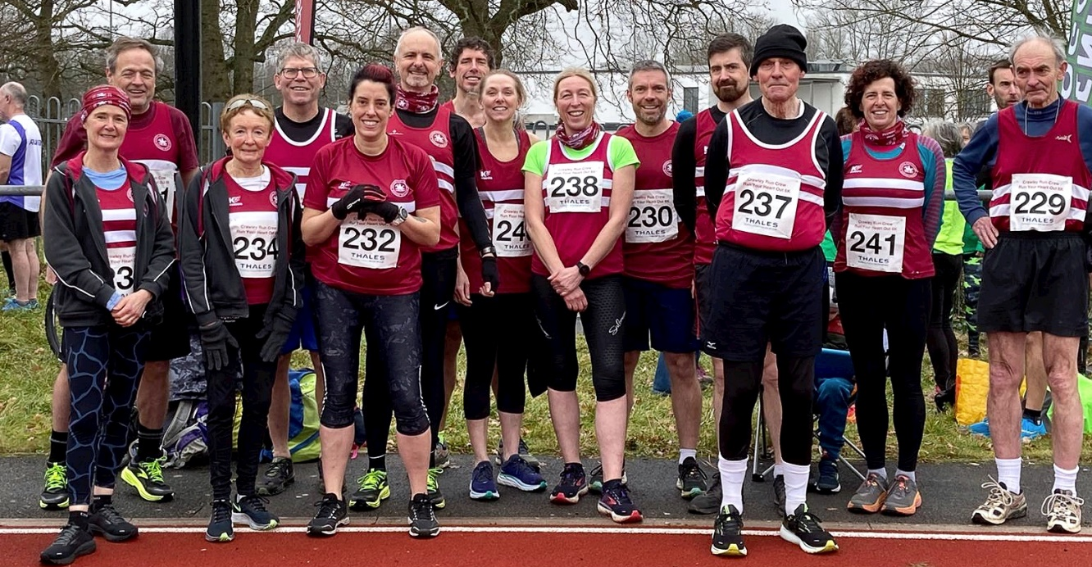
Harriers at the WSFRL at Crawley
There was some excellent running from Haywards Heath Harriers with Andy Hind first across the line followed by Jack Chivers and Abigail Redd. Both Carys Hind and Sarah Hamilton ran a great steadily paced race. Last year was Caroline Gumm's debut run in the league and this year she pulled a magnificent sprint finish out of the bag.
Results: 1st Mike Houston , Chichester Runners, 28:06; 2nd Liam Briscoe, Fittleworth Flyers, 28:27; 3rd Mikeey Kwoka, Chichester Runners, 30:51.
Haywards Heath Harriers results: 13th Andy Hind, 32:41; 54th Jack Chivers 36:41; 78th Abigail Redd, 38:04; 127 Phil Scott, 41:18; 166 Clare Kenward, 43:35; 207 Richard Jobling, 46:24; 231st Marion Hemsworth, 48:25; 250th Michael Parish, 49:33; 257th Carys Hind, 50:20; 267th Caroline Gumm, 50:59; 269th Sarah Hamilton, 51:02; 363rd Richard Bates, 01:06:04; 368th Rupert Purchase, 01:07:59.

More Athletics…
Jack Gumm
Local athlete, Jack Gumm, 22 from Haywards Heath was recently invited to run the 1500 metres race at the UK Championships at Birmingham on 19 February, running for the Brighton Phoenix in his first race for the club.
In an exciting race labelled the “blue ribband event” Jack ran his own race. With eleven starters, Jack ran from the back working his way forwards and finished in a super fifth place in 3 minutes 49.63 seconds in his first championship race and first time running indoors.
Jack said, “It was a great experience to run in my first major championship and I’m happy with the result. “He also said he was “gutted not to medal.” The challenge of indoor track running has certainly whetted his appetite for future success at the outdoor championships later in the summer.
Road Racing
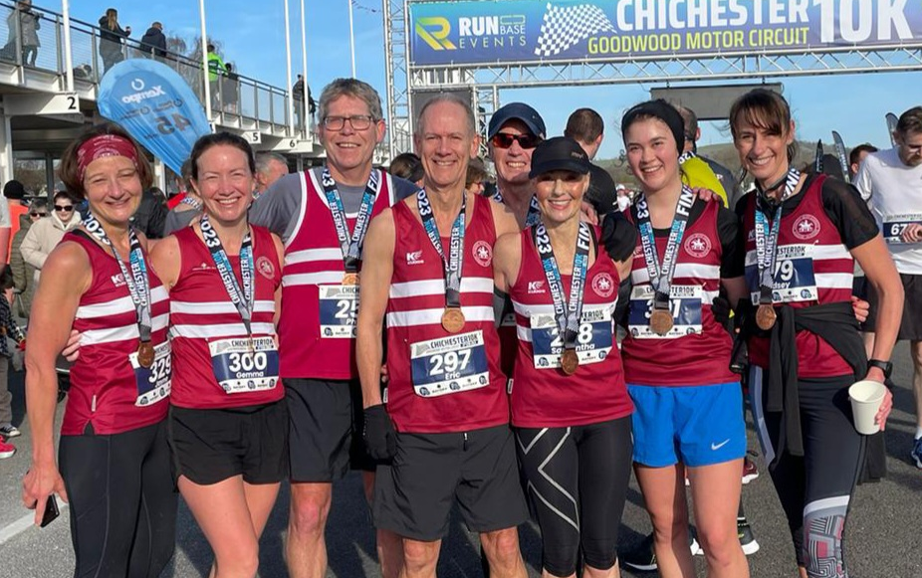
Harriers at Chichester 10k
There was a wonderful set of results for the club from the Chichester 10 Kilometres race on 5 February. The Harriers veteran runners achieved four top three age group positions with Carl Bicknell 44.57 (1st V60), Sam Ridley (1st V55) with 42:55 and Jayne Brewer 48.51 (3rd V55) and Lins Blain 44.38 (3rd V50). There was a personal best for Gemma Morgan 45.23 (PB). Other Harriers results were Phil Scott 46.21; Eric Hepburn 47.40 Amy Lovejoy 52.25.

Other Results
On the 19th February, Haywards Heath Harrier Michael Parish took part in Run Series Run Reigate 10km Trails Race in Surrey. The Run Series have both Run Reigate and Run Gatwick half marathons on their books and last year opened up their 10km trails race, taking place at the Royal Alessandra and Albert School at the north end of Redhill.
Michael who completed the race in 01:04:30 normally runs the course with fellow Haywards Heath Harrier Ollie Farr who couldn’t take in the race after just becoming a father for the first time with baby Logan.
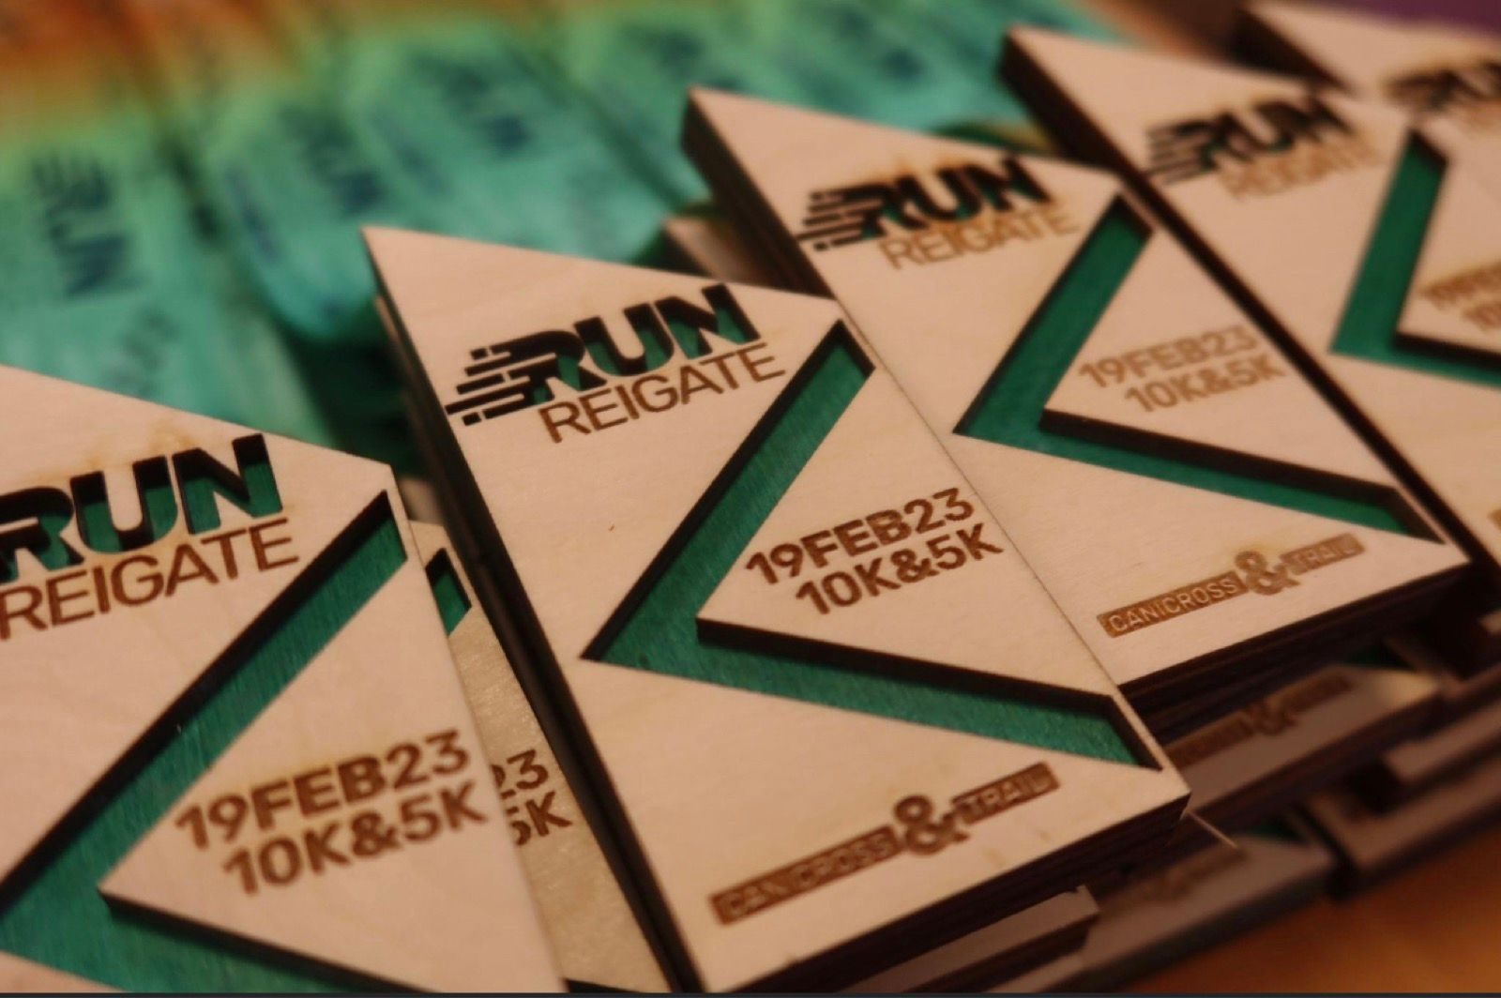

This week’s parkrun round-up
Clair parkrun: 2nd David Adams 19:52; 8th Patrick Kenward 21:20; 12th James Bennett 21:49; 22nd Pete Francis 23:10; 29th Simon Robinson 23:47; 43rd Carl Bicknell 25:42; 80th Shelagh Robinson 29:55; 85th Ian Dumbrell 31:01; 87th Emma Pryor 31:29; 125th Rupert Purchase 39:20; 136th Tracy Adams 51:07.
Brighton & Hove parkrun: 27th Abigail Redd 21:26.
Princes parkrun, Liverpool: 42nd Steven Heath 21:05.
Tilgate parkrun: 28th James Smyth 21:20.
Preston Park parkrun: 77th Ian Tomkins 23:52.
East Grinstead: 4th Julian Boyer 21:54; 7th Paul Cousins 22:14; 36th Greg Hilton 29:57
Bevendean Down parkrun: 25th Michael Essex 31:39.
Seaford parkrun: 35th Lucy Anderson: 23:05.
Ifield Mill Pond parkrun: 75th Katherine Buckeridge 39:12.
Sandringham parkrun: 69th Clare Kenward 29:27; 70th Graham Kenward 29:27.
University Parks parkrun: 7th Harvey Alcock 17:41.

