Haywards Heath Harriers Enjoy Hilly Marathon!
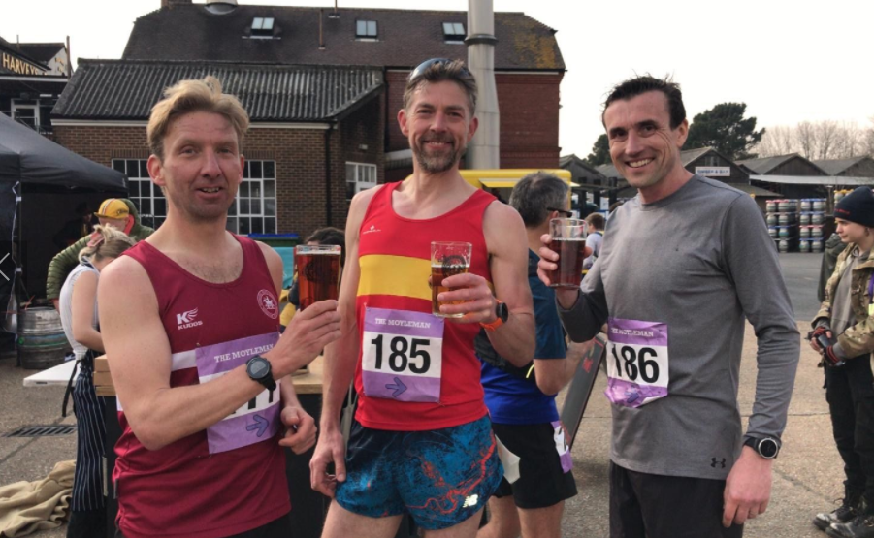
Marcus Kimmins (left) and James Moffat (right) celebrating their marathon success with Robert Cooper (Lewes AC) at the Moyleman marathon.

On Sunday 20 March was the Moyleman marathon. The Moyleman is one of the hilliest marathons in the United Kingdom alongside Beachy Head Marathon (which is normally held in October). The Moyleman has an elevation of around 3340 feet of climb!!

The race over the South Downs was won by James Turner in an amazing time of 2 hours 51 minutes and 35 seconds. The first lady finisher was Claire Hammett in 3 hours 29 minutes and 50 seconds.

Harriers taking part were: Michael Burke, James Moffat, Marcus Kimmins, Oli Farr (his 69th marathon) and Marion Hemsworth. At the finish line there was the “prize” of a free pizza and pint of beer for all who took part!!

Harriers’ results were:
19th Michael Burke 3 41.30; 20th James Moffat 3:42.26; 21st Marcus Kimmins 3:44.28; 136th Oli Farr 5:01.50; 174th Marion Hemsworth 5:30.30.

Other Harrier results:

Balcombe Bull Run

3rd Andy Hind 29 mins 52 secs; 6th Ryan Armstrong (no time provided).

Hastings Half Marathon
Pete Francis finished in 1 hour 33 minutes and 15 seconds.
Carl Bicknell finished in a time of 1 hour 47 minutes and 58 seconds.

Crystal Palace Half Marathon

Abby Ross had a scintillating run and finished as first lady in this hilly half marathon, although the race distance had been cut by nearly a mile by the police! Abby’s time was 1 hour 34 minutes and 40 seconds.

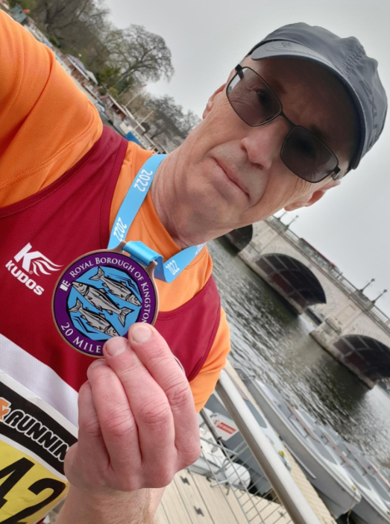
Carl Bicknell.

Kingston Spring Raceday 20 Miler

Carl Bicknell : 2 hours 57 minutes and 24 seconds.

Bryan Tiller ran in the Lydd Half Marathon on 6 March in 2 hours 45 minutes and 16 seconds.

The Martello Half Marathon 2022

Kim Lo – 3rd lady at Martello Half Marathon.

Kim Lo had a great run at the Martello Half marathon on 27 March that started and finished in Seaford, taking in the hills of the South Downs and following a clockwise looped course passing through Firle Beacon and Bo Peep on the South Downs Way. Kim finished as third lady in a time of 1 hour 45 minutes and 53 seconds. Steve Dallman also took part and finished in ninth place overall in a time of 1 hour 38 minutes and 1 second.

This Week’s Harrier’s parkrun Round-up:

Clair parkrun: 1st Sam Fernley 18:14; 2nd Will Grey 18:30; 3rd Harvey Alcock 18:32 (pb); 4th Jonathan Beckett 18:33; 7th Ryan Armstrong 19:50; 9th Andy Hind 19:52; 17th Oscar Dalgliesh 21:53; 20th Paul Cousins 22:27; 25th Eric Hepburn 23:43; 28th Simon Robinson 23:47; 31st Bob Adams 24:02; 34th Jason Robinson 24:25; 41st Katie Reed 25:15; 45th Carl Bicknell 25:41; 54th Daniel Mardle 26:42; 70th Andy Guy 28:17; 77th Shelagh Robinson 28:56; 88th Oliver Francis 30:01; 95th Sarah Heron-Smith 31:58; 99th Carys Hind 33:04.

Brighton & Hove parkrun: 4th James Collins 17:33.

Milton Keynes parkrun: 4th Daniel Moll-Morgan 18:05.

Lymington Woodside parkrun: 5th Pete Francis 20:55.

Tilgate parkrun: 50th Jack Chivers 22:47; 172nd Sarah Ann Hamilton 29:07.
Pontypridd parkrun: 87th Michael Parish 27:13.

Preston Park parkrun: 33rd Abigail Redd 21:13 (pb); 92nd James Smyth 23:53.

Hove Prom parkrun: 28th Barry Tullett 19:29; 33rd James Bennett 19:37; 123rd Ian Tomkins 22:51; 397th Linda Tullett 30:56.

Worthing parkrun: 5th Sean Duff 18:29; 54th Abby Ross 22:08.

Warwick parkrun: 197th John Morgan 37:33.

Get Into Coaching

Alongside these fantastic results, Haywards Heath Harriers are running a ‘Get Into Coaching’ campaign to encourage more coaches to get involved with the club. With sponsorship available to get qualified, there’s never been a better time to get into coaching. Details are on the Harriers website.

www.haywardsheathharriers.co.uk/getintocoaching.html

