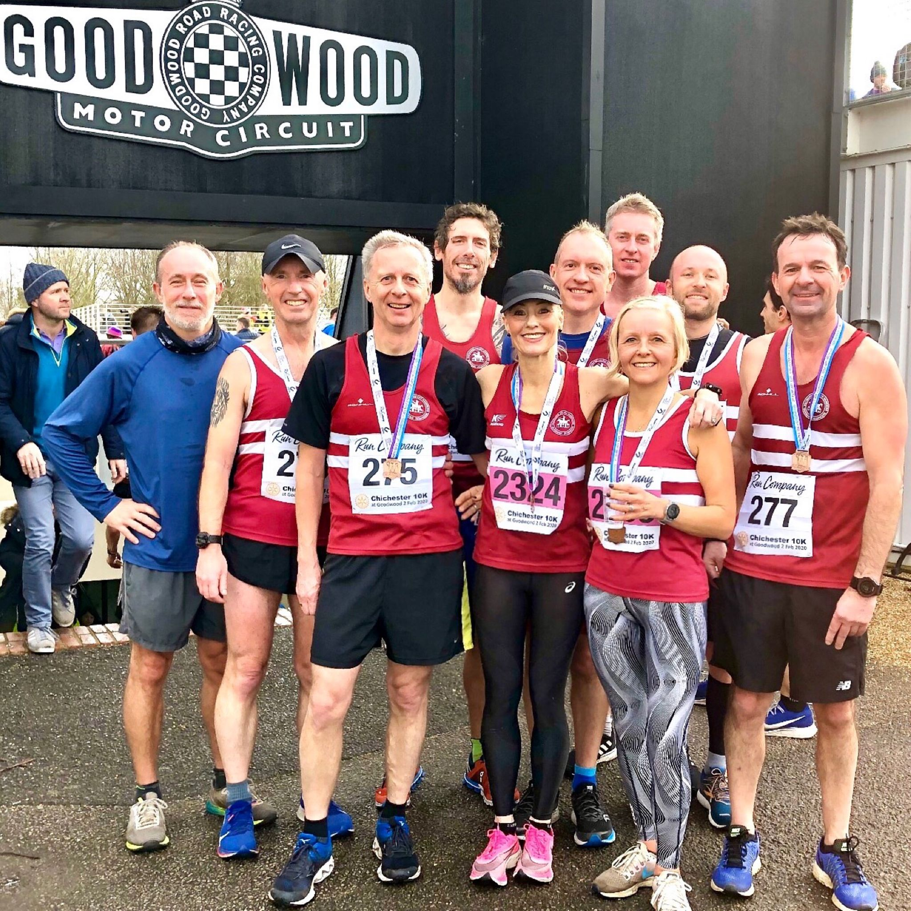

**Harriers at Chichester**

**Chichester 10 km**

Eighteen Harriers took part in the Chichester 10 kilometres race held at Chichester Motor racing circuit on 2 February for one of the first road races of the year. On a flattish course, a quality field lined up for one of the top 10 kilometres running races in the United Kingdom, James Skinner was first Harrier home for the club in a scintillating 32 minutes and 37 seconds. James was also first in his age category and will qualify to claim an England vest later in the Spring. Emma Navesey was also twelfth female finisher is a super 36 Minutes and 58 seconds.

Results were as follows:

44th James Skinner 32:37, 114th Russ Mullen 34:39, 185th Emma Navesey 36:58, 222nd Andy Hind 38:04, 231st Mark Green 38:16, 262nd Rob Watts 39:03, 274th Sam Atkin 39:22, 398th Sam Ridley 42:32, 416th Chris Russell 42:52, 457th Chris Faulkner 43:48, 499th Matt Quinton 44:50, 503rd Bryan Tiller 44:50, 538th Carl Bicknell 45:43, 584th Ian Dumbrell 46:56, 654th Josh Franks 48:23, 706th Sarah Banks 49:33, 730th Graham Kenward 49:34, 759th Clare Kenward 50:21.

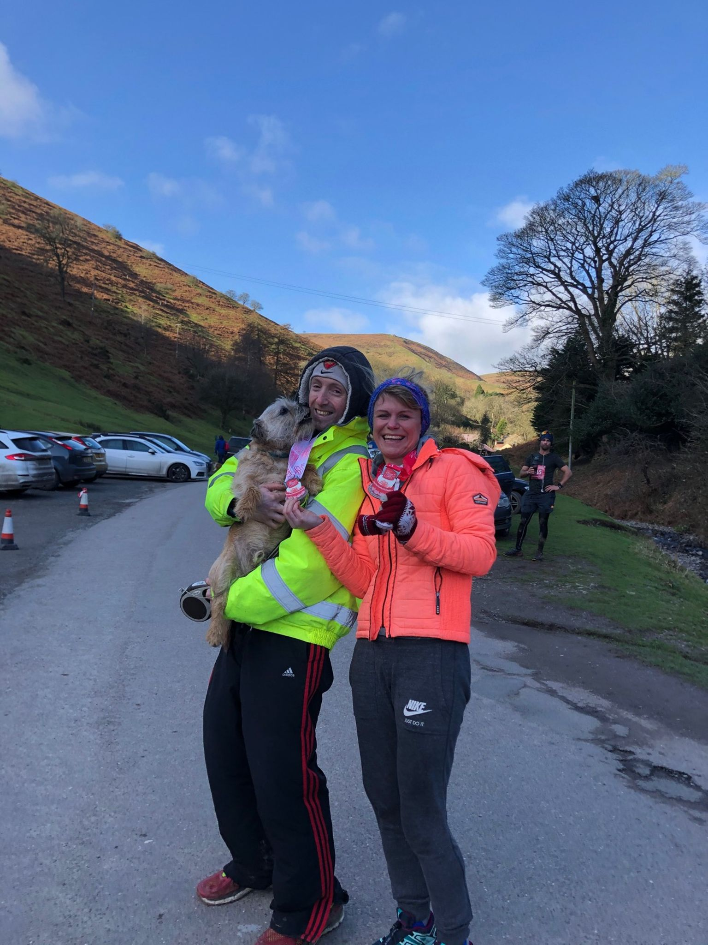

**Phil Payne and Kim Lo.**

Both Phil and Kim had great runs at the Icing on The Cake Half Marathon on 1 February, which is a trail race in Shropshire covering the beautiful Shropshire Hills. Kim winning the ladies race in one hour and fifty nine minutes and Phil finishing second male finisher in one hour forty five minutes.

**Athletics**

Young Siobhan McMahon competed in the indoor Leinster Juvenile Track and Field championship in Ireland on 1 February. She finished third in the long jump with a personal best and a new under 13 Harrier club record of 4 metres and 39 centimetres improving on her record of 4 metres and 19 centimetres. She also competed in the 60 metres sprint, running 8.81 seconds in the heat for another personal best and then 8.86 seconds in the final finishing in sixth place.

**The Arc of Attrition** **by Michael Burke.**

Haywards Heath Harriers ultra-runner Michael Burke took on The Arc of Attrition in Cornwall signposted by organisers as only suitable for experienced ultra-runners.   A 100 mile point to point extreme coastal run from Coverack to Porthtowan.   Running the stunning and dramatic southwest foot of the Cornish Coast path in challenging winter conditions.

The 2020 race took place over Friday to Saturday 31st January to 1st February. Starting in Coverack at noon on the Friday, competitors had 36 hours to complete the self navigated course via Lizard point, Penzance, Lands End and St Ives to Porthtowan.

227 runners started the race but only 111 finished, a 51% drop out rate.

Michael finished his first attempt of the course in a time of 31 hours 57 minutes in 61st place overall and 56th male, recording 106 miles covered.

Michael said: “Although the course had some 4010m of ascent a lot of these were short sharp climbs and descents on narrow paths, a lot of which had steps cut into them. Added to this the boggy and muddy conditions, along with rocks and boulders, it was hard to pass others and maintain a steady pace for any distance.” Whilst he was pleased with his result and a silver buckle, he plans to return in 2 years to see if he can secure the coveted Black (sub24hour) or Gold (sub30hour) buckle.

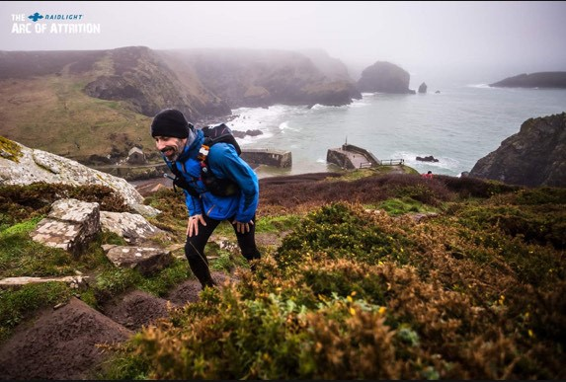

**Michael Burke.**