Athletics

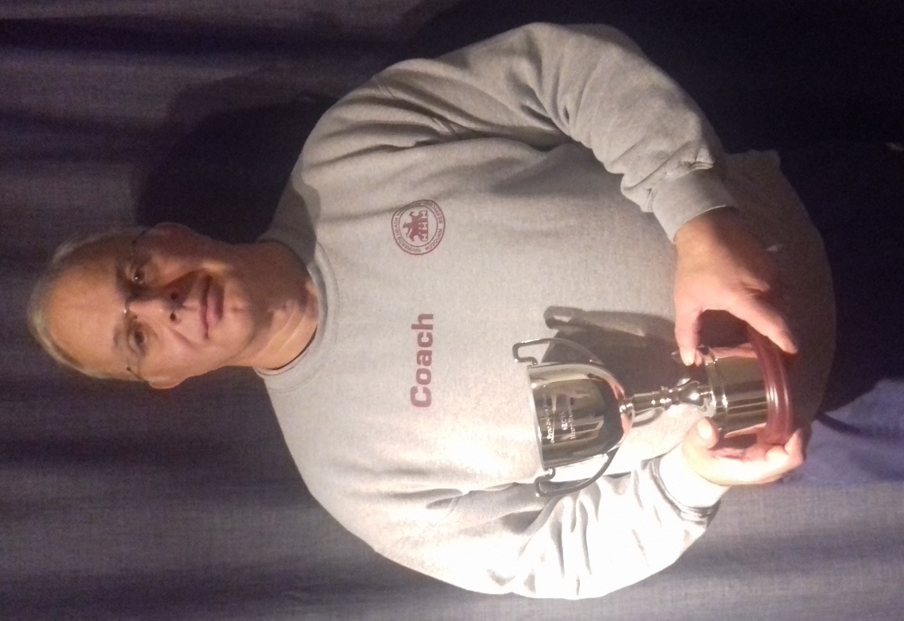
Mike Bale.

Haywards Heath Harrier Mike Bale attended the Xmas throws pentathlon at Walton run by the South East Counties Throws Association (SECTA) on Sunday 8 December. This was combined with their AGM where they award a number of trophies.
Mike said, “I was awarded the "Heavy Hammer" trophy. This was in recognition of both the distances I have been throwing and the consistency I have been throwing them all year.”
Mike is the most experienced thrower in Haywards Heath Harriers and also is a greatly respected athlete and adversary in the South East. He is also the Harriers throws coach.
Mike said "Throwing is great fun and rewarding. We could do with more throwers in the club"
He generally competes in all the throwing disciplines: namely the hammer, heavy hammer, discus, javelin and also putts the shot. All these disciplines require technique as well as strength.

Road/Trail:

A bunch of Harriers took part in the Mince Pie 10 Mile race at Peacehaven on 8 December. The race started and finished up at the Peacehaven Leisure Centre. The course was a multi-terrain event.

Harriers results were:
77th Paul Turner 1 hr 18 mins 10 secs, 78th Bryan Tiller 1 hr 18 mins 12 secs, 130th Carl Bicknell 1 hr 25 mins 58 secs, 158th Kath Buckeridge 1 hr 28 mins 18 secs, 167th Sarah Banks 1 hr 28 mins 42 secs, 233rd Lindsey Blain 1 hr 34 mins 21 secs, 234th Sam Ridley 1 hr 34 mins 21 secs, 275th Shelagh Robinson 1 hr 38 mins 8 secs, 469th Marion Hemsworth 2 hrs 1 min 46 secs.

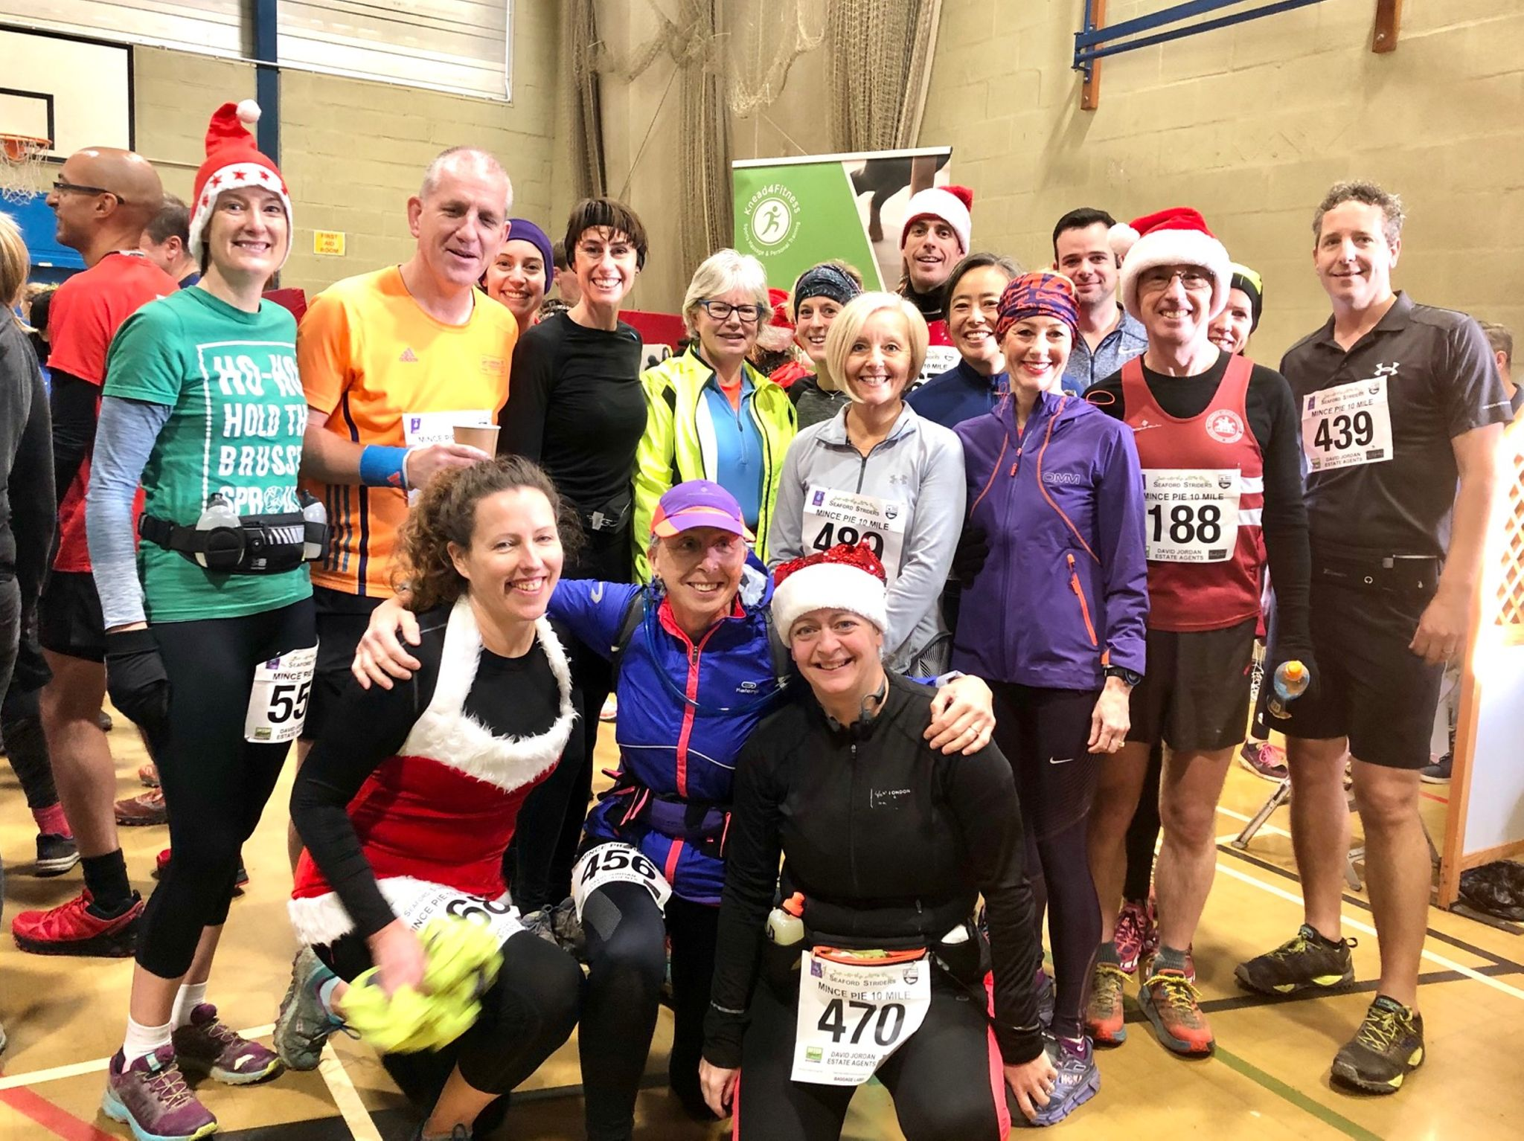

Ultra

By Parish and Burke
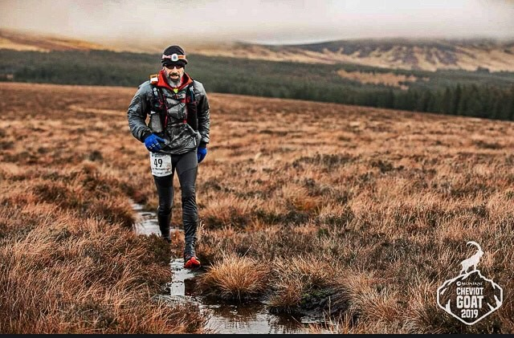
Michael Burke.

SATURDAY 7TH December saw the Montane Cheviot Goat Winter Ultra take place running through the Northumberland National Park and along the England/Scotland border. Taking part was Haywards Heath Harrier’s ultra-runner Michael Burke.

The route traverses a loop of the largest hills in the border region at a time when most livestock are brought down off the tops and only the hardy feral Cheviot goat is left to fend for itself. Due to the location a large part of the route is inaccessible to vehicles making rescue difficult.

The 55 mile winter ultra-run will test an athlete’s abilities to its limits in terms of both mind and body and are placed under extreme stress in this unforgiving environment, especially in winter weather. High in the fells, runners will need cross peat covered hills, descend grassy banks and chug along the mighty border ridge with Scotland on one side and England on the other.

The route is circular and has previously been run in a clockwise direction from the village hall at Ingram. This means the Cheviot, the highest peak on the course (and Northumberland National Park) at 815metres is the last before descending back through deep bogland to the village. This 3rd year of the race the event team along with mountain rescue took the decision with less than 12 hours before the start to send competitors racing the route backwards due to forecasted high winds and poor conditions. In the usual direction the later part of the route is inaccessible even by 4x4. The lower parts of the course, this year at the end, are far more accessible for vehicles which meant that the safety teams were able to better effect rescue of injured or exhausted runners whilst not putting themselves at heightened risk.”

Michael ran with 385 other runners out of which 60% made it to the finish line. He came 40th (36th male) in a time of 13 hours and 52 minutes with a total ascent of 3378 metres.

