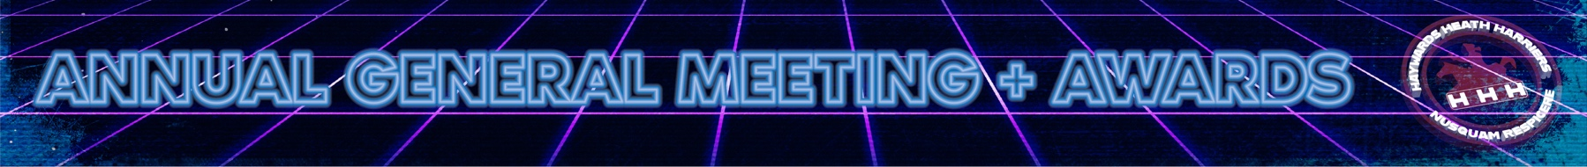
HHH Presidents Report 2022 (AGM 21/4/23)
2022 – A rather more normal year for Harriers, so perhaps a less entertaining Presidents report! However, on behalf of the club I do have some duties to perform, notably to thank those who continue to “make the club happen”. Most notably, of course, are the Committee - ably led by Marion and Andy. I think we all appreciate what they do – and if you think you could do better, well there’s still time to stand and join the next year’s team – you’ll certainly be welcomed.
2022 saw a big surprise for many of us as we lost – to Nottinghamshire – two of our longest serving stalwarts Linda & Barry Tullett. I think the multi-faceted competitive sports afternoon at Whiteman’s Green at the end of the Summer was a lovely tribute to their efforts for the club over the decades. It’s good to see them here this evening, and I’ll use this opportunity to have the club’s gratitude to them both formally recorded in the AGM minutes.
Their departure left a big hole in the organisation of the Junior section – so a special thankyou to Abi and Helen as well as all the other supportive Junior Coaches/Leaders who give their free time to help nurture the “next generation”.
Our Coaches and Run Leaders have had a slightly more “normal” year. Athletes seem to appreciate the variety of sessions offered. We respect the Coach’s stoicism and fortitude as they stand, cold, damp and murmuring supportive exhortations on street corners across mid Sussex – Thank you to all of you.
There’s a Social side to the club also with fun formal evenings – like the Bent Arms quiz night, the Christmas Social at Francisco’s and also less formal affairs like the recent “Toad” evening at the Stand-up, and a variety of “Run & Drink” events – male ones involving beer and Ladies one’s rather more stylishly Prosecco.
So many other people keep doing “small tasks that take time” but keep the club being what it is. Paul publishes excellent summaries of Harriers efforts that are both on the website and, in the Middy, the team who organise the well-respected Ardingly Show Ground XC League race (Andy Carter to the fore) – the quiet competence of the entries and results crew (Howard Booth, John Rix). Sarah Hamilton is a vital cog in the upcoming Awards Process – animators of the differing Whatsapp Groups… and many other examples I fail to recall.
I would also like to mention the work Greg Hilton has undertaken with his Running Calendar which is now live and well, 'running'. He developed this in response to members wanting an easy way to find out what races people were interested in and coordinating themselves to race. This is a great example of someone using their skills to help out the club; thankyou Greg for all your hard work on this. And please do check out the demo version that is currently living on the Harriers ClubHub.
Finally, before handing back to your Chairs, I’ll say a big thank you to Marion as she steps down – more later, but you leave a committee in good shape.

