HHH Middy Report 26.06.18

.

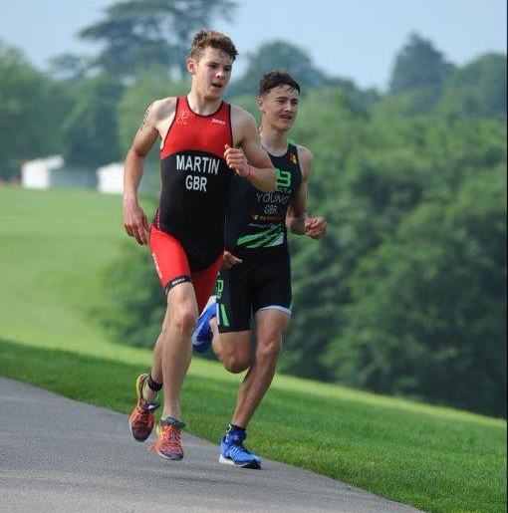
Joseph Martin – 1st place in the ITU British Triathlon in Leeds.

Congratulations goes to Joseph Martin from Haywards Heath Harriers, who represented England at the ITU British Triathlon on 9/10 of June that was held in Leeds. This was Joseph’s first national gold at the triathlon. His fastest run saw him home in first place.

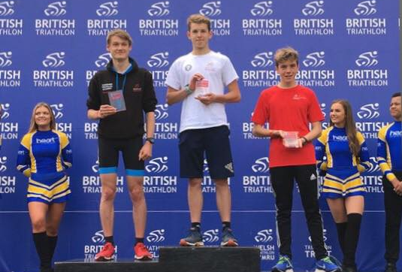
On the podium in first place for Joseph Martin.

Meanwhile on the road racing circuit, on 17th June at the Eastleigh 10km, four Harriers took part in this popular road race. James Skinner was Harrier home and he was also the first veteran finisher in the race and finished in a new personal best time of 32 minutes and 48 seconds (which also improved his Harrier V45 record). Emma Navesey was 9th woman home in 37 minutes and 56 seconds (a new personal best) and Russ Mullen had a rather more sedate run than usual, the race helping him back to a better fitness and also pacing Emma at the same time. Russ’s time was 37 minutes and 25 seconds.

********************

At the Crawley Open Meeting on 20 June 2 Harriers competing in this event were Darja Knotkova-Hanley who ran the 1500 metres in a time of 4 minutes 55.98 seconds and broke the under 20 women’s Harriers record at the same time. Also, young Charlie Parvin came first in his race in the Under 13 Boys in a time of 13.98 seconds. Senior, John Palmer (Haywards Heath Harriers / Burgess Hill Runners), ran 31.41 seconds in the 200m.

********************

Southern Athletics League at Lewes on Saturday 23 June, Haywards Heath Harriers joined with Lewes Athletic Club and finished in 2nd place out of 4 teams. Individual results were as below:

Women’s results:
Lucie Venables: 2nd ‘B’ string 100m in 14.6 secs; 1st ‘A’ string 100m Hurdles in 20.4 secs; 2nd ‘A’ string 400m Hurdles in 82.2 secs; 3rd ‘A’ string Long Jump 3.72m; 2nd ‘A’ string Triple Jump 8.64m
Emma Navesey: 1st ‘B’ string 1500m in 4 min 55.0 secs; 2nd ‘A’ string 3000m in 10 mins 26.5 secs.
Jenny Denyer: 3rd ‘B’ string Triple Jump 5.94m; 2nd ‘B’ string Shot Putt 5.86m; 3rd ‘A’ string Discus 15.02m; 1st ‘B’ string Hammer 19.64m; 3rd ‘B’ string Javelin 9.35m.

Women’s 4 x 100m Relay 2nd Lewes AC / Haywards Heath Harriers (Brittany Croydon-Kempster) in 57.8 secs.
Women’s 4 x 400m Relay: 2nd Lewes A.C./Haywards Heath (Emma Navesey) in 4 min 20.5 secs.

Men’s results:
Tim Popkin: 3rd ‘B’ string 2000m s/c in 9 mins 5.9 secs; n/s 800m in 2 mins 30.9 secs;
Martin Dawson: 2nd ‘A’ string High Jump 1.60m; 2nd ‘A’ string Triple Jump 11.60m; n/s 400m in 55.7 secs.
James Skinner: 2nd ‘A’ string 5000m in 15 mins 49.6 secs; n/s1500m in 4 mins 24.7 secs.
Ben Gibson: 1st ‘B’ string 5000m in 16 mins 31.8 secs; n/s 1500m 4 mins 35.8 secs.
Mark McLoughlin: n/s 800m in 2 min 25.2 secs; n/s 1500m in 5 min 17.5 secs.
Paul Cousins: 3rd ‘A’ string 2000m s/c in 7 min 44.2 secs’ 3rd ‘B’ string Javelin 19.79m.

Men’s 4 x 400m Relay: n/s (John Palmer, Tim Popkin, Paul Cousins and Mark McLoughlin) in 4 min 35.3 secs.

***********************

At the Sussex Vets Track & Field League at Lewes on 11 June the combined team of Haywards Heath Harriers and Lewes Athletic Club came a super 1st place in the team event out of 4 teams. James Skinner had the most notable performance as he ran a fine race to break an age-old Harrier record that was set back in 1985 by Rodney Burrows of 9.15.1 secs. James’s new record time was 9 mins 11.6 seconds. There were other great performances with Andy Dray shining in the 200 metre and 800 metre races, Karen Thompson making her debut on the track for the ladies and Ian Dumbrell for the men.

Men’s Results:
John Morgan:3rd M50 Discus 11.13m; 3rd M50 Triple Jump 5.98m.
Mile Bale: 2nd M60 Discus 28.04m; 4th M50 Javelin 17.16m;
Tom Mullen: 3rd ‘B’ string M35 800m in 2 min31.5 secs.
James Skinner: 2nd M35 ‘A’ string 3000m in 9 mins 11.6 secs (pb).
Paul Cousins: 2nd M50 3000m in 10 mins 25.9 secs.
Andy Dray: 4th ‘A’ string M35 200m in 27.9 secs (pb);
Jack Chivers: 3rd ‘B’ string M35 200m in 30.5 secs (pb);
John Palmer: 3rd M50 200m in 30.8 secs.
Men’s 4 x 200m Relay: Haywards Heath Harriers (John Palmer, Andy Dray, Ian Dumbrell & Jack Chivers) in 1 min 58.3 secs.

Women’s Results:
Helen Diack: 3rd W35 ‘A’ string Discus 16.00m; 2nd ‘A’ string W35 Long Jump 3.94m.
Linda Tullett: 3rd ‘W35 B’ string Discus 9.78m; 2nd ‘B’ string W35 2000m Walk in 16 mins 20.7 secs.
Jenny Denyer: 1st W60 Discus 12.61m; 3rd W50 Shot Putt 6.41m; 2nd W60 200m in 42.5 secs; 1st W50 Pole Vault 1.30m.
Abigail Redd: 2nd ‘A’ string W35 2000m Walk in 12 mins 21.3 secs; 2nd ‘B’ string W35 5000m in 23 mins 14.3 secs.
Karen Thompson: 2nd ‘B’ string W35 800m in 3 mins 12.2 secs (pb).
Women’s 4 x 200m Relay: Haywards Heath Harriers & Lewes AC (Karen Thompson) in 2 mins 32.3 secs.

In the non-scoring events, the Harriers had plenty of athletes taking part:
Andy Dray: 800m in 2 mins 25.0 secs (pb).
Jack Chivers: 800m 2 mins 27.0 secs; 3000m in 10 mins 32.0 secs.
Tim Popkin: 800m in 2 mins 29.9 secs; 200m in 29.4 secs; 3000m in 12 mins 13.8 secs.
Ian Dumbrell: 800m in 2 mins 31.1 secs (pb).
Mark McLoughlin: 800m in 2 mins 32.2 secs.
Paul Cousins: 200m in 29.9 secs.
Julian Boyer: 3000m in 10 mins 53.6 secs (pb).
Barry Tullett: 3000m in 11 mins 9.7 secs (pb).
Darja Knotkova-Hanley: 3000m in 10 mins 34.9 secs.
Karen Thompson: 200m in 34.9 secs (pb).

**********************

U/13 Track and Field League at Horsham on 14th June.

Boys:
Charlie Parvin: 2nd ‘A’ string 75m in 10.6 secs.
Alex Stubbs: 3rd ‘B’ string 75m in 10.9 secs; 3rd ‘B’ string 150m in 22.2 secs.
Archie Hale: 3rd ‘A’ string 150m in 21.8 secs.
Alexander Todd: 2nd ‘A’ string 600m in 1 min 49.1 secs; 2nd ‘A’ string Long Jump 4.00m.
Oliver Mamoany: 3rd ‘B’ string 600m in 1 min 58.8 secs; 2nd ‘B’ string Javelin 14.77m.
Charlie Bonwick-Adams: 2nd ‘A’ string 1000m in 3 mins 18.2 secs, 4th ‘B’ string High jump 0.95m.
Oliver Simpson: 2nd ‘B’ string 1000m in 3 mins 24.9 secs; 3rd ‘A’ string Discus 10.60m.
George Bonwick-Adams: 4th ‘A’ string High Jump 1.00m; 3rd ‘A’ string Shot Putt 5.94m.
Alexander Booth: 2nd ‘B’ string Long Jump 3.85m.
Henry Francis: 4th ‘B’ string Shot Putt 3.85m.
Dino Draper: 3rd ‘A’ string Javelin 15.13m.
Boys 4 x 100m: 1st Haywards Heath in 56.8 secs.

Girls:
Millie Sommerville: 5th ‘A’ string 600m in 2 mins 6.5 secs; 5th ‘A’ string Shot Putt 4.18m.
Ella Chatfield: 4th ‘B’ string 600m in 2 mins 18.1 secs; 4th ‘B’ string Shot Putt 2.59m.
Phoebe Whiting: 4th ‘A’ string 1000m in 3 mins 38.6 secs; 4th ‘A’ string Long Jump 3.23m.

Non-scoring races:
Dino Draper: 3rd 75m in 12.1 secs.
Alex Booth: 1st 75m in 11.0 secs.
James Manns: 1st 75m in 11.1 secs; 3rd Long Jump 3.70m.
Archie Hale: 2nd Long Jump 4.09m.
Boys 4 x 100m: Haywards Heath (B Team) in 59.5 secs.
Boys 4 x 100m: Haywards Heath (C Team) in 64.1 secs.

