GREAT TURNOUT BY HARRIERS FOR THE CROSS COUNTRY LEAGUE!
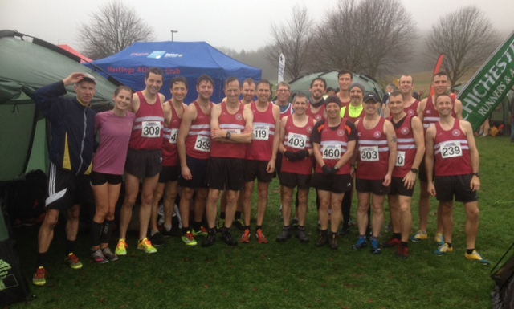
Harriers at Stanmer Park for the Sussex Cross Country League.

Last Saturday, the 1st December, the second Brooks Sussex Cross Country League was held at Stanmer Park, Brighton after the venue at Lancing was changed at late notice. Haywards Heath Harriers had a great turnout by the club for this second out of four cross country league events. With lots of rain during the previous week leading up to the cross country, Stanmer Park was muddier than the previous league race a few weeks back at the same venue which made tougher conditions for all the runners. With over 600 runners from all the age groups taking part meant the individual and team races were hotly contested by all the clubs.

Young Arun Khursheed was top Harrier finisher where he had a great run in the Under 11 Boys race finishing in a superb 4th place! Emma Navesey led the Senior Women’s team home in 9th place and Chris Smith led the Senior men home in 8th place.

Cross country runners hiding from the rain.

Results were as follows:

Senior Men:
8th Chris Smith 29:17, 14th James Skinner 39:47, 20th Ben Gibson 30:45, 47th Russ Mullen 32:43, 52nd Jamie Gibson 33:22, 54th Matt King 33:26, 58th Paul Cousins 33:45, 63rd Darren Bird 34:10, 81st Mark Green 35:13, 87th Andy Hind 35:36, 98th Julian Boyer 36:17, 108th James Bennett 36:54, 109th Barry Tullett 36:56, 110th Nick Skov 37:10, 122nd Andy Dray 38:09, 126th Tim Hicks 38:42, 150th Phil Scott 41:09, 160th Mark Sykes 42:49, 164th Carl Bicknell 43:57, 187th Michael Parrish 54:42.

Senior Women:
9th Emma Navesey 21:19, 37th Siobhan Amer 23:14, 71st Gemma Morgan 26:13, 79th Jasmine Mamoany 26:48, 84th Karen Thompson 27:15, 85th Kath Buckeridge 27:16, 91st Sarah Banks 27:56, 104th Claire Annesley 30:40, 118th Jenny Denyer 42:28.

Under 15 Girls:
29th Harrier Dray 19:19.

Under 11 Boys:
4th Arun Khursheed 8:07, 29th Noah Seymour 9:34.

Under 13 Boys:
19th Sam Fernley 12:27, 20th Charlie Bonwick-Adams 12:34, 39th George Bonwick-Adams 13:32, 42nd Jonathan Beckett 13:36.

Under 15 Boys:
23rd Harvey Alcock 16:16, 33rd Ryan Armstrong 17:32, 36th Patrick Stedman 17:52, 45th Ewan Kemsley 20:29.

Under 17 Men:
7th Adam Dray 18:46.

Other Harrier News:
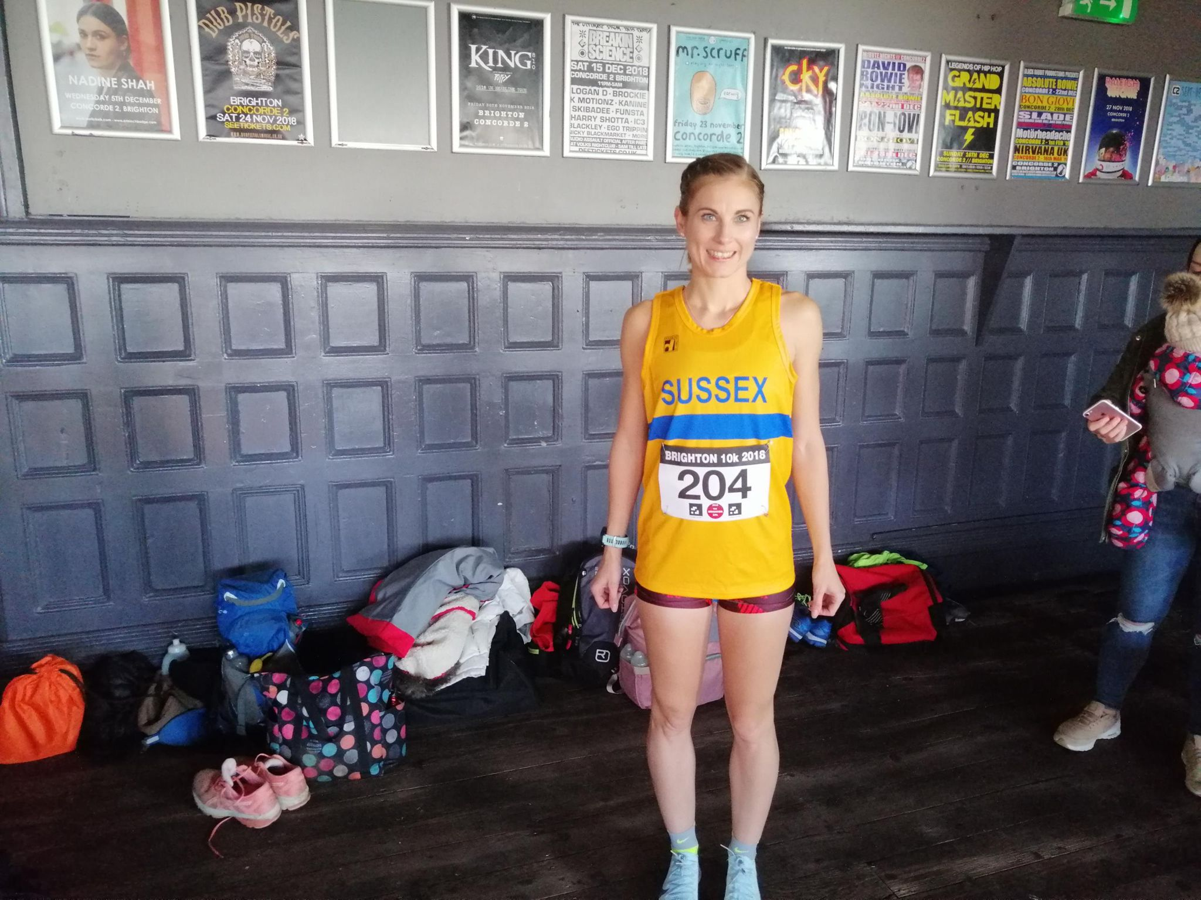
Emma Navesey – Sussex calling!

Emma Navesey has been selected to run at the Inter Counties Cross Country event at Horspath, Oxford next Saturday the 8th of December. Emma also recently represented Sussex at the Brighton 10 km race on 18th November.

At the Poppy Half marathon at Bexhill on 10 November Darren Bird finished in 7th place in 1 hr 23 mins and 57 seconds. Other Harrier finishers were 28th Tim Miller 1 hr 33 mins 16 seconds and 32nd James Bennett 1 hr 32 mins 8 seconds

On 24th November Michael Burke and Oliver Farr both ran in the Winter Chase 2018, an endurance event. Michael ran the furthest distance and covered 39.6 miles in 6 hrs 25 mins and 3 secs. Oliver ran 26.4 miles in 4 hrs 0 mins and 24 secs.

Phil Payne ran in the Buxted 10 km race and finished in second place in a time of 44 mins 44 secs.

Last Sunday, the 2nd December Oliver Farr ran the Mouth to Mouth Marathon which started at Shoreham by Sea and follows the River Adur up onto the South Downs then turning south along the River Arun to Littlehampton. Oli finished the race in a time of 5 hours 2 minutes and 52 seconds.

On 25th November at the Crowborough 10k, eight Harriers were again present at the Sussex Grand Prix race. First home was Darren Bird in 9th place in a time of 38 minutes and 19 seconds and was closely followed by fellow Harrier Ben Duncan in 11th place in 38 minutes and 27 seconds. Other Harrier results were: 23rd Rob Watts 39:45, 73rd Matt Quinton 45:54, 103rd Phil Scott 47:33, 107th Mark Sykes 47:41, 133rd Carl Bicknell 49:41, 182nd Karen Thompson 52:43.

On Sunday 2 December, at the Downland Devil 9 mile race, Siobham Amer won the ladies race and was also 41st overall in a time of 1 hour 14 minutes and 4 seconds. Darren Bird was the first Harrier home and finished in 8th place overall in a time of 1 hr 3 mins and 59 seconds. Other Harriers were Steve Dallman who finished in 33rd position in a time of 1 hour 12 minutes and 22 seconds and Carl Bicknell was 152nd in 1 hour 28 minutes and 37 seconds.

